PUSH THE GIVEN REPO GIVEN INTO YOUR GITHUB:-

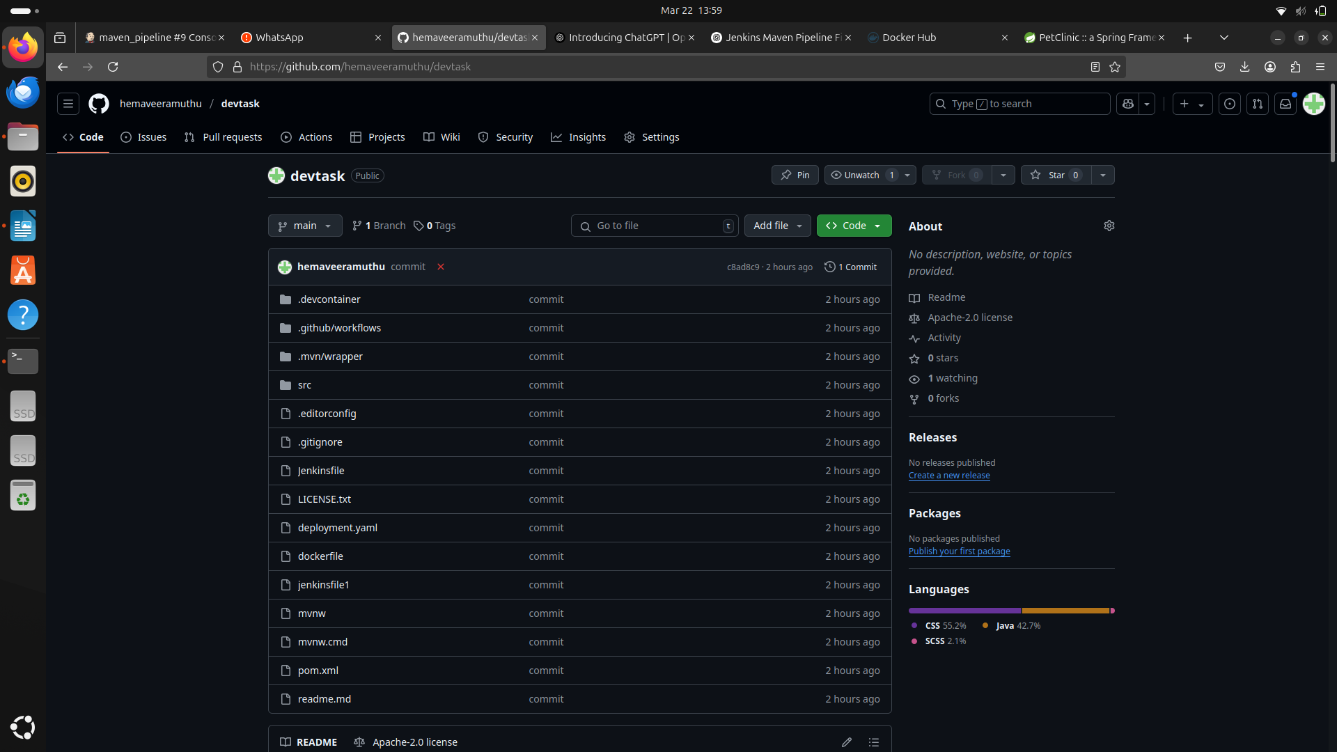

THEN USE THE BELOW PIPELINESCRIPT ACCORDING TO YOUR OWN CREDENTIALS:-

pipeline {
agent any

environment {
DOCKER_IMAGE = "hemadharunika/maven_repo"
DOCKER_TAG = "latest"
DOCKER_CREDENTIALS_ID = "docker"
GITHUB_CREDENTIALS_ID = "github_seccred"
KUBECONFIG = "/var/lib/jenkins/.kube/config"
MAVEN_CMD = "/usr/bin/mvn" // Ensure Maven path is correct
}

stages {
stage('Checkout Code') {
steps {
script {
git credentialsId: GITHUB_CREDENTIALS_ID, url: 'https://github.com/hemaveeramuthu/devtask', branch: 'main'
}
}
}

stage('Build Application') {
steps {
script {
sh "${MAVEN_CMD} clean package -DskipTests"
}
}
}

stage('Run Maven Tests') {
steps {
script {
catchError(buildResult: 'SUCCESS', stageResult: 'FAILURE') {
sh "${MAVEN_CMD} test"
}
}
}
}

stage('Build Docker Image') {
steps {
script {
sh "docker build -t ${DOCKER_IMAGE}:${DOCKER_TAG} ."
}
}
}

stage('Push Docker Image') {
steps {
script {
withCredentials([usernamePassword(credentialsId: DOCKER_CREDENTIALS_ID, usernameVariable: 'DOCKER_USER', passwordVariable: 'DOCKER_PASS')]) {
sh '''
echo "$DOCKER_PASS" | docker login -u "$DOCKER_USER" --password-stdin
docker push ${DOCKER_IMAGE}:${DOCKER_TAG}
'''
}
}
}
}

stage('Deploy to Kubernetes') {
when {
expression { fileExists('scripts/deploy.sh') }
}
steps {
script {
sh '''
chmod +x scripts/deploy.sh
./scripts/deploy.sh
'''
}
}
}
}

post {
success {
echo "✅ Deployment Successful!"
}
failure {
echo "❌ Deployment Failed!"
}
}
}

BUILD THE PIPELINE:-

In Tools:-
Use Maven 3.9.6
and Maven Home as /opt/home

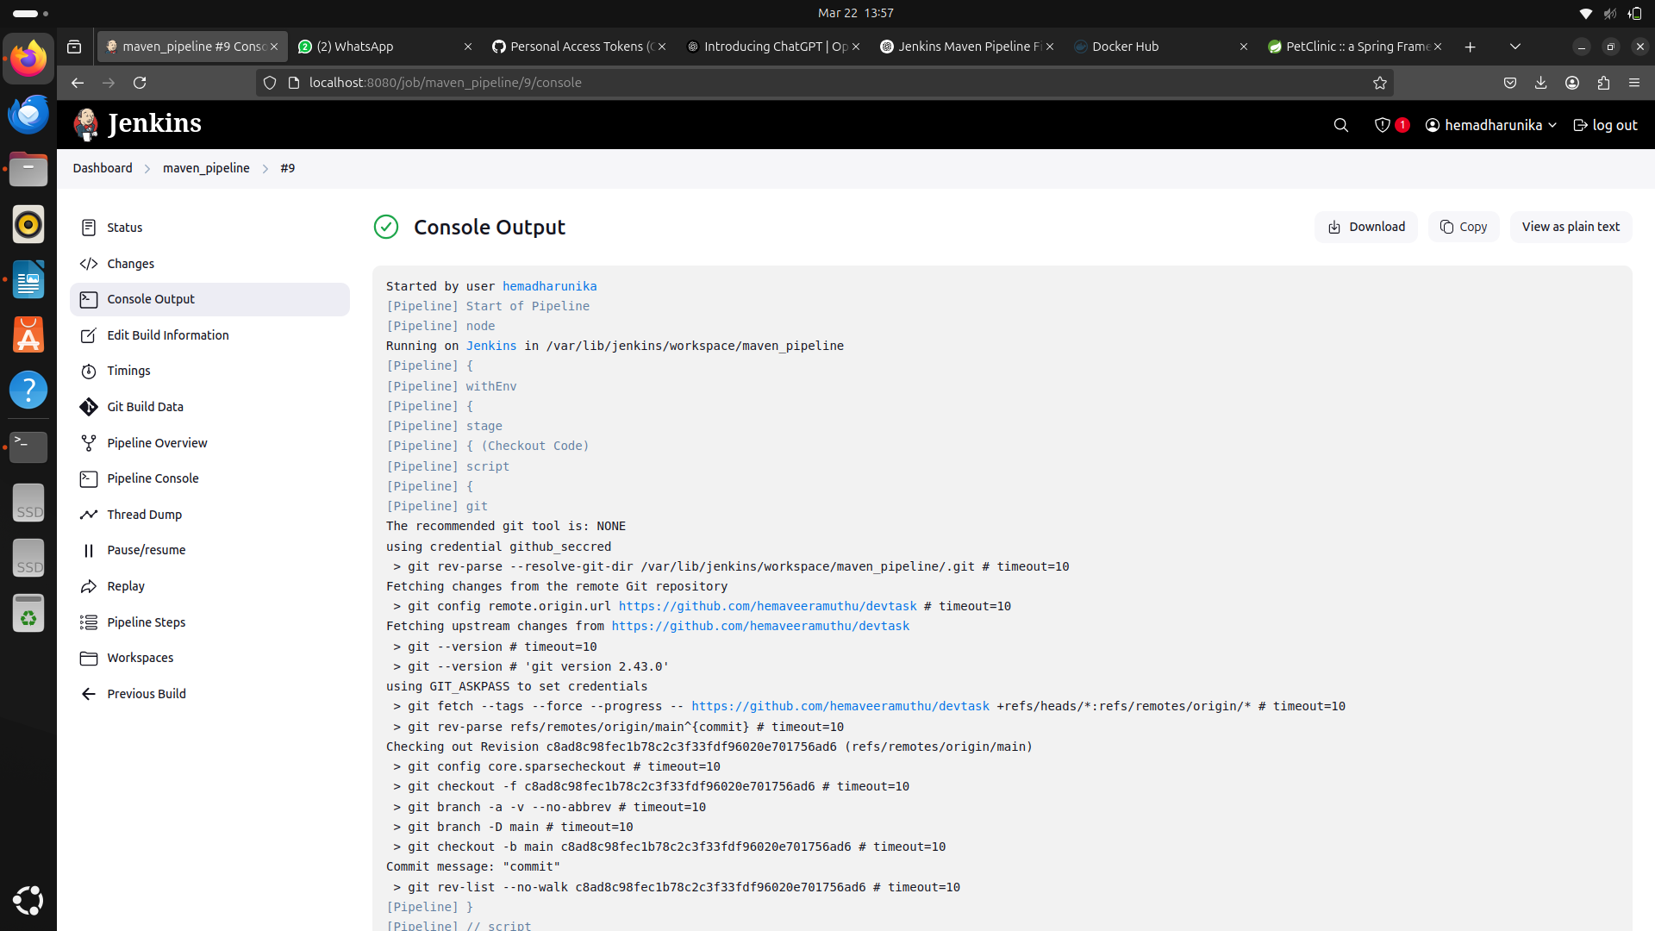

AFTER BUILD:-

docker ps -a
docker run -it kowsika12/maven:latest /bin/bash
/usr/local/tomcat# ps aux | grep tomcat
docker run -d -p 9098:8080 --name my-app hemadharunika/maven_repo

BUILD SUCCESS OUTPUT:-

FINAL OUTPUT IN localhost:9098
