1)Develop a system using UML for implementing E-Ticketing System. This is to be used by the passenger for reserving the tickets for their travel. This E-ticketing is organized by the central system. The information is provided  
by the railway reservation system.

**Aim:** To draw the UML diagrams for implementing the E-Ticketing system by using Umbrello software.

**Use Case:** 

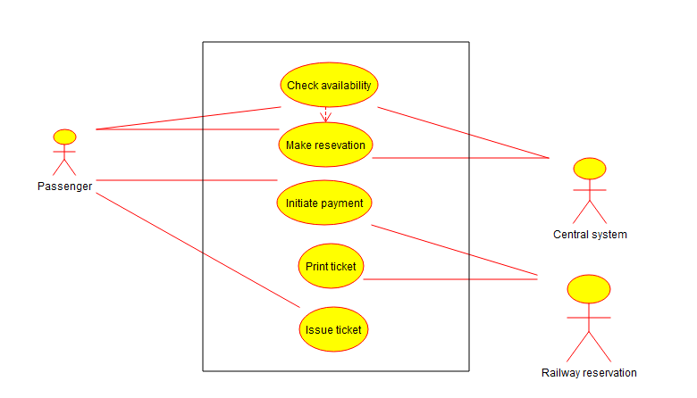

**Class Diagram: V. Hema(192211398)**

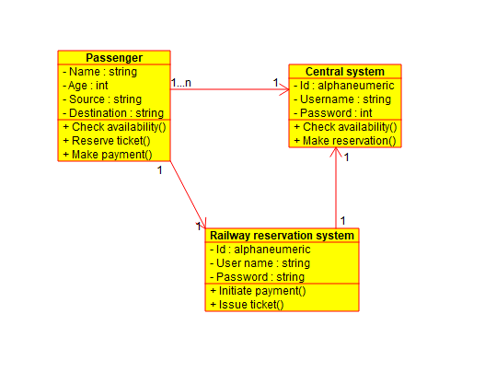

**Activity Diagram: V. Hema(192211398)**

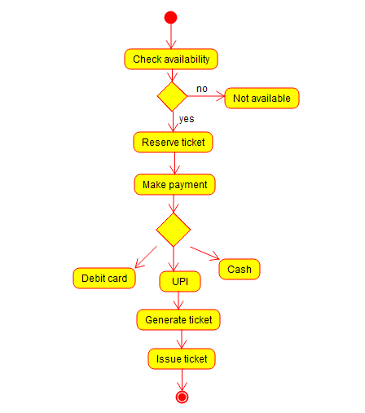

**Result:** Thus the UML diagram for E-Ticketing system has been drawn successfully by using Umbrello software.

1. Develop a system using UML for implementing Credit Card Processing System. In this system, the cardholder can purchase items and pays the  
   bill with the aid of a credit card. The cashier should accept the card and proceed with the transaction using the central system. The bill is to be verified and the items are delivered to the cardholder based on it.

**Aim:** To draw the UML diagrams for implementing Credit Card Processing System using Umbrello software.

**Use Case: V. Hema(192211398)**

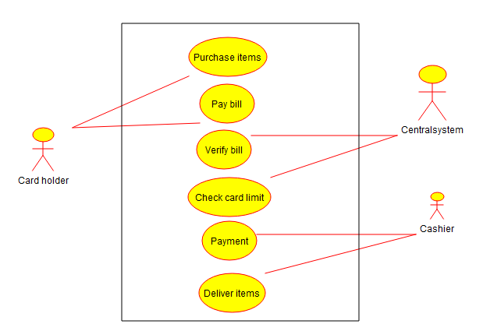

**Class Diagram**:

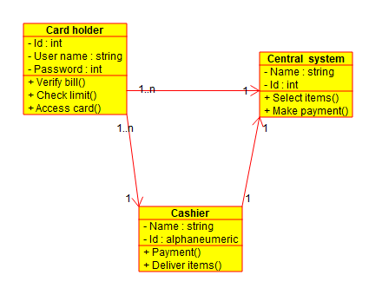

**Activity Diagram:**  **V. Hema(192211398)**

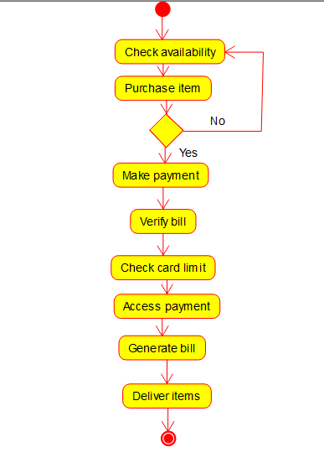

Result: Thus the UML diagrams for implementing Credit Card Processing System has been drawn successfully by using Umbrello software.

1. Develop a system using UML for Software Personnel Management System. It should be used to process the details of a person who works in a software company. The details are to be stored in the central management system for cross-checking the person’s details

Aim: To draw the UML diagrams for Software Personnel Management System using Umbrello software.

**Use Case:** **V. Hema(192211398)**

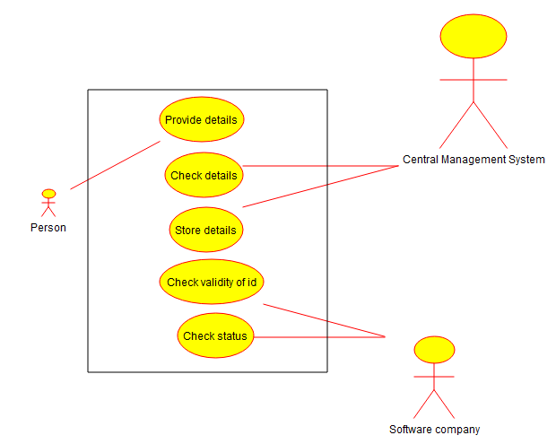

**Class Diagram:** **V.Hema(192211398)**

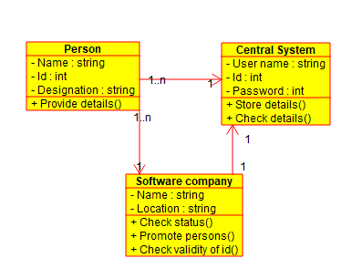

**Activity Diagram:**  **V.Hema(192211398)**

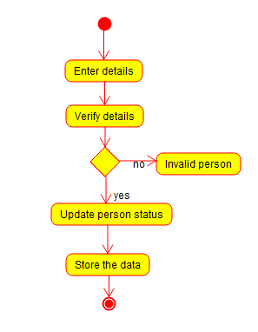

**Result:** Thus the UML diagrams for Software Personnel Management System has been drawn successfully by using Umbrello software.

1. Develop a system using UML for E-Book Management System. It should be designed to manage the books that were read through the internet. That should consist of the details of the e-book that were read by the user online. It will be controlled by the central system. This system should act as a backup all details together.

Aim: To draw the UML diagrams for E-Book Management System using Umbrello software.

**Use Case:** **V.Hema(192211398)**

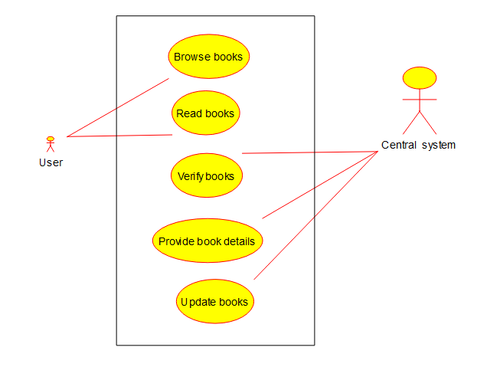

**Class Diagram: V.Hema(192211398)**

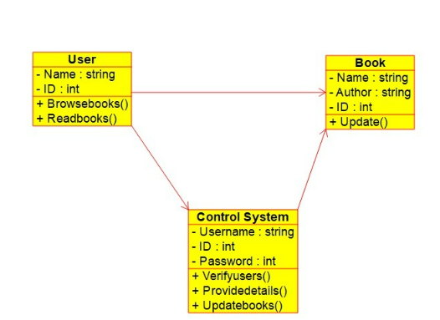

**Activity Diagram: V.Hema(192211398)**

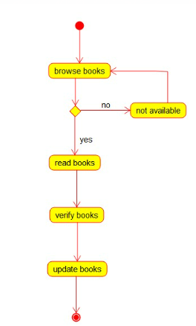

**Result:** Thus the UML diagrams for E-Book Management System has been drawn successfully by using Umbrello software.