Report on “MEMS, RF circuits and Circuit Level Design in Industries”
Program: Guest Lecture
Resource Persons: Professor Shiban K Koul, Deputy Director (S&P) and Professor Centre for Applied Research in Electronics, Indian Institute of Technology (Delhi)
Target Audience: Faculty from VNR VJIET and Students of B.Tech and M.Tech
Number of Participants: 240
The guest lecture was scheduled for one day in ECE department, VNR Vignana Jyothi Institute of Engineering and Technology, Hyderabad.

- Department of ECE has organized a distinguished lecture by Prof.S.K.Koul, Deputy Director (Strategy and Planning) and Professor Centre for Applied Research in Electronics, Indian Institute of Technology Delhi on “Radio Frequency Microsystems”, as part of IEEE AP / EMC/MTT- Chapter under Hyderabad section in association with IEEE Student Branch, ISTE & ISF of VNRVJIET for III & IV Year B.Tech, I Year M.Tech (VLSI & ES) students and Faculty members of ECE on 17-07-2015 at B-Block Seminar hall.
205 students, 12 faculty members and 4 technical staff were attended the lecture.
The following points were discussed:
- Students were suggested to attend summer training program for 2 months in IIT to improve their knowledge and able to work on design aspects.
- The trust areas of research in the field of RF and Microwave were given and the developed applications were shown.
- Visited ECE labs and RCC, ACTS and Driver Monitoring system were suggested to be presented in International Microwave and RF conference (IMaRC)-2015 which is held at Hyderabad during 10-12 December 2015 and last date for submission is 27th July 2015.
- Innovative ideas funding are supported by “SIGHT” an Microwave Theory and Techniques Society (MTT-S) Initiative.
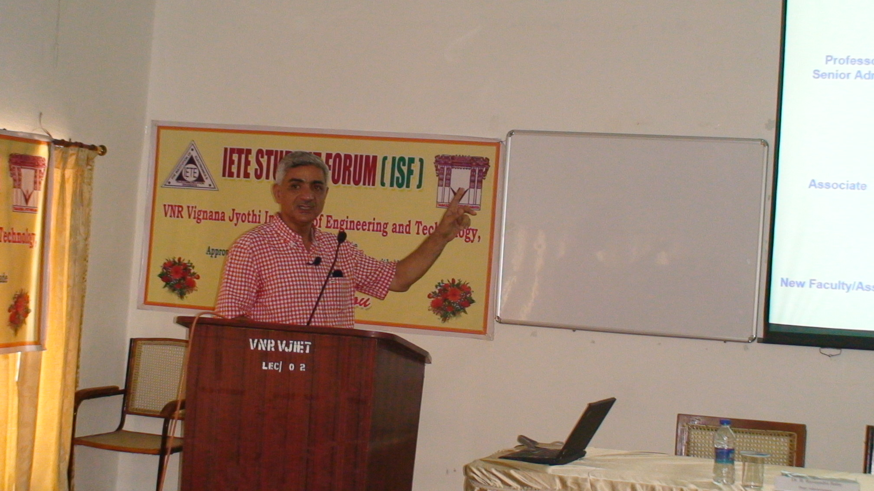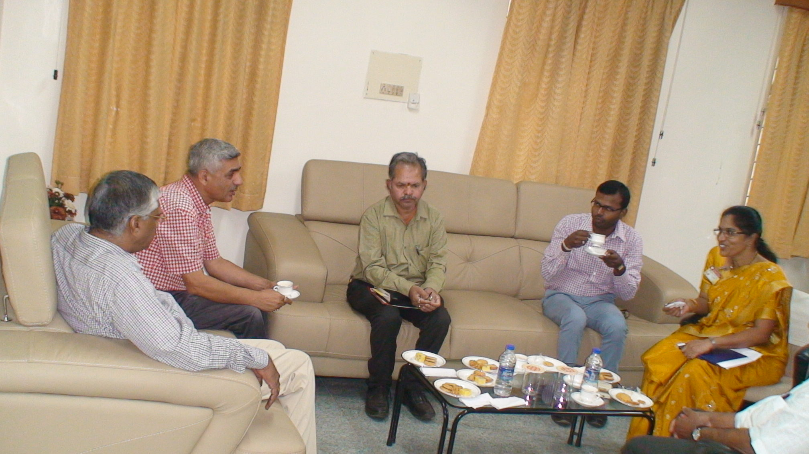
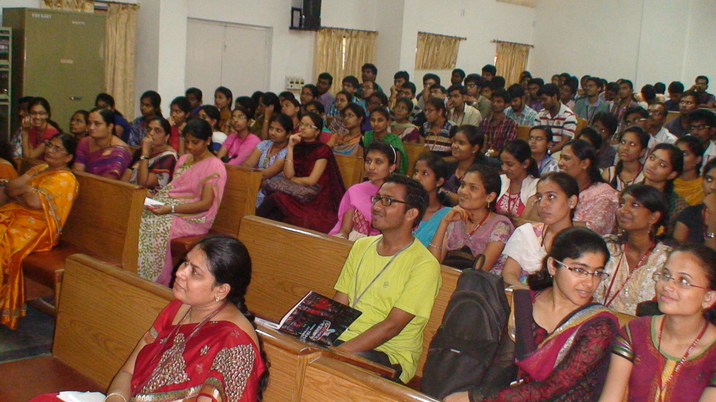

Co-Ordinator HOD/ECE
JLV Ramana Kumari Dr. Y. Padma Sai

