G.PULLAIAH COLLEGE OF ENGINEERING & TECHNOLOGY: KURNOOL
Report On “ 10th ISTE AP&TS Section Annual Convention and Awards Function- 2015 “
On Dec 29, 2015

G.Pullaiah college of Engineering &Technology ,Kurnool, hosted 10th ISTE AP&TS Section Annual Convention andAwards Function- 2015 “on 29th December 2015 at seminar Hall of GPCET, Kurnool. The program was started by the presidential address by Sri G.V.M.Mohan Kumar, Chairman GPCET and shared his happiness over getting an award as the best ISTE Chapter in the Andhra Pradesh award. Sri G.Pullaiah Secretary GPCET announced that he will sponsor one award for the next year. Distinguished guests like Dr. K. Lal Kishore Chairman ISTE-AP, Dr. T.Kishen kumar Reddy Chairman –ISTE –TS, Dr.K.Hemachandra Reddy, Secretary&Treasurer of ISTE A.P Section, Prof Y.Padma Sai Secretary & treasurer-TS, Dr.P.Ravindra Babu EC Member ISTE-AP addressed the gathering and have explained the importance of ISTE and its membership. Dr.P.Nageswara Rao Principal, GPCET has given a brief report about the events that were conducted in the college in the academic year 2014-15.
Life Time Achievement award was given to Prof. D.N.Reddy Ex Chairman, ISTE-TS section. He was felicitated by Sri G.Pullaiah Secretary GPCET, Sri G.V.M.Mohan Kumar, Chairman GPCET. ISTE awards were presented to the winners by Dr.P.Ravindra Babu EC Member ISTE-AP . Vote of thanks was given by Dr S.Prem Kumar, HOD of CSE.
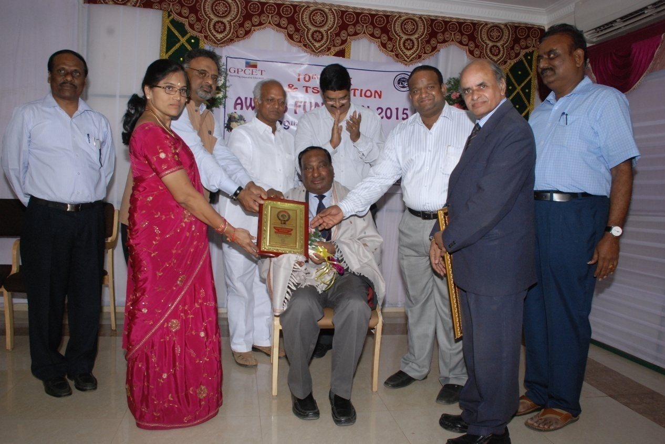 Prof. D.N.Reddy Ex Chairman, ISTE-TS section receiving Life Time Achievement award from Sri G.Pullaiah Secretary GPCET and Sri G.V.M.Mohan Kumar, Chairman GPCET

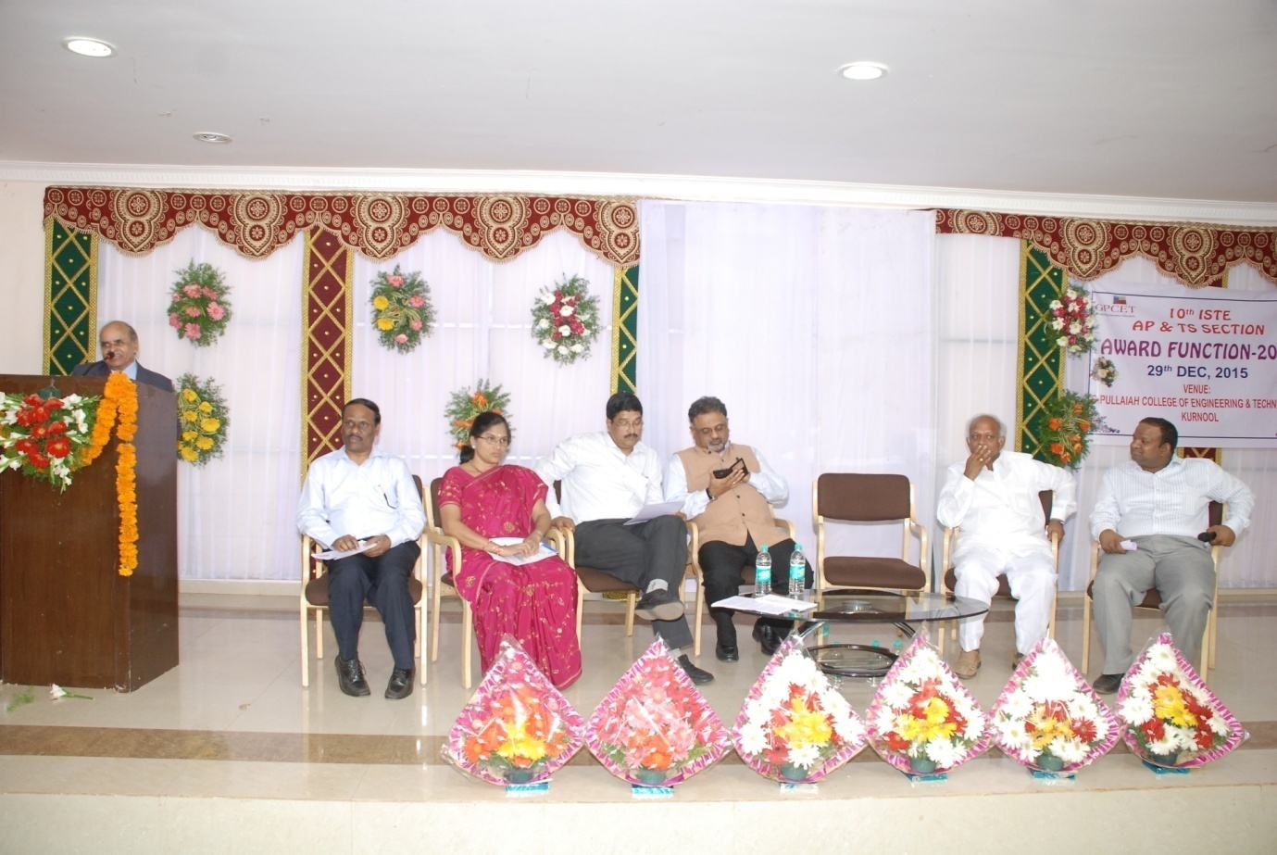 Dr. K. Lal Kishore Chairman ISTE-AP addressing the Participants and ISTE Award winners
