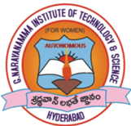 | G.NARAYANAMMA INSTITUTE OF TECHNOLOGY & SCIENCE (For Women)  (AUTONOMOUS)  Accredited by NBA & NAAC, An ISO 9001:2015 Certified Institution  Shaikpet, Hyderabad- 500 104 | 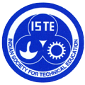

Date: 03/01/2020

ISTE Telangana Section Convention and Awards Function- 2019

14th ISTE Telangana Section Convention and Award function-2019 was hosted at G. Narayanamma Institute of Technology & Science, Shaikpet, Hyderabad on 30th December 2019.
Sri Navin Mittal, IAS, Commissioner of Technical Education Telangana State was the Chief guest of the function , Prof. A. Venugopal Reddy, Ex Vice Chancellor JNTUH & Chairman ISTE TS section, Prof. Smt.Y.Padma Sai, Hon.Secretary-Cum-Treasurer, ISTE-TS section and Smt. Srividya Reddy Gunnampalli, Secratary, G. Narayanamma Institute of Technology & Science, Shaikpet, Hyderabad the guests of Honor.

The award function was attended by more than 300 participants from various colleges, awardees and ISTE Members.
Prof.M. Kommuraiah, Professor & Dean of Academics Srinidhi Institute of Technology & Science, Hyderabad was awarded Life Time Achievement award.
ISTE Telanagana Section awards for various categories were presented in the function (list of awardees is enclosed).
Chief Guest Sri Navin Mittal, IAS addressed the gathering and motivated the student and faculty community on how we need to update and upgrade ourselves in terms of latest trending technologies and stay in the race.
Guest of Honor Prof. A. Venugopal Reddy, suggested faculty members to learn new technologies by conducting Workshops through ISTE and enhance the skills and make the students ready for industry.
As a token of gratitude Smt. Srividya Reddy Gunnampalli, Secratary, G. Narayanamma Institute of Technology & Science, Shaikpet, Hyderabad chief guest and Guests of honor.

Pics of the 14th ISTE Convention:
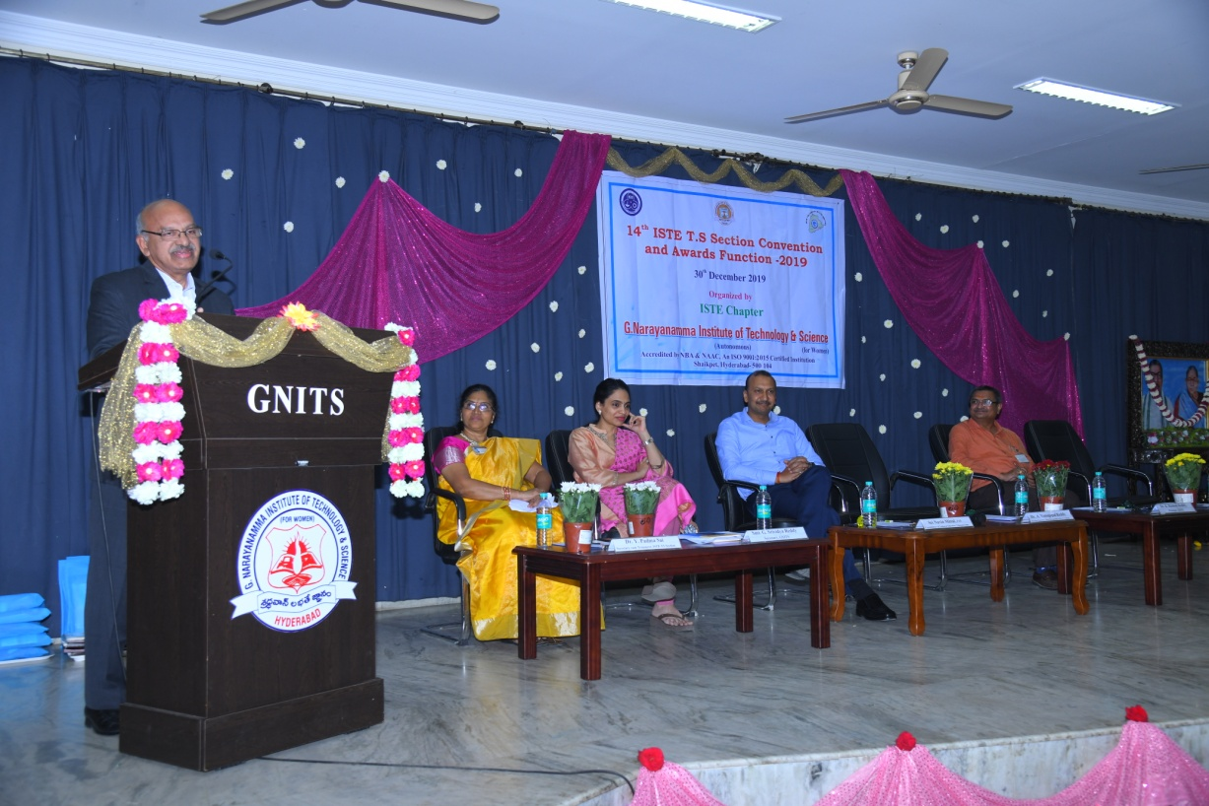
Guest of Honour Prof. A. Venugopal Reddy, Ex Vice Chancellor JNTUH & Chairman ISTE TS section addressing the gathering
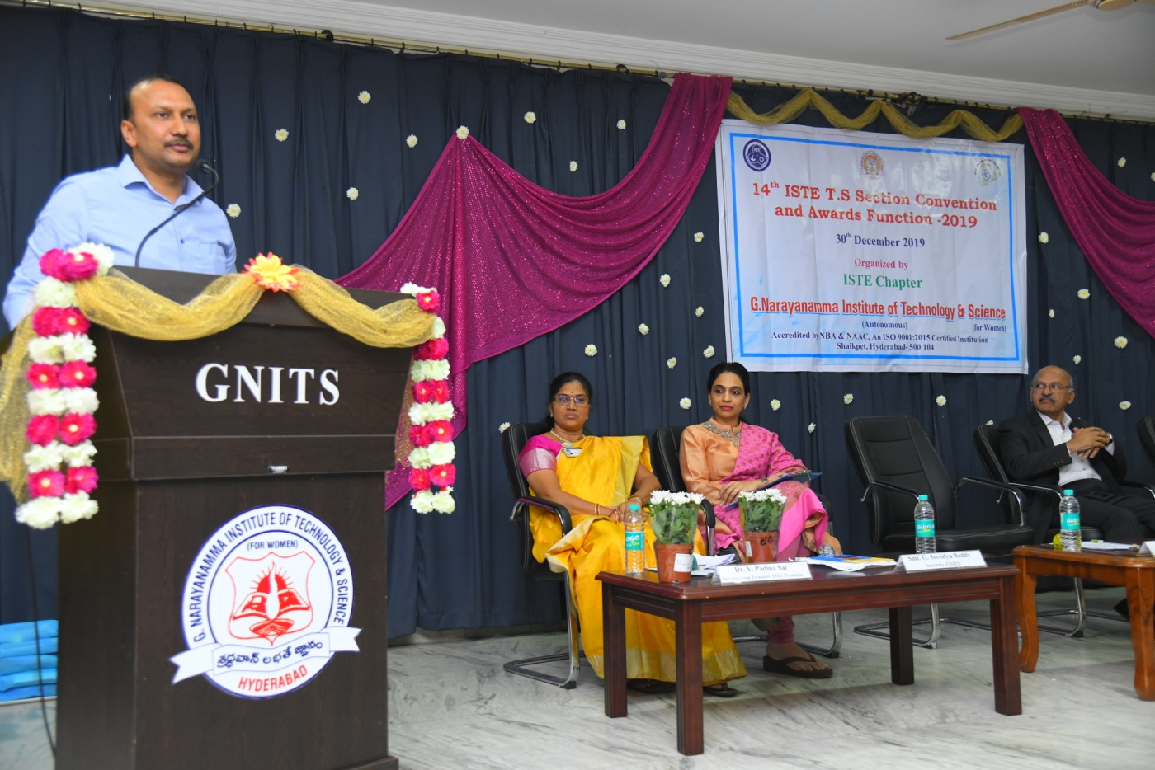
Chief Guest Sri Navin Mittal, IAS, Commissioner of Technical Education Telangana State addressing the gathering

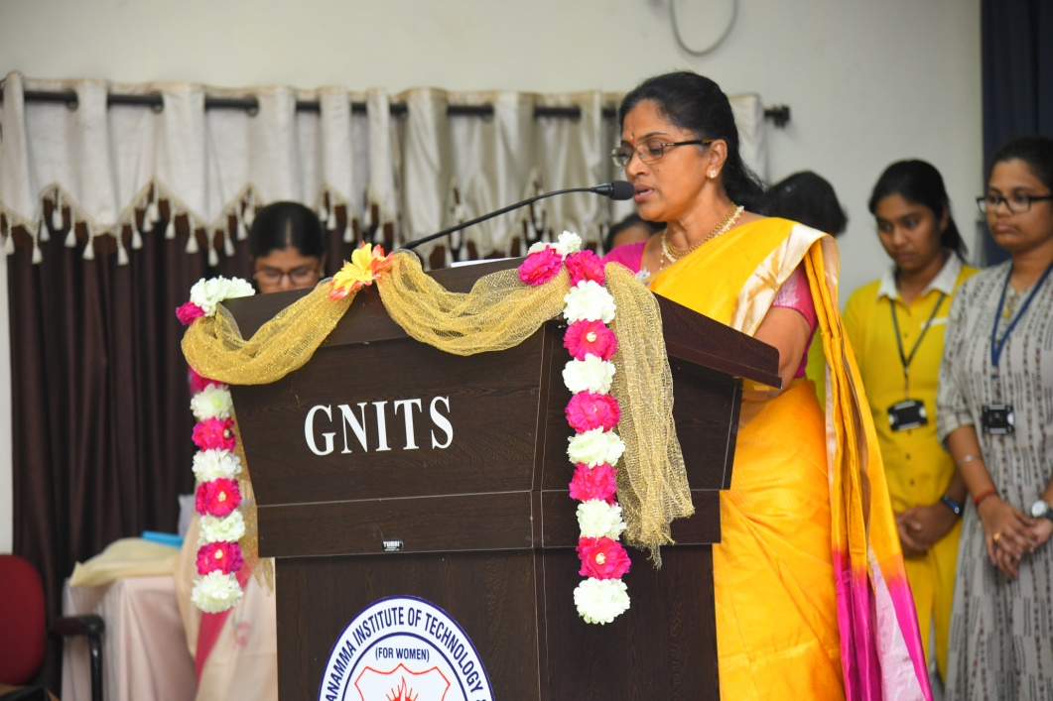
Prof. Smt.Y.Padma Sai ,Hon.Secretary-Cum-Treasurer.ISTE-TS addressing the audience.

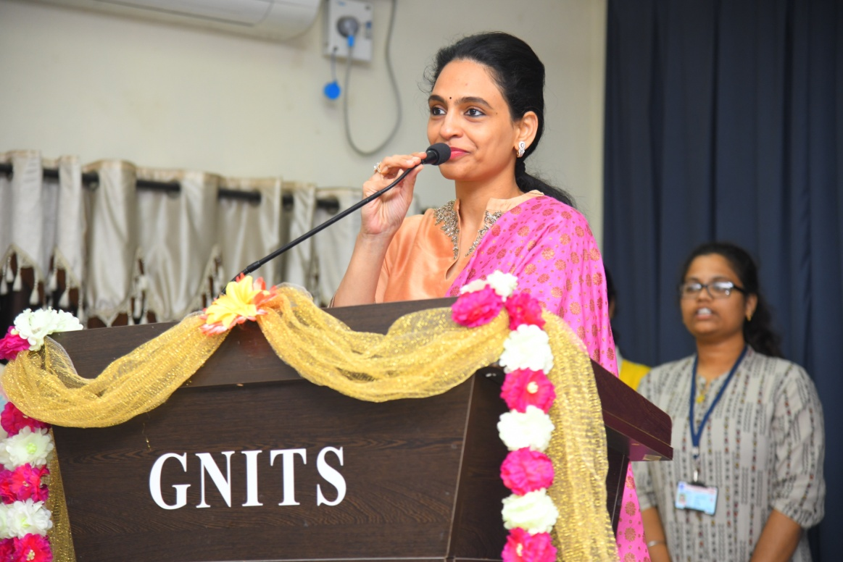
Smt. Srividya Reddy Gunnampalli, Secratary, G. Narayanamma Institute of Technology & Science, Shaikpet, Hyderabad addressing the gathering

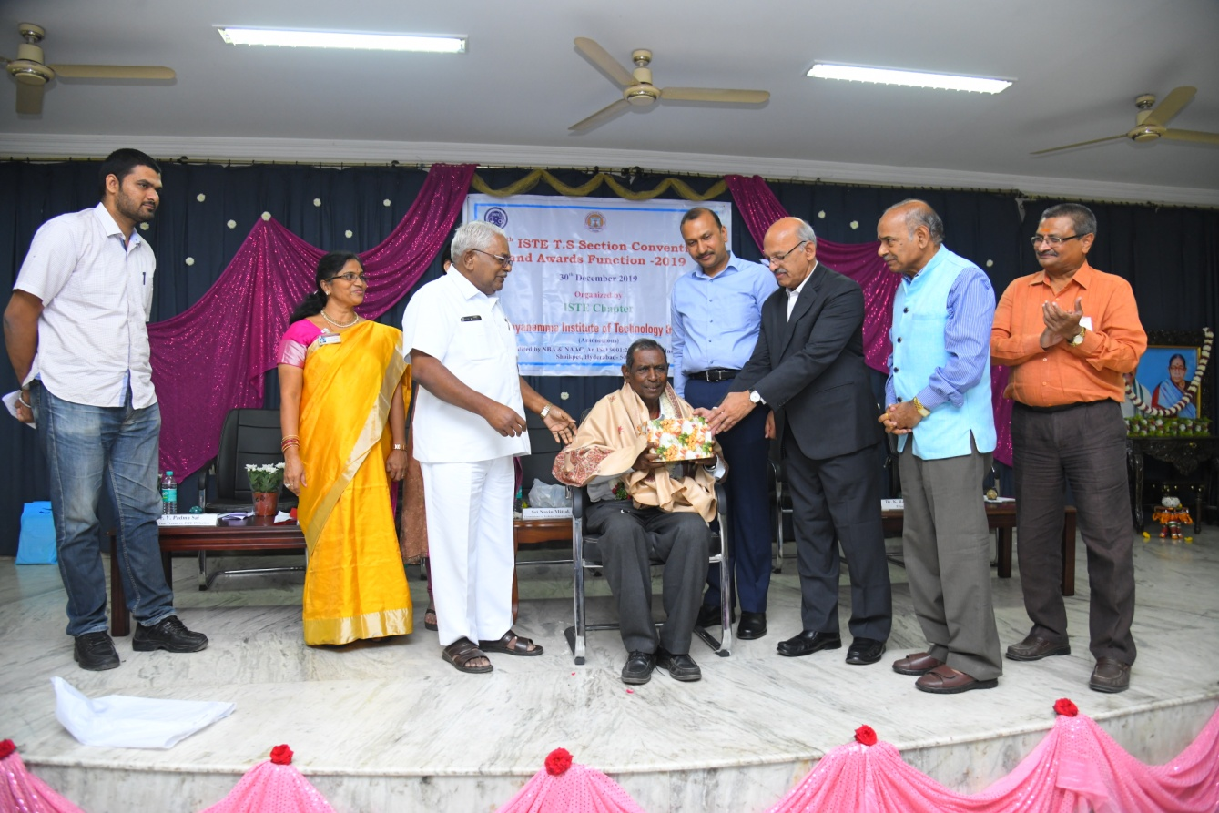
Prof.M. Kommuraiah, Professor & Dean of Academics Srinidhi Institute of Technology & Science, Hyderabad was awarded Life Time Achievement award.
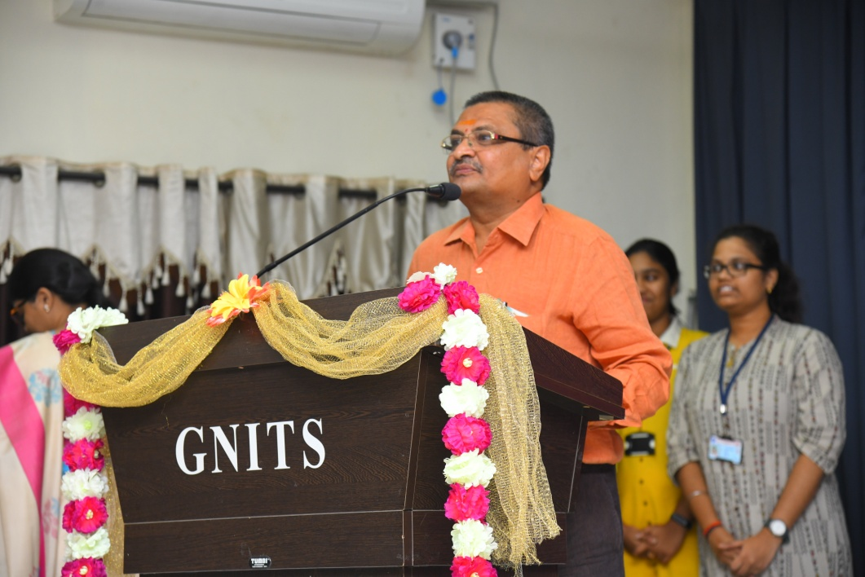
Dr.K.Ramesh Reddy, Principal, G. Narayanamma Institute of Technology & Science, Shaikpet, Hyderabad addressing the gathering.

Glimpses of awards
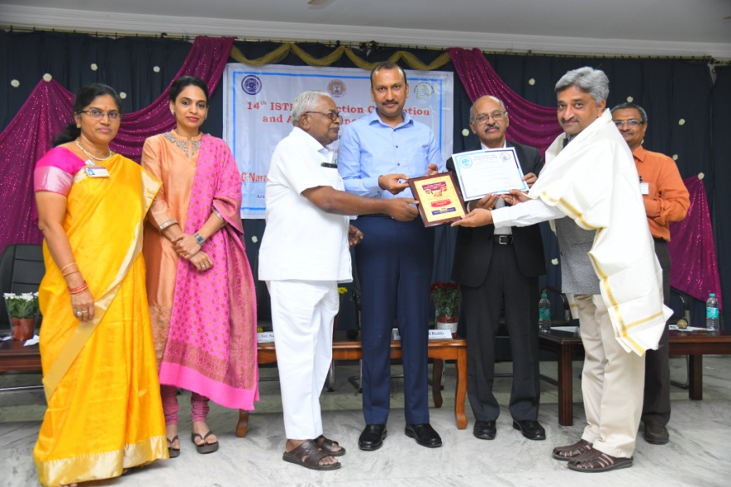 | 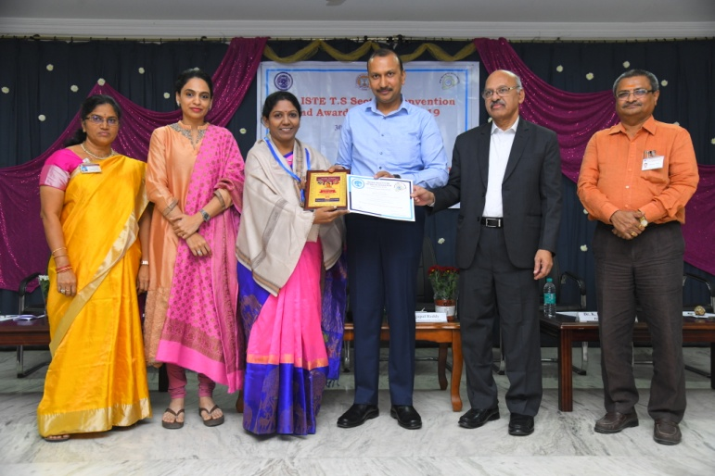
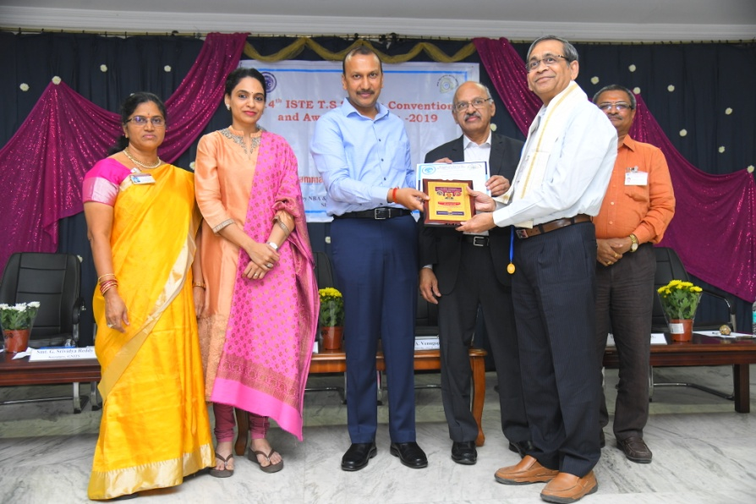 | 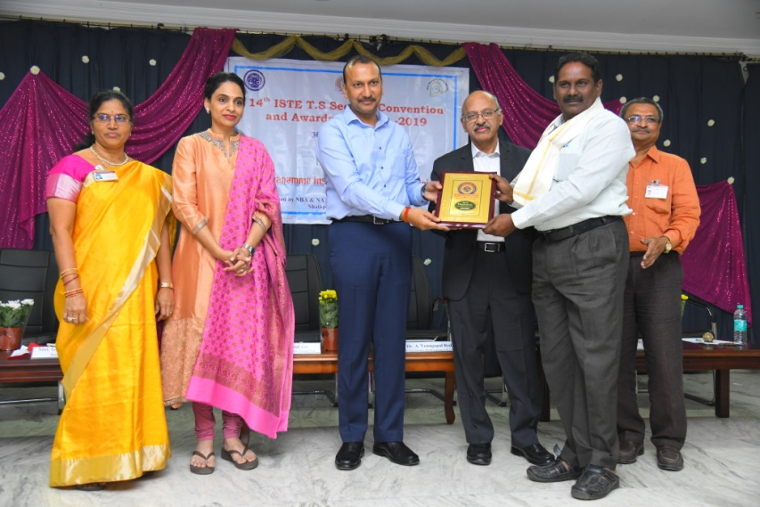

Coverage in Local News papers
