Does Graph-Based Retrieval Beat Vector Search on Multi-Hop Questions?
A HippoRAG-style Study Using Personalized PageRank
Team members: Chitiveli Hemcharan Varma | Course: CS 328 Introduction to Data Science | Date: November 2026
1. Problem Description
Retrieval-augmented generation (RAG) usually retrieves passages by dense vector search: each passage is embedded independently and ranked by similarity to the question. This works for single-hop lookups but is structurally weak on multi-hop questions, where the answer needs two or more passages linked through an entity the question never mentions. Because passages are scored independently, the retriever often finds the passage that matches the question’s wording and misses the second-hop passage. If only one of two required passages is retrieved, the reader cannot complete the reasoning chain.
We test whether an entity-graph retriever using Personalized PageRank (PPR), following HippoRAG [1], retrieves multi-hop evidence better than a dense baseline.
- RQ1: Does Graph + PPR achieve higher recall@2, recall@5 and all-recall than a dense-vector baseline?
- RQ2: With the same LLM reader, does the better retriever also give higher exact match (EM) and F1?
- H1: Graph + PPR has higher recall, with the largest gains on questions needing multiple passages. H0: no difference.
Data. 2WikiMultiHopQA [2] (dev set, 12,576 questions) has annotated supporting passages, so recall can be measured directly. We use a stratified evaluation sample of N = 200 questions with their 1,484 passages (compositional 83, bridge comparison 44, comparison 48, inference 25).
2. Solution Approach
2.1 Survey of existing methods
- Dense retrieval (DPR, SentenceTransformers + FAISS). Bi-encoder embeddings with inner-product search. Fast and strong for single-hop, but the corpus is an unstructured set of points with no way to move from a named entity to an unmentioned bridge entity.
- Iterative retrieval (Self-Ask, IRCoT). An LLM generates sub-queries step by step. It handles bridges but needs sequential LLM calls at query time, so it is slow and costly, and early-hop errors propagate.
- Curated knowledge graphs (Wikidata, Freebase). Support traversal but require an existing schema and knowledge base, which unstructured domain text does not have.
- HippoRAG (Gutierrez et al., NeurIPS 2024). Builds an entity graph from passages via OpenIE, links query entities to graph nodes and runs PPR to spread activation along multi-hop paths, with no query-time LLM loop. Our method follows this design.
2.2 Our approach
Both arms use the same 1,484 passages, formatted identically (“Title: … Text: …”), the same embedding model (all-MiniLM-L6-v2, 384-d) and the same reader (gemini-3.1-flash-lite).
Arm 1: Dense baseline. Passage embeddings in a FAISS IndexFlatIP (exact cosine similarity); top-k passages by similarity to the question.
Arm 2: Graph + PPR.
- Graph construction. An LLM extracts (subject, predicate, object) triples from every passage. Passage titles are connected to the entities in their passage. Result: 7,948 nodes and 10,254 edges (Figure 1 shows a sample neighbourhood).
- Entity linking with LSH. To merge synonyms and link query entities without all-pairs comparison, we use random-hyperplane LSH over the embeddings. Query entities (extracted by the LLM) are linked to graph nodes with softmax-weighted cosine similarity.
- Personalized PageRank. Linked query entities form the teleport vector u. PPR is computed by power iteration (damping α = 0.5): p = (1 − α) u + α p W.
- Passage scoring. score(p) = Σ PPR(e) / df(e), summed over the entities e in passage p, where df(e) is the number of passages containing e. Dividing by df penalises generic hub entities. The top-k passages are returned.
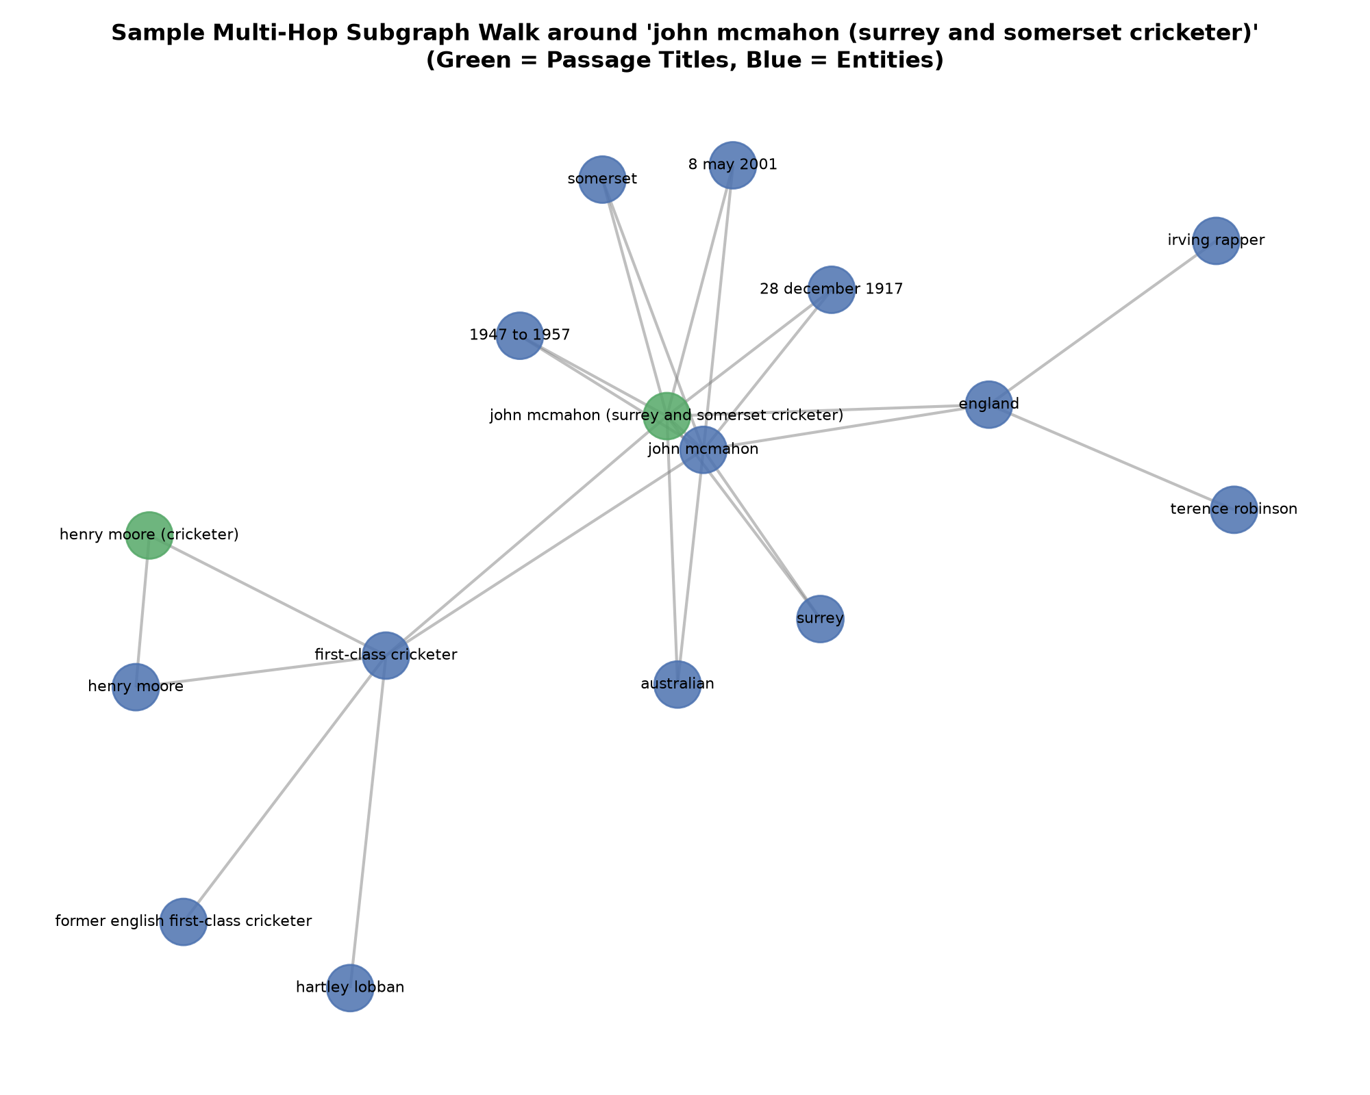
Figure 1: Sample multi-hop subgraph around one passage; green = passage titles, blue = entities.
Evaluation protocol. Metrics: recall@2, recall@5, all-recall (both gold passages retrieved), EM and token F1. Decision criteria were fixed before running: Graph + PPR counts as better if the recall gain is positive and statistically significant, with a 95% bootstrap CI reported. Control: a no-walk ablation (α = 0, entity matching only).
3. Results
3.1 Retrieval (RQ1)
Metric | Dense baseline | Graph + PPR (α = 0.5) | Gain (pp) | Test
Recall@5 (primary) | 67.12% | 93.75% | +26.62 | Paired bootstrap 95% CI [+22.38, +30.63]; sign-flip permutation p < 0.00001
Recall@2 | 56.88% | 73.88% | +17.00 | Permutation p < 0.00001 (Holm-Bonferroni)
All-recall@5 | 35.00% | 85.50% | +50.50 | McNemar exact p = 5.15e-25 (Holm-Bonferroni)
No-walk control (α = 0) | n/a | 71.38% |  | Full PPR is +22.37 pp over no-walk, p < 0.00001

The pre-registered verdict is to reject H0: Graph + PPR retrieves significantly more supporting evidence than dense search on this benchmark. The no-walk control shows that most of the gain comes from graph diffusion, not from entity recognition alone.
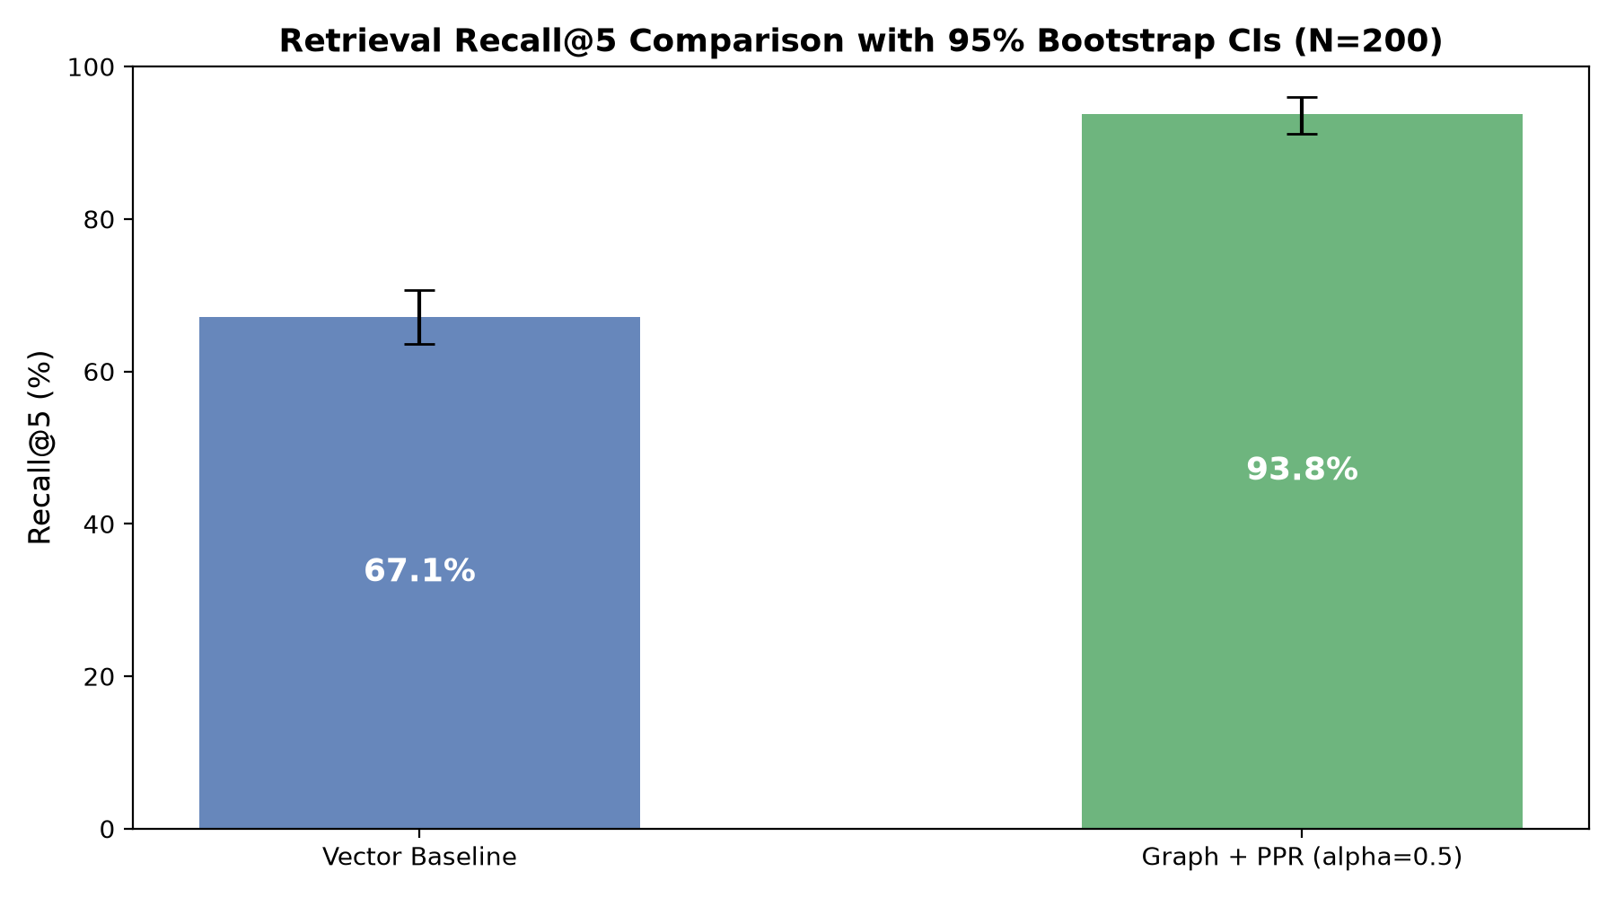
Figure 2: Recall@5 with 95% bootstrap confidence intervals (N = 200).
3.2 By question type
Question type | N | Dense recall@5 | Graph + PPR recall@5 | Gain (pp)
Bridge comparison | 44 | 49.43% | 87.50% | +38.07
Compositional | 83 | 60.84% | 94.58% | +33.73
Inference | 25 | 72.00% | 90.00% | +18.00
Comparison | 48 | 91.67% | 100.00% | +8.33

H1 predicted the largest gains on multi-passage questions, and this holds. Relational chains (compositional + inference) gain +30.09 pp versus +8.33 pp for direct comparisons, a contrast of +21.76 pp. When both entities are named in the question, dense search already does well (91.67%). When a bridge entity is unmentioned, dense recall falls to 49–61% while Graph + PPR stays at 88–95%.
3.3 Downstream QA (RQ2)
Reader condition | Context | EM | F1
Closed-book | None | 96.0% | 96.0%
Vector reader | Top-5 from dense baseline | 88.0% | 88.0%
Graph reader | Top-5 from Graph + PPR | 96.0% | 96.0%
Gold oracle | Gold passages | 96.0% | 96.0%

The graph reader matches the gold-oracle ceiling and scores 8 points above the vector reader. However, the closed-book reader also scores 96%, so retrieval added nothing over the model’s own knowledge in this setup. We therefore do not claim a downstream benefit (see Conclusions). The reader subset size is [n = to be confirmed].
4. Conclusions
- Retrieval (RQ1): supported. Graph + PPR raised recall@5 from 67.1% to 93.8% (+26.6 pp, 95% CI [+22.4, +30.6]) and all-recall@5 from 35.0% to 85.5%. Dense search retrieved the full evidence chain for only about a third of questions.
- Mechanism. The gain comes from graph diffusion: the no-walk control reaches only 71.4%. Gains are largest on bridge and compositional questions, where the connecting entity is not in the question, and smallest on direct comparisons.
- Downstream QA (RQ2): not demonstrated. The reader with graph-retrieved passages equals the gold oracle (96%) and exceeds the vector reader (88%), but closed-book also reaches 96%. The reader appears able to answer these questions from parametric memory, and the reader sample is small, so the 8-point gap is suggestive only and was not tested for significance.
- Limitations.
  - The corpus is small (1,484 passages pooled from the 200 questions’ own contexts), which is easier than open-domain retrieval, so absolute numbers will not transfer to large corpora.
  - Graph quality depends on LLM triple extraction and entity linking, and graph construction adds LLM cost that the dense baseline does not pay.
  - Only one dataset was used.
  - Deviation from the proposal: significance for recall used paired sign-flip permutation tests rather than the Wilcoxon signed-rank test originally planned; the conclusion is the same at the 0.05 level.
5. Code and Data
Code and data: [GitHub repository link: to be added]
6. References
[1] B. J. Gutiérrez et al. “HippoRAG: Neurobiologically inspired long-term memory for large language models.” NeurIPS, 2024.
[2] X. Ho et al. “Constructing a multi-hop QA dataset for comprehensive evaluation of reasoning steps.” COLING, 2020.
[3] P. Lewis et al. “Retrieval-augmented generation for knowledge-intensive NLP tasks.” NeurIPS, 2020.
[4] T. H. Haveliwala. “Topic-sensitive PageRank.” WWW, 2002.

