Visual Inspection PoC — Results & Findings
PatchCore anomaly detection on MVTec AD · bottle, screw, tile, toothbrush

1. What I did
I built a proof-of-concept for automated quality inspection: for each of four part types, a model that looks at a photo of the part and decides GOOD or DEFECT. The key idea is that the model is trained only on good parts — it is never shown a defect during training. It learns what “normal” looks like and flags anything that departs from it.
I used four categories from the public MVTec AD dataset: bottle, screw, tile, and toothbrush. Each part gets its own independent model. The parts are deliberately varied — a smooth bottle top, a screw at any angle, a random tile texture, a toothbrush — to show the method is not tied to one kind of object.
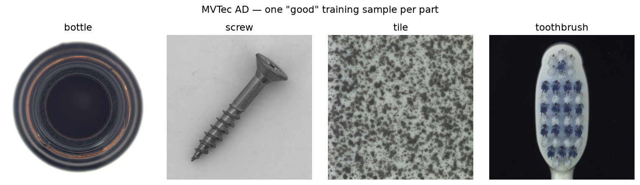
One “good” training image from each of the four MVTec AD parts.

2. How it works (in plain terms)
The method is called PatchCore. There is no hand-trained neural network and no defect labels — it works in four steps:
- Describe the image. A standard pretrained vision network (ResNet-18, frozen) converts each image into a grid of small “patch” descriptions — one per local region of the image.
- Remember what good looks like. Every patch from all the good training images is stored in a “memory bank.” A trimming step keeps a representative subset so it stays fast. This memory bank is the model.
- Score a new part. For a test image, each patch is compared to the closest good patch in the bank. If a region looks nothing like anything good, it scores high. The image’s overall score is its most unusual patch.
- Decide & show where. Score above a threshold → DEFECT, below → GOOD. The per-patch scores also form a heatmap that highlights exactly where the unusual region is.
Because parts are compared region-by-region, a good screw photographed at any rotation still matches good patches in the bank — so the method does not need parts to be aligned or in a fixed pose.

3. What it resulted in
On the MVTec test images (which include real defects, used only for scoring — never for training), all four parts cleared the success bar of AUROC ≥ 0.85. AUROC is a 0–1 measure of how well the scores separate good from defective (1.0 = perfect). The average across the four parts was 0.971.
Part | AUROC | Precision | Recall | ≥ 0.85?
bottle | 1.000 | 0.94 | 1.00 | PASS
screw | 0.924 | 0.98 | 0.69 | PASS
tile | 0.960 | 0.94 | 0.90 | PASS
toothbrush | 1.000 | 0.71 | 1.00 | PASS
mean | 0.971 | 0.89 | 0.90 | PASS
Precision and recall are measured at each part’s own threshold (the 99th percentile of its good-training scores). Two trade-offs show up: screw catches only 69% of defects at that threshold — its AUROC of 0.92 shows the separation is there, so lowering the screw threshold (accepting a few more false alarms) recovers most of the misses; toothbrush is the opposite, catching every defect but with 0.71 precision, meaning it over-flags some good parts. AUROC is threshold-free, so both parts still separate good from defective well — the threshold just needs tuning per part in deployment.
Beyond the pass/fail number, the model also shows where the defect is. Below are heatmaps on real defective MVTec test parts — one per category. In every case the red (most unusual) region lands on the actual defect: the contamination on the bottle, the scratched neck of the screw, the crack in the tile, and the flaw at the toothbrush head.
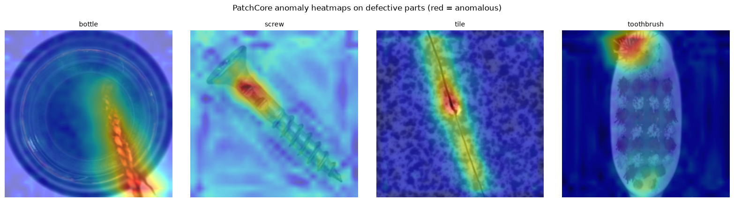
PatchCore anomaly heatmaps on defective MVTec test images (red = anomalous). The hotspot sits on the real defect in each part.

4. Live webcam test
I also wired the trained models to a laptop webcam and held up a real toothbrush. Below: the captured frame (left) and the anomaly heatmap (right). The heatmap correctly concentrates on the bristles/tip — the structurally distinctive part — rather than scattering randomly.
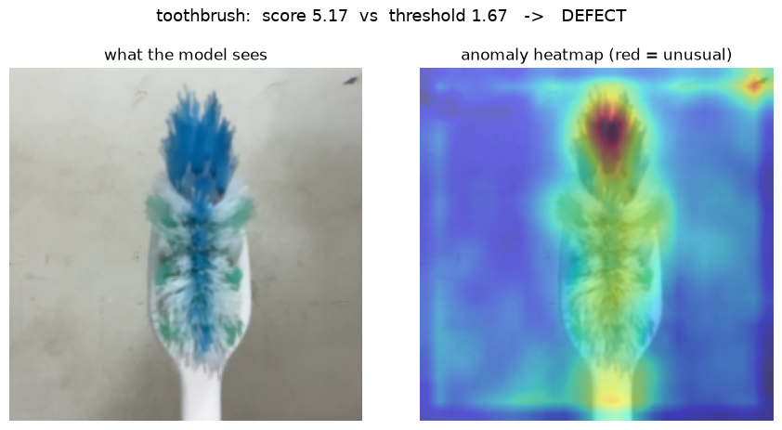
Live webcam capture of a toothbrush. Heatmap localizes to the bristles; the score reads DEFECT for the reason explained below.
Note the verdict says DEFECT. That is expected, and it is the single most important thing to understand about this demo — see the next section.

5. Important limitation — background & lighting
The models learned from MVTec photos: one object, filling the frame, on a plain background, under even studio lighting. A laptop webcam is a different world — different camera, lighting, and a cluttered background. Under that change everything looks a bit unfamiliar to the model, so all the scores rise. Because the threshold was set on the clean studio images, a perfectly good part shown to the webcam often trips over it and reads DEFECT — a false alarm caused by the background, not by any real defect.

What to trust, and what not to
- Background matters a lot. A busy background, or an object that doesn’t fill the frame, is read as unusual. For the demo: plain background, object centered and close, even lighting.
- On webcam, trust the heatmap, not the score. The heatmap is scaled within each image, so it still points at the most unusual region even when every score is inflated. The raw GOOD/DEFECT verdict is not reliable across this camera change.
- Comparing one photo against all four models is not a classifier. Under this much background change the scores bunch together — PatchCore tells you “normal vs. not” for one part, it does not identify which part you’re holding.

Why this is not a problem for real deployment
On a real line the camera, lighting, and background are fixed and known. The threshold is simply calibrated on good images taken by that same production camera, instead of borrowed from MVTec. Same method, same model — only the calibration photos change. Matching the imaging conditions is a setup step, not a redesign.

6. From this PoC to real production deployment
This exercise validates the detection method itself. The table below maps what was built here onto the actual production system, which also includes a barcode scanner, a Jetson Orin running the model, and a PLC that acts on its verdict.
Stage | PoC (this exercise) | Real production deployment
Camera | Laptop webcam | Industrial camera,
Objects | Bottle, screw, tile, toothbrush (MVTec AD + physical samples) | Actual parts on the production line
Model | PatchCore, ResNet-18 backbone, run locally | PatchCore (or finalized model), same method, calibrated on production images
Where it runs | Laptop CPU / GPU | NVIDIA Jetson Orin, model converted to TensorRT for fast on-device inference
Calibration images | MVTec AD studio photos | Photos taken by the actual production camera, in place
Verdict output | Printed / shown in notebook (GOOD / DEFECT + heatmap) | Sent via OPC-UA to the Siemens S7-1500 PLC
Actuation | None — no physical action taken | PLC fires the actuator (arm, air jet, gate, etc.) to remove rejected parts
Goal | Prove the detection method works end to end | Run that same method reliably, in real time, at line speed
In short: the model, the training approach, and the scoring/thresholding logic built here are the same logic the production system will run. What changes is the camera, the calibration images, the runtime hardware, and the fact that the verdict drives a physical actuator instead of a printed line.

7. Bottom line
- The detection method works: all four parts beat the AUROC ≥ 0.85 target (mean 0.971), trained with zero defect examples, and the heatmaps localize defects on the test images.
- The webcam demo is an illustration, not a metric: background/lighting differences inflate scores and cause false alarms; the heatmap is the trustworthy output there.
- Ready for the next phase, where the same models are calibrated on in-domain images from the production camera.

