Popularity based Recommnedation

# Popularity based Recommnedation for given user.PNGPopularity based Recommnedation for given user:

# Popularity based Recommnedation for another user:

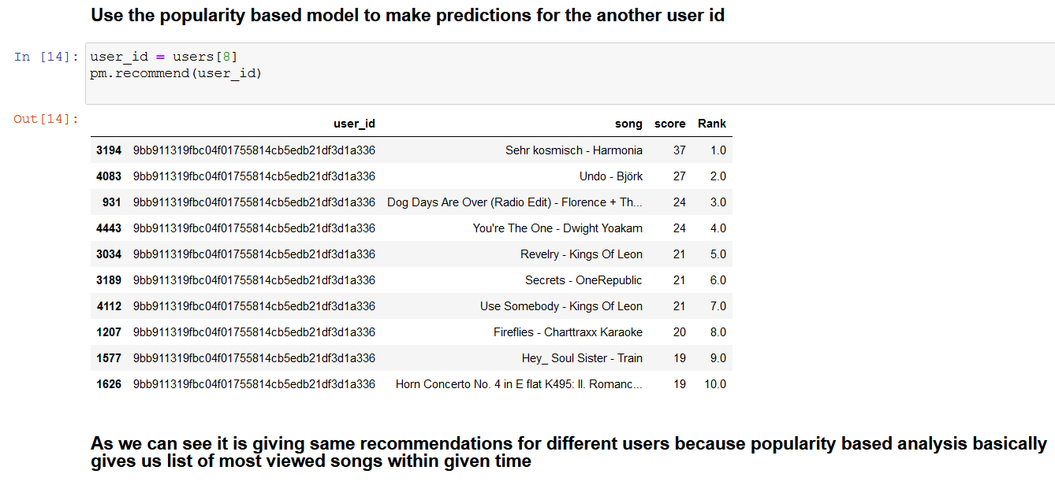

Item Based Collabrative Recommendation

## Item Based Collabrative Recommendation for given user:

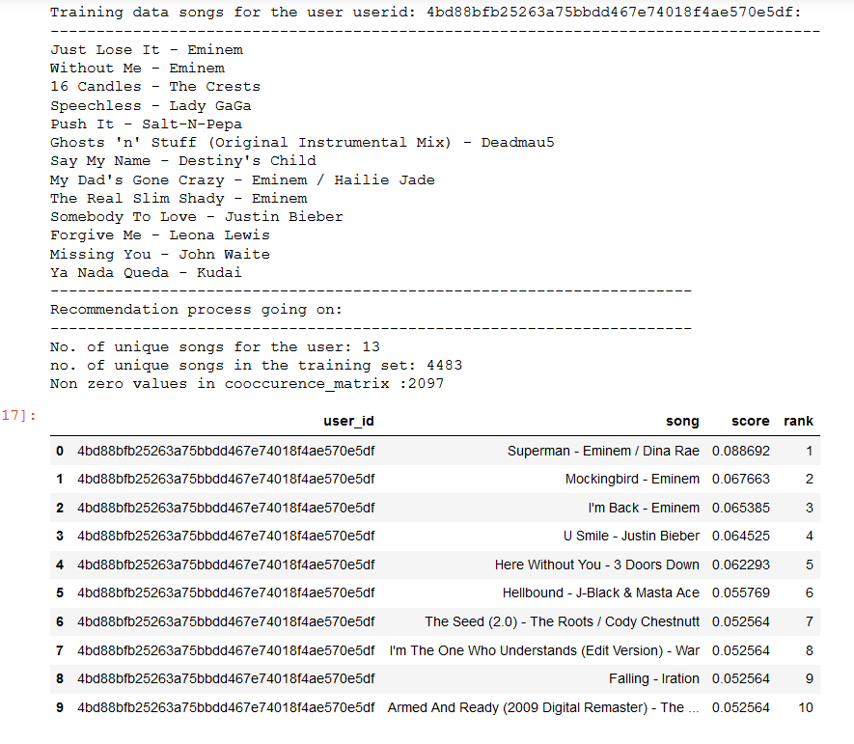

## Item Based Collabrative Recommendation for another user:

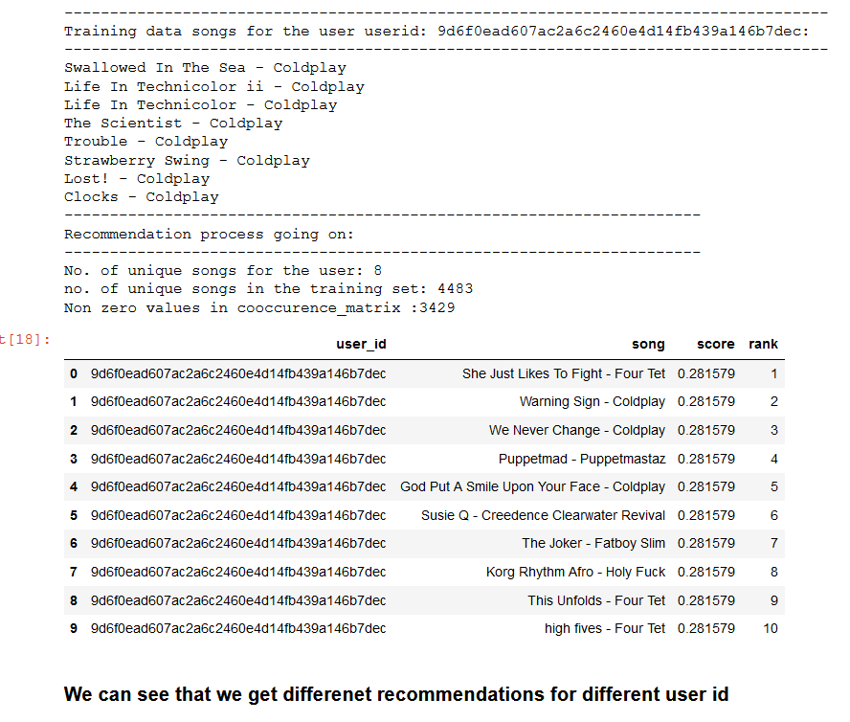

Content based filtering for given Song

## Content based filtering for given Song.PNGContent based filtering for given Song:

## Content based filtering for another Song:

