Description of HemeLB: An Application for running Patient Specific Simulations of Cerebral Blood Flow

1. Introduction
HemeLB is an application being developed to characterise the fluid flow in complex systems. HemeLB can be adopted as a tool for the prevention and treatment of cerebral vascular diseases. It will allow clinicians to visualise the intra-cranial blood flow of a patient whom they are about to operate on. It uses the the lattice-Boltzmann method (LBM) in thre-dimensions to carry out the fluid dynamics simulation. Appropriate specific boundary conditions are applied in order to simulate a pulsatile blood flow of a patient. It also has the option of investigating a steady flow. The application produces separate images of the pressure, velocity and stress flow fields at certain intervals of time throughout a pulsatile period, using a ray tracing technique. The images can be viewed in sequence or interactively displayed on a client through an effective visualization pipeline which incorporates optimised steering capabilities.

The code is mainly written in C, but some routines contain C++ features. The simulations usually require a large amount of computing power, so it is designed to run on multiple processors in parallel. It uses the Message Passing Interface (MPI) to handle communication between the processors. This document gives a brief overview of some algorithms used in HemeLB, instructions for compiling and running the code, a detailed description of input and output, visualisation of the data and parallel performance of the code.

2. How HemeLB Works
The code is made up of the following key files
config.h/cc
http_post.cc
io.cc
lb.cc
main.cc
network.h/cc
realitygrid.cc
rt.cc
steering.cc
steering-common.cc
steering-sim-params.h/cc
topology.cc

plus some files of less importance, like

benchmark.h/cc
fileutils.h/cc
usage.h/cc
visthread.h/cc

and some files useful to handle I/O with the well-known portable XDR format (located in the directory “xdr”).

2.1 Reading the Input Parameters
First, functions located in io.cc read the pressure boundary conditions at the inlets and outlets of the system and parameters for the visualisation tasks. The files containing the pressure boundary conditions and visual parameters must be in ASCII format and called pars.asc and rt_pars.asc respectively. The imaging parameters include the zoom factor, the orientation from which we want to visualise, the brightness (not used at the moment) the velocity and pressure values that define the ranges to be used by the colour palette. At the moment, the parameters read in the latter file are reset through an initialisation accomplished in steering.cc. The files give the parameters in physical units and the program converts them to lattice units.

2.2 Reading the Configuration File
Prior to the simulation itself, a configuration file in XDR format must be constructed by our graphical-editing tool through the manipulation of a three-dimensional volumetric dataset, which is obtained from a x-ray Angiography or Magnetic Resonance Angiography scan. The file must be called config.dat and it contains information about every voxel, including whether it is a solid site (not part of the vasculature) or a fluid site. If it is, we need to know whether it is surrounded by other fluid sites, or whether it is at a boundary, and if so, what type of boundary it is, so that the appropriate boundary condition method can be applied during the simulation.

The module io.cc reads this file and records the data into arrays. The brain is a sparse system, i.e. less than 10% of it is occupied by fluid lattice sites. Therefore, a bilevel structure is used so that if we have a block of solid sites, this is stored as one point, which saves memory.

2.3 Domain Decomposition and Buffer Management
The simulation is done in parallel by each processor working on its own set of fluid lattice sites. Therefore, the stage after the input reading is the domain decomposition. The simulation works on the distribution functions, as explained in Sec. 3, which are related to the probabilities of a particle having a particular microscopic velocity. During the simulation, there is a collision step in which the distribution functions are locally changed, and a streaming step in which the distribution function in each direction propagates to the nearest neighbour in that direction. Some of the neighbouring sites to those at the edge of the current subdomain reside on a neighbouring processor, so these distribution functions for the edge sites have to be communicated at every simulation time step. Functions from topology.cc determine the directions in which the communication will be needed and sets up buffers for sending and receiving the distribution functions to/from the neighbouring processors.

2.4 The Initial Conditions
Functions in lb.cc set all the velocities to zero and all the densities to a certain value dependent on the boundary data. As soon as the simulation starts, the inlet and outlet pressures will be set, as explained in the next section.

2.5 The Simulation Itself
During the simulation, the collision phase is carried out first, then the propagation to the nearest neighbours. We have global buffers called f_old and f_new to store the source and destination distribution functions typically needed for the LBM. First, this is done for fluid sites, then sites on the boundaries. At each time step, the pressure, velocities and stresses are calculated from the distribution functions. This is accomplished by the function lbmCycle in lb.cc, called by at every time step by the main function. At the end of each time step the buffers f_old and f_new are swapped.

2.6 The Images and Output File
At certain intervals of time, each processor locally ray trace its own subdomain and in parallel with the others. Imaginary rays are sent through the system in a front-to-back order. Volume rendering of velocity and von Mises stress is carried out, which means that the velocity or stress is integrated (averaged) along the line of each ray to give the pixel colour of the image. Images are also produced for the velocity and von Mises stress on the external surface such that the first point encountered keeps track of the intercepted flow field value which will then be properly coloured. The colours in the images are stored as compressed images. During each cycle, the images overwrite those from the previous cycle, so at the end, we have only the images from the last cycle. Similar arguments hold for the snapshots which comprise pressure, velocity and stress at each fluid lattice site (all details are given within the functions lbmWriteConfig/ASCII. There is more about the images in sections 5.3, 5.5 and 5.8.

The program also produces an output file with results showing whether the files opened successfully, whether the simulation ran successfully, how many time steps were done before it ended, the amounts of time taken by the various stages of the program, how the system was decomposed and some information about the minimum and maximum physical pressure, velocity and stress values.

3. The LB algorithm
The simulation takes place on a three dimensional lattice. Each point is joined to its neighbours by a set of lattice vectors e_i. In the current implementation of the LBE algorithm, we use a cubic lattice with 15 lattice vectors joining each node with its neighbours. The motivation for using this lattice is that it is known to yield isotropic Navier-Stokes behaviour. During each step of the simulation, the following processes take place:

Collision:
The velocities and densities are calculated from the distribution functions, f_i, which give the relative probability of a particle having a particular microscopic velocity e_i:

density = sum (f_i). i =0, 1, 2....14 (1)
v = sum(f_i*e_i)/density. (2)

The equilibrium distribution function, f_i^{(eq)} is calculated from the velocities and densities.
The collision itself takes place, in which the distribution functions are adjusted according to the fundamental equation of the lattice-Boltzmann method:
f_i = f_i – (1/tau) * (f_i – f_i^{(eq)}) (3)

Streaming:
For each of the 15 directions, the distribution functions are propagated along the lattice velocity, e_{_i} to the adjacent sites. More specifically, the equilibrium distribution f_i , with velocity e_i moves from the site at position r to the site at position (x,y,z) + e_i.

The fifteen lattice velocities are:
i = 0: (0, 0, 0)
i = 1, 2....6: (±1, 0, 0); (0, ±1, 0); (0, 0, ±1); (4)
i = 7,8...15: (±1, ±1, ±1)

The functions are set in a different way at the boundaries of the system (e.g. wall, inlets and outlets). Please, see the paper hemelb/Doc/HemeLB_doc.pdf for all details.

In the present implementation of the code, the LB model with a sound speed in lattice units given by c_{s} = (1/3)^(1/2) is used. In this model, the equilibrium distribution functions are as follows:
f_i^{(eq)} = rho*(2/9)*(1 – (3/2) * u^2), i = 0; (5)
= rho*(1/9)*(1 + (3) * e_i.u + (9/2) * (e_i.u)^2 – (3/2) * u^2), i = 1...6;
= rho*(1/72)*(1 + (3) * e_i.u + (9/2) * (e_i.u)^2 – (3/2) * u^2), i = 7...14

where rho is the lattice density.

4. Compiling the Code
For debugging and testing, one can run on any computer which has MPI and C++ compiler installed. Use the makefile “hemelb/Code/Makefile” and set the variable HEMELB_MACHINE, like in the following:

export HEMELB_MACHINE=Lonestar

to appropriately compile on the machine called Lonestar (TeraGrid).

The flag NOMPI prevents the MPI commands from being executed so it can be used when you are running the code on one processor. Do not use it when you want to run the code in parallel.

For a whole brain simulation at high resolution, it is likely that the code will be launched from a batch queue system for a supercomputer. The documentation for the specific system used should be read carefully, since batch queue systems may vary widely in their behaviour.

5. Running the Code

5.1 Input Files
Before running, you must make sure the following input files are available and all stored in the same directory:
pars.asc, containing the parameters in lattice units;
rt_pars.asc, containing the parameters needed to make the images;
config.dat, which should be a binary file in XDR format containing the information about the system you wish to simulate.

5.2 Syntax of the file pars.asc
The file pars.asc should be in ASCII format. On the first line, we should have the number of inlets, which must be an integer.
A separate line should be used for each inlet, on which there must be 3 floating point parameters separated by spaces. The first one is the average pressure in mm Hg, the second is the amplitude of the oscillation in mm Hg, and the third is the phase in degrees. After that, the number of outlets should be specified, then the average pressure, amplitude and phase in the same way as for the inlets.

In the program, the phase is converted to radians and the pressure is calculated as shown:

inlet pressure = inlet pressure average + inlet density amplitude * cos(omega * timestep)

where omega = 2*PI/(time steps per pulsatile period)

One can choose a steady flow by specifying a zero pressure amplitude at all pressure boundaries.

5.3 Syntax of the file rt_pars.asc
The parameters should be specified in the following order and on separate lines:
ctr_x
ctr_y
ctr_z
longitude
lattitude
zoom
brightness
threshold velocity
threshold stress

This file specifies the viewpoint characteristics that the user desires. Longitude and latitude are the spherical polar and vertical angle (in degrees) from which the system is viewed from. For positive polar and vertical angles the eye location moves to the right and to the top respectively. For positive vertical angles, the eye location moves up. ctr_x, ctr_y and ctr_z are the coordinates of the centre of rotation. The zoom is the magnification.

The images are coloured according to the flow fields, by linear interpolation between a minimum and maximum value. The colours vary from blue at the minimum value to red at the maximum value or higher. The brightness must be between zero and one. We can choose this maximum value of the velocity and stress flow fields in ms-1 and Pa respectively.

5.4 Command for Running the Simulation
To run the simulation, the command is:
/usr/bin/mpirun -np 2 ./<arg1> <arg2> <arg3>... <arg8>.
where 2 is the number of cores and <arg> is a command line argument. If we only use five arguments, a benchmark will be done. Otherwise, we carry out a normal simulation.

The first argument is the name of the executable file. This is usually hemelb, though the name can be chosen at compile time. The second is the input file path (e.g. ../Input/angio2/). The third is the number of pulsatile periods we wish to simulate (if this number is greater than 1000, the convergence criterion is applied and the simulation is stopped if the flow field at the current and previous cycles differ by less than the tolerance TOL = 10⁻⁶) The fourth argument is the number of time steps per pulsatile period. The fifth is the physical size of one voxel in metres. The sixth and the seventh are the numbers of snapshots and images per cycle, respectively, and the eight is the steering session identifier. For benchmarking purposes, the third argument is the number of time steps per period; the fourth is the voxel size and the last one is the number of minutes to run for.

5.5 Hand-Coded Parameters
We hand-coded some parameters and constants in agreement with the ones in the literature, so that we can compare our results. We set
Blood viscosity = 0.004 Pa s
Blood density = 1000 kg m⁻³
Period of oscillation = 60/70 s.

5.6 Submitting to a Batch Queue
A script will be required, which vary between systems. As an example, the following script submits a 128 processor job to HPCx in Edinburgh (see www.hpcx.ac.uk/support/documentation/UserGuide/HPCxuser/Batch_Processing.html for more information on submitting jobs to HPCx). Each node has 16 cores on it. We have found that the code runs most efficiently when you have two threads per core, so we specify 256 threads and 32 threads per node.

#@ shell = /bin/ksh
#@ job_name = #e27G38-HemeLB#hemelb
#@ requirements = (Feature == "SMT")
#@ job_type = parallel
#@ cpus = 256 [Number of threads]
#@ tasks_per_node = 32 [Number of threads per node]
#@ node_usage = not_shared
##@ network.MPI = csss,shared,US
#@ bulkxfer = yes
#@ wall_clock_limit = 3:00:00 [maximum CPU time the program can run for]
#@ account_no = X [the account you wish to use]
#@ output = $(job_name).$(schedd_host).$(jobid).out [standard output file name]
#@ error = $(job_name).$(schedd_host).$(jobid).err [standard error file name]
#@ notification = never
#@ queue

# suggested environment settings:
export MP_EAGER_LIMIT=65536
export MP_SHARED_MEMORY=yes
export MEMORY_AFFINITY=MCM
export MP_TASK_AFFINITY=MCM

poe <arg1> <arg2> ... <arg8>

On some machines it is possible to reserve a certain number of cores and for a specific time using the Highly Available Resource Co-Allocator (HARC).

5.7 The output files
The .dat images are stored in a directory called Images inside the directory containing the input files. HemeLB also produces one more output file in the same directory as the input files called timings<#processes>.asc, in ASCII format. An example of the timings file is shown here:
Opening parameters file:
/hpcx/...../pars.asc
Opening config file:
/hpcx/...../config.dat
Opening vis parameters file:
/hpcx/...../rt_pars.asc

cycle id: 1
cycle id: 2
cycle id: 3
cycle id: 4
cycle id: 5

threads: 256, machines checked: 1

topology depths checked: 1

fluid sites: 597025

time steps: 1000000

time steps per second: 258.046

Opening output config file:
/hpcx/home/e10/e10/gary/hemelb/Input/angio2/out.dat

density min, max: 9.984890e-01, 1.001528e+00
velocity min, max: 0.000000e+00, 1.000932e-02
stress min, max: 1.050889e-18, 5.073858e-06

domain decomposition time (s): 0.468
pre-processing buffer management time (s): 0.120
input configuration reading time (s): 2.118
flow field outputting time (s): 2.702
total time (s): 3883.251

Sub-domains info:

rank: 0, fluid sites: 2333
rank: 1, fluid sites: 2333
rank: 2, fluid sites: 2333
rank: 3, fluid sites: 2333
...
rank: 255, fluid sites: 2332

The file tells us the number of threads, number of fluid sites, the total number of timesteps during the simulation and how many were done per second. The maximum and minimum density, velocity and stress over all lattice points and timesteps for the last cycle are given. It then tells us how many fluid sites were on each process.

5.8 Visualisation of the Images
To visualise the images, our program visualize_images.c is needed, which uses the OpenGL library. The images can be visualised on a local machine.
Type gcc <flags> visualize_images.c to compile and
./a.out <input path> <output path> to run where <input path> contains the compressed HemeLB ouput images <output path> is the path where the corresponding images in .ppm format will be located.

The screen will be split into four parts. The top left image shows the external pressure, the bottom left image is the external von Mises stress, the top right one is the volume-rendered velocity and the bottom right one is the volume-rendered von Mises stress.

5.9 Steering
For the pressure, the minimum and maximum pressures for the visualisation are set thorugh the steering capabilities (see steering.cc). The same holds for other simulation and visualisation parameters like the magnification, the viewpoint angles and so on (see steering.cc and steering-common.cc). After the simulation has started and the HemeLB-GUI has launched on a local workstation, one needs to connect to the supercomputer by setting the host name in the menu. The first portion of the host name is written in the output file env_details.asc; the second part is the machine name.

6. Parallel Performance
The performance of our simulation is very important because if clinicians have to visualise a blood flow, it must run within a clinically useful time scale. We have carried out several benchmarks on different machines like HPCx, NGS2 nodes (UK), Ranger, Abe (TeraGrid).

The graph on the next page shows the performance on HPCx and Abe for a simulation of blood flow in the brain using a configuration of about 7.7 million fluid sites. The number of time steps per second for the simulation itself scales almost linearly up to 512 cores for HPCx, reaching a performance of 300 time steps per second. On Abe, it is only 100 time steps per second on 512 cores, but the scaling is always superlinear up to at least 2048 cores. The performance including producing volume-rendered images of one flow field at every time step is about 110 and 60 time steps per second on HPCx and Abe respectively with 512 cores. The behaviour is similar to the simulation on its own in that HPCx has the best performance with 512 cores, giving 110 time steps per second, compared with 60 time steps per second on Abe, but the scaling is better on Abe. The performance on Abe overtakes that on HPCx when 2048 cores are used, reaching 160 time steps per second.

Simulations with realistic parameters for blood flow have been carried out using a configuration file with 600000 fluid sites. This took 5 cycles to converge and 200000 time steps per cycle were needed. For a simulation of pulsatile flow, images are not needed at every time step but very infrequently. The performance would then be close to that without volume rendering.
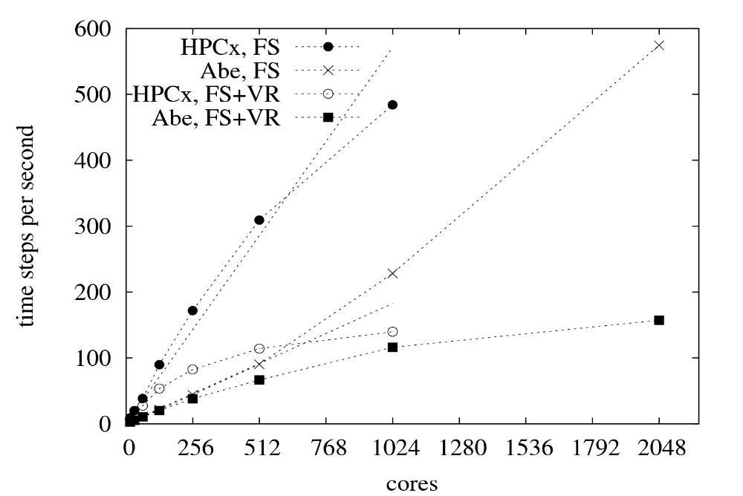

7. Numerical Instability
We found that the simulation becomes numerically unstable above certain threshold values of the pressure gradient. This is because the velocity becomes comparable to the speed of sound, so some terms in the equilibrium distribution function formula makes the overall distribution functions negative, which is unphysical. Instability can also occur if tau is too low in equation 3. If the simulation is unstable, it is restarted with twice the number of time steps per cycle; if this becomes greater than 400000, the simulation is terminated.

