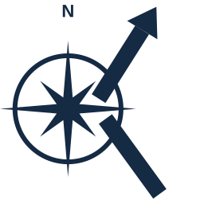 KEEL
Guiding project success
One place to run every engagement, from idea to invoice.
Built for boutique IT consultancies — an AI-driven project and portfolio tracker that replaces the spreadsheet-and-inbox scramble with one shared system.
THE PROBLEM
Running several client engagements at once means budgets, staffing, risk, and vendor evaluation live scattered across spreadsheets, inboxes, and whatever tool each PM prefers. Nobody has one place to see the whole portfolio — and every status update, charter, or RFP gets written from scratch.
WHAT KEEL DOES
Full project lifecycle  Ideation, charters, sprints or waterfall phases, tasks, risks, and budgets — one tracker from first idea to steady-state. | An AI project manager  Drafts charters, RFPs, risks, tasks, and incidents from a rough note; estimates effort; suggests assignments; briefs you out loud.
Vendor evaluation, built in  Draft an RFP straight from a project charter, invite vendors with a no-login link, and let AI score responses against your own weighted rubric. | Operations & support  Portfolio-wide incident tracking, cost-to-serve estimates, and AI that flags recurring incidents and converts them into improvement projects.
Reports that look the part
Branded, board-ready PDF and PowerPoint exports for status reports, steering decks, and executive one-pagers — generated on demand.
WHY NOW
Keel's AI doesn't just summarize — it drafts. A rough note becomes a properly formed risk, task, incident, or communication log entry. Recurring support incidents get flagged and converted straight into improvement projects.
WHO IT'S FOR
PMO Directors, Heads of Delivery, VPs of Professional Services, and founders at boutique IT consultancies running multiple client engagements at once.
Let's talk.
Hemender Kumar · hemender.kumar@gmail.com

