Northern University

of Business and Technology Khulna

Lab Report - 02

Course Code: CSE 3204

Course Title: Microprocessor and Assembly Language Programming Lab

Submitted By

Submitted To

Name : Hemendra Nath Mondal Section : 6B

ID : 11220320873

Dept : Computer Science & Engineering

Name : Md. Abdul Halim Khan

Designation : Lecturer

Dept : Computer Science & Engineering

**Lab Report – 02**

**Description:**

The three programs in 8086 Assembly demonstrate how to read a character from the user and display it back. The first program simply echoes the input character. The second program adds formatting by printing the character on a new line using carriage return and line feed. The third program improves readability by using the PRINTN macro from the EMU8086.INC file to automatically insert a newline. While the core functionality remains the same, each version introduces better output formatting and cleaner code structure, showcasing the use of MS-DOS interrupts and macros in assembly language. The three 8086 Assembly programs are designed to demonstrate the process of reading a character from the keyboard and displaying it back on the screen using MS-DOS interrupt services. The first program performs a basic task of reading a single character and immediately echoing it back without any additional formatting. The second program builds on this by introducing formatting to the output: after reading the character, it inserts a newline by using the carriage return (0DH) and line feed (0AH) functions before displaying the character. This ensures that the output appears on a new line, improving the visual clarity of the result. The third program takes advantage of the EMU8086.INC file and utilizes the PRINTN macro, which simplifies the code by automatically inserting a newline. This version not only provides the same functionality as the previous ones but also demonstrates how using macros can make the code more efficient and readable. Overall, these programs illustrate the basic concepts of character input and output in assembly language, while progressively enhancing formatting and code structure for better user experience and maintainability.

**Code:**

.MODEL SMALL

.STACK 100H

.DATA

.CODE

MAIN PROC

MOV AH,1

INT 21H

MOV BL,AL

MOV AH,2

MOV DL,BL

INT 21H

MOV AH,4CH

INT 21H

MAIN ENDP

END MAIN

**Output:**

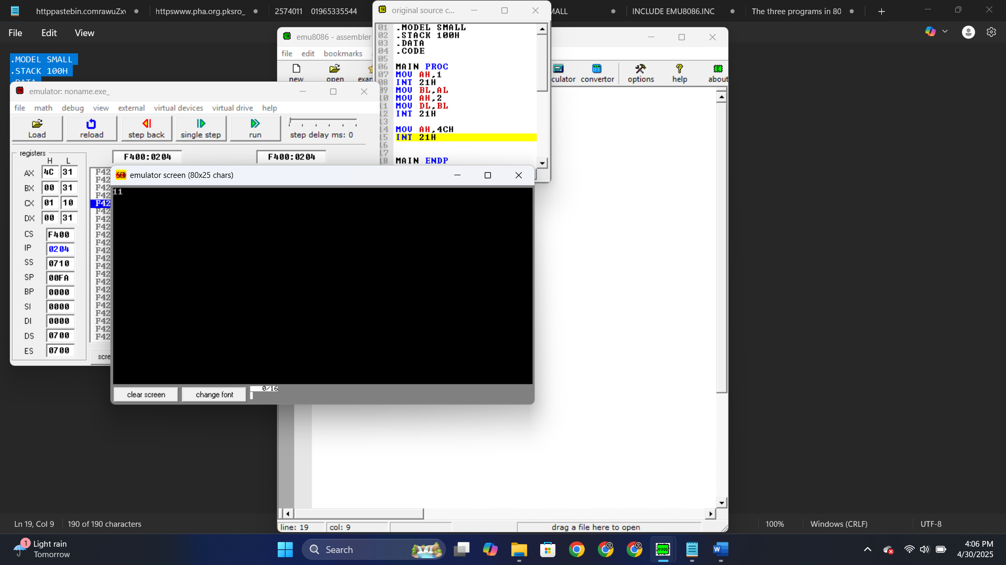

**Code:**

.MODEL SMALL

.STACK 100H

.DATA

.CODE

MAIN PROC

MOV AH,1

INT 21H

MOV BL,AL

MOV AH,2

MOV DL,0DH

INT 21H

MOV DL,0AH

INT 21H

MOV AH,2

MOV DL,BL

INT 21H

MOV AH,4CH

INT 21H

MAIN ENDP

END MAIN

**Output:**

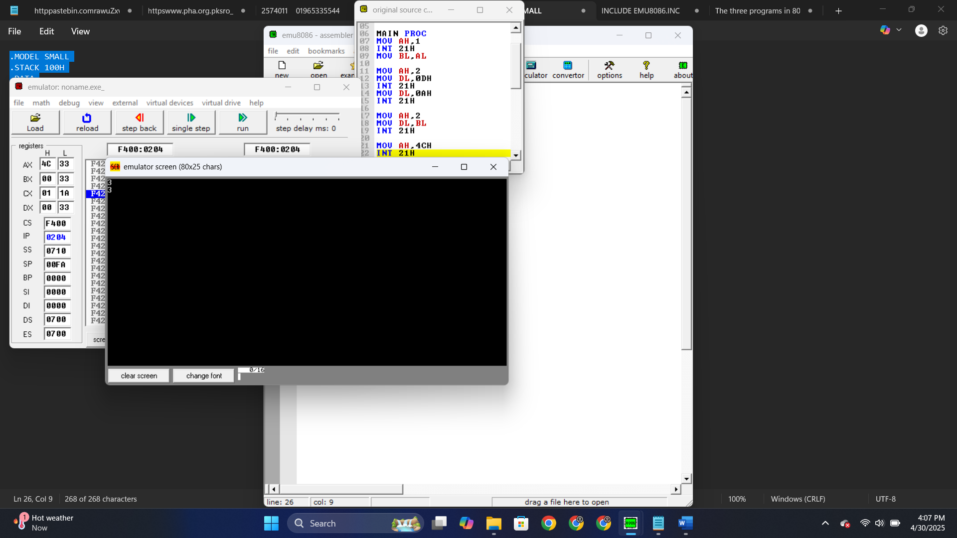

**Code:**

INCLUDE "EMU8086.INC"

.MODEL SMALL

.STACK 100H

.DATA

.CODE

MAIN PROC

MOV AH,1

INT 21H

MOV BL,AL

PRINTN ""

MOV AH,2

MOV DL,BL

INT 21H

MOV AH,4CH

INT 21H

MAIN ENDP

END MAIN

**Output:**

