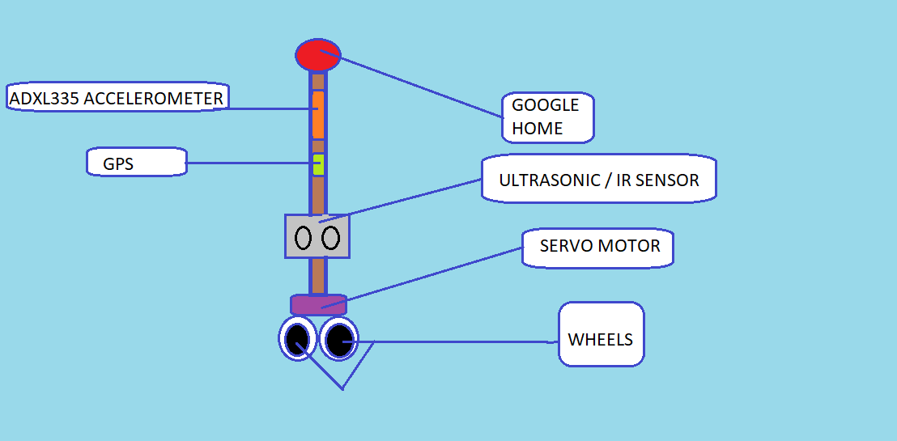Smart Navigating Stick for the blind

Problem:

Blind People cannot navigate from one place to another such as from the house to a restaurant etc. They can also be in an unknown place which sometimes may be dangerous. If the person uses the Google Maps, it will be difficult for the person to determine directions and if there are any obstacles.

Solution:

To solve the problem I have created this project. This stick as the name suggests helps the blind people for navigation. There will be a Google Home in the stick. There will also be motors with wheels at the bottom to help in navigation. So if the person wants to go to the nearest bus station, the person can simply ask the Google Home to navigate to the nearest bus station and then the motors start spinning. If the Google Home say to turn left, the motors turn left and the same is for the other directions. The motors can spin in different direction as there will be a servo motor at the top which will spin the main motor in that direction. There will also be sensors to track the direction the person is moving. There will also be an IR sensor to determine whether there is an obstacle.

This is really useful for blind people as it helps them in navigation.