Cloud Resource Usage & Cost Optimization System
21CSC205P Database Management Systems

A MINI PROJECT REPORT

Submitted by

HEMISH JAIN [RA2411003010147]

C M HARISH PRASHANTH[RA2411003010137]

Under the Guidance of

Dr. Briskilal Joe

Assistant Professor, Computing Technologies

in partial fulfillment of the requirements for the degree of

BACHELOR OF TECHNOLOGY

in

COMPUTER SCIENCE ENGINEERING


DEPARTMENT OF COMPUTING TECHNOLOGIES

SCHOOL OF COMPUTING

COLLEGE OF ENGINEERING AND TECHNOLOGY
SRM INSTITUTE OF SCIENCE AND TECHNOLOGY

KATTANKULATHUR- 603 203

MAY 2026



SRM INSTITUTE OF SCIENCE AND TECHNOLOGY KATTANKULATHUR – 603 203

BONAFIDE CERTIFICATE

Certified that Project report titled “Cloud Resource Usage & Cost Optimization System” is the Bonafide work of “STUDENT1 NAME [REG NUM], STUDENT2 NAME [REG NUM]” who carried out the 21CSC205P Database Management Systems mini project work under my supervision.

Dr. Briskilal Joe | HEAD OF THE DEPARMENT
Assistant Professor  Department | PROFESSOR AND HEAD  Department

ABSTRACT

TABLE OF CONTENTS

Chapter No. | Title | Page no.
 | ABSTRACT
1 | Problem understanding, Identification of Entity and Relationships, Construction of DB using ER Model for their project
2 | Design of Relational Schemas, Creation of Database and Tables for their project
3 | 3.1Writing queries based on the concepts of Aggregate functions, constraints, sets
 | 3.2 Writing complex queries based on subqueries, joins and views
 | 3.3 Writing complex queries based on the concepts of functions, Triggers, Cursors and Exception Handling
4 | 4.1 Analysing the pitfalls, identifying the dependencies, and applying Normalizations- 1NF, 2NF, 3NF
 | 4.2 Analysing the pitfalls, identifying the dependencies, and applying Normalizations- 4NF, 5NF
5 | Implementation of concurrency control and recovery mechanisms.
6 | Front-end And Back-End Implementation code
7 | Results and Discussions

LIST OF FIGURES

Figure No. | Name | Page no.
1
2
3
4
5

LIST OF TABLES

Figure No. | Name | Page no.
1
2
3
4
5

CHAPTER 1

PROBLEM UNDERSTANDING, IDENTIFICATION OF ENTITY AND RELATIONSHIPS, CONSTRUCTION OF DB USING ER MODEL FOR THE CLOUD RESOURCE USAGE & COST OPTIMIZATION SYSTEM
  - Introduction
Cloud computing platforms provide scalable infrastructure such as Virtual Machines, Storage, and Databases. Organizations often deploy multiple cloud resources for various applications. However, improper monitoring and management of these resources leads to unnecessary cost, idle infrastructure, and inefficient utilization.
The Cloud Resource Usage & Cost Optimization System is a database-driven system that helps track resource usage, calculate billing information, and identify cost-saving opportunities using structured relational data.
  - Motivation
Many organizations face the following issues:
- Over-provisioned cloud resources
- Idle virtual machines consuming billing hours
- Untracked storage growth
- No structured billing analysis
Manual tracking is inefficient and error-prone. A database-backed system can automate tracking, maintain historical logs, and generate optimization suggestions using SQL queries.
  - Scope
The scope of the project includes:
- Managing users and their cloud resources
- Recording periodic resource usage logs
- Calculating billing information
- Detecting idle or underutilized resources
- Generating optimization suggestions
- Producing analytical reports

The system does not connect to real cloud providers but simulates cloud resource management.

  - Problem Statement
Organizations incur unnecessary cloud expenses due to improper monitoring and inefficient resource allocation. There is a need for a structured database system that can:
- Store cloud resource details
- Track usage over time
- Calculate billing automatically
- Detect inefficient resource usage
- Suggest optimization actions
  - Project Requirements

Functional Requirements
- Add, update, delete cloud resources
- Record usage logs
- Generate billing reports
- Identify idle resources
- Suggest optimization actions

Non-Functional Requirements
- Data integrity
- Scalability
- Concurrency control
- Efficient query performance
  - Identification of Entity and Relationships

Entity Attributes

User
- user_id (PK)
- name
- email
- organization

Cloud_Resource
- resource_id (PK)
- user_id (FK)
- resource_type
- instance_type
- region
- status
- created_at

Usage_Log
- log_id (PK)
- resource_id (FK)
- cpu_usage
- memory_usage
- storage_used
- timestamp

Billing
- bill_id (PK)
- resource_id (FK)
- usage_hours
- cost_per_hour
- total_cost
- billing_date

Optimization_Suggestion
- suggestion_id (PK)
- resource_id (FK)
- suggestion_type
- reason
- estimated_savings

Relationships
- One User can create many Cloud_Resources (1:M)
- One Cloud_Resource can have many Usage_Logs (1:M)
- One Cloud_Resource generates many Billing records (1:M)
- One Cloud_Resource can have multiple Optimization_Suggestions (1:M)

  - Construction of DB Using ER Model for the Cloud Resource Usage & Cost Optimization System
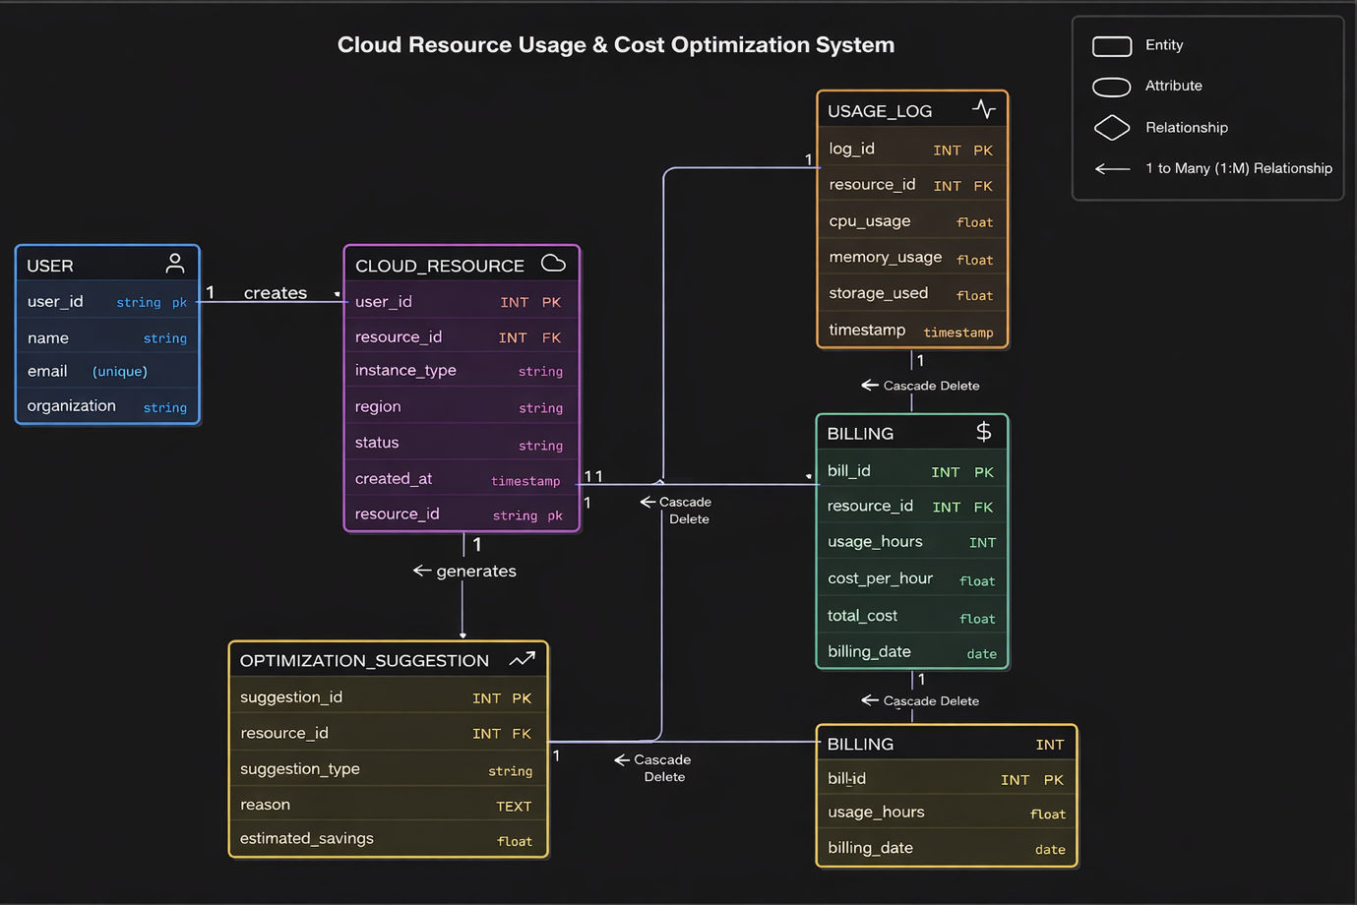

Chapter 2
Design of Relational Schemas, Creation of Database and Tables for Cloud Resource Usage & Cost Optimization System

2.1 Relational Schema for Cloud Resource Usage & Cost Optimization System
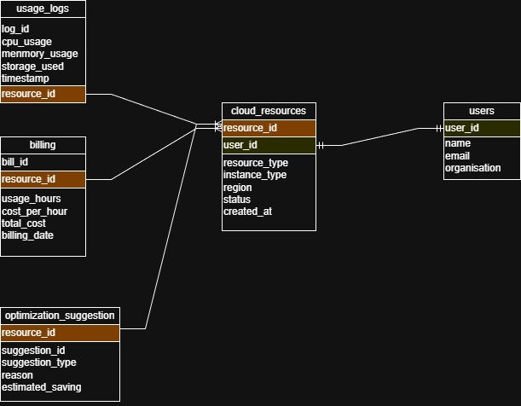
Figure 2.1: Relational Schema for Cloud Resource Usage & Cost Optimization System

2.2 Description of Tables:
User :
Purpose: Stores information about users who manage or own cloud resources.
Primary Key: user_id (INTEGER)
Data Types and Constraints:
1.user_id: INTEGER, Primary Key, Not Null
2.name: VARCHAR(255), Not Null
3.email: VARCHAR(255), Not Null, Unique
4.organisation: VARCHAR(255)

Cloud_Resources:
Purpose: Stores details of cloud resources created and managed by users.
Primary Key: resource_id (INTEGER)
Foreign Key: user_id references Users(user_id)
Data Types and Constraints:
1.resource_id: INTEGER, Primary Key, Not Null
2.user_id: INTEGER, Not Null
3.resource_type: VARCHAR(100), Not Null
4.instance_type: VARCHAR(100), Not Null
5.region: VARCHAR(100), Not Null
6.status: VARCHAR(50), Not Null
7.created_at: TIMESTAMP, Not Null

Usage_Logs:
Purpose: Stores usage statistics of cloud resources such as CPU, memory, and storage consumption.
Primary Key: log_id (INTEGER)
Foreign Key: resource_id references Cloud_Resources(resource_id)
Data Types and Constraints:
1.log_id: INTEGER, Primary Key, Not Null
2.resource_id: INTEGER, Not Null
3.cpu_usage: FLOAT, Not Null
4.memory_usage: FLOAT, Not Null
5.storage_used: FLOAT, Not Null
6.timestamp: TIMESTAMP, Not Null

Billing:
Purpose: Stores billing and cost details associated with cloud resource usage.
Primary Key: bill_id (INTEGER)
Foreign Key: resource_id references Cloud_Resources(resource_id)
Data Types and Constraints:
1.bill_id: INTEGER, Primary Key, Not Null
2.resource_id: INTEGER, Not Null
3.usage_hours: INTEGER, Not Null
4.cost_per_hour: DECIMAL(10,2), Not Null
5.total_cost: DECIMAL(10,2), Not Null
6.billing_date: DATE, Not Null

Optimization_Suggestion:
Purpose: Stores optimization recommendations to improve performance and reduce cost of cloud resources.
Primary Key: suggestion_id (INTEGER)
Foreign Key: resource_id references Cloud_Resources(resource_id)
Data Types and Constraints:
1.suggestion_id: INTEGER, Primary Key, Not Null
2.resource_id: INTEGER, Not Null
3.suggestion_type: VARCHAR(100), Not Null
4.reason: TEXT, Not Null
5.estimated_saving: DECIMAL(10,2)

2.3 Creation of Database and Tables - DDL Commands
CREATE DATABASE Cloud_Cost_Optimization;
USE Cloud_Cost_Optimization;

CREATE TABLE User (
user_id INT PRIMARY KEY,
name VARCHAR(100) NOT NULL,
email VARCHAR(100) UNIQUE,
organization VARCHAR(100)
);

CREATE TABLE Cloud_Resource (
resource_id INT PRIMARY KEY,
user_id INT,
resource_type VARCHAR(50),
instance_type VARCHAR(50),
region VARCHAR(50),
status VARCHAR(20),
created_at DATE,
FOREIGN KEY (user_id) REFERENCES User(user_id)
);

CREATE TABLE Usage_Log (
log_id INT PRIMARY KEY,
resource_id INT,
cpu_usage FLOAT,
memory_usage FLOAT,
storage_used FLOAT,
timestamp DATETIME,
FOREIGN KEY (resource_id) REFERENCES Cloud_Resource(resource_id)
);

CREATE TABLE Billing (
bill_id INT PRIMARY KEY,
resource_id INT,
usage_hours INT,
cost_per_hour FLOAT,
total_cost FLOAT,
billing_date DATE,
FOREIGN KEY (resource_id) REFERENCES Cloud_Resource(resource_id)
);

CREATE TABLE Optimization_Suggestion (
suggestion_id INT PRIMARY KEY,
resource_id INT,
suggestion_type VARCHAR(30),
reason TEXT,
estimated_savings FLOAT,
FOREIGN KEY (resource_id) REFERENCES Cloud_Resource(resource_id)
);

2.4 Insertion of tuples into the table – DML commands
User:
INSERT INTO User VALUES
(1, 'Rahul Sharma', 'rahul@gmail.com', 'TechCorp'),
(2, 'Anita Verma', 'anita@gmail.com', 'CloudWorks');
Cloud_Resources:
INSERT INTO Cloud_Resource VALUES
(101, 1, 'VM', 't2.micro', 'Mumbai', 'Running', '2025-01-10'),
(102, 2, 'Database', 'db.small', 'Bangalore', 'Running', '2025-01-12');
Usage_logs:
INSERT INTO Usage_Log VALUES
(1001, 101, 3.2, 40.5, 20.0, '2025-02-01 10:00:00'),
(1002, 101, 2.5, 38.0, 20.1, '2025-02-02 10:00:00'),
(1003, 102, 65.0, 70.0, 150.0, '2025-02-02 11:00:00');
Billing:
INSERT INTO Billing VALUES
(501, 101, 24, 5.0, 120.0, '2025-02-01'),
(502, 102, 24, 8.0, 192.0, '2025-02-01');
Optimisation_suggestion:
INSERT INTO Optimization_Suggestion VALUES
(9001, 101, 'Stop', 'CPU usage below 5% for last 7 days', 80.0),
(9002, 102, 'Resize', 'Memory usage consistently high', 50.0);

CHAPTER 3
Complex queries based on the concepts of constraints, sets, joins, views, Triggers and Cursors.
(min 3 questions with queries for all topics)
< create complex queries based on the sub-topic with questions and SQL statement with output>

  - Adding Constraints and queries based on constraints
Question:
- Ensure CPU usage is between 0 and 100.
- Ensure billing cost is always positive.
- Retrieve only valid CPU usage records.

SQL Statement:
- ALTER TABLE Usage_Log ADD CONSTRAINT chk_cpu CHECK (cpu_usage BETWEEN 0 AND 100);
- ALTER TABLE Billing ADD CONSTRAINT chk_cost_positive CHECK (total_cost >= 0 AND cost_per_hour >= 0);
- SELECT resource_id, cpu_usage FROM Usage_Log WHERE cpu_usage BETWEEN 0 AND 100;

Output:
| Resource ID | CPU Usage |
|-------------|-----------|
| 101 | 3.2 |
| 101 | 2.5 |
| 102 | 65 |

  - Queries based on Aggregate Functions
Question:
- Find total cost per resource.
- Find average CPU usage per resource.
- Find maximum cost incurred by any resource.

SQL Statement:
1. SELECT resource_id, SUM(total_cost) AS total_cost FROM Billing
GROUP BY resource_id;
2. SELECT resource_id, AVG(cpu_usage) AS avg_cpu FROM
Usage_Log GROUP BY resource_id;
3. SELECT MAX(total_cost) AS highest_cost FROM Billing;
Output:
1. +-------------+------------+
| resource_id | total_cost |
+-------------+------------+
| 101 | 120 |
| 102 | 192 |
+-------------+------------+
2. +-------------+-------------------+
| resource_id | avg_cpu |
+-------------+-------------------+
| 101 | 2.850000023841858 |
| 102 | 65 |
+-------------+-------------------+
3. +--------------+
| highest_cost |
+--------------+
| 192 |
+--------------+

  - Complex queries based on Sets
Question:
- Find resources present in Usage_Log but not in Optimization_Suggestion.
- Find common resources in Billing and Usage_Log.
- Find all unique resource IDs from both Billing and Usage_Log.
SQL Statement:
- SELECT resource_id FROM Usage_Log WHERE resource_id NOT IN (SELECT resource_id FROM Optimization_Suggestion);
- SELECT resource_id FROM Billing INTERSECT SELECT resource_id FROM Usage_Log;
- SELECT resource_id FROM Billing UNION SELECT resource_id FROM Usage_Log;

Output:
- Empty set
- +-------------+
| resource_id |
+-------------+
| 101 |
| 102 |
+-------------+

3. +-------------+
| resource_id |
+-------------+
| 101 |
| 102 |
+-------------+

  - Complex queries based on Subqueries
Question:
- Find resources with CPU usage below overall average.
- Find resources with highest total cost.
- Find users who own resources with cost greater than 150.
SQL Statement:
1. SELECT resource_id FROM Usage_Log GROUP BY resource_id
HAVING AVG(cpu_usage) < (SELECT AVG(cpu_usage) FROM Usage_Log);
2. SELECT resource_id FROM Billing WHERE total_cost = (SELECT MAX(total_cost) FROM Billing);
3. SELECT name FROM User WHERE user_id IN (SELECT user_id FROM Cloud_Resource WHERE resource_id IN (SELECT resource_id FROM Billing WHERE total_cost > 150));
Output:
1.+-------------+
| resource_id |
+-------------+
| 101 |
+-------------+
2. +-------------+
| resource_id |
+-------------+
| 102 |
+-------------+
3. +-------------+
| name |
+-------------+
| Anita Verma |
+-------------+

  - Complex queries based on Joins
Question:
- Display user and their resources.
- Display resource with usage and billing.
- Display full details (User + Resource + Cost).
SQL Statement:
1. SELECT u.name, c.resource_id, c.resource_type FROM User u
JOIN Cloud_Resource c ON u.user_id = c.user_id;
2. SELECT c.resource_id, u.cpu_usage, b.total_cost FROM Cloud_Resource c JOIN Usage_Log u ON c.resource_id = u.resource_id JOIN Billing b ON c.resource_id = b.resource_id;
3. SELECT u.name, c.resource_id, b.total_cost FROM User u
JOIN Cloud_Resource c ON u.user_id = c.user_id JOIN Billing b ON c.resource_id = b.resource_id;
Output:
1.+--------------+-------------+---------------+
| name | resource_id | resource_type |
+--------------+-------------+---------------+
| Rahul Sharma | 101 | VM |
| Anita Verma | 102 | Database |
+--------------+-------------+---------------+

2. +-------------+-----------+------------+
| resource_id | cpu_usage | total_cost |
+-------------+-----------+------------+
| 101 | 3.2 | 120 |
| 101 | 2.5 | 120 |
| 102 | 65 | 192 |
+-------------+-----------+------------+

3. +--------------+-------------+------------+
| name | resource_id | total_cost |
+--------------+-------------+------------+
| Rahul Sharma | 101 | 120 |
| Anita Verma | 102 | 192 |
+--------------+-------------+------------+
  - Complex queries based on views
Question:
1. Create view for high-cost resources.
2. Create view for low CPU usage resources.
3. Query the views.
SQL Statement:
1. CREATE VIEW High_Cost AS SELECT resource_id, SUM(total_cost) AS total FROM Billing GROUP BY resource_id HAVING total > 150;
2. CREATE VIEW Low_CPU AS SELECT resource_id, AVG(cpu_usage) AS avg_cpu FROM Usage_Log GROUP BY resource_id HAVING avg_cpu < 5;
3. SELECT * FROM High_Cost;
SELECT * FROM Low_CPU;
Output:
+-------------+-------+
| resource_id | total |
+-------------+-------+
| 102 | 192 |
+-------------+-------+

+-------------+-------------------+
| resource_id | avg_cpu |
+-------------+-------------------+
| 101 | 2.850000023841858 |
+-------------+-------------------+

  - Complex queries based on Triggers
Question:
- Trigger to insert suggestion when CPU < 5%.
- Trigger to update total_cost automatically.
- Trigger to prevent negative usage hours.
SQL Statement:
1. DELIMITER $$

CREATE TRIGGER low_cpu_trigger
AFTER INSERT ON Usage_Log
FOR EACH ROW
BEGIN
IF NEW.cpu_usage < 5 THEN
INSERT INTO Optimization_Suggestion
VALUES (FLOOR(RAND()*10000), NEW.resource_id,
'Stop', 'Low CPU usage', 50.0);
END IF;
END$$

DELIMITER ;
2. DELIMITER $$

CREATE TRIGGER calc_total_cost
BEFORE INSERT ON Billing
FOR EACH ROW
BEGIN
SET NEW.total_cost = NEW.usage_hours * NEW.cost_per_hour;
END$$

DELIMITER ;
3. DELIMITER $$

CREATE TRIGGER check_usage_hours
BEFORE INSERT ON Billing
FOR EACH ROW
BEGIN
IF NEW.usage_hours < 0 THEN
SIGNAL SQLSTATE '45000'
SET MESSAGE_TEXT = 'Invalid usage hours';
END IF;
END$$

DELIMITER ;
Output:
  - Query OK, 0 rows affected
  - Query OK, 0 rows affected
  - Query OK, 0 rows affected

  - Complex queries based on Cursors
Question:
- Cursor to display billing records.
- Cursor to calculate total cost.
- Cursor to count resources.
SQL Statement:
1. DELIMITER $$

CREATE PROCEDURE show_billing()
BEGIN
DECLARE done INT DEFAULT 0;
DECLARE rid INT;
DECLARE cost FLOAT;

DECLARE cur CURSOR FOR
SELECT resource_id, total_cost FROM Billing;

DECLARE CONTINUE HANDLER FOR NOT FOUND SET done = 1;

OPEN cur;

read_loop: LOOP
FETCH cur INTO rid, cost;
IF done THEN LEAVE read_loop;
END IF;

SELECT rid, cost;
END LOOP;

CLOSE cur;
END$$

DELIMITER ;
2. CALL show_billing();
3. SELECT COUNT(*) FROM Cloud_Resource;
Output:
1.+------+------+
| rid | cost |
+------+------+
| 101 | 120 |
+------+------+

2.+------+------+
| rid | cost |
+------+------+
| 102 | 192 |
+------+------+

3.+----------+
| COUNT(*) |
+----------+
| 2 |
+----------+

CHAPTER 4

ANALYZING THE PITFALLS, IDENTIFYING THE DEPENDENCIES, AND APPLYING NORMALIZATIONS

user_id | name | resource_id | resource_type | cpu_usage | total_cost
1 | Rahul | 101 | VM | 3.2 | 120
1 | Rahul | 101 | VM | 2.5 | 120
2 | Anita | 102 | DB | 65 | 192
Problems:
- Repetition of user and resource data
- Multiple values for CPU usage (violates atomicity)

4.1 Analyse the Pitfalls in Relations
Before normalization, the database may suffer from:
- Data Redundancy
Repeated storage of user or resource details across tables.
- Insertion Anomaly
Cannot insert a resource without user details.
- Update Anomaly
Updating user info requires multiple changes.
- Deletion Anomaly
Deleting a resource may remove important user/billing data.

4.2 First Normal Form
4.2.1: Identify Dependency
- user_id → name
- resource_id → resource_type
- log_id → cpu_usage

4.2.2: Apply Normalization to 1NF
Rules:
- Remove repeating groups
- Ensure atomic values

After 1NF
Separate tables:
User Table
user_id | name
1 | Rahul
2 | Anita
Cloud_Resource Table
resource_id | user_id | resource_type
101 | 1 | VM
102 | 2 | DB
Usage_Log Table
log_id | resource_id | cpu_usage
1001 | 101 | 3.2
1002 | 101 | 2.5

4.3 Second Normal Form
4.3.1: Identify Dependency
Composite key issue:
- (resource_id, timestamp) → cpu_usage
- But resource_type depends only on resource_id

4.3.2: Apply Normalization to 2NF
Remove partial dependency:
- Keep resource details separate
- Keep usage logs independent

4.4 Third Normal Form
4.4.1: Identify Dependency
- resource_id → user_id
- user_id → user details
So:
resource_id → user details (transitive dependency)
Already achieved in our schema:
- Cloud_Resource
- Usage_Log

4.4.2: Apply Normalization to 3NF
Separate user table:
Our schema already follows 3NF:
- User
- Cloud_Resource
- Billing
- Usage_Log

4.5 BCNF
4.5.1: Identify Dependency
Every determinant must be a candidate key.
Example:
- user_id → name ✔ valid
- resource_id → resource details ✔ valid

4.5.2: Apply Normalization to BCNF
All tables satisfy BCNF since:
- Every functional dependency has a super key

4.6 Fourth Normal Form
4.6.1: Identify Dependency
Check for multi-valued dependencies
Example:
- A resource can have multiple logs and multiple suggestions

4.6.2: Apply Normalization to 4NF
Separate into:
- Usage_Log
- Optimization_Suggestion
✔ Already done in our design → satisfies 4NF

4.7 Fifth Normal Form
4.7.1: Identify Dependency
Check for join dependencies
Example:
- User ↔ Resource ↔ Billing

4.7.2: Apply Normalization to 5NF
All tables are decomposed such that:
- No redundancy after joins
- Data can be reconstructed without loss
✔ Our schema satisfies 5NF

CHAPTER 5
IMPLEMENTATION OF CONCURRENCY CONTROL AND RECOVERY MECHANISMS

5.1 Introduction to Transactions
5.1.1 Properties
- Atomicity → All or nothing
- Consistency → Valid state maintained
- Isolation → Independent execution
- Durability → Changes are permanent

5.1.2 States
- Active
- Partially Committed
- Committed
- Failed
- Aborted

5.2 Transaction Control Language (TCL)
5.2.1 Save point
Marks a point inside a transaction
5.2.2 Commit
Saves changes permanently
5.2.3 Rollback
Undo changes

5.3 create 5 transactions for your project and execute
5.3.1 Transaction1 code with output (min 5 transactions)
Use savepoints, commit, rollback

Transaction 1: Resource Update with Rollback
START TRANSACTION;

UPDATE Cloud_Resource
SET status = 'Stopped'
WHERE resource_id = 101;

SAVEPOINT sp1;

UPDATE Billing
SET total_cost = total_cost - 20
WHERE resource_id = 101;

ROLLBACK TO sp1;

COMMIT;

Transaction 2: Insert Usage Log
START TRANSACTION;

INSERT INTO Usage_Log
VALUES (2001, 101, 4.5, 50.0, 22.0, NOW());

COMMIT;

Transaction 3: Billing Calculation
START TRANSACTION;

INSERT INTO Billing (bill_id, resource_id, usage_hours, cost_per_hour, total_cost, billing_date)
VALUES (600, 101, 10, 5, 0, CURDATE());

SAVEPOINT calc;

UPDATE Billing
SET total_cost = usage_hours * cost_per_hour
WHERE bill_id = 600;

COMMIT;

Transaction 4: Delete Resource with Safety
START TRANSACTION;

DELETE FROM Cloud_Resource
WHERE resource_id = 102;

SAVEPOINT before_delete;

ROLLBACK TO before_delete;

COMMIT;

Transaction 5: Optimization Suggestion Insert
START TRANSACTION;

INSERT INTO Optimization_Suggestion
VALUES (9500, 101, 'Resize', 'High CPU usage', 30.0);

COMMIT;

5.4 Concurrency control
5.4.1 Locking commands
a. Row-Level Locking – SELECT ... FOR UPDATE
SELECT * FROM Cloud_Resource
WHERE resource_id = 101
FOR UPDATE;
b. Table-Level Locking – LOCK TABLE
LOCK TABLE Cloud_Resource WRITE;
Lock Modes
Lock Mode | Description
ROW SHARE | Allows concurrent access; prevents other sessions from locking the table exclusively.
ROW EXCLUSIVE | Prevents other sessions from locking in share mode. Used by default for DML.
SHARE | Allows queries but not updates or deletes.
SHARE ROW EXCLUSIVE | A mix; more restrictive than SHARE.
EXCLUSIVE | Prevents all other access — full table lock.

c. COMMIT – Release All Locks
- Releases locks
- Saves changes
d. ROLLBACK – Undo Changes & Release Locks
- Undoes changes
- Releases locks
5.4.2 Example (1 example for your project)
START TRANSACTION;
SELECT * FROM Billing WHERE resource_id = 101 FOR UPDATE;
UPDATE Billing SET total_cost = 150 WHERE resource_id = 101;
COMMIT;
Explanation:
- Transaction A locks the row
- Transaction B waits
- Prevents inconsistent updates

CHAPTER 6
FRONT-END AND BACK-END CODE OF <PROJECT TITLE>

6.1 Front–End Module codes
6.2 Database connectivity

CHAPTER 7
RESULTS AND DISCUSSIONS

7.1 Screenshots of front-end

7.2 Screenshots of Database

References

