Voltcraft_Frequenzgang.vi

Anschlussfeld
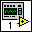

Frontpanel
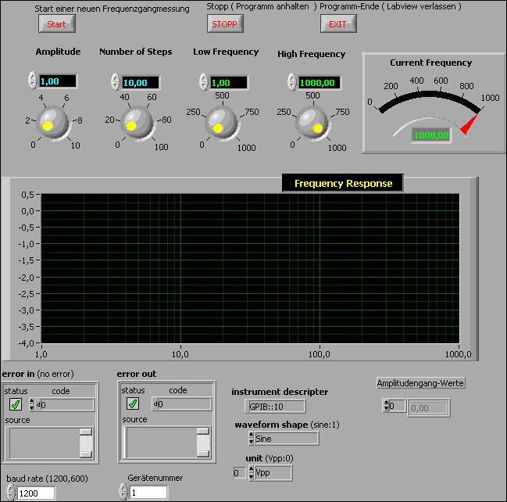

Blockdiagramm
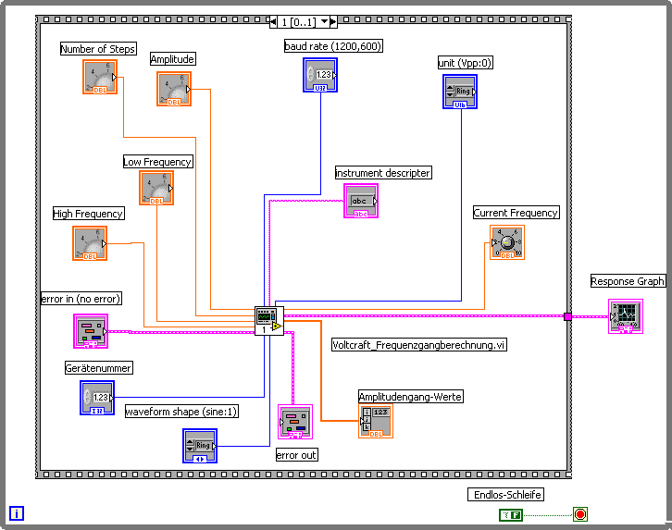

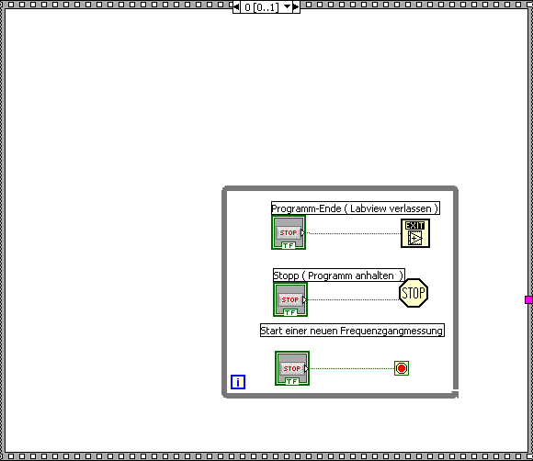

Voltcraft_Frequenzgangberechnung.vi

Anschlussfeld
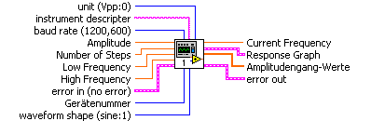

Frontpanel
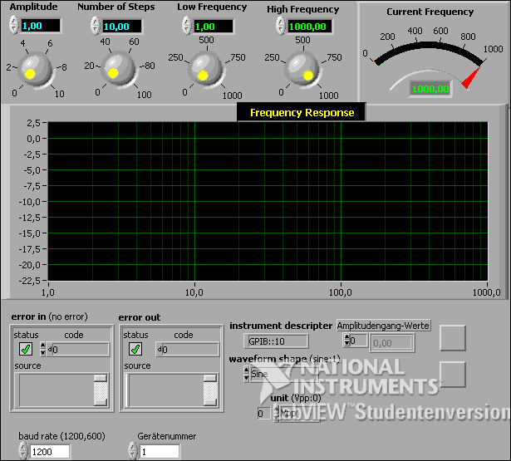

Blockdiagramm
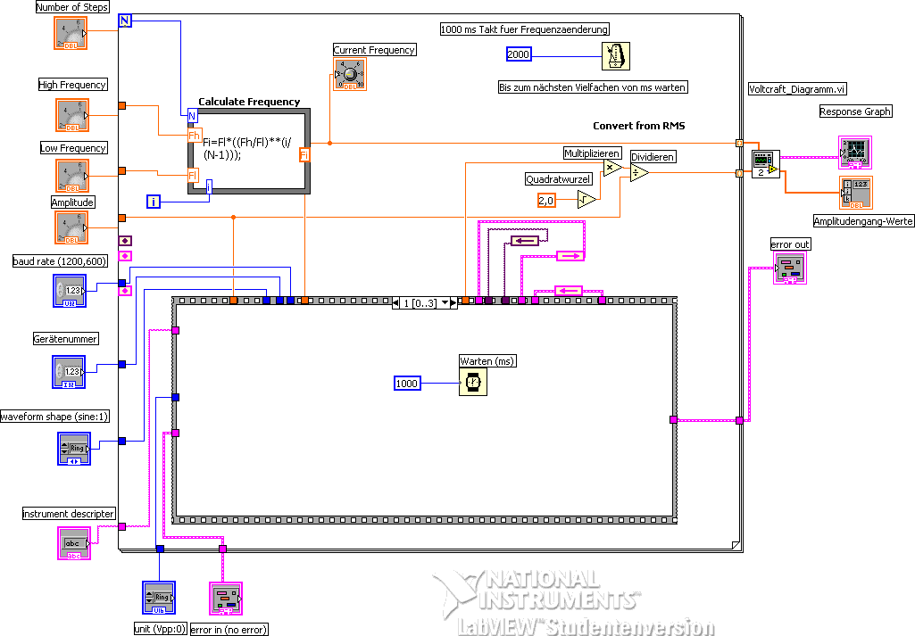

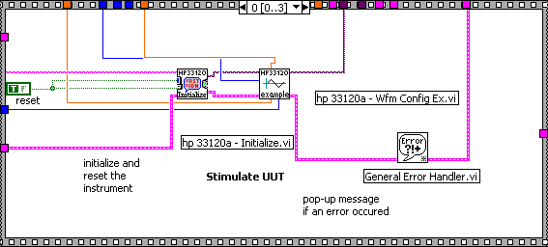
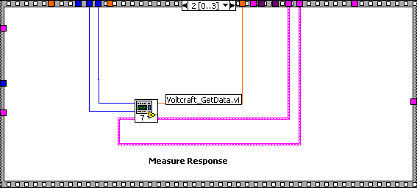

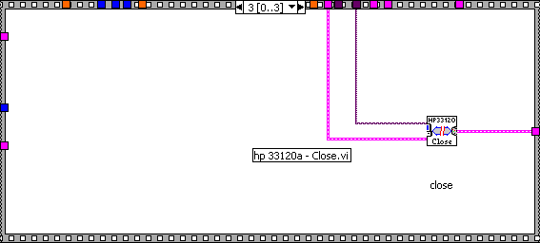

hp 33120a - Initialize.vi
This VI loads the addressing information about the instrument into the Open VXI Instrument VI and returns the instrument ID. You can reset the instrument by setting the front panel reset control. You must run this VI before using any of the instrument driver VIs for this instrument.

Anschlussfeld
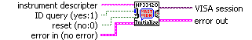

Frontpanel
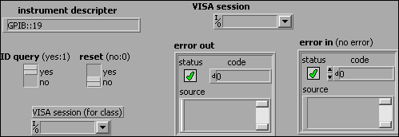

Blockdiagramm
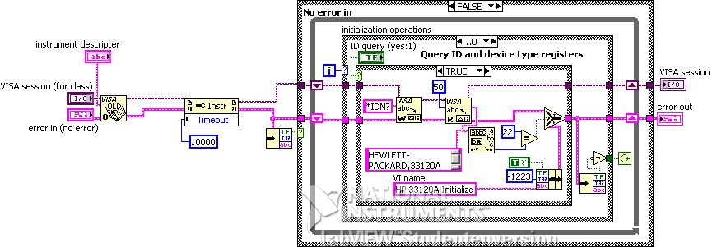
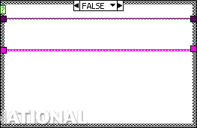
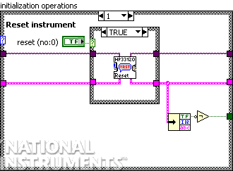
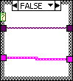

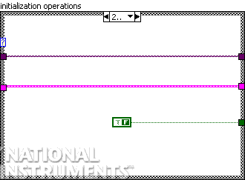

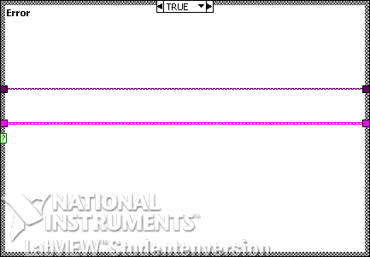

hp 33120a - Reset.vi
This VI causes the instrument to reset. Consult the user's manual for the default parameter settings to which this command resets the instrument.

Anschlussfeld

Frontpanel
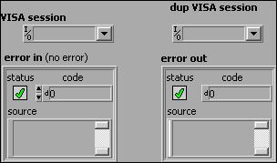

Blockdiagramm
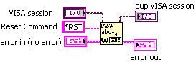

hp 33120a - Wfm Config Ex.vi
Performs the basic waveform configuration.

The instrument must be initialized for this example to function properly.

Anschlussfeld
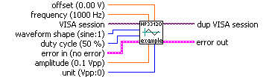

Frontpanel
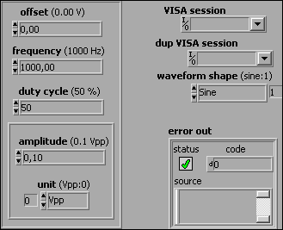

Blockdiagramm
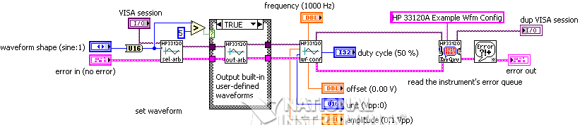

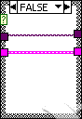

hp 33120a - Config Waveform.vi
sets the parameters of the basic waveform.

Anschlussfeld
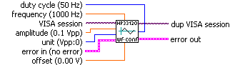

Frontpanel
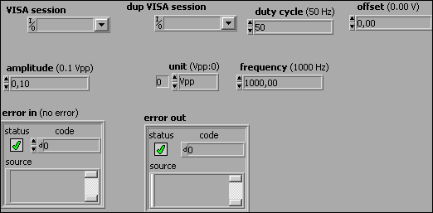

Blockdiagramm
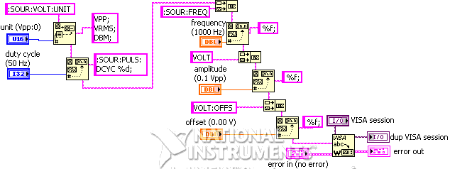

hp 33120a - Error Query.vi
This VI reads the status message from the power meter and determines whether an error has occurred during the previous operations. If an error is detected, the front panel LED (error) will be turned on, and the messages will be displayed.

Anschlussfeld
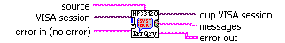

Frontpanel
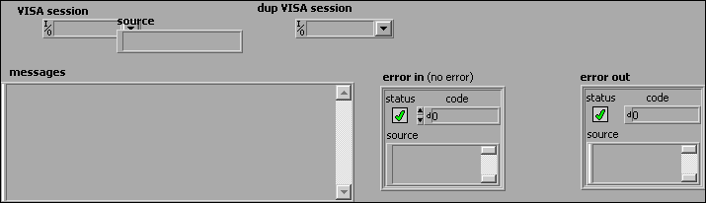

Blockdiagramm
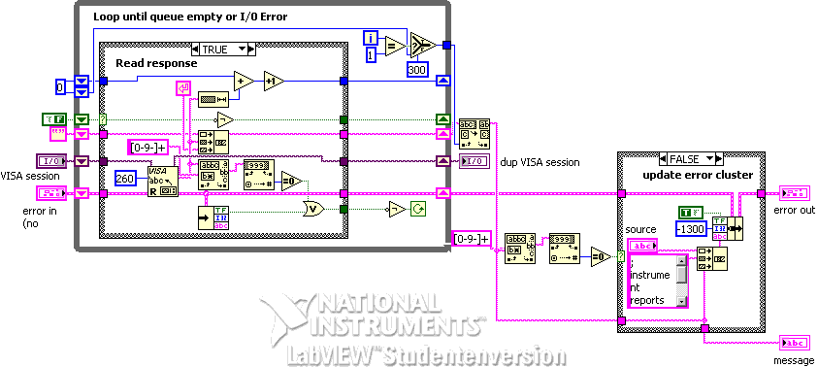

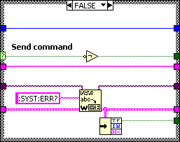

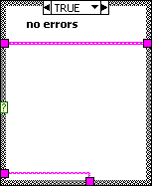

hp 33120a - Select Arbitrary Waveform.vi
Selects one of the five built-in arbitrary waveforms, one of four user-defined waveforms, or the waveform currently downloaded to volatile memory, and provides the option of outputting the selected waveform.

Anschlussfeld
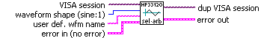

Frontpanel
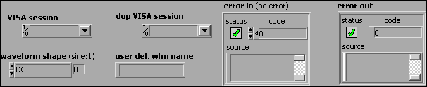

Blockdiagramm
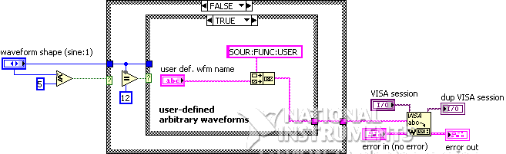

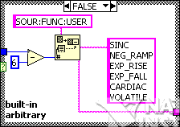

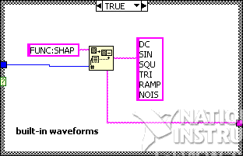
hp 33120a - Output Arbitrary Waveform.vi
This VI outputs the currently selected user waveform. The selected waveform is output using the previously selected frequency, amplitude, and offset settings.

Anschlussfeld

Frontpanel
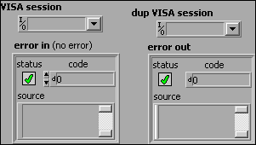

Blockdiagramm
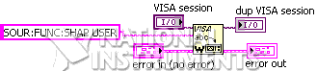

hp 33120a - Close.vi
This VI closes the I/O interface with the instrument.

Anschlussfeld
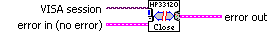

Frontpanel
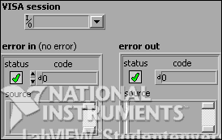

Blockdiagramm
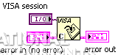

Voltcraft_GetData.vi

Anschlussfeld

Frontpanel
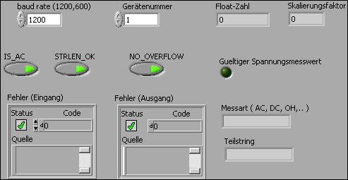

Blockdiagramm
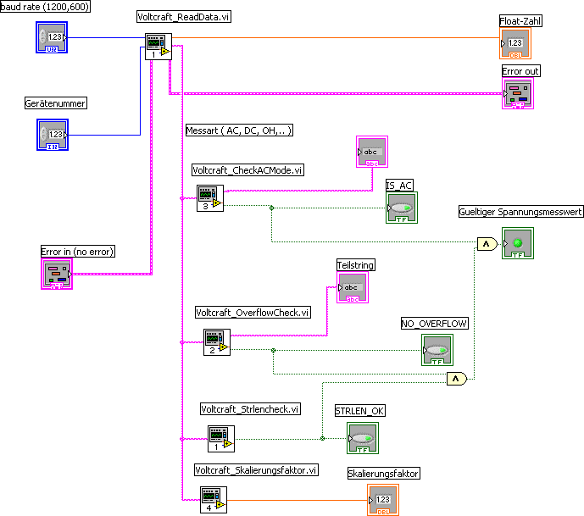

Voltcraft_Strlencheck.vi

Anschlussfeld

Frontpanel
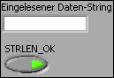

Blockdiagramm
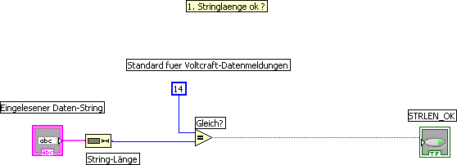

Voltcraft_OverflowCheck.vi

Anschlussfeld

Frontpanel
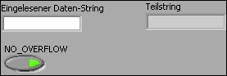

Blockdiagramm
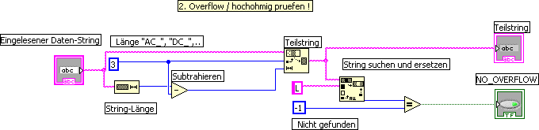

Voltcraft_CheckACMode.vi

Anschlussfeld

Frontpanel
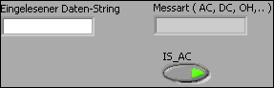

Blockdiagramm
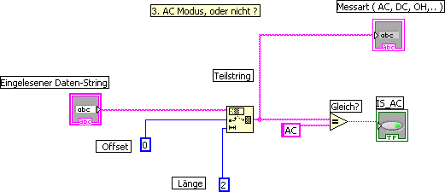

Voltcraft_Skalierungsfaktor.vi

Anschlussfeld

Frontpanel
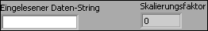

Blockdiagramm
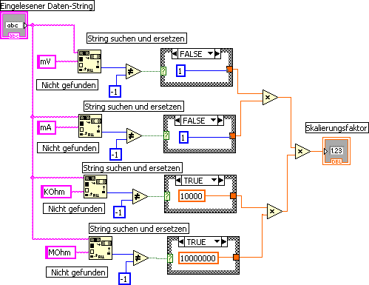
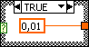
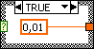
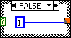
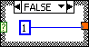

Voltcraft_ReadData.vi

Anschlussfeld
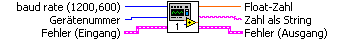

Frontpanel
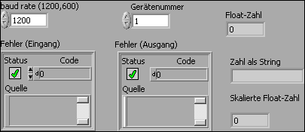

Blockdiagramm
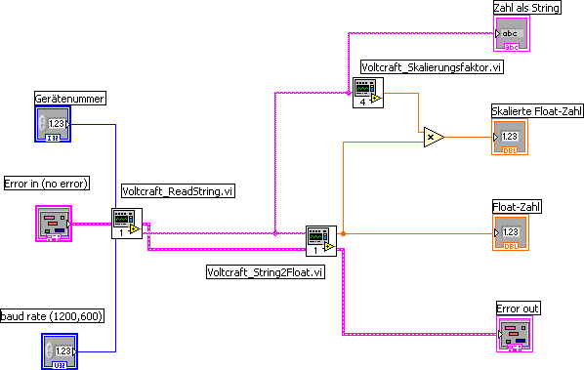

Voltcraft_ReadString.vi

Anschlussfeld

Frontpanel
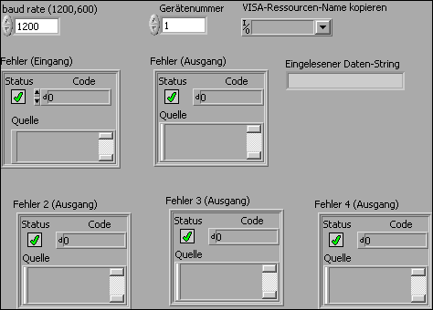

Blockdiagramm
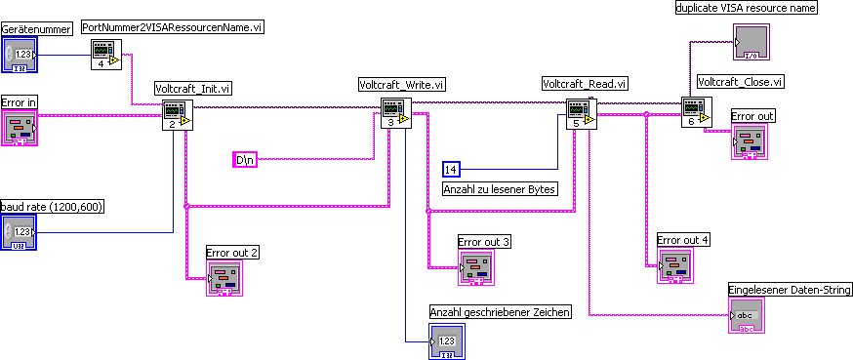

Voltcraft_Init.vi

Anschlussfeld

Frontpanel
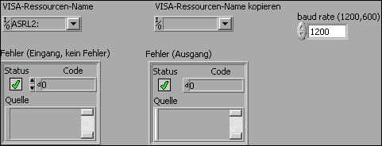

Blockdiagramm
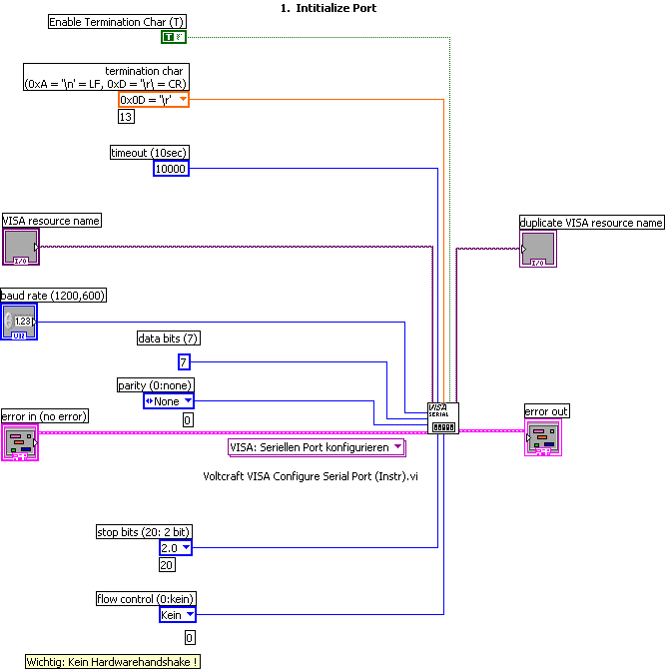

Voltcraft VISA Configure Serial Port.vi
Initialisiert den über den VISA: Ressourcennamen ausgewählten seriellen Port mit den angegebenen Einstellungen.

Anschlussfeld
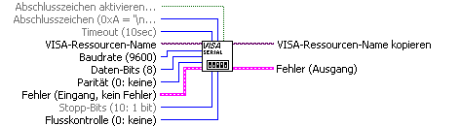

Voltcraft VISA Configure Serial Port (Instr).vi
Initialisiert den über den VISA: Ressourcennamen ausgewählten seriellen Port mit den angegebenen Einstellungen.

Anschlussfeld

Frontpanel
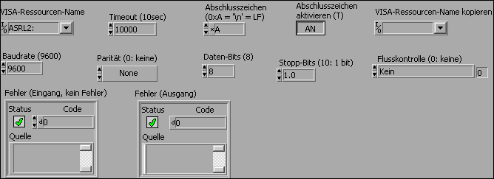

Blockdiagramm
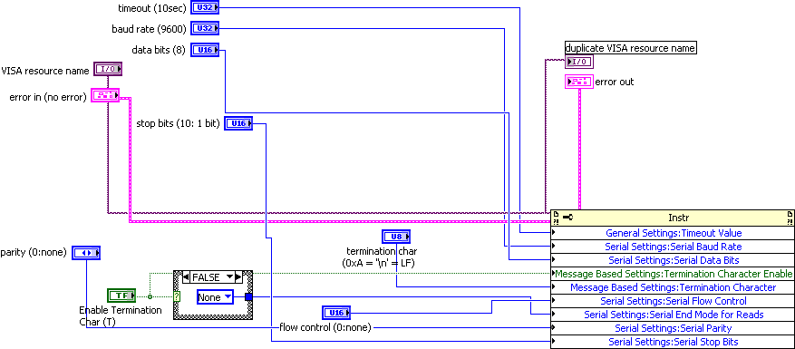

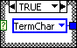

PortNummer2VISARessourcenName.vi

Anschlussfeld

Frontpanel
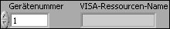

Blockdiagramm
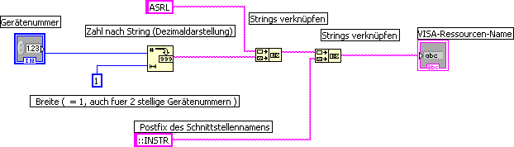

Voltcraft_Write.vi

Anschlussfeld

Frontpanel
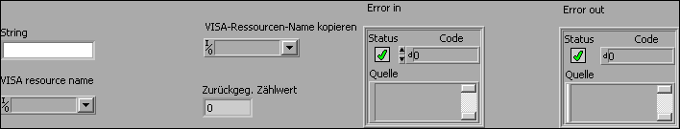

Blockdiagramm
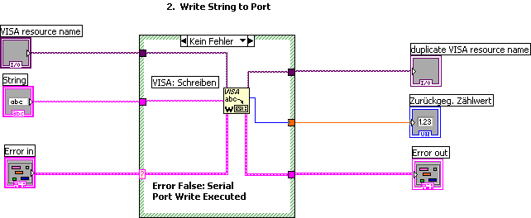

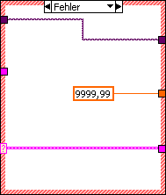

Voltcraft_Close.vi

Anschlussfeld
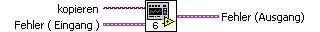

Frontpanel
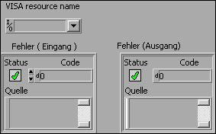

Blockdiagramm
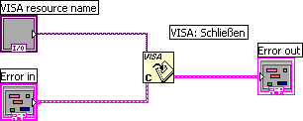

Voltcraft_Read.vi

Anschlussfeld

Frontpanel
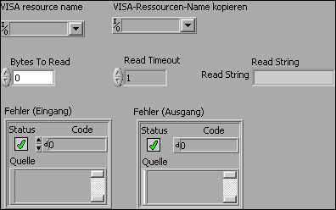

Blockdiagramm
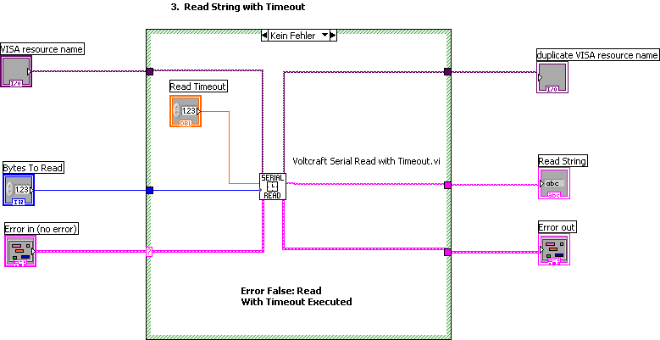

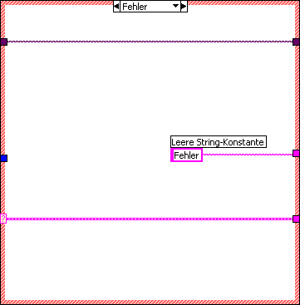

Voltcraft Serial Read with Timeout.vi
The Serial Read with Timeout VI will read bytes until either the requested number of bytes is received, or until a timeout occurs.

Anschlussfeld
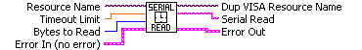

Frontpanel
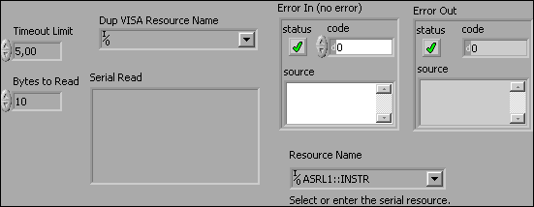

Blockdiagramm
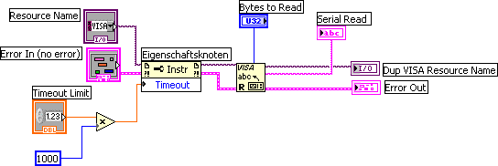

Voltcraft_String2Float.vi

Anschlussfeld

Frontpanel
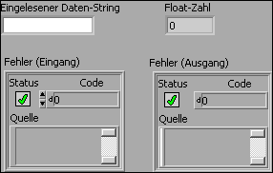

Blockdiagramm
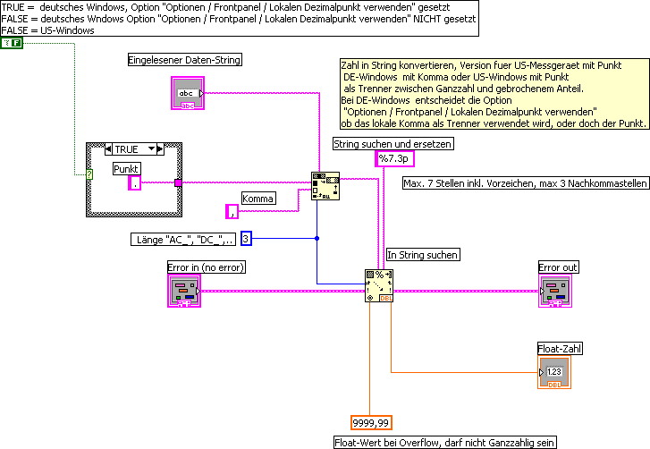

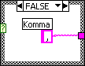

Voltcraft_Diagramm.vi

Anschlussfeld
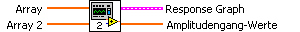

Frontpanel
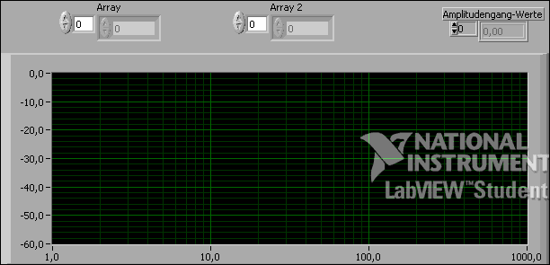

Blockdiagramm
