Rice University – An Introduction to Interactive Programming In Python ( 2012 )

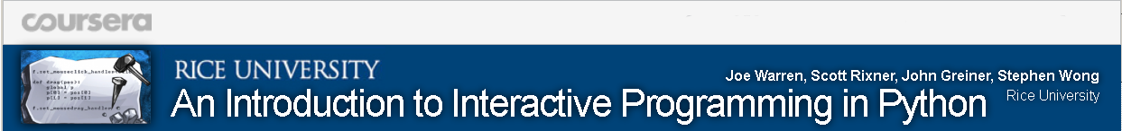
Self report: Me, Rolf Hemmerling, participated successfully at the online course of Rice University, Houston, USA on the e-learning platform “Coursera” ( http://www.coursera.org ) 2012-10-07 – 2012-12-21 with a Final Grade “90.97 / 100.00”.

For each listed tasked, I developed a software program in the programming language Python 2.6 and submitted it in time for anonymous assessment by 5 other course participants ( “Peer Assessment” ), according to criteria given by the organizer:

- Rock-paper-scissors-lizard-Spock ( Variation of the “Rock-paper-scissors” game with 5 choices, popular by the TV series “The Big Bang Theory” )
- Guess the number
- Stopwatch: The game
- Pong ( Video game “Pong” )
- Memory ( Card game according to the Pairs principle in which all of the cards are laid face down on a surface and two cards are flipped face up over each turn. The object of the game is to turn over pairs of matching cards )
- Blackjack ( Casino banking game “Blackjack” ),
- Spaceship ( The spaceship for the video game “Asteroids” )
- RiceRocks ( Video game “Asteroids” )

I myself also assessed the software programs of 5 other course participants in addition to my own solution.

The target platform was the online development environment “CodeSculptor”, http://www.codeskulptor.org/, running in the Firefox browser and supplying a Python 2.6 runtime. I did parallel software development on a Python 2.7.3 system, running as local installation. I developed with the unit test method, by using the Python module PyUnit.

Additionally I passed successfully 15 online testquestion formulars for learning support ( “Quizz” ), similar to test question sections in a classical paper book. By the options to process the tests without time pressure and to repeat tests, the course participants were supported in their learning process.

The organizer estimated the average workload for course participation to about 7-9 hours/week.

