DIGITAL FORENSICS
(20CP411T)
UNIT 1 — INTRODUCTION
Complete Study Notes — Mid-Semester Examination
Computer forensics fundamentals • Benefits of forensics • Computer crimes • Computer forensics evidence and courts • Understanding computing investigations • Sources of digital/electronic evidence

Contents
- Introduction to Forensics & Digital Forensics
- Computer Forensics Fundamentals
- Digital Forensics Categories
- Benefits of Digital Forensics
- Computer Crimes
- Digital Evidence & Computer Forensics Evidence in Courts
- Understanding Computing Investigations
- Sources of Digital / Electronic Evidence
- Quick Revision Summary

1. Introduction to Forensics & Digital Forensics

1.1 What is Forensics?
- Forensics refers to the use of scientific methods and techniques to solve a crime.
- It involves the examination of objects that are related to or involved in a crime.
- It includes collecting, preserving, analysing and presenting evidence in a manner acceptable in a court of law.
- Forensic science helps law enforcement agencies identify suspects, reconstruct events and establish facts.
Key Objectives of Forensic Science
- Identify evidence related to criminal activities.
- Analyse evidence using scientific methodologies.
- Support legal proceedings with factual findings.

1.2 Evolution from the Traditional to the Digital World
Modern society relies heavily on computers, smartphones, networks and cloud services. Organisations increasingly use computerised systems to store, process and manage information. Digital technology has been widely adopted across:
- Government sectors
- Private businesses
- Educational institutions
- Healthcare organisations

1.3 Need for Digital Forensics
Individuals increasingly use computers and smartphones to store personal information, conduct financial transactions, communicate and access online services. This growing dependence has created new risks, or “emerging challenges”:
- Data theft
- Identity fraud
- Unauthorised access
- Malware attacks
- Cyber espionage
This dependence on digital devices creates the need for a systematic investigation of digital evidence — which is exactly what Digital Forensics provides.

1.4 Rise of Cybercrime
Cybercriminals continuously exploit vulnerabilities in digital systems. Common cybercrimes include hacking, phishing, ransomware attacks, data breaches and online fraud. The consequences include financial losses, reputational damage, privacy violations and national security concerns.

1.5 What is Digital Forensics?
Key takeaway: Digital Forensics is the branch of forensic science that uses scientific knowledge for collecting, analysing, documenting and presenting digital evidence related to computer crime, so that it can be used in a court of law.

- Also known as computer forensics or cyber forensics (used as synonyms).
- Scope has expanded to cover investigating all devices capable of storing digital data — not just computers.
- Goal: to uncover digital evidence while maintaining its integrity and admissibility in court.
Importance of Digital Forensics
- Investigates cybercrimes and security incidents.
- Recovers deleted or hidden information.
- Supports legal investigations and court proceedings.
- Helps organisations improve their security practices.

1.6 Can Deleted Data Solve a Crime?
A common misconception is that deleting files, clearing browser history, removing emails, or formatting a hard drive makes evidence disappear forever. Digital Forensics proves this is usually “not necessarily” true — deleted data very often leaves recoverable traces (e.g., in unallocated disk space, backups, logs, or connected devices).
Illustrative Case Studies
- The Deleted Email Mystery: An employee who resigned deleted emails and cleared documents before leaving after leaking confidential data. Investigators still recovered deleted emails, USB connection records, file-access timestamps and login history — proving that deleting data does not always remove the evidence.
- The Smartphone That Lied: A suspect claimed to be home all evening, but GPS records, call logs, texts, Wi-Fi history and time-stamped photos placed the phone near the crime scene — showing that every smartphone creates a digital footprint.
- The Hospital Ransomware Attack: A ransomware attack locked a hospital out of patient records. Analysis of system logs, network traffic and malware files identified the entry point and traced attacker activity — showing Digital Forensics is used for cybersecurity investigations, not just traditional crime.

1.7 Digital Forensics Goals
- Recover, analyse and preserve computers and related materials so they can be presented as evidence in a court of law.
- Determine the motive of the crime and identify the primary attacker.
- Ensure the integrity of the digital evidence obtained from the crime scene.
- Keep the evidence safe by adhering to the chain of custody.

1.8 The Digital Forensics Process
Although some sources list slightly different numbers of steps, the core Digital Forensics process consists of the following stages:
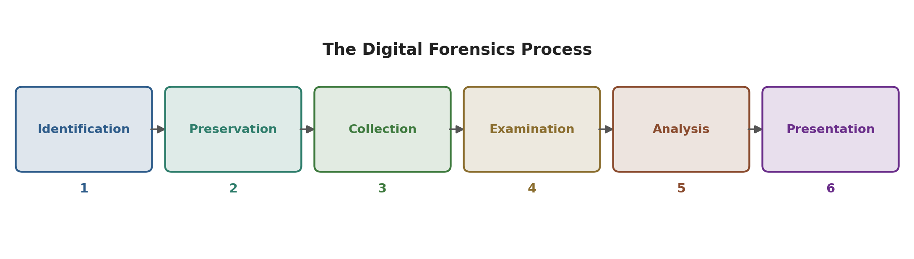
Figure 1.1 — The Digital Forensics Process
- Identification: Recognising potential sources of digital evidence (desktops, laptops, mobiles, cloud storage, removable media).
- Preservation: Ensuring the integrity of evidence using write-blockers and forensic imaging so nothing is altered.
- Collection: Extracting data with appropriate tools without compromising the original content; every action is documented.
- Examination: Applying forensic techniques to uncover hidden, deleted or encrypted information — keyword search, file recovery, log analysis, metadata extraction.
- Analysis: Interpreting data to reconstruct events and user activity, correlating evidence across devices and timelines.
- Presentation: Compiling findings into clear, legally acceptable reports, exhibits and expert testimony.

2. Computer Forensics Fundamentals

2.1 Definition
Computer forensics is a specialised branch of digital forensic science focused on the legal recovery of data. It is concerned with investigating digital evidence found on desktop computers, laptops, external storage devices, SD cards and RAM, along with OS and application traces and their logs. Its main activity is recovering deleted data from a target device's storage and analysing it for incriminating or exonerating evidence.

2.2 The Four Pillars of Computer Forensics
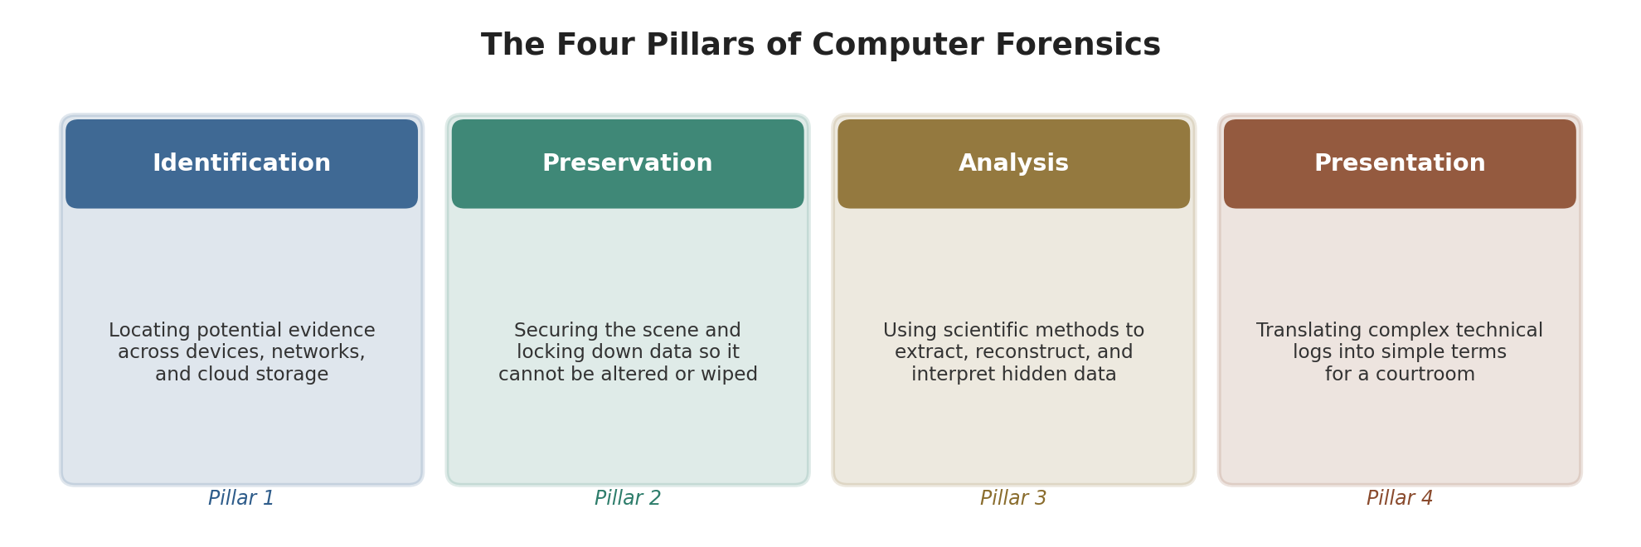
Figure 2.1 — The Four Pillars of Computer Forensics

2.3 Legal Scope
- Criminal Investigations: Homicide, cyberwarfare, intellectual property theft, fraud.
- Civil Investigations: Corporate disputes, divorce proceedings, employment breaches.

2.4 Goals of Computer Forensics
- Evidence Recovery: Extract active, hidden, encrypted and deleted files from target storage media.
- Maintain Data Integrity: Guarantee the original evidence stays 100% pristine — investigators work only on bit-stream forensic copies, never the original device.
- Ensure Legal Admissibility: Strictly follow privacy laws and search warrants; improperly collected evidence gets thrown out, however guilty the suspect.
- Establish Chain of Custody: Maintain a meticulous chronological log of who handled evidence, when, and why.
- Objective Support: Provide unbiased, verifiable facts to support either the prosecution or the defence.

2.5 Computer Forensics Process
- Identification: Identify target media (laptops, servers, backup tapes, smartphones, IoT devices) and determine the scope of the warrant/authorisation.
- Preservation: Isolate mobiles in Faraday bags to block remote-wipe commands; use hardware write-blockers to clone drives without altering logs.
- Analysis: Carve unallocated space for deleted fragments; examine registries, browser history and timeline logs.
- Documentation: Keep an absolute paper trail of tools, plugin versions and commands so the investigation is repeatable by an independent expert.
- Presentation: Generate formal forensic reports and prepare expert-witness testimony that strips away technical jargon.

2.6 Common Tools in Computer Forensics
Tool | Known For
EnCase Forensic (Guidance Software / OpenText) | Enterprise gold standard; deep keyword search, automated indexing, court-ready reports.
FTK — Forensic Toolkit (AccessData / Exterro) | Speed and large database architecture; password cracking, email archive analysis, registry parsing.
Autopsy | Free, open-source GUI built on The Sleuth Kit (TSK); ideal for students, small agencies, quick triage.
X-Ways Forensics | Lightweight, fast, portable; manual disk editing, sector-by-sector analysis.
Volatility Framework | Industry-standard open-source tool for volatile memory (RAM) analysis; captures live connections/processes/malware.

2.7 Types of Digital Evidence (Computer Forensics View)
Communication Artefacts
- Emails: Message bodies, attachments, server routing headers, deleted mail archives.
- Chat logs: IM threads, encrypted chat databases, application metadata.
User Activity Files
- Documents: Word files, PDFs, spreadsheets and their metadata (author, creation/edit times).
- Browser history: Visited URLs, search queries, download logs, cookies, cached images.
Media & System Records
- Images/videos: EXIF metadata with GPS coordinates and camera models.
- System logs: Event logs, registry entries, USB connection records showing exact login/plug-in times.

2.8 Challenges in Computer Forensics
- Encryption/password protection: Full-disk encryption (e.g., BitLocker) blocks access without recovery keys.
- Anti-forensic techniques: Data wiping, obfuscation, timestomping, or running malware only in RAM.
- Data volume & complexity: Sifting through terabytes to find a “needle in a digital haystack.”
- Cloud computing & jurisdiction: Evidence hosted on international servers complicates warrants.
- Legal & privacy issues: Balancing investigation with data-privacy laws such as GDPR.

2.9 Applications of Computer Forensics
- Criminal investigations
- Corporate investigations
- Data breach analysis
- Incident response
- Intellectual property theft cases

2.10 Computer-Oriented Crime vs Cyber-Crime vs Digital Crime
Term | Definition | Focus
Computer-Oriented Crime | Criminal behaviour where a computing machine or network is the primary tool used to execute illegal activities. | The computer is the instrument (e.g., DDoS attack, malware distribution, phishing).
Cyber-Crime | Misuse or abuse of computing systems, networks or electronic devices by individuals. | Broad term for illicit network-based activity, online identity theft, digital harassment.
Digital Crime | Unauthorised access into systems with intent to destroy data, alter records or execute illegal operations. | Targets data integrity and confidentiality (e.g., hacking a bank database to erase loans).

3. Digital Forensics Categories
Digital Forensics is generally divided into four major categories, based on the type of device or data being investigated:
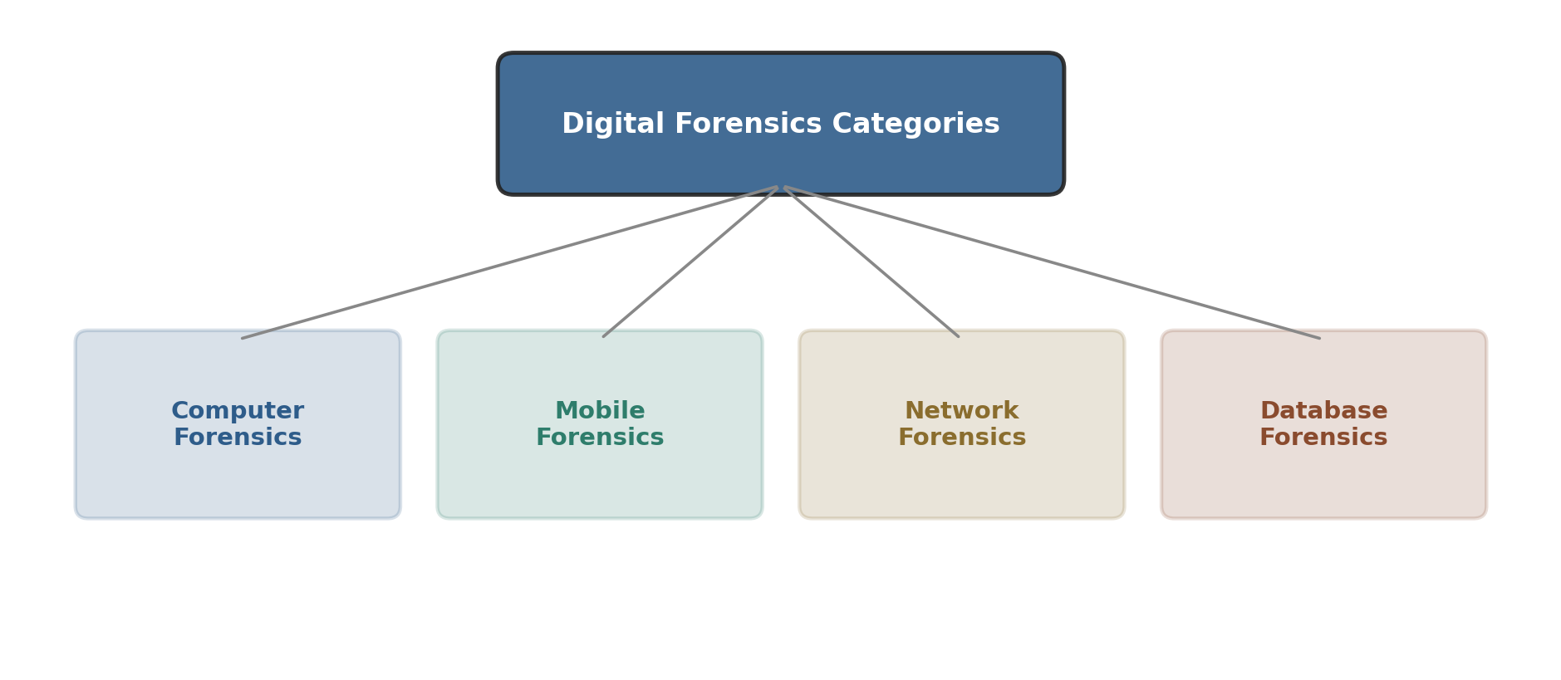
Figure 3.1 — Categories of Digital Forensics
1. Computer Forensics
- Investigates digital evidence found on desktop computers, laptops, external storage devices (hard drives, SD cards) and RAM.
- Also examines operating system and application traces and their associated logs.
- Main activity: recovering deleted data from a device's storage and analysing it for incriminating or exonerating evidence.
2. Mobile Forensics
- Concerned with acquiring digital evidence from mobile devices.
- Includes phones, smartphones, tablets, SIM cards and wearables such as smart watches.
3. Network Forensics
- Concerned with monitoring and analysing traffic flow across computer networks to extract incriminating evidence (e.g., tracing the source of an attack) or detect intrusions.
- Network data can be captured in bulk in real time for later analysis, or analysed live while saving only segments of interest (which needs less storage).
- Unlike other digital forensics types, network forensics deals only with volatile (live) data.
4. Database Forensics
- Concerned with the analysis of data and metadata within databases such as Microsoft SQL Server, Oracle, MySQL, etc.
- Looks at who accessed a database and what actions were performed, to help uncover malicious activity.

4. Benefits of Digital Forensics — Who Benefits?
Digital Forensics is not only a tool for solving crimes — it benefits many different stakeholders in society. Governments, banks, hospitals, companies and police forces invest heavily in Digital Forensics for the following reasons.

4.1 Benefits to Law Enforcement Agencies
Law enforcement agencies are among the largest users of Digital Forensics because modern crimes — and even traditional crimes such as murder, kidnapping, fraud and theft — frequently leave digital traces (via smartphones, social media, cloud services, etc.).
Digital Forensics helps investigators:
- Identify suspects — linking an individual to a device, account or online activity.
- Reconstruct crime timelines — when an activity occurred, sequence of events, and actions before/after the incident.
- Locate missing persons and criminals using GPS records or mobile tower connections.
- Support criminal prosecution with objective evidence.
Real-life example: In a kidnapping investigation, examining mobile call records, GPS history, messaging activity and social media revealed that the suspect's and victim's phones were in the same area at the same time — helping investigators narrow their search.

4.2 Benefits to the Judicial System
The judicial system's objective is to deliver justice based on facts, evidence and the rule of law. As society becomes digital, many disputes involve electronic devices and records. Digital Forensics assists judges, prosecutors and defence lawyers with scientifically analysed evidence.
- Establishes facts objectively: Digital evidence records events automatically, unlike human witnesses who may forget or contradict themselves.
- Supports fair decision-making: Helps verify statements, compare testimony with records, and reduce uncertainty.
- Protects both victims and the accused: Can prove guilt or demonstrate innocence.
- Strengthens public confidence: Objective evidence makes judicial decisions more transparent and credible.
Real-life example: In a contract dispute, the court reviewed email communication, timestamps, attachments and version history to establish when an agreement was exchanged and by whom.

4.3 Benefits to Organizations & Businesses
Organisations store customer information, financial records, IP, business strategies and employee communication electronically — making them attractive targets for cybercriminals, dishonest employees and insiders.
- Investigation of insider threats: Unauthorised file access, IP theft, misuse of company computers.
- Investigation of data breaches: What was compromised, how access occurred, which systems were affected, and when.
- Detection of financial fraud: Online payment fraud, unauthorised transactions, accounting manipulation, payroll fraud.
- Protection of intellectual property: Determining whether source code or research has been copied or leaked.
- Reducing financial & reputational damage: Identifying the cause of an incident supports business resilience.
Example — Source Code Theft: A software engineer resigns; a competitor soon releases a strikingly similar product. A forensic investigation determines whether confidential files were accessed and copied before resignation, and by which account.

4.4 Benefits to Individuals
As individuals rely on smartphones, online banking, social media, email, cloud storage and e-commerce, they also become exposed to cyber threats.
- Protection against online financial fraud: Determining when/how an unauthorised transaction occurred.
- Investigation of identity theft: Fake social media accounts, unauthorised email access, misuse of Aadhaar/PAN data.
- Assistance in cyber harassment/abuse: Cyberstalking, cyberbullying, online blackmail.
- Recovery of valuable digital information: Family photos, personal documents, academic/business files.
- Protecting personal privacy: Investigating unauthorised device access and data leakage.

4.5 Benefits to Cybersecurity Teams
Cybersecurity aims to prevent attacks before they happen; Digital Forensics investigates attacks after they happen so organisations can learn, recover and improve. The two disciplines complement each other.
- Identifying the root cause: How access was gained, which vulnerability was exploited, which systems were affected.
- Understanding the attack timeline: When the attacker entered, how long they remained undetected, what actions were taken.
- Improving future security: Strengthening policies, access controls, employee awareness and monitoring.
- Supporting threat intelligence: Understanding attack patterns, attacker behaviour, and emerging threats.

4.6 Benefits to Society and National Security
- Protecting critical infrastructure: Power grids, railways, hospitals, communication and water systems, digital payments.
- Enhancing public safety: Missing persons, financial fraud, cybercrime, child exploitation, terror-related cases.
- Strengthening national security: Investigating attacks on infrastructure; supporting national cyber defence.
- Protecting public trust in digital services: Online tax filing, digital ID, e-governance portals.
- Supporting a secure digital society: Every investigation improves awareness, policy and risk management for the future.

4.7 Challenges of Digital Forensics
Current Challenges
- Encryption and data security: Encrypted data is hard to decrypt without proper keys; encryption keeps evolving.
- Evolving technologies: New devices, apps and communication methods require continuous learning.
- Volume and complexity of data: Sorting massive datasets across cloud and social platforms is resource-intensive.
Future Challenges
- Internet of Things (IoT): Diverse OS/formats across interconnected devices demand specialised skills.
- Artificial Intelligence (AI): Detecting deepfakes, tracing AI-driven attacks, and ethical impact on evidence.
- Privacy and legal concerns: Balancing evidence collection with privacy rights requires clear guidelines.
- Global collaboration & standardisation: Cross-border crimes need international cooperation despite differing laws.

5. Computer Crimes

5.1 What is a Computer Crime?
Key takeaway: A computer crime (also called a cybercrime) is any unlawful act in which a computer, digital device, or computer network is used either as the target of the crime or as the tool to commit the crime.

5.2 Two Ways a Computer is Involved
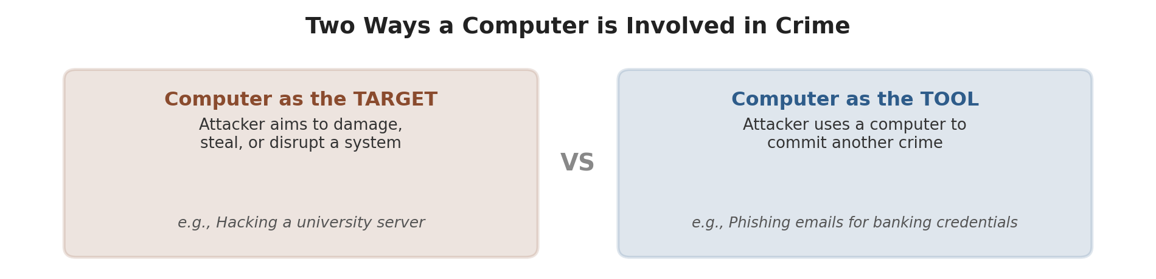
Figure 5.1 — Computer as Target vs Computer as Tool
 | Computer as the Target | Computer as the Tool
Attacker's aim | Damage, steal, or disrupt a computer system | Use a computer to commit another crime
Example | Hacking a university server | Sending phishing emails to steal banking credentials
Goal | Attack the system | Commit another offence using the system

5.3 Major Types of Computer Crimes
Category | Description | Example
Financial Crimes | Crimes committed to obtain financial gain through digital means. | Online banking fraud, credit card fraud
Unauthorized Access (Hacking) | Accessing a computer or network without permission. | Breaking into a university server
Malware Attacks | Using malicious software to damage or disrupt systems. | Ransomware, viruses, worms
Identity Theft | Misusing another person's personal information. | Fake social media profile, stolen credentials
Email & Internet Crimes | Crimes carried out using email or web services. | Phishing, email spoofing, spam
Crimes Against Individuals | Targeting people through digital platforms. | Cyberbullying, cyberstalking, harassment
Crimes Against Organizations | Attacks on businesses or institutions. | Data breaches, insider attacks
Crimes Against Society & Government | Crimes affecting public services or national interests. | Attacks on infrastructure, government portals

5.4 Financial Computer Crimes
Financial computer crimes involve using computers, mobile devices or the Internet to steal money, financial information or valuable digital assets. Unlike traditional bank robberies, these are often committed remotely across cities or countries.
Crime | Description | Example
Credit/Debit Card Fraud | Unauthorized use of payment card information. | Card details stolen and used for online purchases.
UPI & Online Banking Fraud | Fraud involving digital payment platforms. | Fake payment requests or unauthorized transfers.
Phishing Attacks | Fake emails/SMS/websites to steal banking credentials. | Victim enters login details on a fake bank site.
Online Shopping Fraud | Fake e-commerce sites or sellers deceive customers. | Customer pays but never receives the product.
Cryptocurrency Fraud | Fraud involving fake crypto investments/exchanges. | Fake scheme promising unrealistic returns.

5.5 Crimes Against Individuals
These target people directly — stealing identity, invading privacy, harassing, or manipulating personal information — causing emotional distress, financial loss and reputational damage.
Crime | Description | Example
Identity Theft | Using another person's information without permission. | Fake social media account using someone's name/photos.
Cyberstalking | Repeatedly monitoring or threatening someone digitally. | Unwanted messages, tracking online activity.
Cyberbullying | Using electronic communication to harass or intimidate. | Offensive comments or rumours on social media.
Privacy Violation | Accessing/sharing private information without consent. | Leaking private photos or confidential documents.
Email Account Hacking | Unauthorized access to another's email account. | Changing passwords, impersonating the owner.

5.6 Crimes Against Organizations
Organisations are attractive targets because compromising one can affect thousands or millions of customers.
Crime | Description | Real-Life Example
Data Breach | Unauthorized access to confidential organizational data. | Customer database stolen from an e-commerce firm.
Insider Threat | Employees misuse authorized access for gain or revenge. | Employee copies client data before resigning.
Ransomware Attack | Criminals encrypt files and demand payment. | Hospital systems inaccessible after an attack.
Intellectual Property Theft | Theft of proprietary software/research/designs. | Source code copied to a competitor.
Denial-of-Service (DoS/DDoS) | Flooding a server to make services unavailable. | Shopping site down during a festival sale.

5.7 Crimes Against Society and Government
Some computer crimes disrupt essential public services affecting millions of citizens and can threaten national security — targeting electricity, transport, healthcare, banking, communication and government services.
Crime | Description | Example
Attack on Government Systems | Unauthorized access to government websites/databases. | Defacing a website or accessing citizen records.
Critical Infrastructure Attack | Cyberattack on essential public services. | Attack on a power grid or water treatment plant.
Transportation System Attack | Disruption of transport services via cyber means. | Railway reservation or airport system outage.
Distributed Denial-of-Service (DDoS) | Large-scale attack making public services unavailable. | Government portal down during tax season.
Misinformation & Fake News | Spreading false information to create panic. | Fake emergency messages on social media.

5.8 Case Studies
- WannaCry Ransomware Attack (2017): Spread rapidly worldwide, encrypting files and demanding ransom; affected organisations in 150+ countries. Hospitals cancelled appointments, businesses suspended operations. Lesson: regular updates/patches and backups are critical, and forensics helps understand malware spread.
- Bangladesh Bank SWIFT Heist (2016): Attackers gained access to the bank's systems and attempted to transfer nearly $1 billion via SWIFT; ~$81 million was actually transferred. Lesson: financial institutions need strong security controls and continuous monitoring.
- Colonial Pipeline Attack (2021): A ransomware attack disrupted a major US fuel pipeline, causing fuel shortages and panic buying. Lesson: cyberattacks can affect critical infrastructure; incident-response and recovery plans are essential.

5.9 Emerging Trends in Computer Crimes
Trend | Description | Example
AI-Enabled Scams | Criminals use AI to create convincing scams. | AI voice calls impersonating family/bank officials.
Deepfake Technology | AI-generated fake images/audio/video to deceive. | Fake video of a public figure making false statements.
Mobile & UPI Frauds | Attacks on smartphones and payment apps. | Fake QR codes, fraudulent payment requests.
IoT Device Attacks | Smart devices become attack targets. | Compromised smart cameras/home automation.
Cloud Service Attacks | Criminals target cloud storage/online services. | Unauthorized access to cloud-hosted business data.
Social Engineering | Manipulating people instead of exploiting tech. | Fake tech-support calls asking for passwords/OTPs.
Key takeaway: Every computer crime leaves behind digital traces. The real challenge is not just detecting the crime, but collecting and preserving those traces so they become reliable evidence in a court of law — this is the essence of Digital Forensics.

6. Digital Evidence & Computer Forensics Evidence in Courts

6.1 What is Digital Evidence?
Whenever we use a computer, smartphone, ATM, email, social media or the Internet, we leave behind digital traces. If these traces help establish what happened, who was involved, when, or how, they become digital evidence.
Key takeaway: Digital evidence is any information stored or transmitted in digital form that can be used to establish facts during an investigation or legal proceeding.

6.2 Examples of Digital Evidence by Source
Digital Device / Source | Possible Digital Evidence
Computer | Documents, browser history, downloaded files
Mobile Phone | SMS, WhatsApp chats, call logs, photos
Email | Messages, attachments, timestamps
Internet | Website access logs, IP addresses
CCTV / DVR | Video recordings, timestamps
Cloud Storage | Shared files, activity logs
ATM / POS System | Transaction records
GPS Device | Location history

6.3 Characteristics of Digital Evidence
Unlike tangible physical evidence (e.g., a fingerprint or weapon), digital evidence exists as binary data (0s and 1s) and needs electronic devices to access, interpret and analyse it. Its major characteristics are:
- 1. Fragile: Can be altered, overwritten or deleted easily — even opening a file changes its “last accessed” timestamp.
- 2. Easily Duplicated: A copied file is identical to the original if copied correctly — investigators can therefore work on a copy.
- 3. Invisible to the Human Eye: Cannot be understood without electronic devices/software (binary files, DB records, browser cache, system logs).
- 4. Persistent: Deleting a file does not remove it immediately — traces remain until the storage space is overwritten.
- 5. Large Volume: Modern devices store thousands of photos, years of emails and millions of log entries.
- 6. Time-Stamped: Many digital activities automatically record date/time (email sent time, login time, file creation, GPS history), helping reconstruct events chronologically.

6.4 Role of Digital Evidence in Court
Digital evidence helps courts answer: Who committed the crime? What happened? When did it happen? Where did it happen? How did it happen?
Evidence | Example | Purpose in Court
Emails | Business communication | Establish communication
Chat Messages | WhatsApp, Telegram | Verify conversations
Call Records | Mobile call logs | Identify contacts
CCTV Footage | Security camera recordings | Identify suspects and events
GPS Records | Vehicle or phone location | Determine location
Transaction Logs | ATM, UPI, online banking | Prove financial transactions
Browser History | Websites visited | Show online activity

6.5 Requirements for Accepting Digital Evidence in Court
- Relevant: Must be directly related to the case.
- Authentic: Must be genuine and linked to the correct source.
- Reliable: Must accurately represent the original information.
- Legally Obtained: Must be collected according to applicable laws and procedures.

6.6 Challenges of Digital Evidence
Challenge | Explanation | Example
Huge Volume of Data | Modern devices store enormous amounts of information. | A 1 TB hard drive may contain millions of files.
Encryption | Data may be protected using strong encryption. | Password-protected phones and encrypted messaging apps.
Cloud Storage | Data may be stored on remote servers in other countries. | Files on Google Drive/OneDrive instead of the local PC.
Jurisdiction Issues | Evidence stored abroad makes legal access complex. | Email server located outside India.
Deleted or Hidden Data | Users may intentionally delete or conceal information. | Deleted chat history or hidden files.
Rapidly Changing Technology | New devices/apps/platforms appear continuously. | New messaging apps or IoT devices.
Privacy and Legal Issues | Must balance evidence collection with privacy rights. | Accessing personal data needs legal authorization.

6.7 Computer Forensics Evidence and Courts
- Evidence Gathering & Preservation: Experts extract data from computers, mobiles and storage media, preserving integrity via a documented chain of custody.
- Analysis & Interpretation: Data is analysed to identify relevant information, establish timelines, trace activity, and detect tampering.
- Admissibility in Court: Evidence must be relevant, authentic and possess integrity; strict guidelines ensure reliability.
- Applications: Used in criminal investigations (cybercrime, fraud, theft), civil litigation and regulatory compliance.
- Evolving Landscape: Legal frameworks keep evolving; amendments to evidence rules have streamlined authenticating machine-generated data.

6.8 Admissibility of Digital Evidence in Courts (Indian Legal Framework)
In India, the legal framework for digital evidence is primarily governed by:
- Information Technology Act, 2000 (IT Act): Recognises electronic records and digital signatures as valid, forming the foundation for their use in legal proceedings.
- Indian Evidence Act, 1872 — Section 65B: Details conditions for admissibility of electronic records, requiring a certificate verifying authenticity from the person in control of the device/system.
- Bharatiya Sakshya Sanhita (BSS), 2023 — Section 63: The newly introduced law replacing the Indian Evidence Act, retaining similar admissibility conditions.

6.9 Challenges in Digital Forensics and Evidence Handling
- Maintaining chain of custody: A documented trail of how evidence was collected, handled, stored and transferred prevents allegations of tampering.
- Data integrity and authenticity: Stringent protocols are needed since digital data is easy to alter or delete.
- Technical complexities: Encryption, anti-forensics, vast data volumes, cloud storage, AI and IoT need specialised expertise.
- Legal and procedural complexities: Varying jurisdictional laws, obtaining warrants, and explaining technical findings to non-technical judges/juries.
- Ethical concerns: Balancing the need for evidence against individual privacy rights.

6.10 Types of Digital Evidence (Summary)
- Emails, text messages, and social media interactions
- Digital documents, spreadsheets, presentations
- Images, videos, and audio recordings
- Computer and internet activity logs (browsing history, file access, system logs)
- Location data (GPS)
- Financial transactions and blockchain records

7. Understanding Computing Investigations

7.1 Role of the Digital Forensic Investigator
A digital forensic investigator is a specialised professional who plays a crucial role in investigating cybercrime and cybersecurity incidents — often called “detectives of the digital world.” They use specialised tools and techniques to uncover, analyse and preserve digital evidence found on electronic devices, which can then be used in legal proceedings to prosecute cybercriminals, recover stolen data, or determine the cause of security breaches.
Responsibilities of the Investigator
- Confirms or dispels whether a resource/network has been compromised.
- Determines the extent of damage caused by an intrusion.
- Answers the questions: Who, What, When, Where, How and Why.
- Gathers data in a forensically sound manner.
- Handles and analyses evidence.
- Prepares the investigation report.
- Presents admissible evidence in court.

7.2 Phases of a Computing Investigation
Figure 7.1 — Phases of a Computing Investigation
- Identification: Recognising potential sources of digital evidence — desktops, laptops, mobile phones, cloud storage, removable media.
- Preservation: Ensuring the integrity of digital evidence using write-blockers and forensic imaging tools to prevent alteration.
- Collection: Extracting data using appropriate tools without compromising the original content; documenting every action.
- Examination: Applying forensic techniques to uncover hidden, deleted or encrypted information — keyword searching, file recovery, log analysis, metadata extraction.
- Analysis: Interpreting data to understand sequences of events, reconstruct user activities, and correlate evidence across devices/timelines.
- Presentation: Compiling findings into a clear, legally acceptable format — written reports, exhibits, and possibly expert testimony in court.

7.3 Stages of the Computer Forensics Process — Worked Example
Scenario: A company suspects an employee of intellectual property theft. The computer forensics team would follow these stages:
- Obtain Legal Authorization: Ensure necessary legal permissions to investigate the employee's computer.
- Identify: Determine which devices and accounts are involved.
- Preserve: Take a forensic image of the employee's hard drive and other relevant storage media.
- Collect: Extract relevant emails, documents, and log files.
- Examine: Recover deleted files and analyse the file system and activity logs.
- Analyze: Correlate the data to identify evidence of intellectual property theft.
- Report: Document findings and prepare a report for company management and legal teams.
- Present: If the case goes to court, present the evidence and explain the forensic process.

7.4 Steps for Forensic Planning
- Ensure that monitoring is focused on detecting and preventing serious events.
- Specify the circumstances under which escalation to a full formal investigation (possibly using digital evidence) should be initiated.
- Educate workers on incident awareness so everyone understands their role in the digital evidence process and its legal implications.
- Document an evidence-based case outlining the incident and its impact.
- Ensure legal review to facilitate an appropriate response to the incident.

8. Sources of Digital / Electronic Evidence
Digital evidence is no longer stored only on computers. Investigators today must consider a wide range of physical devices and logical/online sources when searching for evidence.

8.1 Digital Evidence Types — By Creator
Digital artefacts can be differentiated by who created them:
- User-Created Data: Files, documents, photos, messages, and other content deliberately created or saved by a user.
- Machine/Network-Created Data: System logs, metadata, timestamps, and network records generated automatically by devices and networks.

8.2 Physical Sources vs Logical Sources
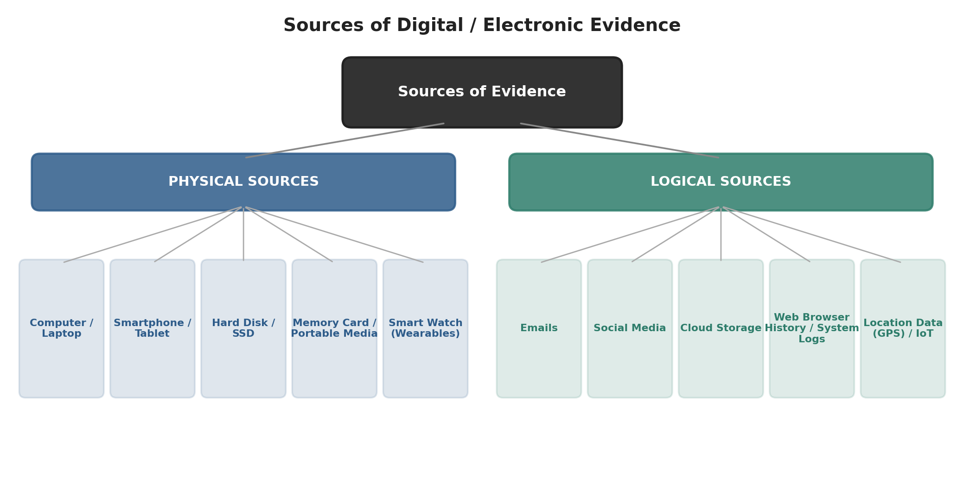
Figure 8.1 — Physical and Logical Sources of Digital Evidence
- Physical Sources: Physical devices that store digital evidence — computer/laptop, smartphone, hard disk drive (HDD), solid state drive (SSD), memory card, tablet, smart watch, and portable media (iPod / MP3 player).
- Logical Sources: Digital data, applications and online services that contain evidence — emails, cloud storage, social media, the internet, web browser history, location data (GPS), system logs and the Internet of Things (IoT).
Digital/electronic evidence can therefore originate from physical devices as well as from digital services and online platforms. It may include emails, messages, photos, videos, documents, browsing history, system logs and location data. Understanding both physical and logical evidence sources is essential for effective digital forensic investigations and legal proceedings.

8.3 Computers & Laptops
A computer or laptop can yield a wide range of evidence, including:
- Documents & personal files
- System & user activity (process/user logs)
- Downloaded & deleted files (recycle bin, download history)
- Emails & communication records
- Web browsing history
- Application data
Together these reveal timelines, interactions and user activities during an investigation.

8.4 Mobile Devices
Mobile phones and tablets are especially rich evidence sources because they travel with the user and constantly log activity:
- Screen-line information: Sent/received texts, timestamps, system event logs.
- SMS & instant messages: SMS, Messenger, WhatsApp.
- Call history & contacts: Call logs, address book, incoming/outgoing calls.
- Device & activity information: Hardware ID, network info, serial number, system event logs.
- Photos, videos & audio: Media files, voice memos, original photos/videos.
- Social media & app data: Social feeds, app logs, posts/comments, usage records.
- GPS & location information: Coordinates, map data, current & past locations, travel route timelines.
Together, mobile evidence can answer Who (user identity/contact ID), When (activity timelines/message timestamps), Where (precise geolocation/travel history) and What happened (device usage patterns, social interactions, file access).

8.5 Cloud Storage
Cloud storage is an increasingly important — but more difficult — location of digital evidence, since data may be:
- Stored & shared files, deleted files, and previous file versions
- Synchronization records across multiple devices
- Distributed across infrastructure controlled by service providers
- Protected by authentication/access controls
- Subject to legal procedures before it can be obtained (jurisdiction, warrants, provider cooperation)
Key takeaway: While cloud evidence is valuable, it is more difficult to acquire and investigate because data can be distributed across infrastructure and controlled by third-party service providers.

8.6 Social Media and Internet
Social media platforms and general internet usage generate rich behavioural evidence, including:
- Posts & comments, messages & conversations
- Account & activity records
- Photos & videos
- Search & browsing activity
- User interactions & connections
This data helps establish a person's identity, associations (social links), behaviour, and a timeline of their online activity.

8.7 IoT & Smart Devices
The Internet of Things (IoT) includes CCTV security cameras, smart watches/wearables, smart home appliances, connected vehicles (infotainment systems), sensors and other connected devices. These can provide:
- Location data and activity data (from wearables)
- Recorded events (CCTV footage, infotainment logs)
- Device interactions (Bluetooth/Wi-Fi connections between devices)
IoT forensics is challenging because each device may have a unique operating system and proprietary data format, demanding specialised extraction skills and tools.

8.8 Challenges in Acquiring Digital Evidence — Technical
Criminals may hide, protect, modify, or destroy digital evidence using techniques such as:
- Password / access protection: Locked accounts, devices, or files.
- Log / history removal: Deleting system/application logs and browsing history.
- Secure data wiping: Overwriting storage so deleted data cannot be recovered.
- File renaming / extension manipulation: Disguising a file's true type (e.g., renaming evidence.docx to system.dll).
- Steganography: Hiding secret data inside an ordinary-looking image, video, or audio file.
- Encryption & full-disk encryption: Making stored data unreadable without the key.
- Strong passwords: Complex passwords can take an estimated very long time to brute-force.

8.9 Forensic & Legal Challenges
Challenge | Explanation
Physical Damage | Damaged storage media (broken hard disks, chips) can make evidence hard or impossible to recover.
Volatile Evidence | RAM contents (active processes) are lost the moment a device is powered off.
Power State (On/Off) | Investigators must decide whether to preserve volatile data (keep on) or avoid unnecessary alteration (turn off) — the wrong choice can destroy evidence.
Easy Alteration | Simply accessing a file can change its “before/after” timestamps.
Fragile / Sensitive Evidence | Digital evidence (on hard disks, USB drives, phones) is delicate and must be handled with forensic care.
Encrypted Evidence | Passwords, keys, and locks may block access to seized devices.
Legal Restrictions | Seizure of devices requires proper legal authorization (warrants, court orders).
Data Ownership | Data may belong to a person, a company, or the public — each with different access rules.
Different Laws / Jurisdictions | Evidence or servers located in another country are governed by different legal systems, complicating investigations.

8.10 Who Should Collect Digital Evidence?
Collecting digital evidence correctly requires a multidisciplinary examiner with a blend of skills, including:
- Digital forensic expertise (forensic tools, data recovery)
- Strong IT knowledge (networks, systems, applications)
- Analytical thinking (correlating evidence, timelines)
- Cybersecurity & hacking knowledge (attack techniques, vulnerabilities)
- Technical & reporting skills (forensic tools, data recovery, documentation, technical reports)
- Legal & ethical awareness (evidence procedures, privacy, legal requirements)
- Communication & organizational skills (coordinating investigations, presenting findings)
- Online research / OSINT skills (open-source intelligence gathering)
Key takeaway: A digital forensic examiner requires multidisciplinary expertise — combining technical, analytical, legal and communication skills — because evidence collection mistakes are often irreversible and can make evidence inadmissible in court.

9. Quick Revision Summary
Definitions to remember
- Digital Forensics: branch of forensic science for collecting, analysing, documenting and presenting digital evidence for use in court.
- Computer Crime: any unlawful act where a computer/device/network is the target or the tool.
- Digital Evidence: any information stored/transmitted digitally that helps establish facts in an investigation or legal proceeding.
Process / phases (memorize the 6 steps)
Identification → Preservation → Collection → Examination → Analysis → Presentation
Categories of Digital Forensics
Computer Forensics, Mobile Forensics, Network Forensics (volatile/live data only), Database Forensics.
Who benefits from Digital Forensics
Law enforcement, judiciary, organisations/businesses, individuals, cybersecurity teams, society & national security.
Characteristics of digital evidence
Fragile, easily duplicated, invisible to the naked eye, persistent, large in volume, time-stamped.
Admissibility requirements
Relevant, authentic, reliable, legally obtained (India: IT Act 2000, Evidence Act 1872 § 65B, BSS 2023 § 63).
Sources of evidence
Physical sources (computer, smartphone, HDD/SSD, memory card, wearables) and logical sources (emails, cloud, social media, browser history, GPS, IoT).

