DIGITAL FORENSICS
(20CP411T)
UNIT 2 — DATA ACQUISITION
Complete Study Notes — Mid-Semester Examination
Understanding storage formats and digital evidence • Determining the best acquisition method • Acquisition tools • Validating data acquisitions • Remote network acquisition tools

Contents
- Image Acquisition and Analysis — the Basics
- Storage Formats for Digital Evidence
- Determining the Best Acquisition Method
- Methods for Capturing Evidence from Different Sources
- Digital Forensics Acquisition Tools
- Validating Data Acquisitions
- Remote Network Acquisition
- The Acquisition Process for Digital Forensics
- Quick Revision Summary

1. Image Acquisition and Analysis — the Basics

1.1 What Is a Forensic Image?
The main task of a computer forensics investigator is to acquire and analyze a computing device's memory images. A memory image — widely known as a forensic image — is a static snapshot of all or part of the data on:
- A computing device's secondary storage (e.g., HDD, SSD)
- An attached storage device (e.g., USB thumb drive, external hard drive, magnetic tape)
- RAM memory (when performing live acquisition on running systems)
This image acts as a container of data, where individual files or the whole drive/live memory can be stored in one image file.

1.2 Why Acquisition Matters
A forensic image contains the digital evidence that must be retrieved and analyzed to identify indications of security incidents, fraud, and other illegal practices that target information systems.
Key takeaway: Because forensic images are often used in a court of law, the tools and techniques used to acquire and analyze them must be legally accepted — improper acquisition can make otherwise-valid evidence inadmissible.

2. Storage Formats for Digital Evidence
Data captured by a forensics acquisition tool is stored as an image file. There are three main formats used to store this data:
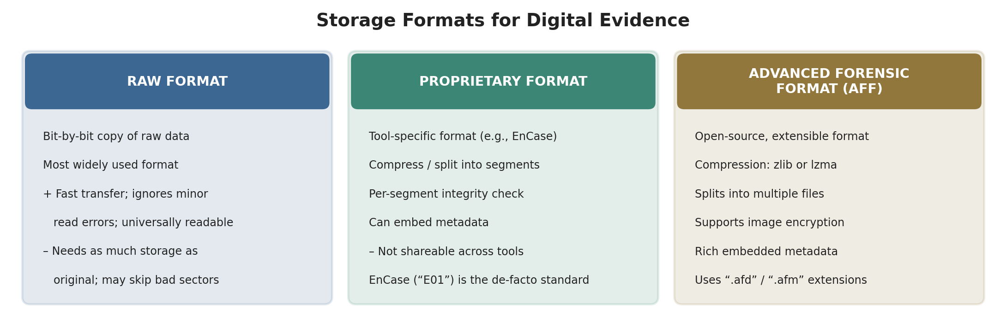
Figure 2.1 — Storage Formats for Digital Evidence

2.1 Raw Format
Raw format is the most-used file format. It is a bit-by-bit copy of the raw data of the drive under investigation, and can be used to image either the complete drive or a single volume (partition) within it.
Advantages | Disadvantages
Fast data transfers | Requires as much storage space as the original disk or data
Ignores minor data read errors on the source drive | Tools might not collect marginal (bad) sectors
Most computer forensics tools can read the raw format

2.2 Proprietary Formats
Most forensics tools have their own proprietary formats. Common features include:
- Option to compress or not compress image files
- Ability to split an image into smaller, segmented files
- Integrity checking of data for every segment
- Ability to integrate metadata into the image file
Disadvantages
- Inability to share an image between different tools
- File-size limitation for each segmented volume
- The Expert Witness format is only an unofficial standard
Expert Witness Format (EnCase)
- Created by Guidance Software for their well-known product “EnCase Forensic.”
- Widely used by law enforcement in criminal investigations around the globe.
- Compressible and searchable; the resultant image can be split into multiple files.
- Metadata can be associated with the image file, but the quantity/type of metadata is limited compared with AFF.
- Uses the file extension “.E01”.

2.3 Advanced Forensic Format (AFF)
- An open-source, extensible file format for forensic images.
- Source code can be freely integrated into other open-source and proprietary programs.
- Supports two compression algorithms: zlib and lzma.
- Can split the resulting forensic image file into multiple files.
- Supports encryption of drive images — can protect an acquired image with a password.
- Allows a wide array of metadata to be stored within the image file itself.
- Supported by tools such as Sleuth Kit, Autopsy, OSFMount, xmount, FTK Imager, and FTK.
- Uses the “.afd” extension for segmented image files and “.afm” for AFF metadata.

3. Determining the Best Acquisition Method
There are two broad acquisition method types — static and live — and the right choice depends on whether the target system can be powered off and on the type of evidence needed.
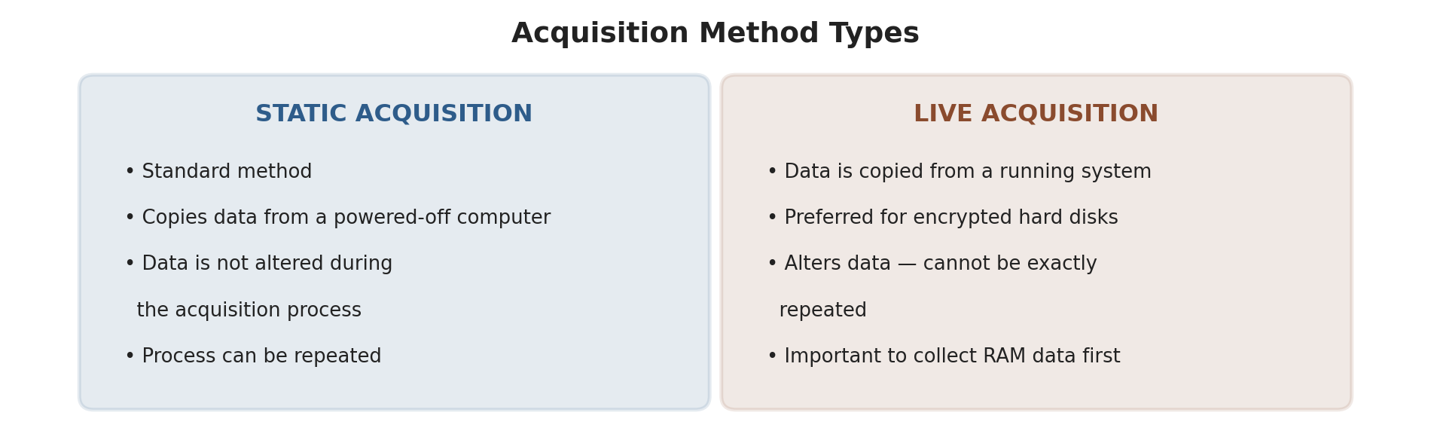
Figure 3.1 — Static Acquisition vs Live Acquisition

3.1 Acquiring Nonvolatile Memory (Static Acquisition)
- Includes all storage media that can retain data for a long time, even after power is turned off.
- Main types: hard drives and flash memory (e.g., thumb drives).
- Many tools can acquire hard-drive images in Windows OS — FTK Imager, ProDiscover, EnCase, and X-Ways Forensics all offer this capability.
- Before acquiring the hard-drive image, the suspect drive must be write-protected before attaching it to the forensic workstation.
- Write-protection can be achieved using hardware tools (write-blockers) or software programs.

3.2 Acquiring Volatile Memory (Live Acquisition)
Live acquisition copies data from a running system. It is the preferred method especially for encrypted hard disks, but note that it alters data on the system and so cannot be exactly repeated — collecting RAM data is a critical first step.
- Many digital artifacts reside only in RAM memory.
- Data is considered volatile because it is lost when a device is turned off or rebooted, and it may also be overwritten during normal use.
- Example: closing an application frees its reserved RAM space for other applications to use — the data disappears.
- Capturing live memory requires specialized software (and sometimes hardware) tools.
- Analyzing volatile-data forensic images also requires specialized software, since RAM does not store data the same way hard drives do.
- Networking devices such as routers and switches can also hold volatile data in their logs.
- The process of capturing data from volatile memory is known as “dumping.”
Types of Information Found in RAM Memory
RAM Artifact | RAM Artifact
Cryptographic keys | Text files and images
Processes running | Deleted files
Executed console commands | Web browsing logs
Clipboard contents | Open/active registry keys
Network information | Internet account passwords
Decrypted contents | Instant messages
Registry hives | Malware (rootkits and Trojan horses)
The Pagefile (Virtual Memory)
- The virtual memory file, commonly referred to as “pagefile.sys,” is created by Windows to compensate for the limited capacity of RAM memory.
- Usually found at the default location C:\pagefile.sys.
- Acquiring virtual memory is a very important part of forensic acquisition — it can contain valuable information transferred from RAM, such as user passwords, encryption keys, web-browser activity, and other important artefacts.

4. Methods for Capturing Evidence from Different Sources
Different evidence sources require different capture techniques. The following covers step-by-step capture methods for nine common evidence sources.
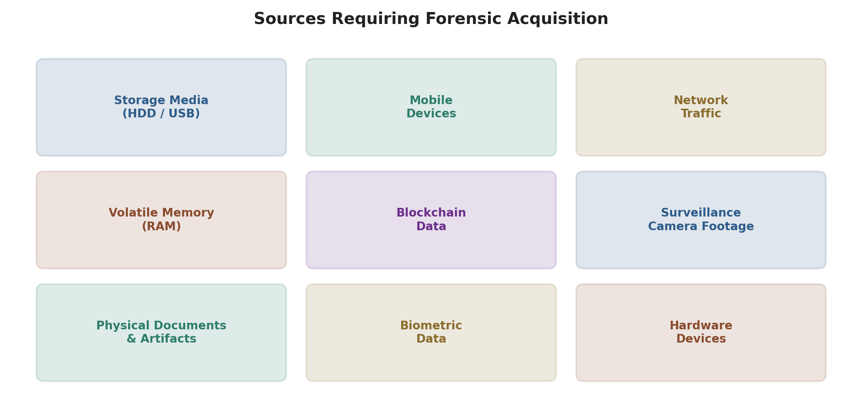
Figure 4.1 — Sources Requiring Forensic Acquisition

4.1 Capturing Storage Media: Hard Drives, USB Drives
- Physically connect the storage media to the forensic workstation.
- Use a write-blocking device (hardware write-blocker) to prevent any modifications to the evidence during acquisition.
- Use forensic software (e.g., FTK Imager, the dd command) to create a forensic image of the storage media.
- Verify the integrity of the image by calculating and comparing hash values (MD5, SHA-256) before and after acquisition.
- Securely store the acquired image on a dedicated, forensically clean storage device.

4.2 Capturing Mobile Devices
- Connect the mobile device to a forensic workstation using a USB cable.
- Use a specialized mobile forensic tool (e.g., Cellebrite, Oxygen Forensic Suite) to perform a physical extraction.
- The tool creates a forensic image of the device's storage, including internal memory and external storage (if applicable).
- Verify the integrity of the acquired data by comparing hash values.
- Store the acquired data securely, and document the process, including any unlock codes or passcodes used.

4.3 Capturing Network Traffic
- Deploy network sniffers or intrusion detection systems (IDS) at strategic points within the network infrastructure.
- Configure the sniffers or IDS to capture and log network traffic.
- Ensure the captured data is stored in a secure location with proper access controls.
- Regularly back up and archive captured network traffic data for forensic analysis.
- Document the capture settings and locations for future reference.

4.4 Capturing Volatile Memory (Memory Forensics)
- Use a dedicated memory acquisition tool (e.g., FTK Imager, Volatility) or hardware memory acquisition device.
- Follow the tool's instructions to create a memory dump of the target system's RAM.
- Store the memory dump in a secure location and maintain its integrity.
- Analyze the memory dump offline to retrieve information about running processes and system state.

4.5 Capturing Blockchain Data
- Maintain a dedicated hardware node running the blockchain software (e.g., Bitcoin Core).
- Continuously sync and update the blockchain data on the dedicated node.
- Regularly back up the entire blockchain data to secure storage.
- Securely store any private keys or access credentials for cryptocurrency wallets.

4.6 Capturing Surveillance Camera Footage
- Configure surveillance cameras to record footage to a DVR, NVR, or cloud-based storage.
- Ensure the recording system has proper access controls and authentication.
- Regularly back up recorded footage to secure storage, including redundant copies.
- Ensure proper labeling and documentation of recorded footage for case reference.

4.7 Capturing Physical Documents and Artifacts
- Photograph the physical evidence from multiple angles using high-resolution cameras.
- Use specialized tools like fingerprint powder or evidence bags to preserve physical evidence.
- Document the chain of custody, including who handled the evidence and when.

4.8 Capturing Biometric Data
- Collect biometric samples (e.g., fingerprints, DNA) following established forensic protocols.
- Properly label, package, and secure the biometric samples to maintain their integrity.
- Document the collection process and the individuals involved.

4.9 Capturing Evidence from Hardware Devices
- Disassemble the hardware device, if necessary, following manufacturer guidelines.
- Extract relevant components (e.g., memory chips, firmware) using appropriate tools.
- Store extracted components securely and maintain a chain-of-custody record.
Key takeaway: Across every source type, the same principles apply: follow proper forensic procedures, maintain a clear chain of custody, and ensure evidence is collected, stored and documented meticulously to preserve its integrity and admissibility. Compliance with legal and ethical standards is paramount throughout the evidence-capture process.

5. Digital Forensics Acquisition Tools
Digital forensics relies on a variety of specialized acquisition tools and software to gather and preserve digital evidence. These tools are designed to ensure the integrity and admissibility of evidence in legal proceedings.

5.1 Full-Featured Forensic Suites
Tool | Description
AccessData FTK (Forensic Toolkit) | Comprehensive forensic tool with imaging, analysis, and reporting; supports a wide range of file systems and evidence sources.
EnCase | Powerful forensic tool with imaging, analysis, and reporting; supports various file systems and evidence sources, including cloud data.
X-Ways Forensics | Known for speed and efficiency in disk imaging and analysis; supports advanced keyword searching and reporting.
Autopsy | Open-source digital forensic tool with both GUI and command-line interfaces; flexible, supports various file systems.

5.2 Mobile Forensic Tools
Tool | Description
Cellebrite UFED | Specializes in acquiring data from mobile devices, including smartphones and tablets; supports various mobile OS and device types.
Oxygen Forensic Detective | Advanced capabilities for extracting data from mobile devices, apps, and cloud services.

5.3 Imaging, Memory & Network Tools
Tool | Description
FTK Imager | Free tool from AccessData for creating forensic images and examining file systems; widely used for quick evidence preview and imaging.
AccessData Registry Viewer | Used for analyzing Windows registry files, which hold valuable configuration/usage information.
Volatility | Popular open-source memory forensics framework for analyzing volatile memory (RAM); useful for uncovering running processes and malware.
Wireshark | Widely used network packet analyzer that captures and analyzes network traffic; essential for network forensic analysis.

5.4 Command-Line & Recovery Tools
Tool | Description
dd (Linux/Unix command) | Command-line tool for creating disk images and copying data; used in basic disk-imaging tasks.
ddrescue | A data-recovery tool used to create disk images from damaged or failed storage media.
dc3dd | An enhanced version of dd with features like hashing and progress reporting, suitable for forensic imaging.

5.5 Platform-Specific and Bootable Tools
Tool | Description
FTK Imager Lite for Mac | A macOS version of FTK Imager, allowing forensic professionals to work with Mac-based systems.
PALADIN | A free, pre-configured Linux distribution designed for digital forensics and incident response; bundles various forensic tools and utilities.

6. Validating Data Acquisitions
Validation is the step that proves an acquired forensic image is an exact, unaltered copy of the original evidence — without it, a court cannot trust that the image being analysed truly represents the original device.

6.1 Hashing — the Core Validation Technique
- Hash the acquired data before and after acquisition to verify data integrity. Common hash algorithms include MD5 and SHA-256.
- If the hash value calculated after acquisition matches the hash value calculated from the original source, the image is confirmed to be an exact bit-for-bit copy.
- Any mismatch indicates the data was altered during transfer, and the acquisition must be treated as unreliable and repeated where possible.

6.2 Verification Checklist
- Verify the integrity of the acquired data by comparing hash values generated before and after acquisition.
- Document the verification process, including the exact hash values and any discrepancies found.
- Ensure the acquired data contains all relevant files, directories, and metadata expected from the source.
Key takeaway: Validation is what makes an acquired image legally defensible — investigators must be able to prove, through matching hash values and clear documentation, that the evidence presented in court is identical to the evidence originally seized.

7. Remote Network Acquisition
Not all evidence can be physically seized — evidence often needs to be acquired over a network from a live, remote or geographically distant system without physically removing it from service (for example, a production server that cannot be powered down).

7.1 Why Remote Acquisition Is Needed
- Servers and critical systems that cannot be taken offline for a traditional static acquisition.
- Evidence located on remote or cloud-hosted machines that are not physically accessible to the investigator.
- Large, distributed enterprise environments where many endpoints must be triaged quickly.

7.2 Remote & Network-Based Acquisition Techniques
- Network traffic capture: deploying network sniffers or intrusion detection systems (IDS) at strategic points to capture and log live traffic for later forensic analysis (see Section 4.3).
- Agent-based remote imaging: enterprise forensic suites (e.g., EnCase Enterprise, FTK Enterprise) can deploy a lightweight agent to a remote endpoint to acquire a disk or memory image over the network without physical access.
- Remote live response tools: utilities that connect to a remote machine over the network to collect volatile data (running processes, network connections, RAM) before the system state changes.
- Secure transfer & chain of custody: acquired images must be transferred over encrypted channels and hashed immediately, so integrity can still be verified even though the evidence never physically changed hands.
Key takeaway: Remote network acquisition trades physical control of the device for speed and reduced downtime — this makes secure transfer, strong authentication, and immediate hash verification even more critical than in traditional on-site acquisition.

8. The Acquisition Process for Digital Forensics
The overall acquisition process involves the systematic and controlled gathering of digital evidence from various sources while maintaining the integrity and chain of custody of that evidence.
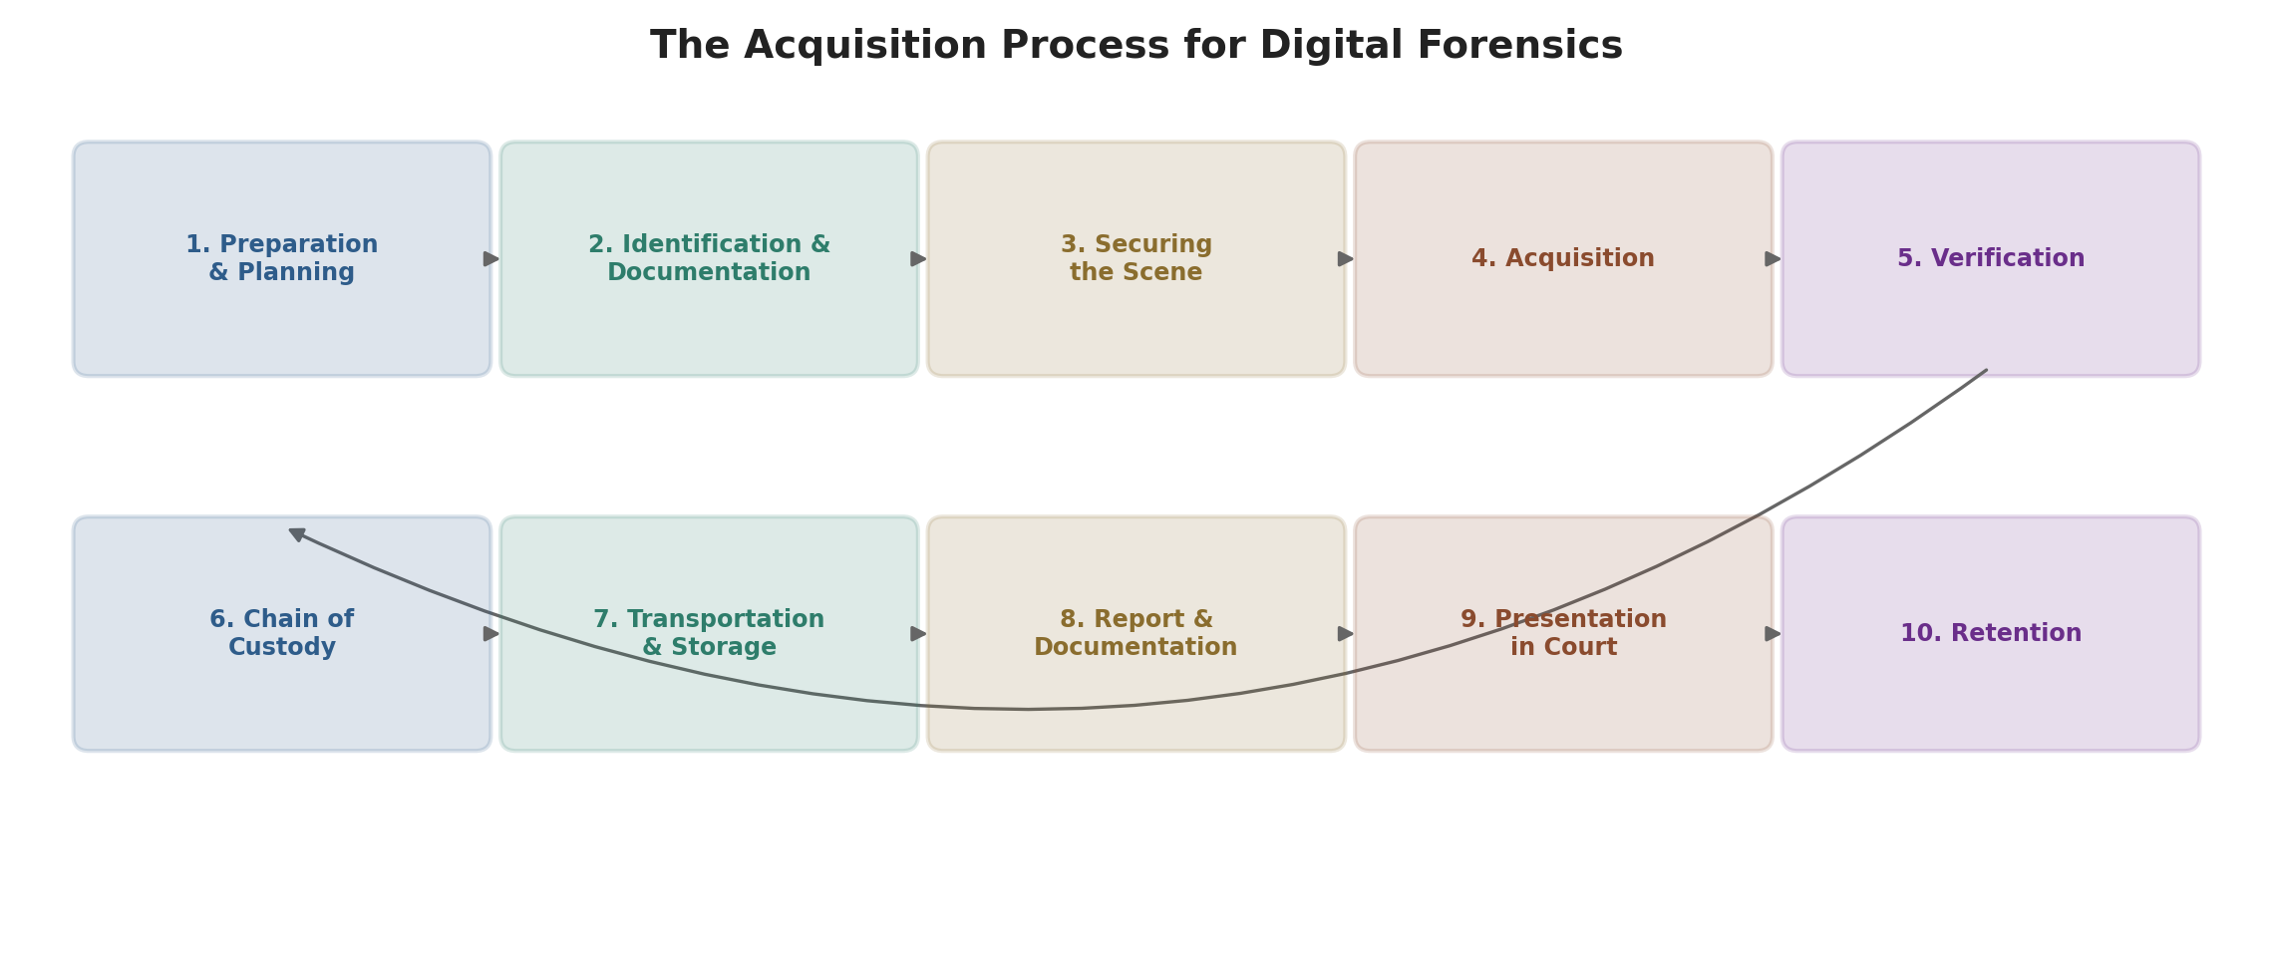
Figure 8.1 — The Acquisition Process for Digital Forensics

8.1 Preparation and Planning
- Define the scope and objectives of the forensic examination.
- Obtain the necessary legal authorization or warrants to seize and examine digital evidence.
- Identify sources of potential evidence — computers, mobile devices, network logs, cloud storage, physical documents.
- Assemble the required tools and equipment: forensic software, hardware write-blockers, and storage media.

8.2 Identification and Documentation
- Document the initial condition of the evidence source, noting any physical damage, labels, or identifying information.
- Create a detailed record of the evidence's location, time and date of acquisition, and the personnel involved.
- Take photographs or videos, where applicable, to visually document the evidence source.

8.3 Securing the Scene
- Ensure the evidence source is powered off or disconnected from networks to prevent remote tampering or data alteration.
- Use hardware write-blockers to prevent any write operations to the evidence source during acquisition.
- Physically secure the evidence source in a tamper-evident bag or container.

8.4 Acquisition
- Create a forensic image of the evidence source using appropriate forensic software tools (e.g., FTK, EnCase, dd).
- Hash the acquired data before and after acquisition to verify data integrity (MD5, SHA-256).
- Store the acquired image on a secure, forensically clean, write-protected storage device.

8.5 Verification
- Verify the integrity of the acquired data by comparing hash values with those generated before and after acquisition.
- Document the verification process, including hash values and any discrepancies found.
- Ensure the acquired data contains all relevant files, directories, and metadata.

8.6 Chain of Custody
- Maintain a detailed chain-of-custody log that tracks the handling and transfer of evidence from the acquisition phase onwards.
- Document any access to the evidence, including who accessed it, when, and for what purpose.
- Ensure all individuals who handle the evidence sign the chain-of-custody log.

8.7 Transportation and Storage
- Safely transport the acquired evidence to a secure storage location with controlled access.
- Store the evidence to preserve its integrity and protect it from physical damage, environmental factors, and unauthorized access.
- Maintain appropriate labeling and documentation to identify the evidence.

8.8 Report and Documentation
- Create a detailed report documenting the acquisition process, the evidence source, acquisition methods, and any issues encountered.
- Include information about the hardware and software used, as well as the chain-of-custody log.
- Prepare the evidence for analysis by ensuring it is organized and cataloged effectively.

8.9 Presentation in Court
- Ensure the digital evidence complies with legal and evidentiary requirements before it is used in legal proceedings.
- Provide expert testimony if necessary to explain the acquisition process and the authenticity of the evidence.

8.10 Retention
- Retain the acquired evidence securely for the duration required by legal and organizational policies.
- Ensure evidence is properly preserved, archived, and protected against loss or destruction.

9. Quick Revision Summary
Definitions to remember
- Forensic Image: a static, bit-level snapshot of all or part of the data on a storage device or RAM, used as a container for evidence.
- Static Acquisition: copying data from a powered-off system — the standard, repeatable method.
- Live Acquisition: copying data from a running system — necessary for RAM/encrypted disks, but alters the source and cannot be exactly repeated.
Three storage formats
Raw format (bit-by-bit, universal, large) → Proprietary formats (compressed, segmented, tool-specific, e.g., EnCase “.E01”) → Advanced Forensic Format / AFF (open-source, encrypted, rich metadata, “.afd”/“.afm”).
Nine evidence-capture source types
Storage media, mobile devices, network traffic, volatile memory (RAM), blockchain data, surveillance footage, physical documents/artifacts, biometric data, and hardware devices — each with its own step-by-step capture procedure.
Key acquisition tools
FTK / FTK Imager, EnCase, X-Ways Forensics, Autopsy, Cellebrite UFED, Oxygen Forensic Detective, Volatility, Wireshark, dd / ddrescue / dc3dd, PALADIN.
Validating acquisitions
Hash before and after acquisition (MD5/SHA-256); matching hashes prove the image is an unaltered, exact copy of the original.
Remote network acquisition
Used when a system cannot be taken offline — via network traffic capture, agent-based remote imaging, or remote live-response tools, always paired with encrypted transfer and immediate hashing.
The 10-stage acquisition process (memorize the order)
Preparation & Planning → Identification & Documentation → Securing the Scene → Acquisition → Verification → Chain of Custody → Transportation & Storage → Report & Documentation → Presentation in Court → Retention.

