Netflix Business Analysis Report

1. Project Overview
The goal of this project is to analyze the Netflix titles dataset to understand:
- Distribution of Movies vs TV Shows
- Content production trends over the years
- Top producing countries
- Popular genres
- Content ratings distribution
- Most frequent directors
- Average movie duration and TV show seasons
The project was completed using three tools:
Tool | Purpose
Python | Data cleaning & preparation
MySQL | Data analysis queries
Power BI | Interactive dashboard visualization

2. Data Preparation Using Python
You used Python (Pandas) to clean and prepare the dataset before loading it into MySQL.

2.1 Loading the Dataset
import pandas as pd
df = pd.read_csv("C:\\HEMNATH\\data\\netflix.csv")
df.head()
This loads the Netflix dataset into a Pandas dataframe.

2.2 Data Exploration
You examined the dataset structure.
df.info()
df.describe(include="all")
df.columns
Purpose:
- Understand column types
- Identify missing values
- Explore dataset structure

2.3 Checking Missing Values
df.isnull().any()
df.apply(lambda X : X.isnull().sum(), axis=0)
This helps identify which columns contain missing data.

2.4 Handling Missing Values
df = df.where(pd.notnull(df), None)
This replaces NaN values with NULL so they can be stored properly in MySQL.

2.5 Exploring Unique Values
You analyzed dataset diversity.

Unique Genres
unique_genre = df['listed_in'].str.split(', ').explode().dropna().unique()
print(unique_genre)
print("Count_unique_gener:", len(unique_genre))

Unique Countries
unique_country = df['country'].str.split(', ').explode().dropna().unique()
print(unique_country)
print("Total_unique_country:", len(unique_country))

Unique Ratings
unique_rating = df['rating'].dropna().unique()
print(unique_rating)
print("Total_unique_rating:", len(unique_rating))

Release Year Distribution
years = df['release_year'].dropna().unique()
print(years)
print("Total_year_count:", len(years))

2.6 Data Cleaning
You removed unnecessary columns.
df = df.drop(columns=['description'])

2.7 Date Formatting
You converted the date_added column to proper date format.
df['date_added'] = df['date_added'].str.strip()
df['date_added'] = pd.to_datetime(df['date_added'], errors='coerce').dt.date

2.8 Detecting Data Issues
You checked rows where rating values were incorrect.
df[df['rating'].str.contains("min", na=False)]
This identifies cases where duration was mistakenly stored in rating.

2.9 Loading Data into MySQL
You used SQLAlchemy to upload the cleaned dataset into MySQL.
from sqlalchemy import create_engine
username = "root"
password = "1234"
host = "localhost"
port = "3306"
database = "netflix_business_analysis"
engine = create_engine(
f"mysql+pymysql://{username}:{password}@{host}:{port}/{database}"
)
table_name = "netflix_data_analysis"
df.to_sql(
name=table_name,
con=engine,
if_exists="replace",
index=False
)
Now the dataset is stored in MySQL for SQL analysis.

3. Data Analysis Using SQL
After loading the dataset into MySQL, you performed analytical queries.

3.1 Movie vs TV Show Distribution
SELECT
IFNULL(type,"Total") AS type,
COUNT(*) AS type_count,
ROUND(
(COUNT(*) /
(SELECT COUNT(*) FROM netflix_data_analysis)) * 100
,2) AS percent
FROM netflix_data_analysis
GROUP BY type WITH ROLLUP;
Purpose:
- Understand content distribution
- Calculate percentage share

3.2 Country-wise Content Distribution
Because countries contain multiple values, you used JSON_TABLE to split them.
SELECT
TRIM(country_name) AS country,
SUM(type = "Movie") AS Movies,
SUM(type = "TV Show") AS TV_Show
FROM netflix_data_analysis ,
JSON_TABLE(
CONCAT('["', REPLACE(country, ',', '","'), '"]'),
'$[*]' COLUMNS(country_name VARCHAR(100) PATH '$')
) AS jt
WHERE country IS NOT NULL
AND TRIM(country_name) != ""
GROUP BY TRIM(country_name)
ORDER BY Movies DESC, TV_Show DESC;
This creates a country-level analysis.

3.3 Top Countries Producing Netflix Content
SELECT
TRIM(country_name) AS country,
SUM(type = "Movie") AS Movies,
SUM(type = "TV Show") AS TV_Show
FROM netflix_data_analysis ,
JSON_TABLE(
CONCAT('["', REPLACE(country, ',', '","'), '"]'),
'$[*]' COLUMNS(country_name VARCHAR(100) PATH '$')
) AS jt
WHERE country IS NOT NULL
AND TRIM(country_name) != ""
GROUP BY TRIM(country_name)
ORDER BY Movies DESC, TV_Show DESC
LIMIT 10;

3.4 Genre Analysis
You split the genre column using JSON_TABLE.
SELECT
TRIM(genre) AS listed_in,
COUNT(*) AS Type
FROM netflix_data_analysis,
JSON_TABLE(
CONCAT('["', REPLACE(listed_in, ',', '","'), '"]'),
'$[*]' COLUMNS(genre VARCHAR(100) PATH '$')
) AS t
WHERE listed_in IS NOT NULL
AND TRIM(genre) != ""
GROUP BY TRIM(genre)
ORDER BY Type DESC;

3.5 Content Trend by Year
SELECT
release_year,
SUM(type="Movie") AS Movies,
SUM(type="TV Show") AS TV_Show
FROM netflix_data_analysis
GROUP BY release_year;
This helps analyze content growth over time.

3.6 Top Directors
SELECT
director,
COUNT(*) AS Movie_directed
FROM netflix_data_analysis
WHERE director IS NOT NULL
GROUP BY director
ORDER BY Movie_directed DESC
LIMIT 10;

3.7 Longest Movies
SELECT
title,
CAST(SUBSTRING_INDEX(duration,' ',1) AS UNSIGNED) AS runtime_minutes
FROM netflix_data_analysis
ORDER BY runtime_minutes DESC
LIMIT 10;

3.8 Average Movie Duration
SELECT
ROUND(
AVG(CAST(SUBSTRING_INDEX(duration,' ',1) AS UNSIGNED))
,2) AS Avg_movie_duration
FROM netflix_data_analysis
WHERE type="Movie";

3.9 Average TV Show Seasons
SELECT
ROUND(
AVG(CAST(SUBSTRING_INDEX(duration,' ',1) AS UNSIGNED))
,2) AS avg_tvshow_seasons
FROM netflix_data_analysis
WHERE type="TV Show";

3.10 Rating Distribution
SELECT
rating,
COUNT(*) AS Distribution_count
FROM netflix_data_analysis
WHERE rating IS NOT NULL
GROUP BY rating
ORDER BY Distribution_count DESC;

4. Power BI Dashboard
After completing the SQL analysis, the dataset was visualized using Power BI.
The dashboard contains:

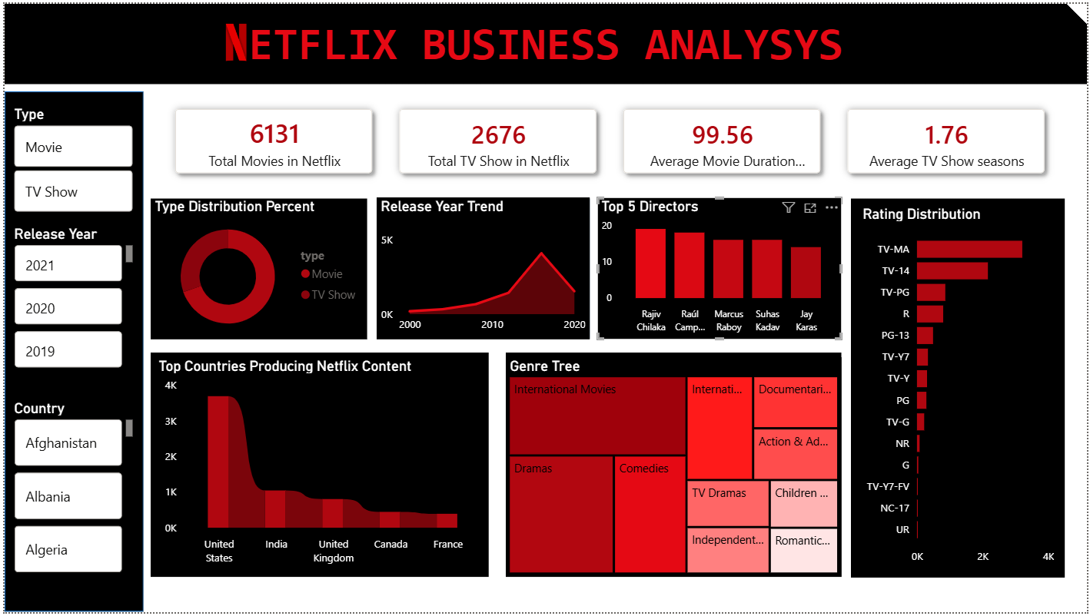

Key Metrics
- Total Movies
- Total TV Shows
- Average Movie Duration
- Average TV Show Seasons

Visualizations
Visualization | Purpose
Donut Chart | Movie vs TV Show distribution
Line Chart | Content release trend
Bar Chart | Top directors
Horizontal Bar | Rating distribution
Bar Chart | Top countries
Treemap | Genre distribution

Filters
- Type (Movie / TV Show)
- Release Year
- Country
These filters allow interactive exploration of Netflix content.

5. Key Insights
From the analysis:
1️ Movies make up ~70% of Netflix titles
2️ United States produces the highest number of titles
3️ Drama and International Movies dominate Netflix genres
4️ TV-MA rating is the most common content category
5️ Netflix content production increased rapidly after 2016

6. Conclusion
This project demonstrates a complete data analysis workflow:
Python → Data cleaning
SQL → Data analysis
Power BI → Visualization
The dashboard helps identify trends in Netflix content production, genre popularity, and country contributions.

