Supplementary Material for: Mitigating Carbon Traps in Carbon-Aware Workflow Scheduling under Real Carbon-Intensity Forecasts
Hemn Khezri, Mohammad Trik. This file contains the supplementary methods (Sections S1–S5), tables and figure cited in the main text. All values come from the public repository of the study; the scripts that produce each table are listed there.

S1. Adapters for the official schedulers
CaWoSched (KIT-EAE/CaWoSched, commit dfc8e49) and CWM (KIT-EAE/CWM, commit 50e9ef5) were built from source. CWM needed two non-algorithmic changes: read-only accessors that print the final schedule, and a missing standard-library include for GCC 13. CaWoSched's validity check rejects edges without data, so every cross-machine edge carries a one-minute transfer inside CaWoSched; this makes its plans slightly conservative in our transfer-free simulator. Intensity over the windows up to D is inverted and rescaled to a budget between the total idle power and the idle power plus frac × the dynamic power: for each 30-minute window k ≤ ⌈D/30⌉, budget(k) = Σₘ p₀(m) + frac · Σₘ (p(m) − p₀(m)) · (Î_{max} − Î(k)) / (Î_{max} − Î_{min}), where Î_{max} and Î_{min} are the largest and smallest planning intensities over those windows. On the homogeneous platform p₀ = 0 and Σₘ (p(m) − p₀(m)) = P · p; on the heterogeneous one the sums run over the four slow and four fast machines (idle 4 · 1 + 4 · 2 = 12 units, dynamic 4 · 9 + 4 · 13 = 88 units). If Î_{max} = Î_{min} the fraction is set to 1, giving the full budget in every window. Budgets are rounded to integers after scaling powers by 10, because the tools take integer budgets. On development data (five workflows, two targets, six submissions, two deadline factors; n = 120 per cell) the full range (frac = 1.0) gave CaWoSched an oracle emission saving of 4.85%, against 2.34–2.56% for frac 0.2–0.4. On the heterogeneous platform (development data, raw CWM) frac 1.0 gave −0.1% against −1.4% to −1.9%. Every schedule returned by either tool was checked for precedence, capacity and the deadline.

S2. Gate and schedulers on the heterogeneous platform
With machines m of busy power p(m), idle power p₀(m) and speed v(m), a task of work w runs ⌈w / v(m)⌉ minutes. All machines stay on until W = max(D, makespan), so emissions are Σᵢ (p(mᵢ) − p₀(mᵢ)) ∫ I dt over each task plus Σₘ p₀(m) ∫₀ᵂ I dt. The second term is the same for all plans that finish by D, so schedulers optimise the marginal (busy − idle) cost. HEFT ranks tasks by upward rank with mean durations and places each on the machine with the earliest finish time, with insertion. CA-List and CA-LS consider all machines and start times. A placement (m, s) of task i has marginal energy E(m) = (p(m) − p₀(m)) · d(m), with d(m) = ⌈w / v(m)⌉, and planned cost E(m) · F̄(s, d(m)), where F̄(s, d) is the mean forecast over [s, s + d). On CWM's platform E is 9w power-minutes on a slow machine and about 6.5w on a fast one. The reference placement (m_{a}, a) is, in CA-List, the machine and start with the earliest finish given the partial plan (HEFT's choice) and, in CA-LS, the task's incumbent placement. The gate accepts the candidate (m_{b}, b) with the largest value of g = E(m_{a}) F̄(a, d(m_{a})) − E(m_{b}) F̄(b, d(m_{b})) − max(E(m_{a}), E(m_{b})) · q[bin(|b − a|), bin(h(a, b))], provided g > 0, and otherwise keeps the reference; h(a, b) uses d(m_{b}). A change of machine at the same start is not exempt: it has lag 0 and must clear the threshold of the 0–3 h bin. With equal energies the rule reduces to Algorithm 1 scaled by E. Proposition 1 does not carry over to changes of machine type. Writing F̄_{a}, Ā_{a} for means over d(m_{a}) and F̄_{b}, Ā_{b} for means over d(m_{b}), the decision error is (E(m_{a}) F̄_{a} − E(m_{b}) F̄_{b}) − (E(m_{a}) Ā_{a} − E(m_{b}) Ā_{b}) = E(m_{b}) e(a, b) + (E(m_{a}) − E(m_{b})) (F̄_{a} − Ā_{a}). When m_{a} and m_{b} have the same type the second term vanishes and the per-decision bound holds as on the homogeneous platform. When they differ, the level error F̄_{a} − Ā_{a} no longer cancels, even at lag 0, and nothing in the calibration bounds it. For such decisions the risk term is a heuristic penalty, and the gate's effect on this platform (G3) is an empirical finding, not a consequence of Proposition 1.

S3. Scheduler–regime combinations
Combinations per job and deadline factor (Table 3 of the main text). HEFT is the reference of every run and is not counted; static and reactive executors and the runtime-noise draws are evaluated on the same plan and are not counted separately. SG: HEFT safeguard; issued reads model forecast for the extension and platform studies. Main study (13): Shift, CA-List+SG and CA-LS+SG under oracle, synthetic and issued (9); CA-List+SG+gate and CA-LS+SG+gate under issued (2); CaWoSched+SG under oracle and issued (2). Generality extension (15): the 13 of the main study, plus CWM+SG under oracle and model forecast (2). Platform sensitivity (12): Shift, CA-List+SG, CA-LS+SG, CWM and CWM+SG under oracle and model forecast (10); CA-List+SG+gate and CA-LS+SG+gate under model forecast (2); exploratory: CaWoSched+SG under oracle and model forecast (+2; 12,800 runs). Robustness study (36): Shift, CA-LS+SG, and CA-LS+SG with slack reserve ρ = 0.75 and 0.5, under oracle and issued (8); under issued, Shift+gate, seven gate variants of CA-LS+SG (difference gate with α ∈ {0.5, 0.8, 0.9, 0.95}, constant threshold, level interval, 6-h deferral cap) and the re-planning variants of Shift and CA-LS+SG with and without gate (12); CWM and CWM+SG with frac ∈ {0.2, 0.4, 1.0} and CaWoSched+SG with frac ∈ {0.2, 0.4}, under oracle and issued (16). Exploratory: re-planning CA-LS+SG under oracle; under issued, re-planning on the submission vintage, the quantile planner, and CA-LS+SG with and without the 0.75 reserve under correlated runtime noise (+5; 24,000 runs).

S4. Statistical details
Because submissions on nearby days share weather regimes, we also report, post hoc, intervals from a bootstrap over calendar days and over ISO weeks, and Holm-adjusted one-sided p-values. The main study has 147 submission times, 78 days and 14 weeks. In the extension every cluster is crossed with the grid (region × submission, region × day, region × week), giving 236, 208 and 92 clusters; the extension data lie within one calendar year, as do the GB data. With 14 clusters the week bootstrap is coarse, and percentile cluster bootstraps with so few clusters can under-cover [62]; we therefore use it only as a sensitivity check, never for a verdict. A one-sided p-value is the share of bootstrap replicates on the null side of the sealed threshold, for example the share with R* ≥ 0.75 for H1. Composite hypotheses are intersection–union tests and take the largest p-value of their parts: H2 and E2 over the four deadline factors, H4 and E3 over the trap difference (null: ≥ 0) and the retained saving (null: < 0.5), and H5, separately for each scheduler, over its H1 part and the four f of its H2 part. Holm's step-down procedure at a one-sided family level of 0.025 is applied within the main study to m = 6 tests (H1, H2, H3, H4, H5 for CA-List and H5 for CaWoSched), within the extension to m = 4 (E1–E4; E4 over the four f of its miss gap and the gate's effect on misses), and within the platform study to m = 5 (G1–G5), whose 80 submissions fall on 76 region × days and 56 region × weeks. The post-hoc script draws its own resamples, so its submission-time intervals can differ from the sealed ones in the second decimal (for H1, [0.61, 0.74] against [0.62, 0.74]). Means are pooled over workflows, makespan targets and seeds.

S5. Gate calibration on daily CarbonCast vintages
The gate and its calibration rule were kept unchanged, so no future intensity enters calibration: only windows realised before t₀ are used, whatever the length of the vintage. With daily vintages the window [t₀ − 7 d, t₀ − 49 h] holds four or five vintages instead of about 240, but each contributes up to 192 windows, so every bin that can hold errors had at least 168 of them (median 2,160) and the fallback for bins with fewer than 50 errors was never triggered; it filled only the six cells in which the lag exceeds the horizon. The horizon h(a, b) is measured from the capture of the vintage, as for GB. The vintage age plus the deadline reaches up to 60 h, so in 66% of submissions a late placement can fall above 48 h and is assigned to the open-ended last bin, whose calibration errors span horizons of 24–96 h. Because every grid receives its vintage at 00:00 UTC, the age of the forecast at a given local hour differs between grids (DE is UTC+1/+2, CISO UTC−7/−8); the submission times are uniform over the day, so the age is uniformly distributed on every grid, but its alignment with the daily intensity cycle is not, which is one more reason to read per-grid differences with care. The extension uses new seeds 30–32 with 20 submissions per seed and grid.
Table S1. Workflow structure (seed 10, T = 12 h) and the forecast loss of CA-LS+SG on the GB confirmatory data (all seeds and targets pooled; R for f ≥ 1.5, trap rate over all f). M: HEFT makespan.
Workflow | Tasks | Depth | Max width | Critical path / M | Oracle saving, f ≥ 1.5 (%) | R | Trap rate, issued (%)
montage-s | 197 | 8 | 91 | 0.25 | 16.0 | 0.68 | 14.7
montage-l | 391 | 8 | 244 | 0.13 | 15.6 | 0.67 | 15.2
epigenomics | 295 | 9 | 71 | 0.73 | 14.0 | 0.68 | 12.6
blast | 298 | 3 | 295 | 0.05 | 11.2 | 0.67 | 10.8
bwa | 298 | 3 | 294 | 0.74 | 13.3 | 0.67 | 12.1
cycles | 297 | 4 | 144 | 0.20 | 14.9 | 0.68 | 12.2
1000genome | 298 | 3 | 163 | 0.25 | 14.6 | 0.69 | 12.4
seismology | 298 | 2 | 297 | 0.08 | 16.2 | 0.72 | 13.9
soykb | 296 | 11 | 210 | 0.43 | 11.8 | 0.62 | 11.2
srasearch | 298 | 4 | 142 | 0.53 | 16.3 | 0.71 | 13.8
Table S2. Development year by season (GB, Mar 2023 – Feb 2024; pilot configuration: CA-LS without the safeguard, f ∈ {1.5, 2.0}). Exploratory.
Season (dev. year) | Oracle saving (%) | Issued saving (%) | R | Trap rate, issued (%) | Submissions
Winter (Dec-Feb) | 8.94 | 5.31 | 0.59 | 18.39 | 30
Spring (Mar-May) | 7.54 | 5.09 | 0.67 | 15.10 | 33
Summer (Jun-Aug) | 6.23 | 3.14 | 0.50 | 22.99 | 29
Autumn (Sep-Nov) | 8.89 | 6.15 | 0.69 | 17.26 | 28
Table S3. Per-grid results of the generality extension (secondary analyses; forecasts are CarbonCast model forecasts).
Grid | κ (Eq. 4) | Oracle saving, f ≥ 1.5 (%) | R [95% CI] | Trap rate (%) ungated / gated | CaWoSched native saving (%) oracle / forecast | CWM native saving (%) oracle / forecast
CISO | 0.46 | 11.4 | 0.85 [0.81, 0.89] | 5.9 / 1.2 | 39 / 29 | 22 / 18
DE | 0.56 | 8.3 | 0.76 [0.67, 0.84] | 9.6 / 2.1 | 40 / 28 | 20 / 17
PJM | 1.03 | 2.2 | 0.52 [0.41, 0.62] | 7.1 / 0.3 | 42 / 12 | 22 / 7
ERCO | 1.47 | 5.7 | 0.19 [−0.05, 0.36] | 28.3 / 14.9 | 44 / -13 | 22 / -7
Table S4. Alternative gates for CA-LS with safeguard (robustness study, GB issued forecasts, seeds 10–11, all f pooled; 9,600 runs per gate). Δ: paired difference against the difference gate with α = 0.9. Misses: deadline misses with runtime noise, static executor. 95% cluster-bootstrap intervals over calendar days.
Gate | Saving (%) | Traps (%) | Δ saving vs gate (pp) | Δ traps vs gate (pp) | Misses (%)
None | 8.31 | 9.7 | — | — | 44.0
Difference, α = 0.5 | 8.29 [6.60, 10.27] | 9.7 [6.6, 13.1] | +1.37 [0.35, 2.54] | +6.0 [3.6, 8.4] | 44.1
Difference, α = 0.8 | 7.79 [6.26, 9.52] | 5.5 [3.3, 7.9] | +0.87 [0.37, 1.40] | +1.7 [0.4, 3.3] | 29.9
Difference, α = 0.9 (ours) | 6.92 [5.53, 8.52] | 3.7 [2.0, 5.7] | 0 | 0 | 23.4
Difference, α = 0.95 | 6.06 [4.60, 7.73] | 2.0 [0.7, 3.8] | −0.86 [−1.14, −0.61] | −1.7 [−2.8, −0.8] | 18.7
Constant, α = 0.9 | 6.14 [4.68, 7.83] | 4.1 [2.2, 6.1] | −0.79 [−1.20, −0.42] | +0.3 [−1.0, 1.7] | 21.6
Level interval, α = 0.9 | 4.82 [3.44, 6.46] | 0.6 [0.0, 1.7] | −2.11 [−2.58, −1.69] | −3.1 [−4.7, −1.7] | 12.8
Deferral cap 6 h | 6.70 [5.16, 8.38] | 7.6 [4.7, 11.1] | −0.23 [−1.33, 1.04] | +3.9 [1.8, 6.3] | 28.6
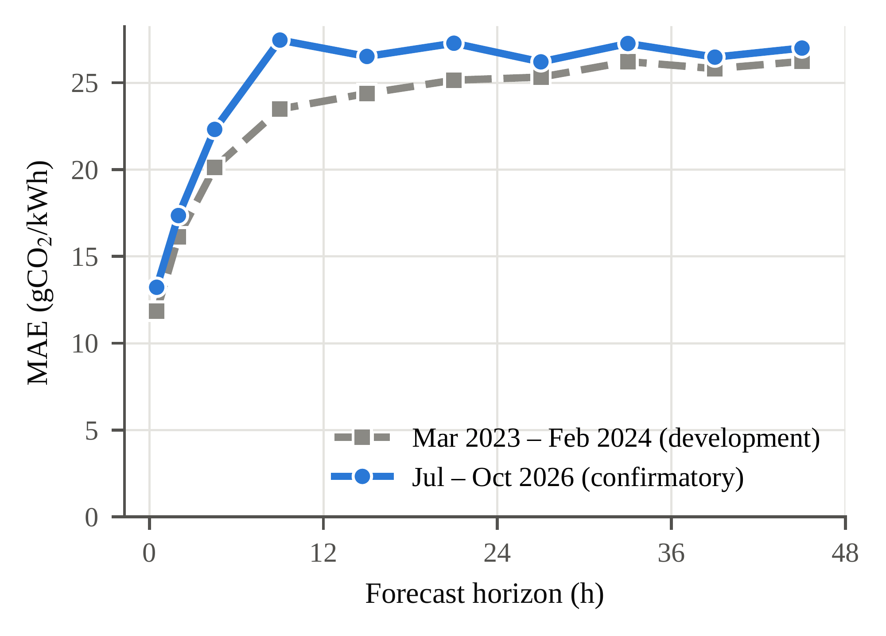
Fig. S1. Mean absolute error of the issued GB national forecasts by horizon, for the development period (Mar 2023 – Feb 2024) and the confirmatory period (Jul – Oct 2026).
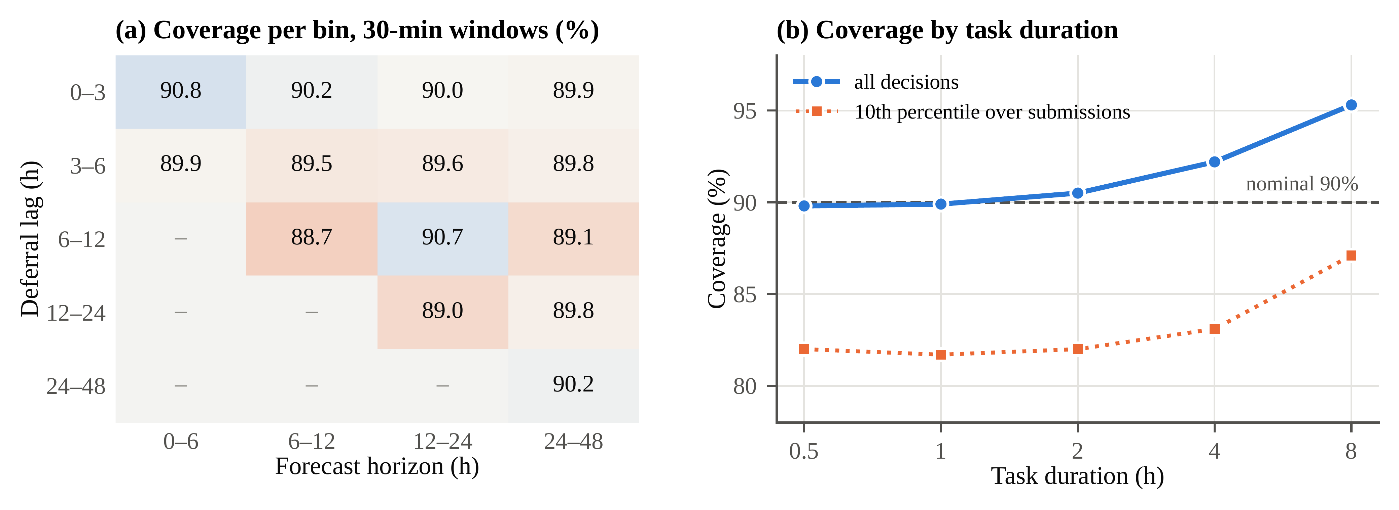
Fig. S2. Empirical coverage of the α = 0.9 gate thresholds on the GB confirmatory data (147 submissions; vintages actually used). (a) Coverage of single 30-minute window pairs per lag × horizon bin; empty cells are impossible because the horizon is at least the lag. (b) Coverage when the decision error is a difference of means over a task's duration, as the schedulers use the thresholds: over all decisions and the 10th percentile over submissions (exploratory).
Table S5. Deadline-miss rate (%) under different runtime-noise models (GB issued forecasts, seed 10, 8 machines, static executor, all f). Log-normal noise with the given spread, and an empirical model that resamples run-to-run log-ratios of task runtimes from repeated executions of the same workflows in WfInstances (Blast, BWA, Montage, SRASearch; tasks of at least 5 s). Exploratory.
Scheduler (issued, all f) | σ = 0.05 | σ = 0.1 | σ = 0.2 | σ = 0.4 | Empirical
HEFT | 0.0 | 0.0 | 0.3 | 3.0 | 25.7
CA-LS | 28.0 | 35.0 | 43.7 | 52.7 | 70.0
CA-LS + gate | 13.3 | 17.6 | 23.3 | 30.6 | 50.5
CA-LS + reserve 25% | 0.0 | 0.1 | 2.8 | 13.8 | 42.0
Shift | 30.3 | 33.9 | 34.9 | 39.5 | 58.2
Table S6. Sensitivity to cluster size (GB, seed 10; runtimes rescaled so that the HEFT makespan matches T on each cluster). Traps and misses over all f, issued forecasts; misses with log-normal noise σ = 0.2. Exploratory.
Machines | Oracle saving, f ≥ 1.5 (%) | R (CA-LS) | Traps CA-LS / + gate (%) | Misses CA-LS / + reserve / HEFT (%) | R (Shift)
8 | 14.05 | 0.80 | 5.5 / 1.5 | 43.7 / 2.8 / 0.3 | 0.80
32 | 15.20 | 0.79 | 7.4 / 2.2 | 52.1 / 16.2 / 3.5 | 0.76
64 | 15.81 | 0.79 | 9.7 / 2.5 | 58.1 / 27.8 / 8.8 | 0.76
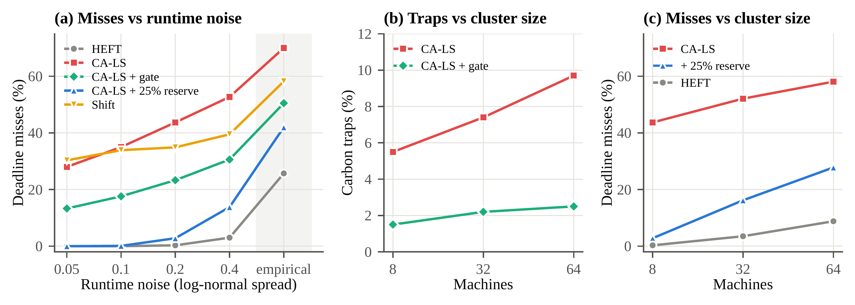
Fig. S3. Sensitivity to runtime noise and cluster size (GB issued forecasts, seed 10, all f; values of Tables S5 and S6). (a) Deadline misses under log-normal runtime noise of increasing spread and under the empirical run-to-run noise of WfInstances (shaded), 8 machines, static executor. (b) Carbon traps and (c) deadline misses (σ = 0.2) on clusters of 8, 32 and 64 machines (exploratory).

