Template Week 7 – Host your website on GitHub
Student number: 546746

Domain name (URL) of your website on GitHub:

https://hemooalantary-blip.github.io/

Relevant screenshots + motivation:
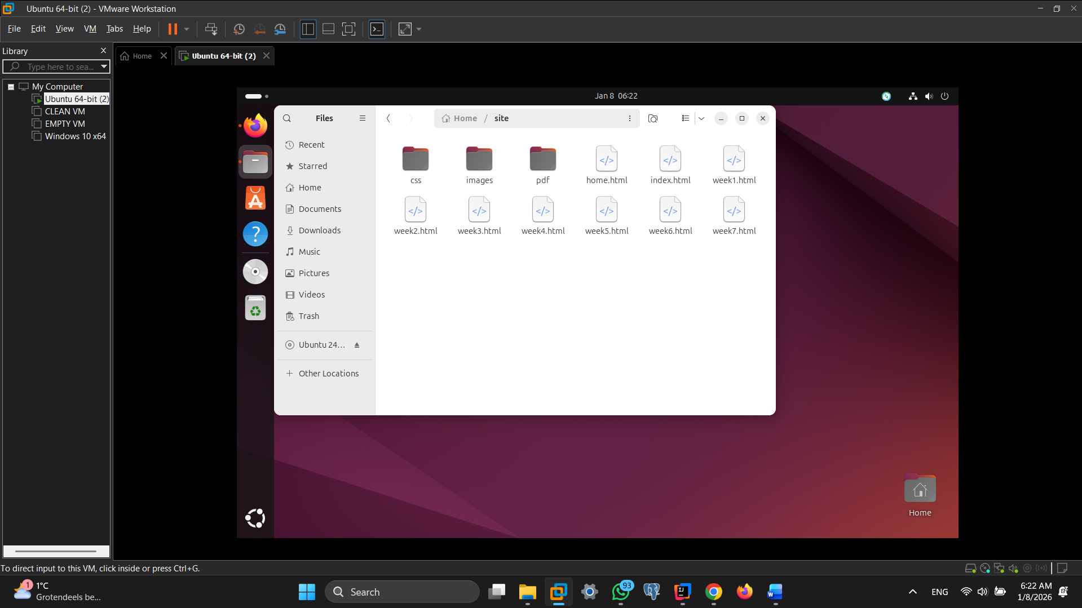
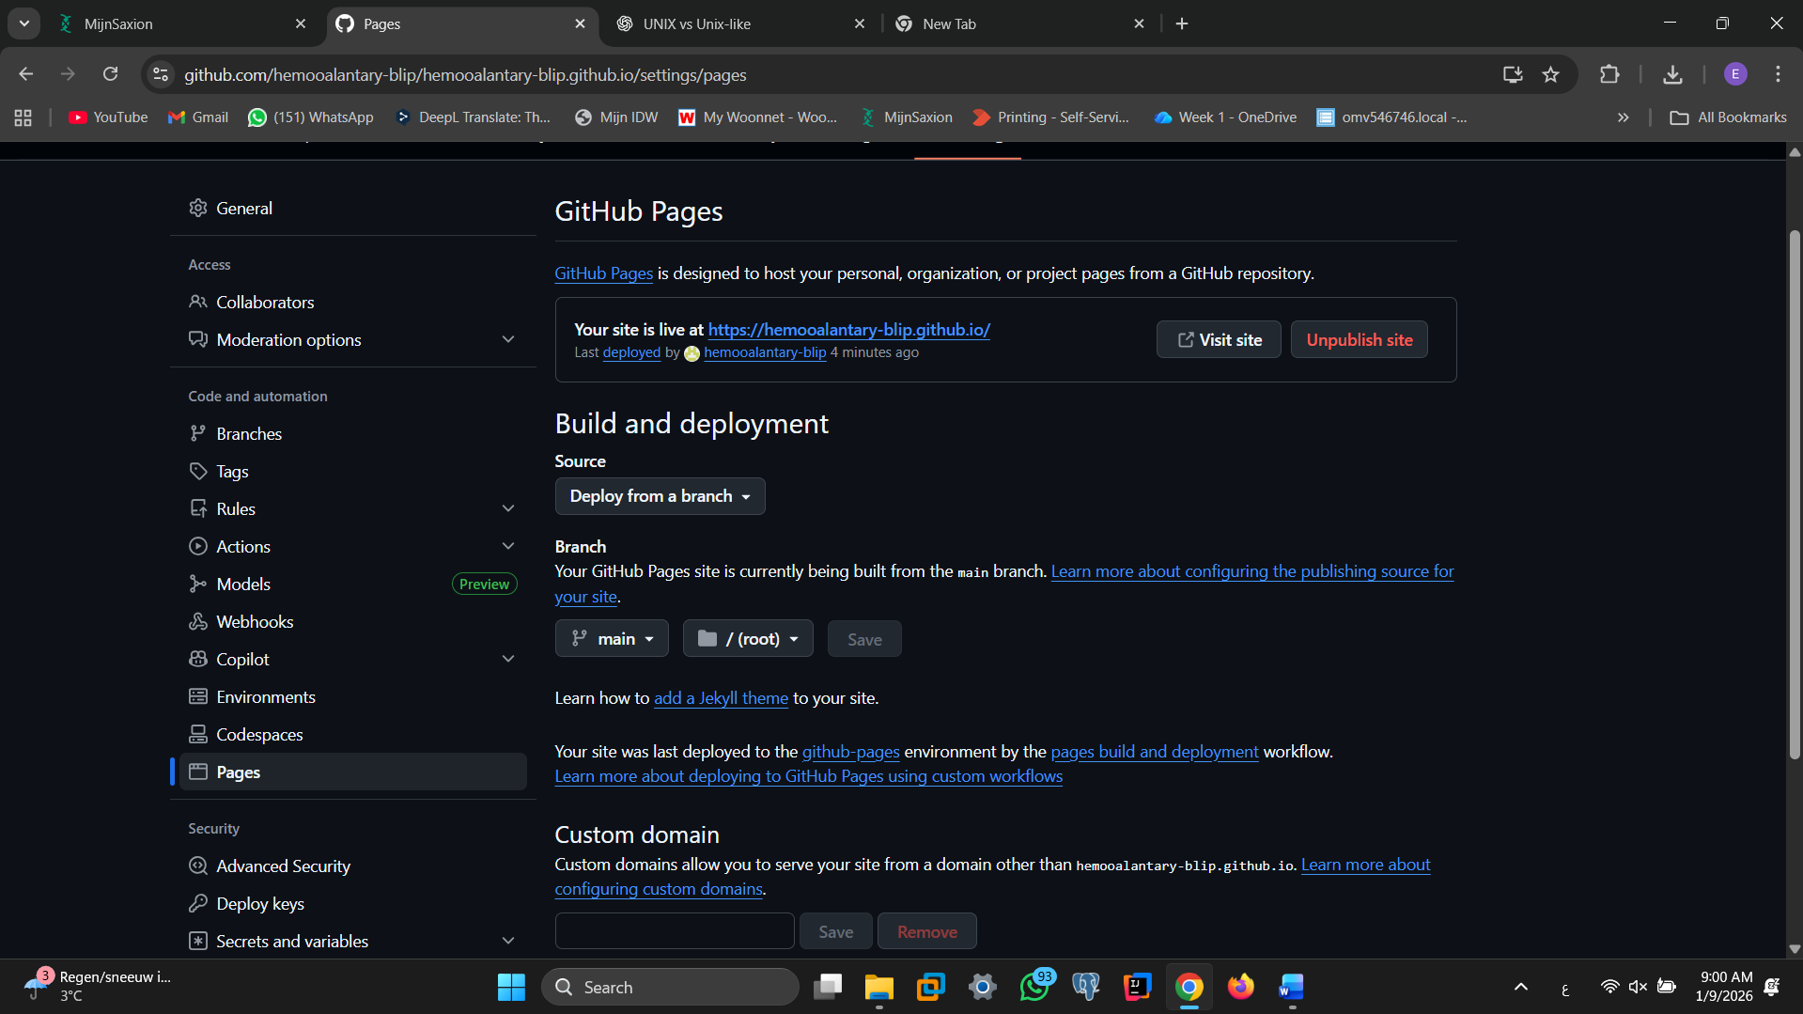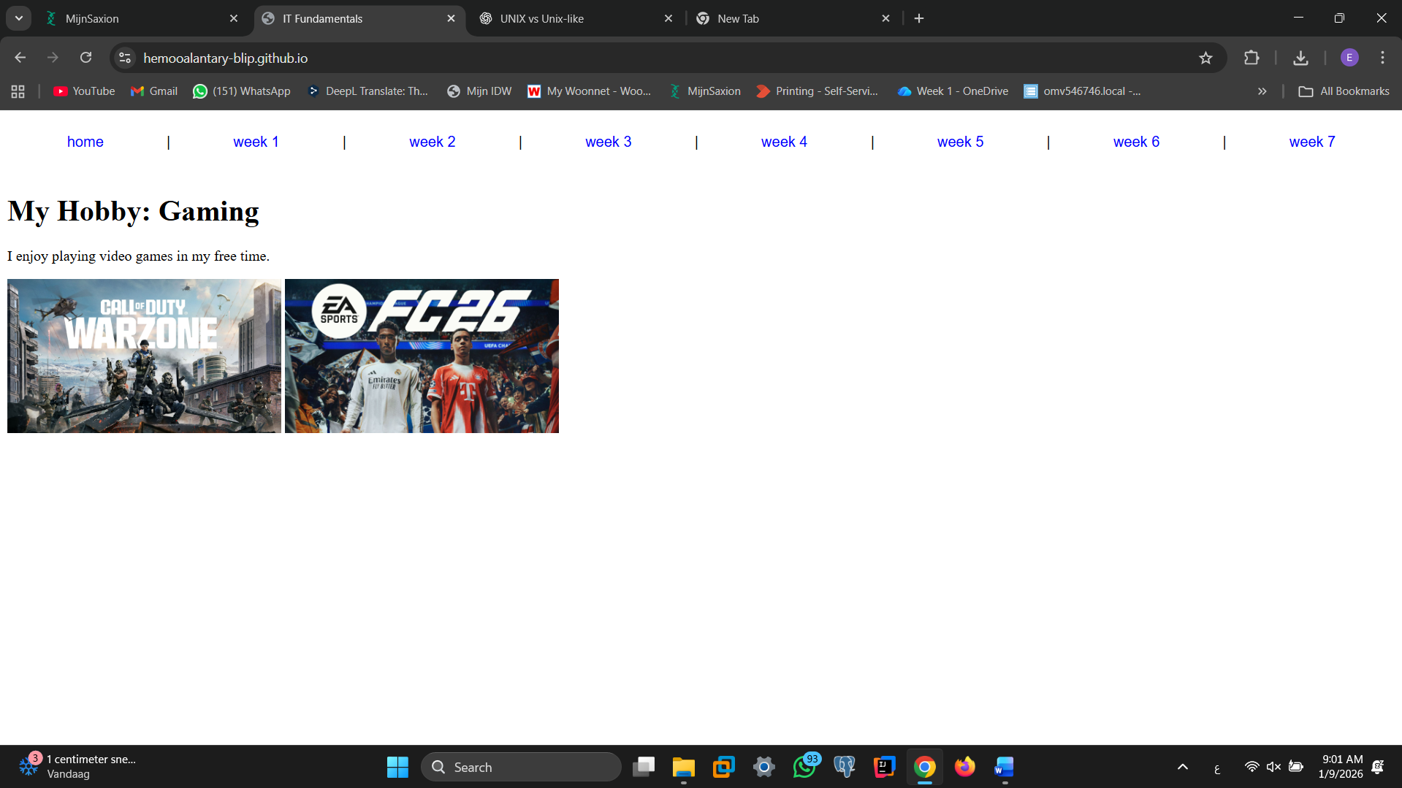

Ready? Save this file and export it as a pdf file with the name: week7.pdf

