Room Acoustic Simulation with CUDA

Introduction

We implemented a 2D room acoustic simulation system. The system is able to simulate the sound for a listener at a designated position in the given room map with the multiple sound sources. The 2D room map and the positions of the sound sources need to be designated in the process of pre-computed simulation. With the acceleration of CUDA, the simulation process can be shorten a lot. The system allows changing the position of the listener and the sound sources input in real time with the acceleration of CUDA. The propagation is simulated in frequency domain by exploiting the Acoustic Wave Equation numerically.

Environment & Device

Computer : Laptop ASUS N82JQ
Operating System : Ubuntu 10.04LTS 32-bit
Cpu : Intel Core i7-720QM
Gpu : NVIDIA GEFORCE GT 335M

Content

project : The whole project source file and executables
project/gpu_src : Simulation with CUDA source file
project/cpu_src : Simulation in CPU source file
project/RoomModel : example simulation room models
project/DemoGui_src : real-time demo tool's gui source file
project/Demo_src : real-time demo tool's background source file
project/Demo : pre-build executables and simulation results(ubuntu 32bit)
project/bin : compile destination folders
docs/ : readme and introduction files

How To Compile

Request library :
CUDA SDK : in our test machine it is CUDA SDK 3.2 and CUFFT is needed
OPENCV : 2.2+ library is needed
QT : QT4 is needed for demo tools gui
pulse-audio : this library is usually pre-installed in current linux

Makefile configuration:
There are few library path(s) should be changed before compilation:
CUDA_SDK_PATH in project/gpu_src/Makefile
OPECV related PATH in every source folder's Makefile

Compile procedure:
>cd project
>clean_all.sh
>build_all.sh
after that, those binary files should located in bin/ folder and the Simulation_gpu and Simulation_cpu link files should auto link to the binarys.

How to Execute the Project

This section assumed that all the binary file have been build-up.

Simulation in GPU:
> cd project
> ./Simulation_gpu [room model file] [src_x] [src_y] [output file]

where model file's example is placed in project/RoomModel, and src_x and src_y is the location of sound source. Output file is the raw impulse response output file, also the only output in this program

After execute the simulation, you should see the whole sound wave propagation in a window.
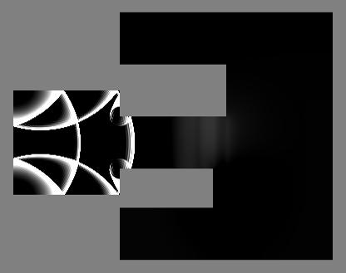
Simulation in CPU:
> cd project
> ./Simulation_gpu [room model file] [src_x] [src_y] [output file]

After execute the simulation, you should see the same window as gpu simulation.

Demo tool:
> cd project/Demo
> ./Qt_Gui [room model file] | ./Mixer_thread [impulse response file]
room model file is the room model text file, and impulse response file is the output of simulation file.
We provide a precompute example impulse response file, which is room_model2_IR.raw. One can simply use it by:
> ./Qt_Gui room_model2.txt | ./Mixer_thread room_model2_IR.raw

After execute the Demo tool, you should see the window just like image in below:
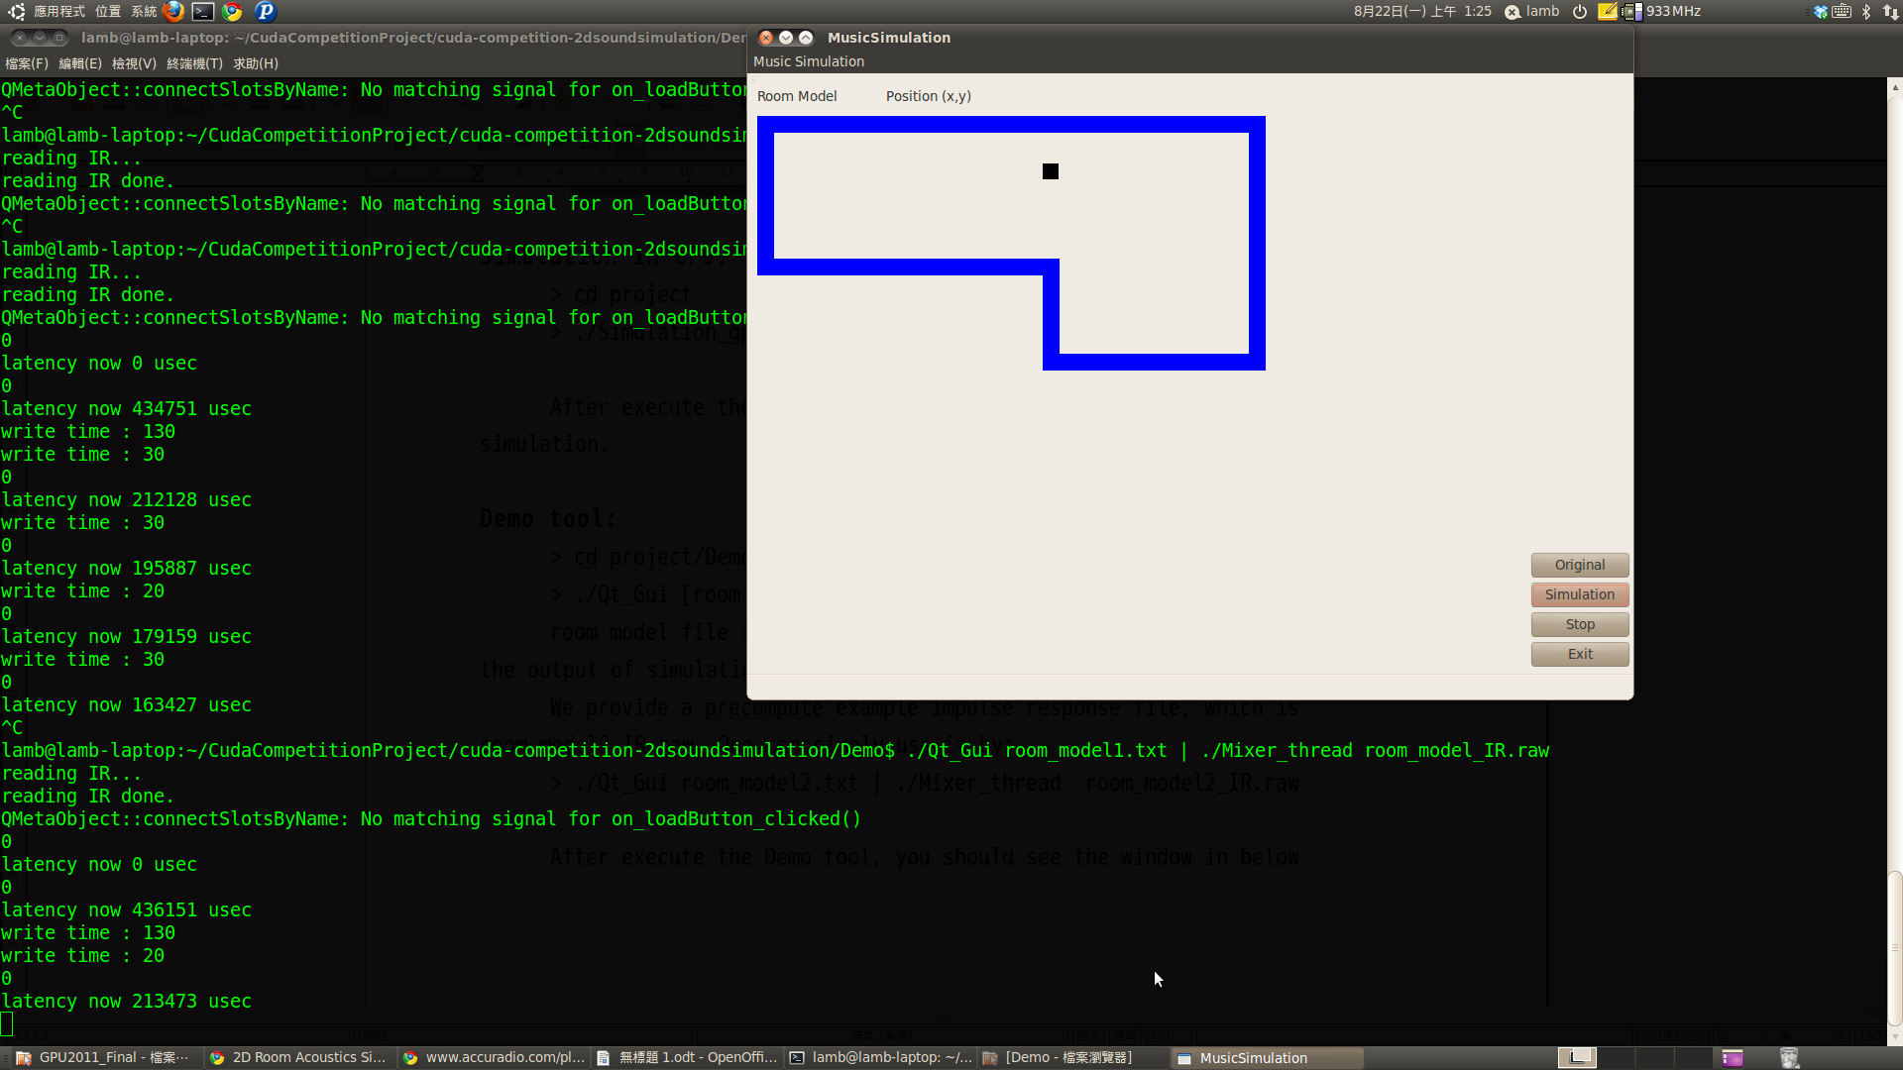
One can change the receiver position by mouse click in the room (need a sort of drag), and this tool will capture the input sound of microphone and play it as you stand in the receiver position hear from the sound source position in this room model. There will be about 2 sec latency due to short time Fourier transform.

Algorithms introduction

Introduction
To make virtual world sound more real, the ability to simulate room acoustic fast and accurately is important. As a result, computational acoustics has been an active research area for many years. To summarize the previous work, techniques for simulating acoustics can be classified into two parts: Geometric Acoustics and Numerical Acoustics. Geometric Acoustics is based on the assumption of rectilinear propagation of sound waves, like light. All the geometric acoustics approach suffer from the common drawback that it results in unphysical sharp shadows and fails to simulate diffraction. On the other hand, Numerical Acoustics is based on Acoustic Wave Equation. Numerical Acoustics approaches are often computationally exhaustive but very suitable for parallel computation.
In this project we use Numerical Acoustics approaches to implement 2D room acoustic simulation. The simulation firstly decomposes room into several rectangles using Adaptive Rectangular Decomposition (ARD)[1] method. Each rectangle is transform by Discrete Cosine Transform (DCT) to compute the sound propagation. The paper[1] showed that in this way, our simulation is faster and more accurate than FDTD method.

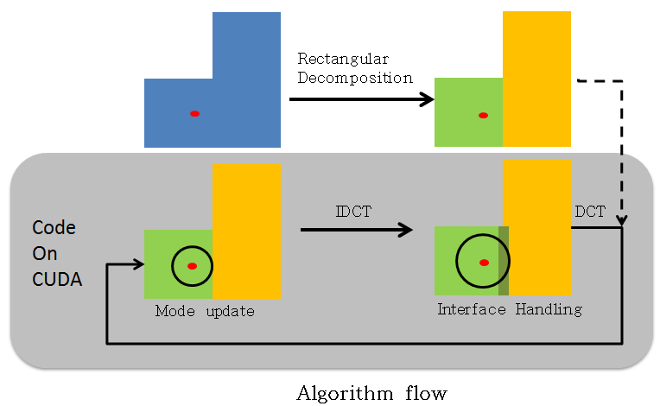
Our system overflow is shown above.

Rectangular decomposition
Traditional methods like FDTD accumulate numerical dispersion errors while calculating propagation on each cell. The dispersion errors can be eliminated by transforming the propagation from time domain onto frequency domain. Discrete Cosine Transform (DCT) is suitable for the transformation. However, DCT can only be performed on rectangles. As a result, a process called rectangular decomposition aims to decompose the room space into rectangles. After transformed onto frequency domain, the propagation introduces only the errors produced between two rectangles. The larger interface produces larger errors. To minimize the errors produced from the interface, the rectangular decomposition aims to minimize the interface length. A heuristic method is implemented that it randomly picks a cell called seed and then find the largest rectangle which contains only the unselected cell including the seed. Then the cells in the rectangle are labeled as selected. The above process is iterated until every cell is selected.

Propagation simulation
A loop is designed to simulate the propagation shown below.
(a) Transform the pressure field and forcing term field onto frequency domain by DCT
(b) Update the mode coefficients using the update rule
(c) Transform the pressure field and forcing term field onto spatial domain by iDCT
(d) Compute the forcing terms. For cells on the interface, use interface handling, and for the cells within point sources, use the sample value.
The loop is iterated for every time step. The four steps in the loop are illustrated in the following subsections.

DCT
After the rectangular decomposition, DCT is performed on the pressure and forcing term fields. The eigenfunctions of the DCT is given by
