**Deep Learning based Email Spam Filter**

**Introduction:**

We have created the email spam filter model using deep learning and evaluate the model with other currently popular machine learning methods like xgboost, random forest, svm etc.

For this sample project, we will use Enron dataset in English. However this approach works well for other languages also which we had empirically tested in my job.

This approach is combining unsupervised learning with supervised learning. We will generate the features in unsupervised way using TF-IDF algorithm and then use this to features to train Models on labelled enron data.

**Steps:**

1. **Pre-processing:**

Here we will generate a pandas dataframe from the enron dataset. We will tokenize and also do some data analysis

1. **Features Generation (Unsupervised Learning)**

We will use TF-IDF as features to be used for training the models.

1. **Model Training**

We will train a 3-layered deep learning model.

We will also train Random forest, SVM and Xgboost for comparison purpose.

We will the same tf-idf features for all the models

1. **Result Analysis and iterate to improve the performance**

We will present our results in nice and informative way to provide good comparison information.

1. **Prepare training and test data**

We will split data into test data and data for model training and validation. We do this step to keep test data out of both tf-idf and classifier models.

We will keep 10000 emails for testing and rest for the model building process.

**Build models :**

**Deep learning model**

We will build our 3 layer deep learning model using Keras and TensorFlow.

**Network**

Input -> L1 : (Linear -> Relu) -> L2: (Linear -> Relu)-> (Linear -> Sigmoid)

Layer L1 has 512 neurons with Relu activation

Layer L2 has 256 neurons with Relu activation

Regularization: We use dropout with probability 0.5 for L1, L2 to prevent overfitting Loss Function: binary cross entropy

Optimizer: We use Adam optimizer for gradient descent estimation (faster optimization) Data Shuffling: Data shuffling is set to true

Batch Size: 64

Learning Rate = 0.001

**Other Machine Learning Models**

We will build 3 more models and compare the performance in the same way. For this purpose we will use the same tf-idf as input feature. We will train following models:

* **SVM**
* **Random Forest**
* **XGboost**

**Results:**

As we see, deep learning model does very well on the test data. The results from other models are close. I have tried this approach over multiple language emails and deep learning model is very consistent with the performance. XGboost also does very well. Please note that i have not optimized random forest and SVM much beyond the defaults. So they may have better performance with tuning.

**Confusion matrix:**

|  |  |
| --- | --- |
|  |  |
|  |  |

**Error function:**

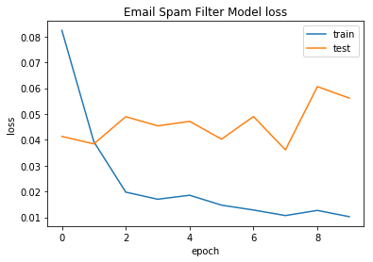

**Performance of various models:**

