

**Basic Linux Commands Assignments**

Assignment-1

Connect and disconnect with login Access

* What happens when you login a non-existent users or username?
  + Provide Screenshot and What you understand, explain in short brief?

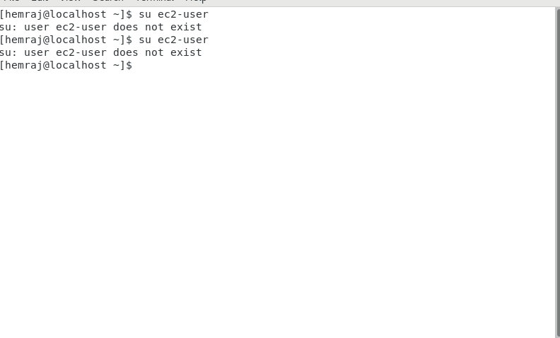

Exp: if we try to login with non-existing user, we will get error **user <username> does not exist** error.

Assignment-2

Password changing

* Login into your account and then change password?
  + Change your password into **IneuR0n#42** and hit the **Enter** key
    - Explain what happen and give screenshot?
  + Try again to change password but use like password ***1234*** or ***abcd***
    - Explain what happen and give screenshot?
  + Try again to change password but now don’t use any password just hit **Enter** key
    - Explain what happen and give screenshot?

1.

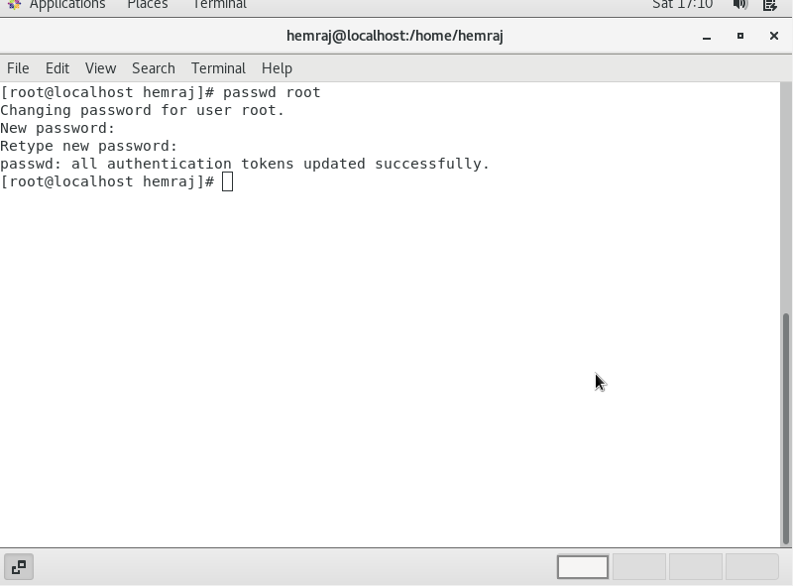

Exp: passwd <username> will be use to change a password for specific username.

2.

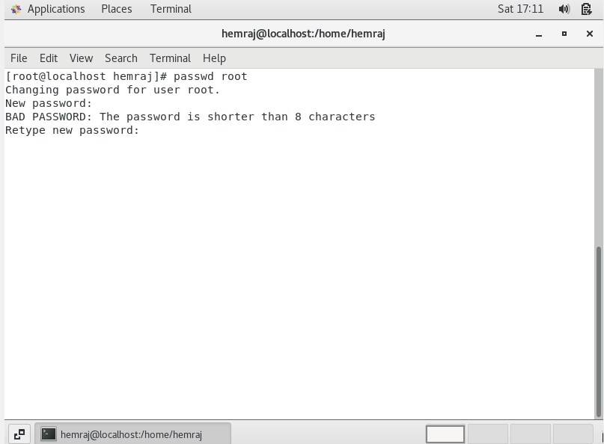

Exp: if try to set short length password, we will get error **password too short**.

3.

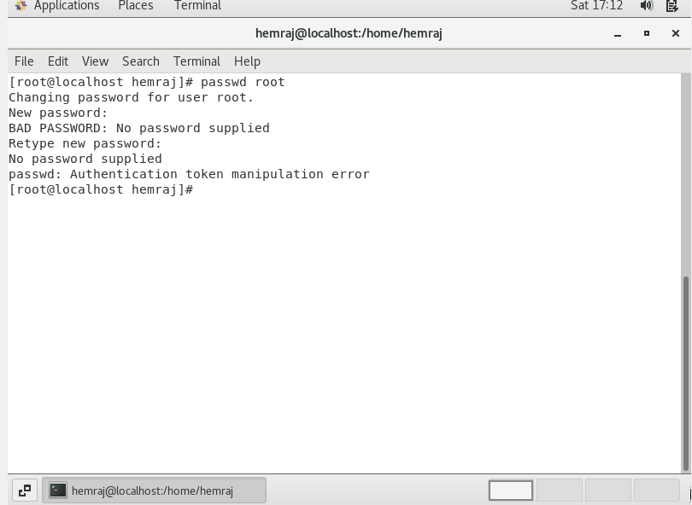

Exp: We will get error, **No password supplied.**

Assignment-3

Working with Directories

* Enter the command **cd /** and then **ls** and then hit **Enter** key
  + Take screenshot and explain what output we got?

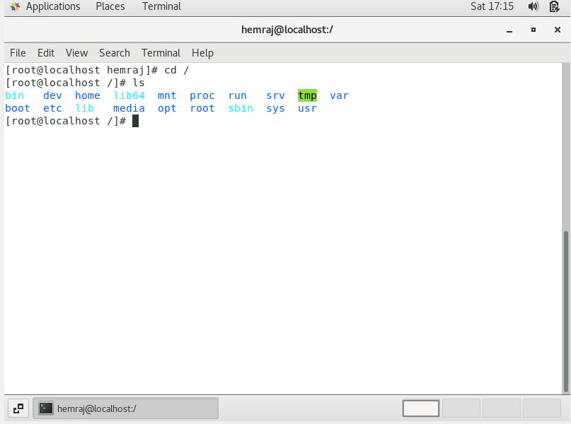

Exp: We can able to see all directory at / path.

* Enter the command now **cd /home** and then hit **Enter** key
  + Do **ls,** provide screenshot and explain what is **/home** directory used for?

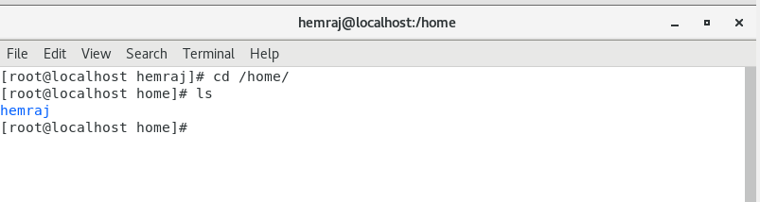

Exp: The Linux home directory is **a directory for a particular user of the system** and consists of individual files. It is also referred to as the login directory. This is the first place that occurs after logging into a Linux system. It is automatically created as "/home" for each user in the directory'.

* Enter **cd ..** and hit **Enter** key [ *Note: here we have space after cd then use double dot*]
  + Check what happen and give screenshot?

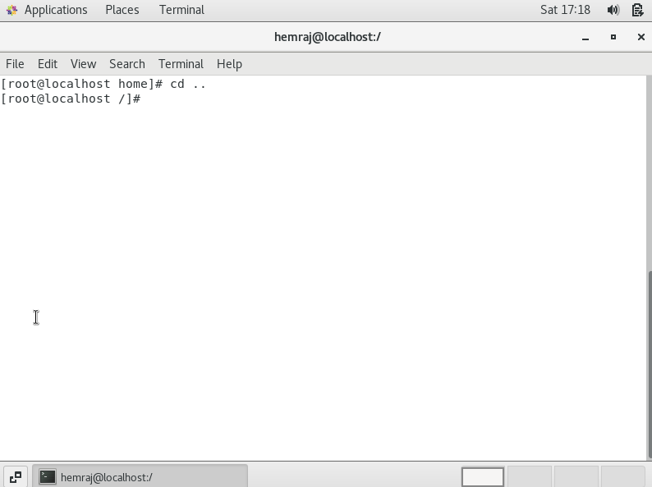

Exp: with cd .., we will be moved one dir back.

* Now enter **cd /var/www/html** and then type **cd** and hit **Enter** key
  + Explain what happen and give screenshot?

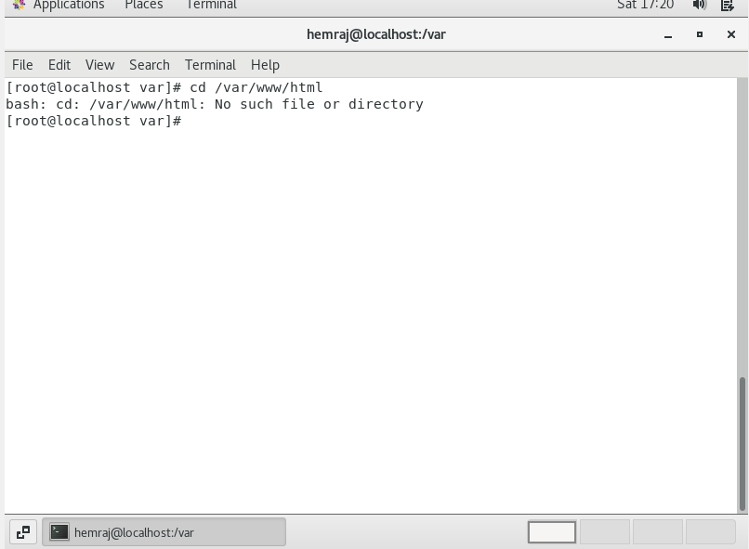

Exp: Not able to find path, because apache is not installed with my Linux.

* Now type **cd /root** and then hit **Enter** key
  + Do **ls,** check any output we have on screen if yes then take screenshot?

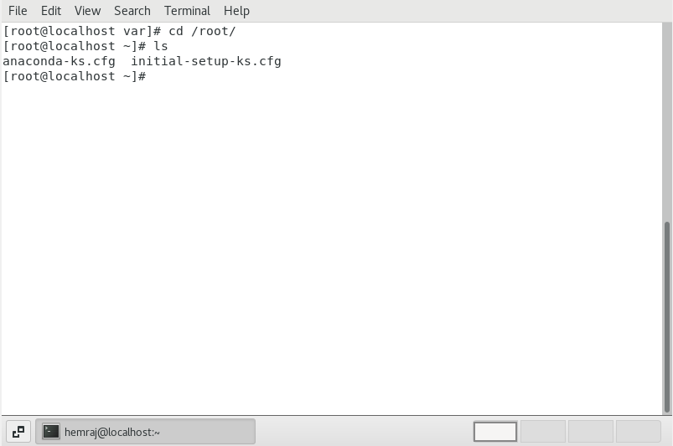

Exp: with cd /root, will be able to move at root dir, with ls we can able to see all files and Dir at root.

Assignment-4

Working with File Listing

* Go to **cd /etc** and type **ls**
  + Take screenshot and explain what files you have seeing?
  + Take screenshot and explain what different output you found compare to previous command you used?

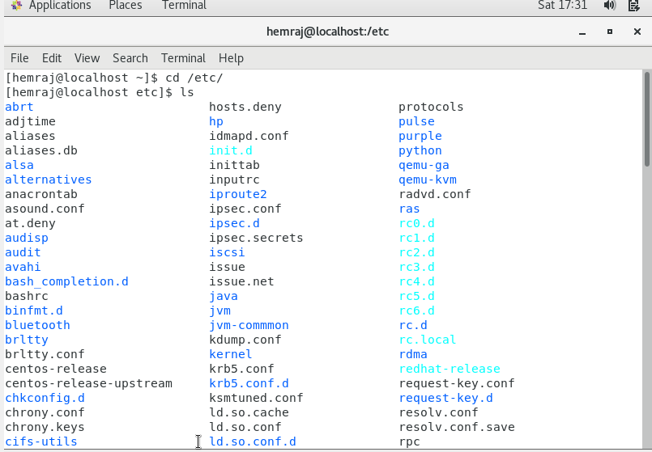

Exp: The /etc (et-see) directory is **where a Linux system's configuration files live**.

* Then type **ls -al** and hit **Enter** key
  + Take screenshot and explain what new file or directory you found?

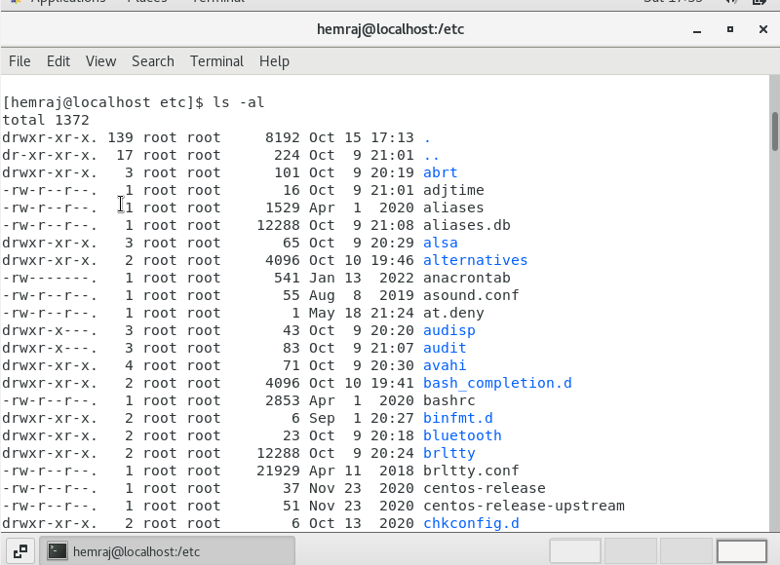

Exp: with ls –al we will get all files with long format.

* Then use **ls -i** and hit **Enter** key
  + Now see what different output its shows and take screenshot?

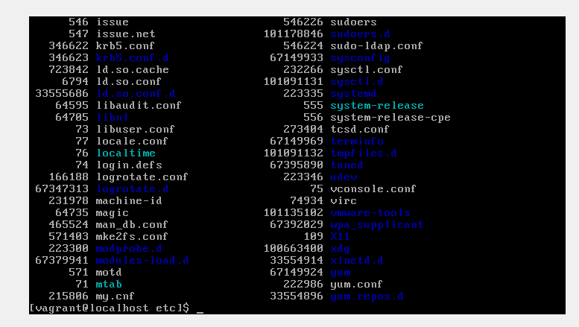

Exp: We will get all file with there indexes.

* Then use **ls –help** and see other options about **ls** command
  + Explore it and try with other attribute we can use with **ls** command

Exp: We will get all possible combination with ls cmd.

Assignment-5

Know where you are and where you working

*Here we use* ***pwd, cd and ls*** *as combine task to understand where you working on terminal and how you can switch from one directory to another one.*

* Open terminal after restart the linux
  + Check which location you working, type **pwd** and take screenshot



Exp: pwd stand for present working dir.

* Now use **cd /var** and hit **Enter** key
  + Do **ls,** and see what output comes, give screenshot?

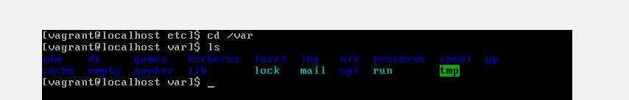

Exp: /var contains things that are prone to change, such as websites, temporary files (/var/tmp) and databases. The name is an abbreviation of "variable".

* Do explore other help options of each command to learn more other things we can do with these commands