

**Linux Basic Commands Assignment**

***Assignment Part-3*** Playing with files

1. Create a file like **nano file1.txt**

* Edit some data and then save the file

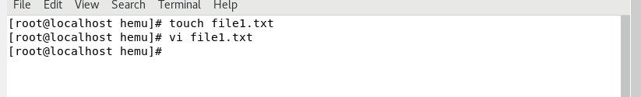

1. Now we will copy data from file1 to new file2

* Then see the output of file2.txt , cat file2.txt
* Give Screenshot

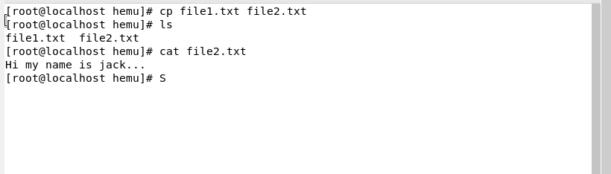

1. Now we will move the file1.txt to new folder /home

* **mv file1.txt /home**
* Then go to /home directory and check ls, file exits or not?
* cp file1.txt file2.txt

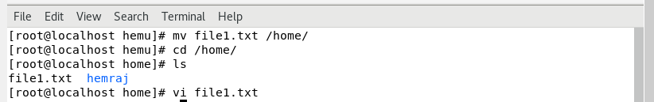

1. Then we create a new **file3.txt and file4.txt** in **home directory** and add content in it.
   * Now do **echo “Hello I am newline” > file3.txt** and provide the output of file3.txt
   * Now do **echo “Hello I am newline” >> file4.txt** and provide the output of file4.txt
   * Tell the different between both step you follow and the reason behind it

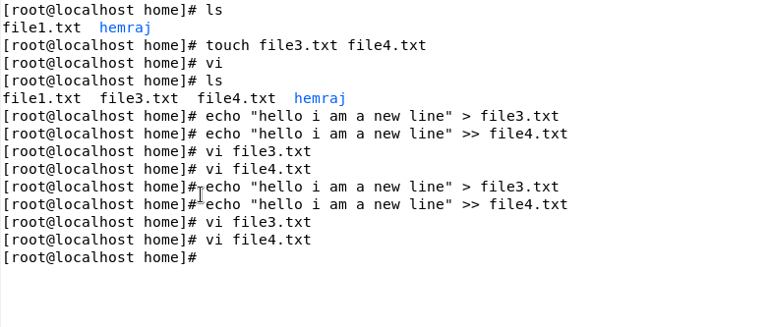

* > will write a content in file and also overwrite if it’s already exists.

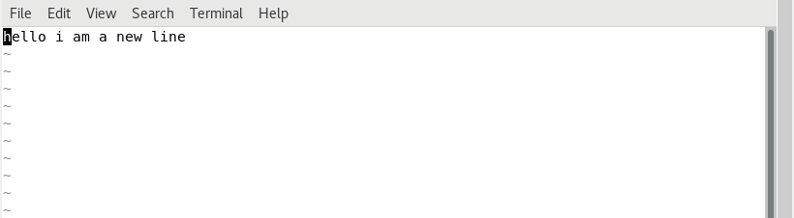

* >> will append content in file.

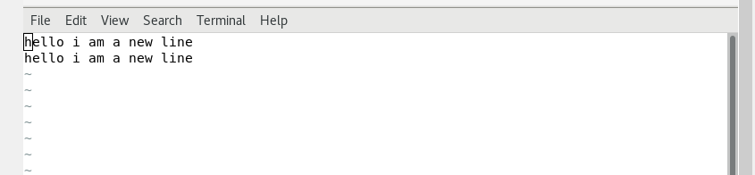

1. For remove a file or directory you can use the below two commands **o** To delete a file – **rm <any_filename>**



* To delete a directory - **rmdir <any_directoryname>**

