Report on Wi-Fi Telemetry ETL Pipeline in Apache Airflow Extension
Course: DT203G - Applied Computer Engineering
Compared with the previous DT212G project, this version increases topology size, workload, Airflow evidence, and graph-based analysis.
https://github.com/hemraj2000/wifi-telemetry-etl-pipeline.git
https://github.com/hemraj2000/wifi-telemetry-etl-pipeline/tree/dt023g-extended-version#
Submitted By: Hem Raj & Mohit Kumar
Total Requests | Success Rate | Mean Latency | Roaming
8000 | 100.0% | 12.32 ms | 1 event
Final refined run: 8000 successful requests out of 8000.

Contents
1. Executive Summary 3
2. Project Objectives 3
3. Previous DT212G Baseline 3
4. DT023G Final Design 4
5. Comparison: DT212G vs DT023G 4
6. Refinement Inside DT023G 4
7. Airflow Workflow and Evidence 5
8. Graph-Based Analysis 6
9. Challenges and Fixes 7
10. Conclusion 7
Appendix: Final Output Files 8

1. Executive Summary
The previous DT212G Wi-Fi Telemetry ETL Pipeline is the foundation for this DT023G project. The previous project demonstrated that Mininet Wi-Fi, Python, Pandas, and Apache Airflow could be utilized to generate a KPI report from Wi-Fi telemetry. The DT023G version allows for a larger experiment and more comprehensive analysis.
Four access points, four stations, and 2000 HTTP requests per station are used in the final DT023G run. It had a total of 8000 requests, a success rate of 100 percent, a mean latency of 12.32 ms, a p95 latency of 18.87 ms, and one roaming event that was detected. AP association, RSSI, and latency graph outputs are also included.

2. Project Objectives
- Extend the previous DT212G project into a larger wireless scenario.
- Increase the number of access points, stations, and HTTP requests.
- Generate a richer telemetry dataset and clearer KPI report.
- Use Airflow to organize the workflow and provide execution evidence.
- Compare the refined DT023G project with the previous DT212G baseline.

3. Previous DT212G Baseline
The previous DT212G project made use of one HTTP server, two stations, and two access points. It used an Airflow DAG with run_experiment, transform, and report tasks to generate 1000 requests per station. The final results were a success rate of 99.95%, a mean latency of 7.60 ms, and a p95 latency of 8.48 ms. Stas 1 and 2 were found to roam.
DT212G Baseline Item | Value
Access points | 2
Stations | 2
Requests per station | 1000
Success rate | 99.55%
Mean latency | 7.60 ms
P95 latency | 8.48 ms
Roaming | Detected for sta1 and sta2

4. DT023G Final Design
The DT023G version expands the network to include four stations and four access points. Additionally, the workload increases to 2000 requests per station. RSSI values, roaming events, HTTP request telemetry, Wi-Fi association data, and graphs are all gathered in this experiment. As a result, the new project is easier to use and analyze during the demonstration.

5. Comparison: DT212G vs DT023G
Metric | DT212G Previous | DT023G Final | Interpretation
Access points | 2 | 4 | Larger network coverage
Stations | 2 | 4 | More clients
Requests per station | 1000 | 2000 | Heavier workload
Total requests | about 2000 | 8000 | Much larger dataset
Success rate | 99.55% | 100.0% | Reliability improved
Mean latency | 7.60 ms | 12.32 ms | Higher because the new setup is larger
P95 latency | 8.48 ms | 18.87 ms | Higher due to a larger workload and roaming
Roaming | sta1 and sta2 | 1 event in the final run | Roaming logic included

Scalability and workflow quality are the most significant enhancements. Raw latency is lower with the smaller DT212G setup, but the DT023G project is stronger because it can handle more devices, a larger workload, and better visual evidence.
6. Refinement Inside DT023G
Tuning was used to improve the DT023G project. A previous DT023G run had 1430 failed requests, a mean latency of 17.39 ms, a success rate of 82.12%, and a p95 latency of 27.28 ms. The final refined run had a 100% success rate, a mean latency of 12.32 milliseconds, a p95 latency of 18.87 milliseconds, and no failed requests.
Metric | Earlier DT023G | Final DT023G | Improvement
Success rate | 82.12% | 100.0% | Higher reliability
Failed requests | 1430 | 0 | No failures in final run
Mean latency | 17.39 ms | 12.32 ms | Lower latency
P95 latency | 27.28 ms | 18.87 ms | Better tail latency

7. Airflow Workflow and Evidence
The processing workflow is kept organized and repeatable by airflow. A final report, transformed analytics, and graph images are all produced by the pipeline. The workflow's execution and task success are demonstrated by the Airflow screenshot.
Figure 1. Airflow DAG evidence
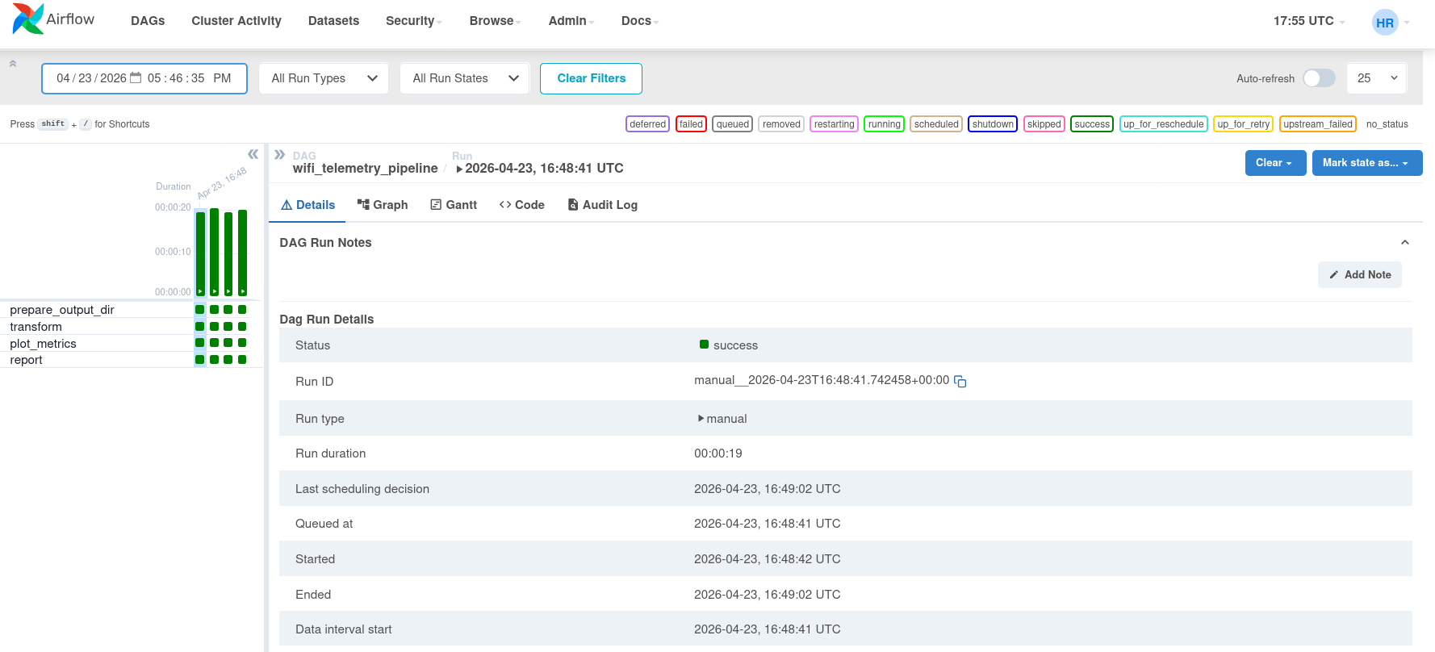

8. Graph-Based Analysis
There are three main graphs in the project. The RSSI graph shows link quality, the AP association graph shows roaming behavior, and the latency graph shows request performance over time.
Figure 2. Latency overtime
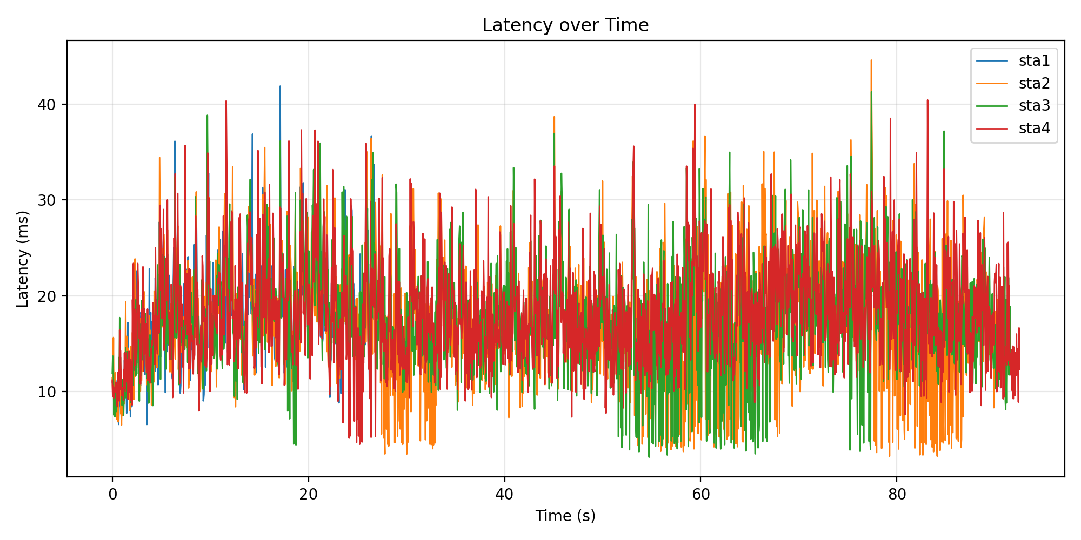
Figure 3. RSSI over time
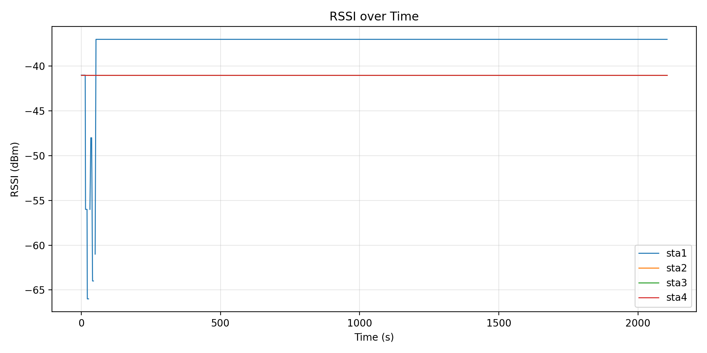

Figure 4. AP association over time
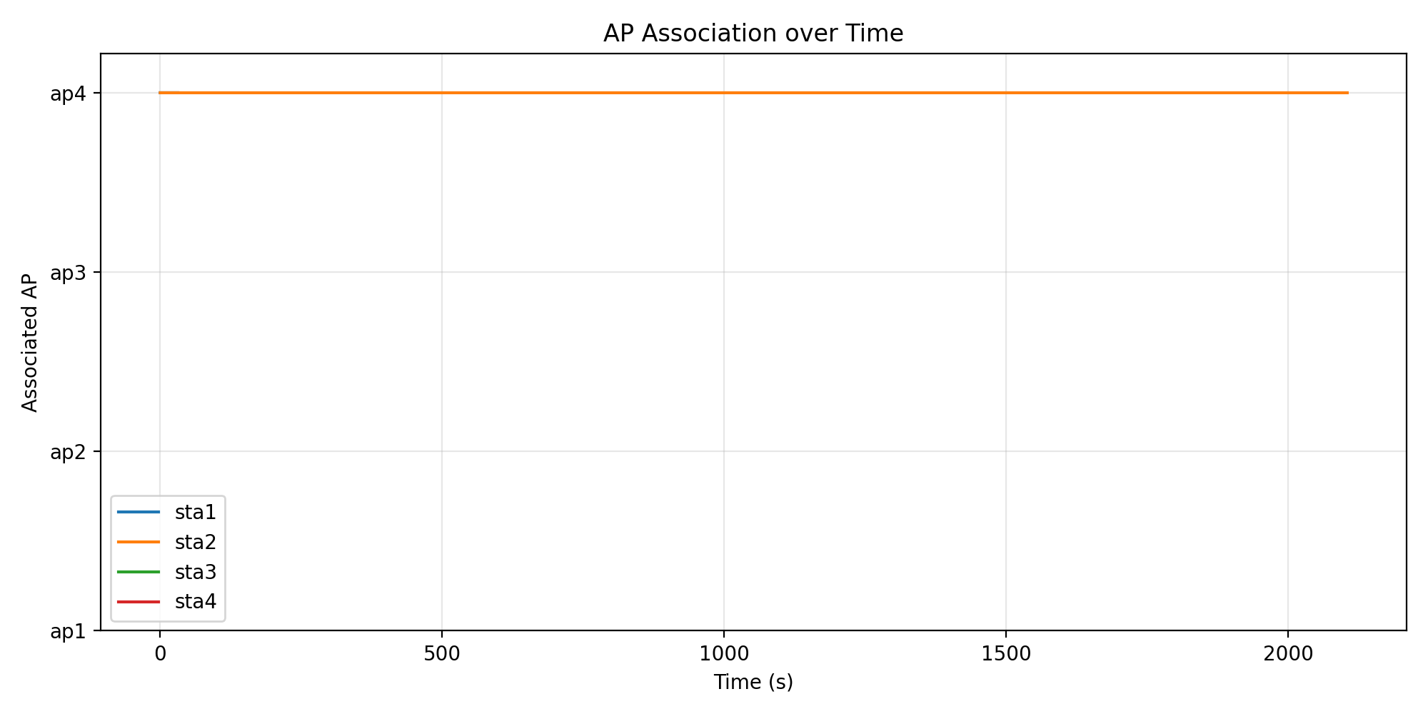

9. Challenges and Fixes
- Because Mininet demanded root access, controlled wrapper scripts were utilized.
- Because the virtual environment was unable to import Mininet, the experiment stage utilized the system Python.
- Because output files owned by the root caused permission issues, ownership and write access were handled after the experiment was carried out.
- At first, roaming movement resulted in failures; consequently, movement, request timing, retries, and AP coverage were adjusted.
- To make the end product easier to comprehend, graphs and Airflow screenshots have been added to the project.

10. Conclusion
The DT212G WiFi Telemetry ETL pipeline is successfully extended by the DT023G project. A more limited proof of concept existed in the previous version. The final version of the DT023G is larger, more dependable, and simpler to analyze. It uses four APs, four stations, 8000 total requests, Airflow workflow evidence, graph outputs, and a clear KPI report.
The main enhancements are in workflow quality and scalability. The final DT023G system provides stronger telemetry evidence through graphs and structured reporting despite having higher raw latency than the smaller DT212G setup. Additionally, the system achieves a success rate of 100 percent despite carrying a heavier workload.

Appendix: Final Output Files
- raw_requests.csv
- wifi_link.csv
- analytics.csv
- roaming_events.csv
- latency_over_time.png
- rssi_over_time.png
- ap_association_over_time.png
- report.txt

