DT023G Project Report
WiFi Telemetry ETL Pipeline Extension
Compared with the previous DT212G project, this version increases topology size, workload, Airflow evidence, and graph-based analysis.
Students: Hem Raj & Mohit Kumar
Total Requests | Success Rate | Mean Latency | Roaming
8000 | 100.0% | 12.32 ms | 1 event
Final refined run: 8000 successful requests out of 8000.

1. Executive Summary
This DT023G project is an extension of the previous DT212G WiFi Telemetry ETL Pipeline. The previous project proved that Mininet-WiFi, Python, pandas, and Apache Airflow could be used to collect WiFi telemetry and generate a KPI report. The DT023G version increases the experiment size and makes the analysis more complete.
The final DT023G run uses four access points, four stations, and 2000 HTTP requests per station. It produced 8000 total requests, 100.0% success rate, 12.32 ms mean latency, 18.87 ms p95 latency, and one detected roaming event. It also includes graph outputs for latency, RSSI, and AP association.

2. Project Objectives
- Extend the previous DT212G project into a larger wireless scenario.
- Increase the number of access points, stations, and HTTP requests.
- Generate a richer telemetry dataset and clearer KPI report.
- Use Airflow to organize the workflow and provide execution evidence.
- Compare the refined DT023G project with the previous DT212G baseline.

3. Previous DT212G Baseline
The previous DT212G project used two access points, two stations, and one HTTP server. It generated 1000 requests per station and used an Airflow DAG with run_experiment, transform, and report tasks. The final reported result was 99.55% success rate, 7.60 ms mean latency, and 8.48 ms p95 latency. Roaming was detected for sta1 and sta2.
DT212G Baseline Item | Value
Access points | 2
Stations | 2
Requests per station | 1000
Success rate | 99.55%
Mean latency | 7.60 ms
P95 latency | 8.48 ms
Roaming | Detected for sta1 and sta2

4. DT023G Final Design
The DT023G version scales the network to four access points and four stations. It also increases the workload to 2000 requests per station. The experiment collects HTTP request telemetry, WiFi association data, RSSI values, roaming events, and graphs. This makes the new project more practical and easier to analyze during demonstration.

5. Comparison: DT212G vs DT023G
Metric | DT212G Previous | DT023G Final | Interpretation
Access points | 2 | 4 | Larger network coverage
Stations | 2 | 4 | More clients
Requests per station | 1000 | 2000 | Heavier workload
Total requests | about 2000 | 8000 | Much larger dataset
Success rate | 99.55% | 100.0% | Reliability improved
Mean latency | 7.60 ms | 12.32 ms | Higher because the new setup is larger
P95 latency | 8.48 ms | 18.87 ms | Higher due to larger workload and roaming
Roaming | sta1 and sta2 | 1 event in final run | Roaming logic included
The most important improvement is scalability and workflow quality. Raw latency is lower in the smaller DT212G setup, but the DT023G project is stronger because it handles a larger workload, more devices, and provides better visual evidence.

6. Refinement Inside DT023G
The DT023G project was improved through tuning. An earlier DT023G run had 82.12% success rate, 17.39 ms mean latency, 27.28 ms p95 latency, and 1430 failed requests. The final refined run achieved 100.0% success rate, 12.32 ms mean latency, 18.87 ms p95 latency, and 0 failed requests.
Metric | Earlier DT023G | Final DT023G | Improvement
Success rate | 82.12% | 100.0% | Higher reliability
Failed requests | 1430 | 0 | No failures in final run
Mean latency | 17.39 ms | 12.32 ms | Lower latency
P95 latency | 27.28 ms | 18.87 ms | Better tail latency

7. Airflow Workflow and Evidence
Airflow keeps the processing workflow structured and repeatable. The pipeline generates transformed analytics, graph images, and a final report. The Airflow screenshot proves the workflow execution and task success.
Figure 1. Airflow DAG evidence
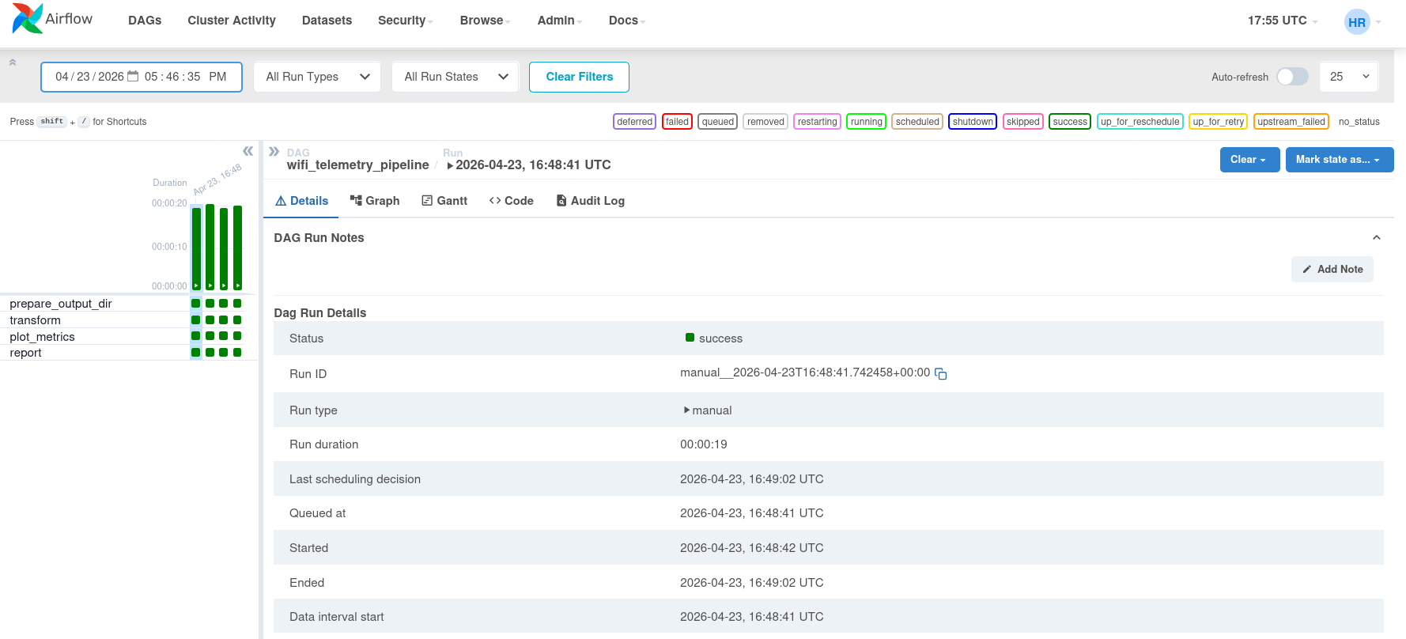

8. Graph-Based Analysis
The project includes three main graphs. The latency graph shows request performance over time, the RSSI graph shows link quality, and the AP association graph shows roaming behavior.
Figure 2. Latency over time
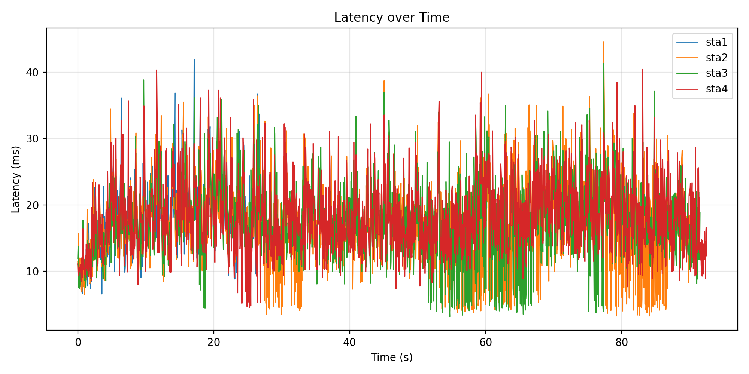
Figure 3. RSSI over time
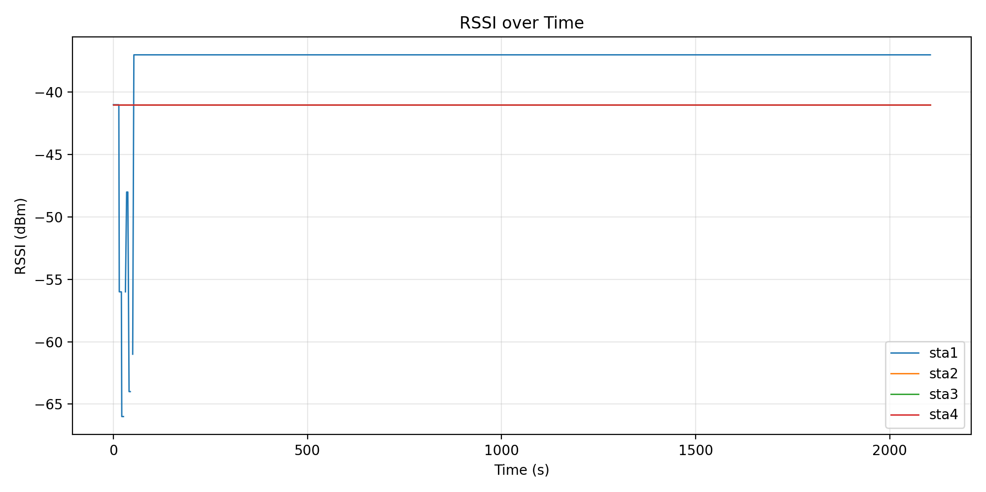
Figure 4. AP association over time
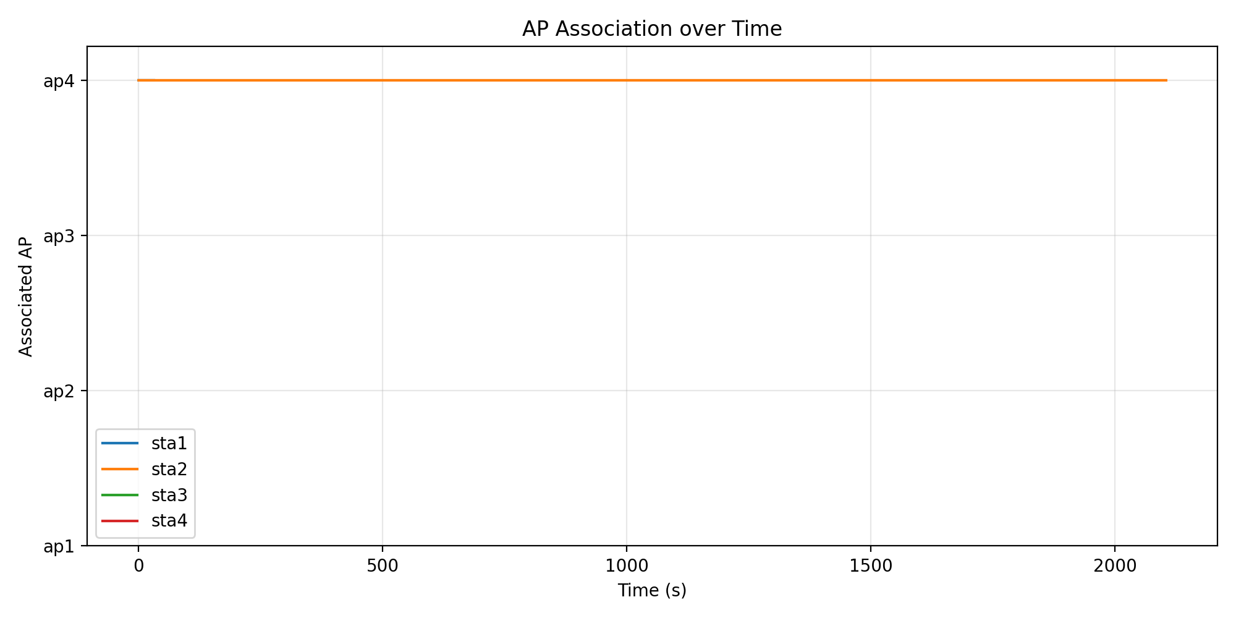

9. Challenges and Fixes
- Mininet required root privileges, so controlled wrapper scripts were used.
- The virtual environment could not import Mininet, so system Python was used for the experiment stage.
- Root-owned output files caused permission problems, so ownership and write access were handled after experiment execution.
- Roaming movement initially caused failures, so movement, request timing, retries, and AP coverage were tuned.
- The final project adds graphs and Airflow screenshots to make the result easier to understand.

10. Conclusion
The DT023G project successfully extends the DT212G WiFi Telemetry ETL pipeline. The previous version was a smaller proof of concept. The final DT023G version is larger, more reliable, and easier to analyze. It uses four APs, four stations, 8000 total requests, Airflow workflow evidence, graph outputs, and a clear KPI report.
The main improvement is scalability and workflow quality. Although raw latency is higher than in the smaller DT212G setup, the final DT023G system achieves 100% success rate under a larger workload and provides stronger telemetry evidence through graphs and structured reporting.

Appendix: Final Output Files
- raw_requests.csv
- wifi_link.csv
- analytics.csv
- roaming_events.csv
- latency_over_time.png
- rssi_over_time.png
- ap_association_over_time.png
- report.txt

