**Masters**

1. **Offices:** When we are trying to delete the Office name “**Chennai 1**” it shows below error



1. In region tab we do not have option to “**Save**”. It has Edit and View. Also, please advise the use of field “**Average volume per week prior to SSC volume<**”

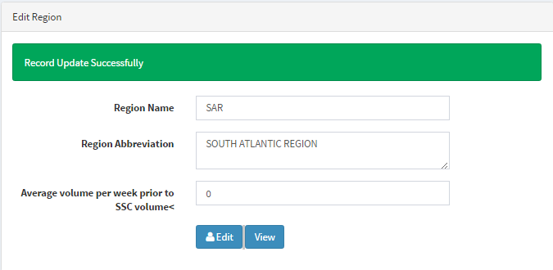

Also, even if we have entered only 6 regions, it is reflecting as 2 pages. Whereas, all the regions are reflecting on 1st page.

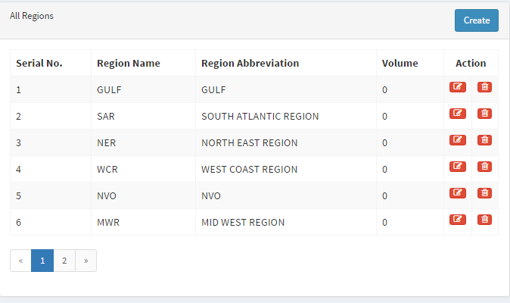

**Status:** When we added few statuses in “UPF” and “APF” separately, all the status is reflecting in “UPF” and “APF” it shall not be the case.

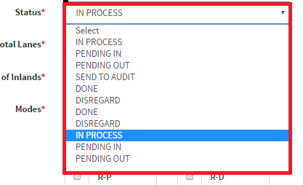

1. Also, we can only view 5 records at a time. Please add a tab wherein if needed we can view all the record at once.



1. **Commodity:** We must be able to download the database.
2. Please add “**Back end data**” tab so that we can download all the data updated in CIRA.

**Indexing:**

**Mail Received Date & Time** – It auto pull system date and time I/O the mail timing. When we try to Copy paste mail received date and time from mail to CIRA

**Priority:** It shall be default as “**STANDARD**”

**Request type**: It shall be default as “**NEW**”

**Office**: It shall be default as “**Mumbai 1**”

Also, once a record is saved the cursor shall move back to “**Mail received date and time**”

**Container Type:** If the container type is marked as reefer it’s TAT will be 24 hrs but please highlight all the reefer requests in red color background.

**Publishing:**

1. TAT calculation is wrong. I have indexed a dummy request at 8.46 EST but the TAT pending minutes states 24:48.

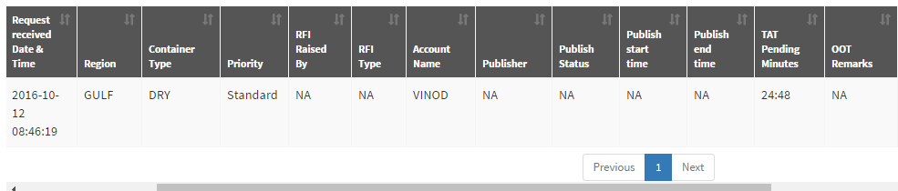

1. Add a column filter so that the user can filter the columns needed by him and hide other columns.

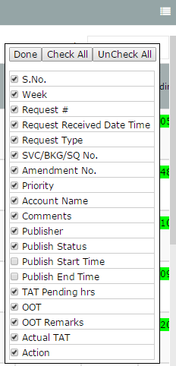

1. **Request No.:** As soon as the user clicks on the “**Unique key”** the request must be assigned and auto saved in the name of that particular user and the status must be “**In Process**”. Also, the same must reflect on the dashboard.
2. **“Request type**” does not reflect in publishing queue.
3. All the “Request Type” which is marked as Correction shall be highlighted in red color background

**UPF**

1. In UPF we must only have 6 status i.e. **“In Process”, “Pending IN”, “Pending Out”,** “**Sent to Audit**”, “**Done**” and “**Disregard**”.
2. If the status is **“In Process”, “Pending IN”, “Pending Out”** it shall not be mandatory to update “**Total lanes**”, “**No. of Inlands**”, “**Modes**”. It shall be mandatory only if the status is “**Sent to Audit**”, “**Done**” and “**Disregard**”.
3. **“Request type” and “User name”** must be grayed out to Users.
4. In Publishing Queue “Action” field shall not be available to Users.
5. **No. of Inlands:** It states value must be greater than or equal to 1, whereas inland can be 0 if the mode is only P-P.
6. **Commodity:** Commodity tab which is mandatory if the Container Type is Reefer shall be free text.
7. UPF form shall be directed to publish queue as soon as the status is changed and saved.
8. If the Users selects the status **“Pending IN”** kindly addone more mandatory field i.e. **“ISR initiated”** and it shall be Free Text
9. Suppose in a particular request if the User raises a query twice i.e. “Pending IN” twice the dashboard is reflecting the latest query only.

**APF:**

* In APF we must only have 5 status i.e. **“In Process”, “Pending IN”, “Pending Out”,** “**Done**” and “**Disregard**”.

1. Add a column filter so that the user can filter the columns needed by him and hide other columns.



1. **Request No.:** As soon as the auditor clicks on the “**Unique key”** the request must be assigned and auto saved in the name of that particular user and the status must be “**In Process**”. Also, the same must reflect on the dashboard.
2. Currently as soon as the auditor opens the **APF** the status is reflecting as “**Sent to Audit**” which is from **UPF**. It shall be “**In Process**”
3. Whenever we are updating any status in “Audit” queue it shows below error.



1. In “APF” we must have “Total Lanes”, “No. of Inlands” and “Modes” tabs.