Azure OpenAI Content Filter Brief
pacEHR AI service: what we need, where, and why
Prepared by | Hem Singh, pacEHR AI development team
Date | 15 October 2026
Request | One custom content filter, pacehr-clinical-extraction, on each environment's Azure OpenAI resource
Effort | About 15 minutes per environment

1. Summary
We need a custom content filter (RAI policy) named pacehr-clinical-extraction on each environment's Azure OpenAI resource. The filter is not attached to any deployment. The pacEHR AI service selects it on each of its own requests with the x-policy-id header, so other applications using the same GPT-4.1 deployment are not affected.
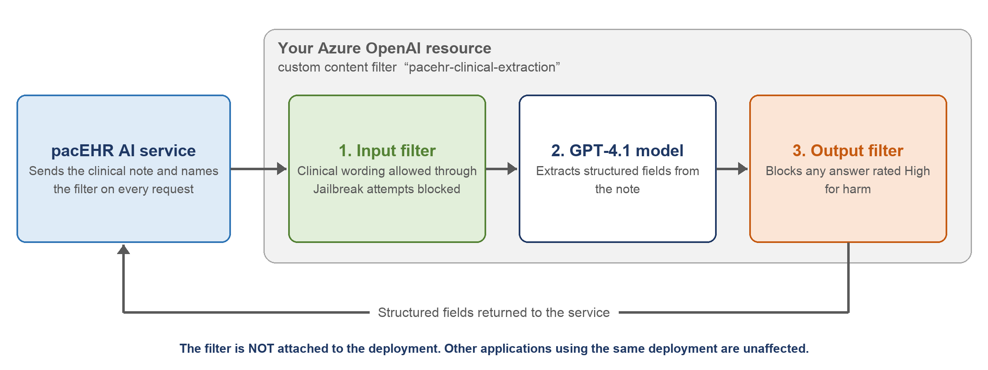
Figure 1: Where the custom filter applies

2. Why it's needed
The pacEHR AI service sends clinical notes to GPT-4.1 to extract structured fields. Azure's default filter blocks input rated Medium or above for self-harm, violence, sexual content or hate. Routine clinical wording reaches that level, for example “Hx of suicidal ideation, denies current SI/HI”, “laceration from assault” and “sexual history: …”. With the default filter, Azure would refuse these notes and the extraction would fail for legitimate patient records.

3. What it adds
Benefit | How
Clinical notes are processed without false refusals | The four harm categories are set to annotate only on input, so clinical wording is let through and still logged with a severity rating.
Safety on the model's answer is kept | The output filter still blocks anything rated High for harm.
Protection against prompt injection | Prompt Shields for jailbreak attacks stays blocking. Our service also runs its own injection scanner and note-length limit before any request reaches Azure.
No impact on other applications | The filter is selected per request, not attached to the deployment, so the deployment's current filter and every other caller stay unchanged.
Fails safe | If the filter is missing or renamed, Azure rejects the request (InvalidContentFilterPolicy). It never silently falls back to a different filter.
Controlled rollout | Our service only starts using the filter in an environment after you confirm it exists there. It can be switched off on our side without any Azure change.

4. Key details
For reference in change requests and tickets.
Item | Value
Filter name (exact, case-sensitive) | pacehr-clinical-extraction
Resource type | Content filter (RAI policy) on the Azure OpenAI resource: Microsoft.CognitiveServices/accounts/raiPolicies
Base policy | Microsoft.Default
Where it is managed | Foundry (classic) portal → Guardrails + controls → Content filters, or the raiPolicies REST API (version 2024-10-01)
Attached to a deployment | No. Leave the deployment's current filter unchanged
How our service selects it | Request header x-policy-id: pacehr-clinical-extraction on every call
Model deployment used | GPT-4.1. Deployment type must be Standard or DataZoneStandard (US). Please tell us if it is a Global type
Role needed to create it | Cognitive Services Contributor, Contributor or Owner on the resource
Error if the filter is missing | HTTP 400 InvalidContentFilterPolicy

5. Filter configuration
Filter | Applies to | Setting
Violence, Hate, Sexual, Self-harm | Input (prompt) | Annotate only. If that isn't available on your subscription, use threshold High, blocking, and let us know
Violence, Hate, Sexual, Self-harm | Output (completion) | Threshold High, blocking
Prompt Shields: jailbreak attacks | Input | Annotate and block
Prompt Shields: indirect attacks | Input | Off
Protected material: text and code | Output | Annotate only
Groundedness, PII (preview) | Output | Off (the answer is meant to contain patient details)
Blocklists, including the built-in Profanity list | Input and output | Off
Streaming mode | Output | Default (our service doesn't stream)

6. Environments and resources
Please confirm or fill in the blanks, and tick each environment once the filter exists.
Environment | Azure OpenAI resource | Resource group | GPT-4.1 deployment | Deployment type | Filter created
Dev | oai-3pillar-dev-eus2 |  |  |  | ☐
QA | thesnfist-q-eastus2-oai (to confirm) |  |  |  | ☐
UAT |  |  |  |  | ☐
Preprod |  |  |  |  | ☐
Prod |  |  |  |  | ☐

7. Rollout and coordination
- One environment at a time, dev first. After each one, we switch our service to the filter and run our test set of made-up clinical notes, then confirm before you move to the next environment.
- Tell us before changing, renaming or removing the filter. We switch our setting off first, because every request names the filter.
- Leave unchanged: the filter attached to the GPT-4.1 deployment, custom blocklists (none), and Purview prompt capture (off).
- If Defender for Cloud AI threat protection is ever enabled, keep prompt evidence off, because it copies note text into alerts.
- Use only made-up text in portal “Try it out” pages. Never paste real patient data.

A detailed step-by-step guide (portal and Azure CLI) is available on request. Contact: Hem Singh, pacEHR AI development team.

