Azure OpenAI Content Filter Setup
pacEHR AI service: a request for your Azure administrator
Prepared by | Hem Singh, pacEHR AI development team
Date | 14 October 2026
Time needed | About 15 minutes per environment
Permission needed | Cognitive Services Contributor (or Contributor, or Owner) on the Azure OpenAI resource

At a glance: what we need from you
1. Create one content filter named pacehr-clinical-extraction on each environment's Azure OpenAI resource, starting with dev. (Section 3)
2. Check one setting (read only): the GPT-4.1 deployment type. (Section 4)
3. Leave a short list of settings unchanged. (Section 5)
4. Send us the confirmation table, and wait for our test result before moving to the next environment. (Section 6)

1. Why this is needed
The pacEHR AI service sends clinical notes to Azure OpenAI, which extracts structured fields from them. Azure's default content filter blocks any text it rates as Medium or above for self-harm, violence, sexual content or hate.
Ordinary clinical notes reach that level, for example:
- “Hx of suicidal ideation, denies current SI/HI”
- “Laceration from assault”
- “Sexual history: …”
With the default filter, Azure would refuse these notes. We are asking for one custom content filter with the same name and settings on each environment's Azure OpenAI resource. It does three things:
- lets clinical wording through on the way in;
- still blocks anything rated High in the model's answer;
- keeps Microsoft's jailbreak detection (Prompt Shields) blocking.

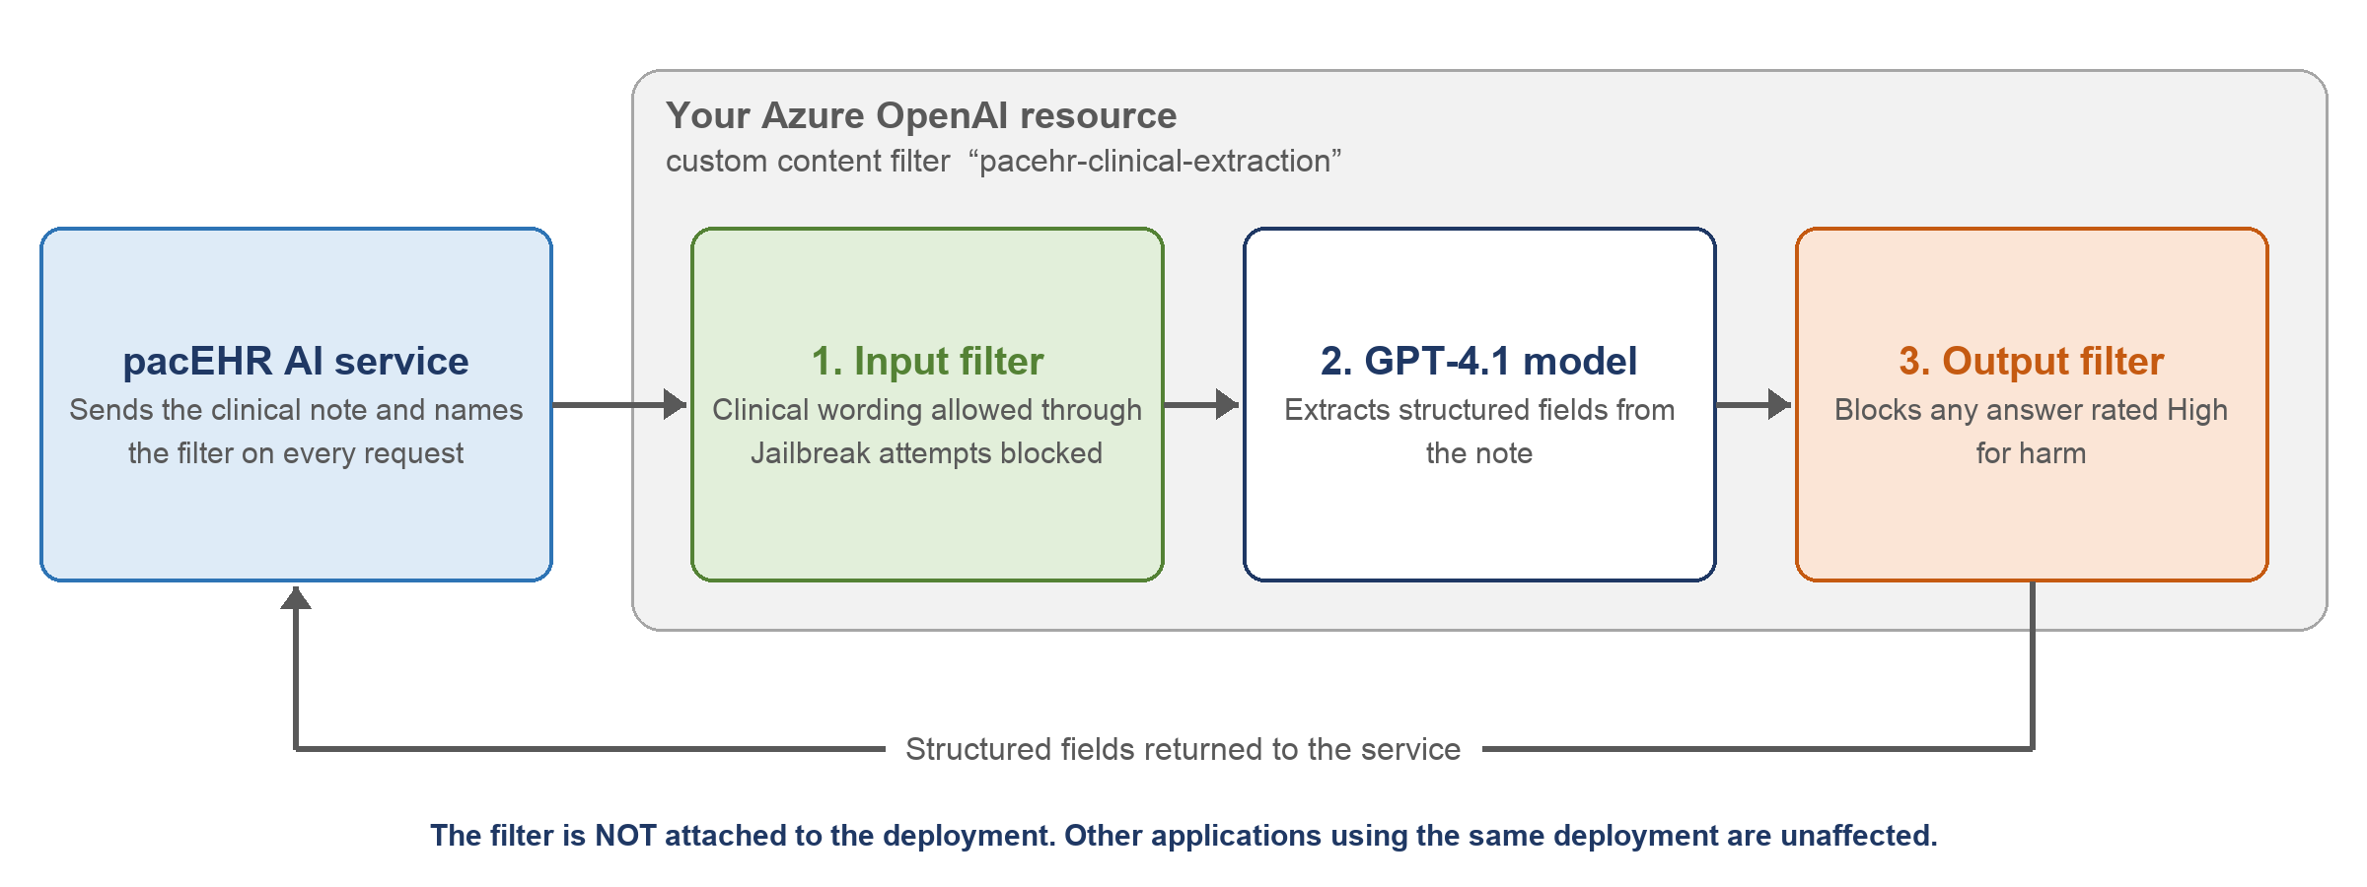
Figure 1: Where the custom filter sits in each request
The filter does not need to be attached to any deployment
Our service names the filter on every request (using the x-policy-id request header). The deployment's current filter stays as it is, so any other application using the same deployment is not affected.

2. Before you start

Environments
Please create the filter on each of these Azure OpenAI resources, one environment at a time, dev first. Please fill in or correct anything marked “to be confirmed”.
Environment | Azure OpenAI resource | Resource group
Dev | oai-3pillar-dev-eus2 | To be confirmed
QA | thesnfist-q-eastus2-oai (please confirm) | To be confirmed
UAT | To be confirmed | To be confirmed
Preprod | To be confirmed | To be confirmed
Prod | To be confirmed | To be confirmed

Important: the name must be exact
Name the filter exactly pacehr-clinical-extraction: all lowercase, with hyphens.
Our service sends this exact name. If the name is different, Azure rejects every request with the error InvalidContentFilterPolicy.

Two ways to do it
Use whichever suits you. Both create exactly the same filter.
- Foundry portal: step by step in Section 3.
- Azure CLI: a ready-made JSON file and commands in Appendix A. This is useful if you prefer scripts or want a repeatable record.

3. Create the content filter in the Foundry portal
The portal walks you through five pages. The figure below summarises what to set on each one; the detailed settings follow.
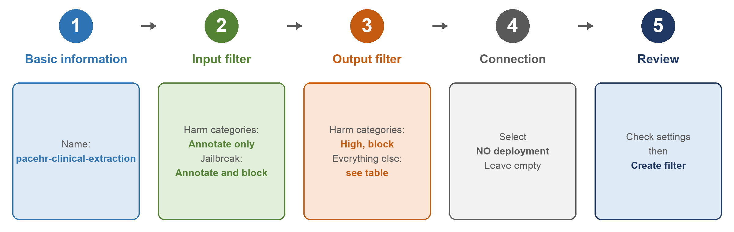
Figure 2: The five pages of the Create content filter wizard

Open the content filters page
Step 1 Sign in to https://ai.azure.com. Make sure the New Foundry toggle at the top of the page is off. These steps are for Foundry (classic).
Step 2 Open the environment's Azure OpenAI resource (for dev: oai-3pillar-dev-eus2).
Step 3 In the left menu, select Guardrails + controls, then the Content filters tab. If you can't see it, select … More at the bottom of the menu.
Step 4 Select + Create content filter.

Page 1: Basic information
Step 5 Enter the Name: pacehr-clinical-extraction. If the portal asks for a Connection, pick this environment's Azure OpenAI resource. Select Next.

Page 2: Input filter (checks the clinical note we send)
Step 6 Set the input filter as follows, then select Next.
Setting | Set it to | Why
Violence | Annotate only | Notes describe injuries and assaults
Hate | Annotate only | Notes quote what patients said
Sexual | Annotate only | Notes include sexual history and screening
Self-harm | Annotate only | Notes include suicide-risk assessments
Prompt shields for jailbreak attacks | Annotate and block | Keeps Microsoft's jailbreak detection on
Prompt shields for indirect attacks | Off | Needs a document format our service doesn't use
Blocklist (including the built-in Profanity list) | Off | Quoted patient language is part of the record

If “Annotate only” isn't offered for the four harm categories
Set their threshold slider to High instead, and let us know. Microsoft's documentation says annotate-only on input is available to all customers, but one page also describes it as needing approval.

Page 3: Output filter (checks the model's answer)
Step 7 Set the output filter as follows, then select Next.
Setting | Set it to | Why
Violence, Hate, Sexual, Self-harm | Threshold High, block | Blocks any harmful answer
Protected material for text | Annotate only | Recorded, not blocked
Protected material for code | Annotate only | Recorded, not blocked
Groundedness (preview) | Off | Not used
Personally identifiable information (PII) (preview) | Off | The answer is meant to contain patient details
Streaming mode | Leave at default | Our service doesn't stream
Blocklist | Off | Not used

Page 4: Connection (apply to deployments)
Step 8 Don't select any deployment. Leave the list empty and continue.
Why no deployment?
Attaching the filter to a deployment would change the behaviour for any other application that uses the same deployment. Our service selects this filter on each of its own requests instead.

Page 5: Review
Step 9 Check the settings against the tables above, then select Create filter.
Done
The filter pacehr-clinical-extraction now exists on this resource. Please send us the confirmation row (Section 6).

4. Check the deployment type (read only)
Under the Business Associate Agreement we want requests to be processed in the US. A Global deployment may process them in any Azure region, so please check which type the GPT-4.1 deployment uses. Nothing needs to change in this step.
- In the portal: open the resource, go to Models + endpoints (or Deployments), select the GPT-4.1 deployment and note its Deployment type.
- Or with the Azure CLI:
az cognitiveservices account deployment show -g "<resource-group>" -n "<openai-resource-name>" \
--deployment-name "<gpt-4.1-deployment-name>" --query sku.name -o tsv

Result | What it means
Standard (regional) or DataZoneStandard (US data zone) | ✅ Fine. Nothing to do.
Anything containing Global | ⚠️ Please tell us; don't change it yourself. Moving to another type means a new deployment and a configuration change on our side.

5. Please leave these unchanged
Item | Leave it as | Why
The filter currently attached to the GPT-4.1 deployment | Unchanged | Our service selects its own filter on each request. The deployment's filter only affects other callers.
Defender for Cloud: AI threat protection | Not enabled | Not needed at this stage; our service logs attack attempts itself. If it is ever turned on, prompt evidence must be off, because that option copies note text into the alerts.
Custom blocklists | None | Our service already blocks those phrasings before Azure sees them.
Data controls (Purview prompt capture) | Off | It would create another copy of patient data.
“Try it out” pages (content safety, prompt shields) | Fine to use, with made-up text only | Never paste a real patient's note into a portal test page.

6. What to send back, and the order
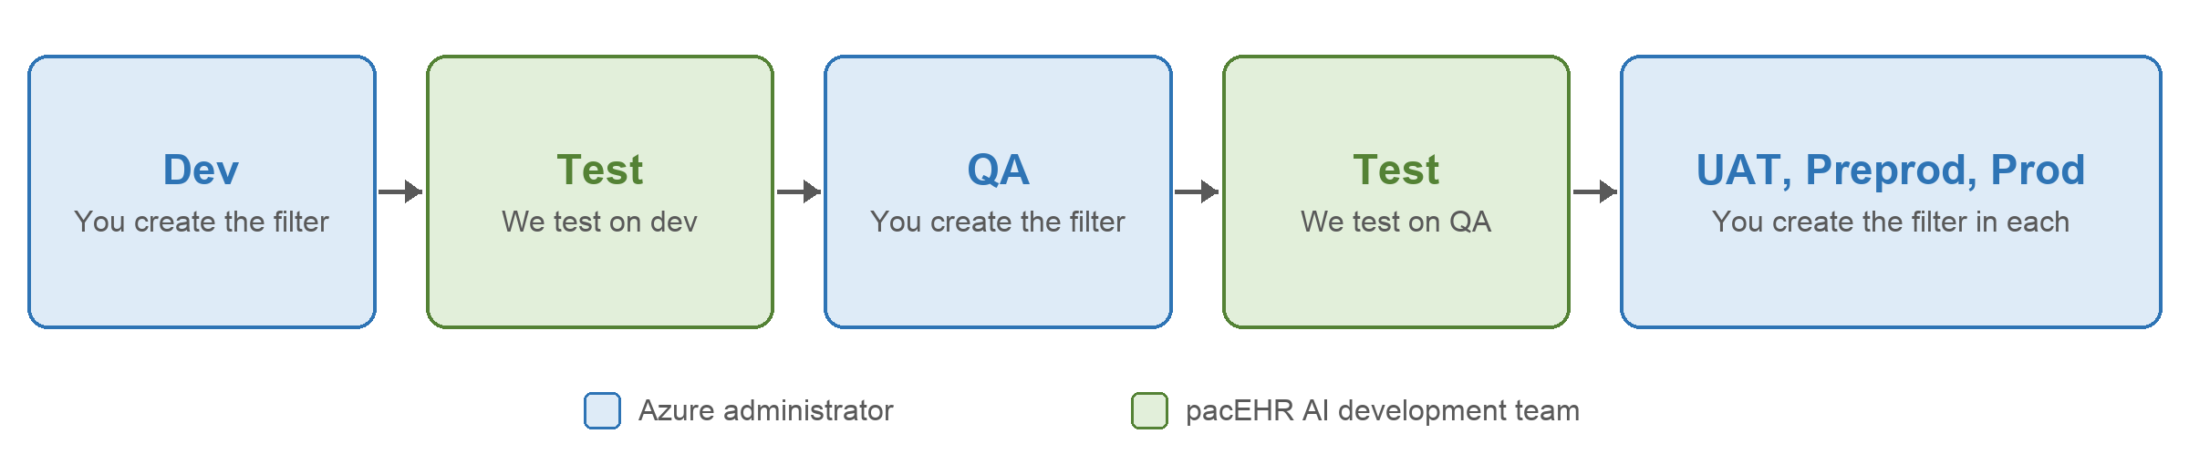
Figure 3: One environment at a time, with a test by us in between

Order
Step 1 Create the filter on dev and send us the dev row of the table below.
Step 2 We switch our dev service to use the filter and run our set of made-up clinical notes against it. We'll tell you whether it passed.
Step 3 Then do QA, and we repeat the test.
Step 4 Then do UAT, preprod and prod. Each environment's service only starts using the filter after you've confirmed it exists there.

Confirmation table
Please fill in one row per environment as you complete it.
Environment | Resource | Resource group | Filter created? | Input harm categories set to | GPT-4.1 deployment name | Deployment type
Dev | oai-3pillar-dev-eus2 |  | ☐ Yes | ☐ Annotate only  ☐ High
QA |  |  | ☐ Yes | ☐ Annotate only  ☐ High
UAT |  |  | ☐ Yes | ☐ Annotate only  ☐ High
Preprod |  |  | ☐ Yes | ☐ Annotate only  ☐ High
Prod |  |  | ☐ Yes | ☐ Annotate only  ☐ High

Changing or removing the filter later: please tell us first
Our service names this filter on every request, so deleting or renaming it would make every request fail. We switch our setting off first; then you can remove or change it.

7. Later, before go-live (not needed now)
These are listed so they aren't forgotten. No action is needed for them now.
Item | What it is
Abuse-monitoring opt-out | By default Azure keeps prompts for up to 30 days, and Microsoft staff may review flagged ones. Opting out is done through Microsoft's “modified abuse monitoring” application form, submitted by whoever holds the Azure agreement (EA or MCA). There is no API for it.
Disable key authentication | disableLocalAuth on the QA, UAT, preprod and prod resources, once the service uses managed identity there. Dev keeps keys while developers need them.
Network access | Already private. Keep public network access disabled.
Diagnostic settings | Send metrics and non-content logs only. Leave off any log category that records request content.

Appendix A. Create the filter with the Azure CLI
This creates exactly the same filter as Section 3. Save the following as pacehr-clinical-extraction.json:
{
"properties": {
"basePolicyName": "Microsoft.Default",
"contentFilters": [
{ "name": "Hate", "enabled": true, "blocking": false, "severityThreshold": "High", "source": "Prompt" },
{ "name": "Sexual", "enabled": true, "blocking": false, "severityThreshold": "High", "source": "Prompt" },
{ "name": "Selfharm", "enabled": true, "blocking": false, "severityThreshold": "High", "source": "Prompt" },
{ "name": "Violence", "enabled": true, "blocking": false, "severityThreshold": "High", "source": "Prompt" },
{ "name": "Hate", "enabled": true, "blocking": true, "severityThreshold": "High", "source": "Completion" },
{ "name": "Sexual", "enabled": true, "blocking": true, "severityThreshold": "High", "source": "Completion" },
{ "name": "Selfharm", "enabled": true, "blocking": true, "severityThreshold": "High", "source": "Completion" },
{ "name": "Violence", "enabled": true, "blocking": true, "severityThreshold": "High", "source": "Completion" },
{ "name": "Jailbreak", "enabled": true, "blocking": true, "source": "Prompt" },
{ "name": "Profanity", "enabled": false, "blocking": false, "source": "Prompt" },
{ "name": "Protected Material Text", "enabled": true, "blocking": false, "source": "Completion" },
{ "name": "Protected Material Code", "enabled": true, "blocking": false, "source": "Completion" }
]
}
}

Then run the following, filling in the subscription, resource group and resource name:
az login
az account set --subscription "<subscription-id>"
URL="https://management.azure.com/subscriptions/<subscription-id>/resourceGroups/<resource-group>/providers/Microsoft.CognitiveServices/accounts/<openai-resource-name>/raiPolicies/pacehr-clinical-extraction?api-version=2024-10-01"
# create the filter (or update it if it already exists)
az rest --method put --url "$URL" --body @pacehr-clinical-extraction.json
# confirm what was saved
az rest --method get --url "$URL"

Notes on the JSON
- "enabled": true, "blocking": false means annotate only.
- If Azure rejects the four "source": "Prompt" harm entries, change each of them to "blocking": true with "severityThreshold": "High", and let us know (the same fallback as in the portal).
- The filter names and the Microsoft.Default base policy come from Microsoft's REST API reference sample.
- Running the command again with the same file changes nothing.

Appendix B. References
- Microsoft Learn: “Configure content filters (classic)”, updated 23 September 2026.
- Microsoft Learn: Azure AI services REST API reference, “RAI Policies – Create Or Update”, API version 2024-10-01.

Questions about this document: Hem Singh, pacEHR AI development team.

