(1) run nginx container

bind port 80 of application to one local host port number

12:45:54 hemu@hemu ~ → docker run -d -p 8080:80 nginx:1.25

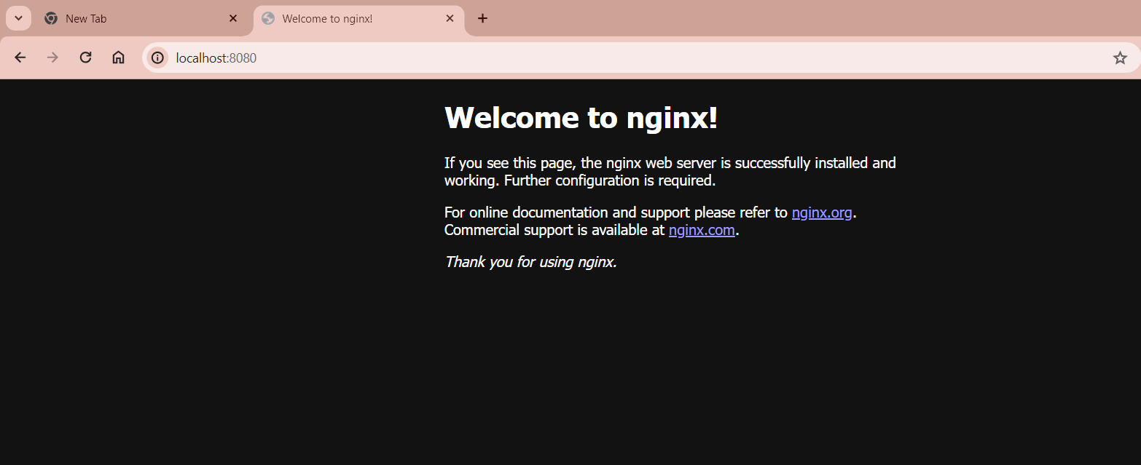

(2) wrote the simple app in node js

(see server.js in "docker in 1 hr course file")

build image for this app --> writing the Dockerfile at **root** application

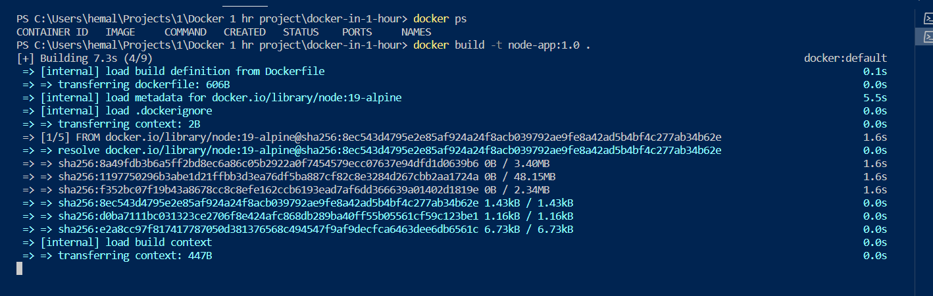

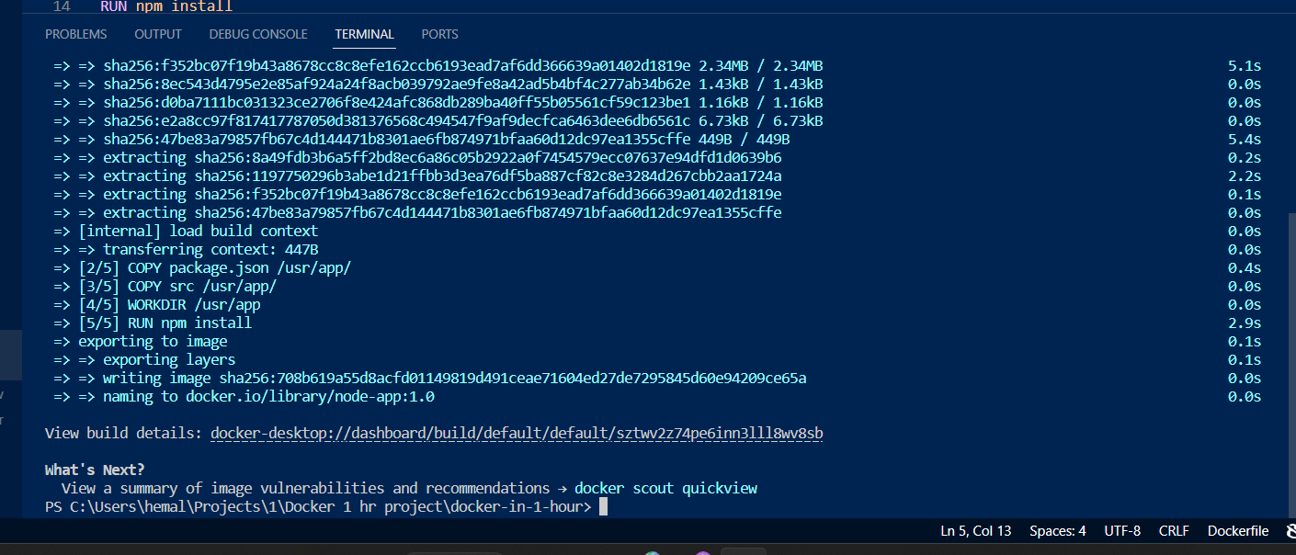

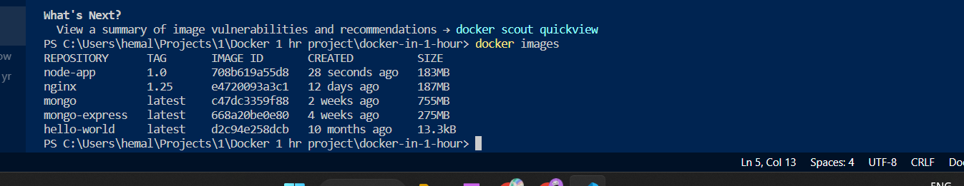

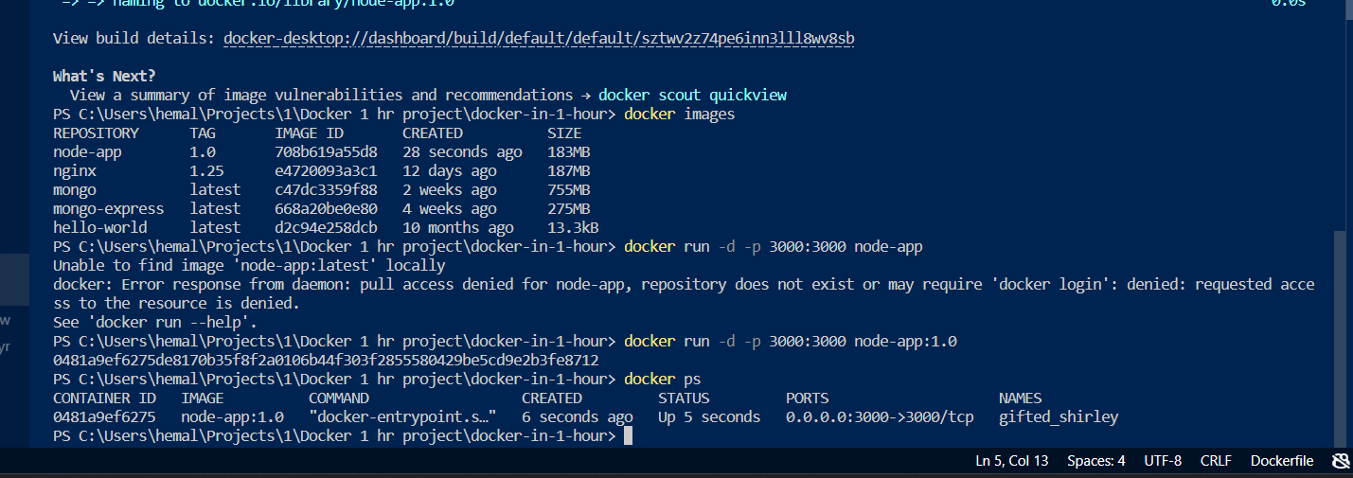

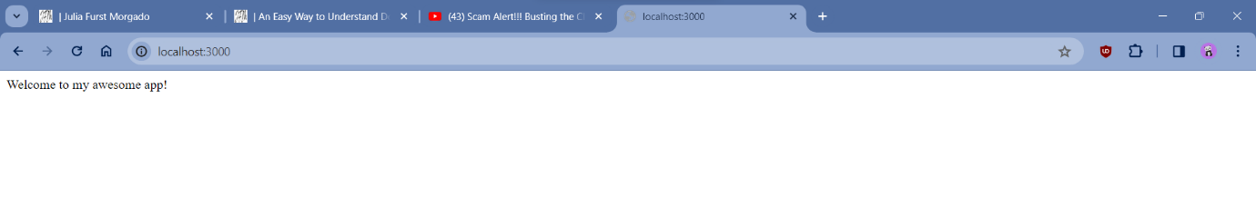

since app in the container will run on port 3000, will expose the same port on local host

