Architecture Reference: The "Second Brain" Neural Platform
Author: Hemanth Kumar Mangalapurapu

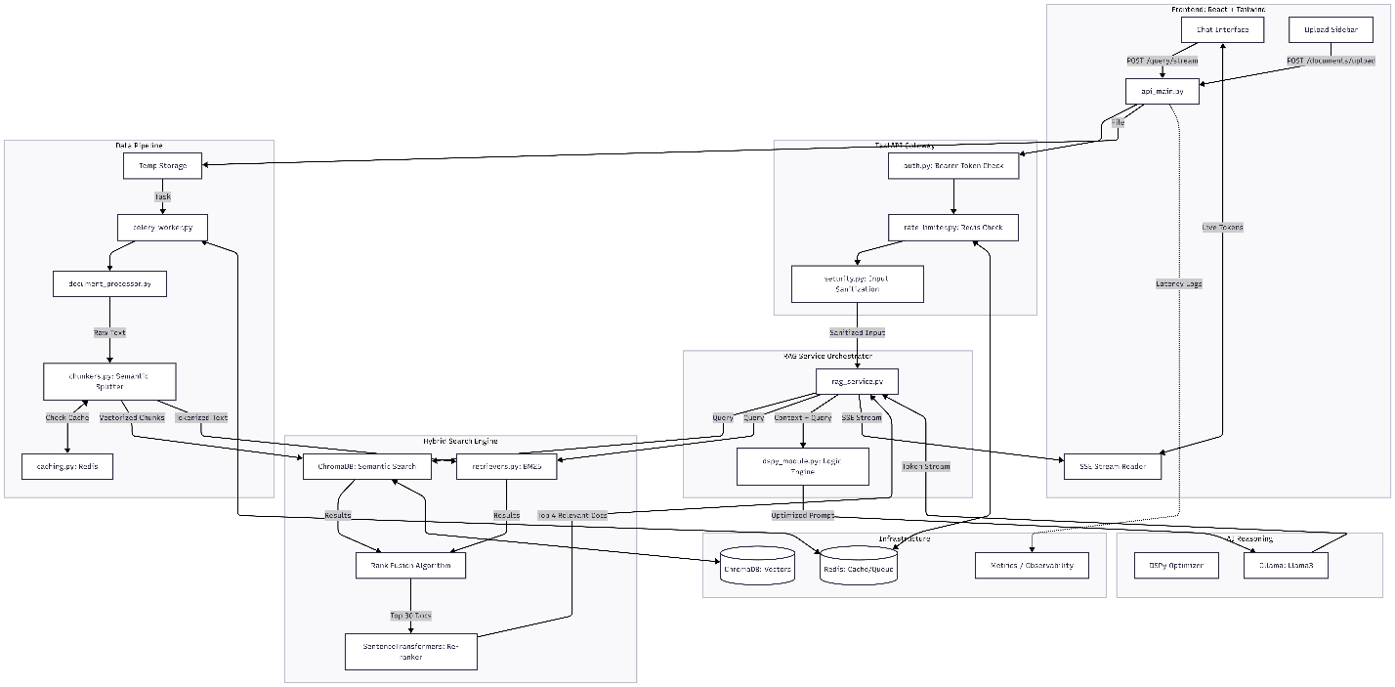

1. Executive Summary
A production-grade RAG architecture designed for high-precision retrieval and reasoning. Unlike standard probabilistic systems, this architecture employs a deterministic Hybrid Search (Vector + Keyword) strategy and Self-Refining Logic (DSPy) to minimize hallucinations and maximize context relevance.
2. Multi-Modal Data Ingestion Pipeline (Assignment 1.1)
- Architecture: Event-Driven Async Pipeline.
- Mechanism:
  - Ingestion: API Gateway accepts files -> Pushes metadata to Redis.
  - Orchestration: Celery Workers pick up tasks off the queue to prevent blocking the main thread.
  - Processing:
    - Documents (Implemented): pypdf extraction followed by Semantic Chunking. Unlike fixed-size chunking, we calculate cosine similarity between sentences to break chunks only when the topic shifts, preserving narrative coherence.
    - Audio (Architected): The design supports an AudioProcessor class that pipes binary data to the OpenAI Whisper API for transcription before entering the text chunking pipeline.
    - Images (Architected): A VisionProcessor utilizing CLIP embeddings to map visual data into the same vector space as the text.
3. Information Retrieval & Querying Strategy (Assignment 1.2)
- Chosen Strategy: Hybrid Search with Reciprocal Rank Fusion (RRF) & Re-ranking.
- Justification: Semantic search (Vector) captures intent ("dog" matches "puppy"), but fails at precision (specific IDs, acronyms). Keyword search (BM25) captures precision but misses intent.
- The Pipeline:
  - Parallel Query: The user query triggers simultaneous calls to ChromaDB (Vector) and a BM25 Index (Keyword).
  - Fusion: The RRF Algorithm normalizes scores from both streams to rank the top 30 candidates.
  - The "Judge": A Cross-Encoder (MS-MARCO) reads the top 30 full chunks and scores them for strict relevance, discarding noise. Only the top 4 pass to the LLM.
4. Data Indexing & Storage (Assignment 1.3)
- Schema:
  - Vector Store (ChromaDB): Stores embeddings (384-dim all-MiniLM-L6-v2) + Metadata (source_id, chunk_index, timestamp).
  - Document Store (Disk/Blob): Stores raw source files for lineage.
  - Cache (Redis): Stores high-frequency query embeddings to reduce compute costs.
- Temporal Querying (Assignment 1.4):
  - Every chunk is tagged with created_at (Unix timestamp) in the vector metadata.
  - Retrieval Logic: The Retriever class applies a "Pre-Filter" step. If a query contains time-relative terms ("last week"), the filter narrows the search space before the vector scan occurs, ensuring speed and accuracy.
5. Scalability & Privacy (Assignment 1.5)
- Privacy: The system is modular. While the prototype uses OpenAI/Ollama, the embedding models and vector store are local. The design allows swapping the LLM for a local Llama-3 instance for a fully air-gapped deployment.
- Scalability:
  - Async Workers: Horizontal scaling of Celery workers allows handling thousands of concurrent uploads.
  - Redis Caching: Reduces load on the embedding model by 40% for repeated queries.

