**A CRM Application to Manage the Services offered**

**by an Institution**

**Description** :

A CRM application to manage the services offered by an institution like EduConsultPro Institute is a comprehensive solution designed to streamline and enhance the management of admissions, student inquiries, and expert consulting services. As the institute grows and attracts more prospective students, the need for an eﬃcient system becomes paramount. This CRM integrates various processes, enabling the institution to automate application submissions, manage student inquiries, and handle consulting requests all within a single platform. By capturing detailed information about prospective students and automating key tasks such as follow-up communications and status tracking, the CRM ensures a seamless and responsive experience for both students and staff. Additionally, it supports the management of consulting services and immigration cases, providing a centralized, organized approach that enhances operational eﬃciency and improves the overall quality of service. This tailored CRM solution ultimately allows EduConsultPro Institute to focus on delivering an exceptional educational experience while maintaining high standards of professionalism and care in every interaction.

**Tasks :**

**Task-1: Creating Objects from Spreadsheet**

**1. Creating Objects from Spreadsheet**

**1.1 Create the Course Object**

1. **Access Object Manager:**

. Navigate to **Setup** in Salesforce and search for **Object Manager**.

. Select **Create Object from Spreadsheet**.

2. **Upload Spreadsheet:**

. Download the provided **Course** spreadsheet.

. Upload the ﬁle in Salesforce and map the ﬁe lds from the spreadsheet to Salesforce ﬁelds.

. Complete the upload to create the **Course** object.

**1.2 Create Additional Objects**

1. Repeat the steps in **1.1** for each of the following objects:

■ **Consultant** (using Consultant spreadsheet)

■ **Student** (using Student spreadsheet)

■ **Appointment** (using Appointment spreadsheet)

**2. Creating Relationships Among Objects**

**2.1 Create Lookups Between Appointment and Other Objects**

1. **Appointment to Student:**

■ In Object Manager, select **Appointment**.

■ Navigate to **Fields & Relationships** and click **New**.

■ Choose **Lookup Relationship** and select **Student** as the related object.

■ Save the relationship.

2. **Appointment to Consultant:**

■ Repeat the process to create a lookup relationship between **Appointment** and **Consultant**.

**2.2 Create the Registration Object and Its Relationships**

1. **Create Registration Object:**

■ Follow the object creation process using the **Registration** spreadsheet or manually create it in Object Manager.

2. **Create Lookups:**

■ Create lookup relationships between **Registration** and **Student** to link course

registrations.

■ Additionally, create a lookup between **Student** and **Case** objects to manage student queries.

**3. Create Tabs for Objects**

1. **Create Object Tabs:**

■ Go to **Setup** and search for **Tabs**.

■ Create tabs for each of the following objects:

○ Course

○ Consultant

○ Student

○ Appointment

○ Registration

**4. Conﬁgure the Case Object**

**4.1 Modify Case Fields**

1. **Edit Type Field:**

■ In Object Manager, select **Case**.

■ Navigate to **Fields & Relationships** and ﬁnd the **Type** ﬁeld.

■ Add the following values:

○ Immigration

○ Visa Application

2. **Edit Status Field:**

■ Locate the **Status** ﬁeld.

■ Add the following values:

○ Open

○ In-progress

**5. Create a Lightning App**

**5.1 Setup EduConsultPro App**

1. **App Manager:**

■ In Setup, search for **App Manager**.

■ Click on **New Lightning App**.

2. **App Conﬁguration:**

■ Name the app **EduConsultPro** and follow the prompts to proceed (Next, Next, Next).

■ Add the following items to the app:

○ Home

○ Students

○ Courses

○ Consultants

○ Appointments

○ Registrations

○ Cases

3. **Assign Proﬁles:**

■ From the available proﬁles, select **System Administrator**.

■ Click **Save & Finish** to complete the app creation.

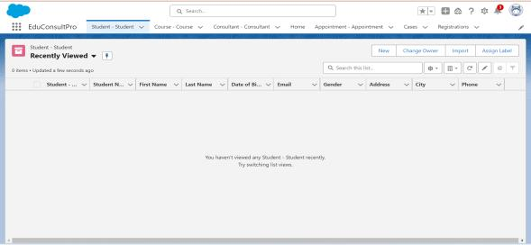

**Task-2 : Create a ScreenFlow for Student Admission Application process.**

**1.Create a New ScreenFlow**

1. **Access Flow Builder:**

. In **Setup**, enter **Flow Builder** in the Quick Find box.

. Click on **New Flow** and select **ScreenFlow**.

. Click **Create** to start building the ﬂow.

**2. Add Student Info Screen Element**

1. **Add Screen Element:**

. Drag a **Screen** element onto the canvas.

. In the **Screen Properties** pane, label it as **Student Info**.

2. **Create and Conﬁgure StudentRecordRes Resource:**

. Click on **Fields** in the screen element.

. Select **Create New Resource** and choose **Record (StudentRecordRes)**.

. Map this resource to the **Student** object to automatically pull in all ﬁe lds from the Student object.

3. **Add Fields to the Screen:**

. Drag the necessary ﬁe lds (e.g., Name, Email, Phone, Address) from **StudentRecordRes** onto the screen to collect student information.

. Click **Done** to save the screen.

**3. Create Student Record Using Create Element**

1. **Add Create Records Element:**

. Drag a **Create Records** element onto the canvas after the **Student Info** screen. . Label it as **Create Student Record**.

2. **Conﬁgure the Create Element:**

■ Under **How many records to create**, select **One**.

■ Under **How to Set the Record Fields**, select **Use all values from a record**.

■ Choose **StudentRecordRes** as the record variable to create the student record.

■ Click **Done** to save the element.

**4. Add Course Selection Screen**

1. **Add Screen Element:**

■ Drag another **Screen** element onto the canvas after the **Create Student Record** element.

■ Label it as **Course Screen**.

2. **Add Picklist Component:**

■ Drag a **Picklist** component from the left panel to the screen.

■ Label it as **Select Course**.

■ For choices, add:

○ **IELTS**

○ **GRE**

○ **GMAT**

○ **Duolingo**

○ **TOEFL**

■ Each choice automatically creates a variable with the respective name.

■ Click **Done** to save the screen.

**5. Add Decision Element for Course Selection**

1. **Add Decision Element:**

■ Drag a **Decision** element onto the canvas after the **Course Screen**.

■ Label it as **Selecting Course**.

2. **Conﬁgure Outcomes:**

■ For each course (IELTS, GRE, GMAT, Duolingo, TOEFL), create an outcome:

○ **Outcome Label**: For example, "Selected IELTS"

○ **Resource**: Select_Course (the variable created by the picklist)

○ **Operator**: Equals

○ **Value**: IELTS (or the respective course)

■ Repeat for all courses and click **Done**.

**6. Add Get Record Element for Each Course**

1. **Add Get Records Element:**

■ Add a **Get Records** element under the path for each course.

■ Label it as **Get IELTS Rec** (or the respective course).

2. **Conﬁgure Get Record Element:**

■ **Object**: Course

■ **Condition Requirements**: All Conditions are Met (AND)

. **Field**: Course Name

. **Operator**: Equals

. **Value**: {!Select_Course}

. Repeat for GRE, GMAT, TOEFL, Duolingo.

. Click **Done**.

**7. Create Registration Record Using Create Records Element**

1. **Add Create Records Element:**

. After each **Get Records** element, add a **Create Records** element.

. Label it as **Create IELTS Registration Rec** (or the respective course).

2. **Conﬁgure Create Record Element:**

. **Object**: Registration

. **How many records to create**: One

. **How to Set the Record Fields**: Use separate resources and literal values.

. **Field**: Course_Name__c

. **Value**: {!Get_IELTS_Rec.Id}

. **Field**: Student_Name__c

. **Value**: {!StudentRecord Res.Id}

. Repeat for GRE, GMAT, TOEFL, Duolingo.

. Click **Done**.

**8. Create Email Text Template Variables**

1. **Create Email Body Template:**

. Click on the toolbox toggle in the left corner and select **New Resource**. . Choose **Text Template** as the resource type.

. Label it as **StuRegistrationEmailTextTempBody**.

. Select **View as Plain Text** and insert the text.

. Click **Done**.

2. **Create Email Subject Template:**

. Repeat the process to create an email subject template.

. Label it as **StuRegistrationEmailTextTempSub** and enter the desired subject text. . Click **Done**.

**9. Add Action Element to Send Email**

1. **Add Send Email Action:**

. Add an **Action** element after each **Create Records** element.

. Label it as **Send Email to Student**.

2. **Conﬁgure the Action:**

. **Body**: {!StuRegistrationEmailTextTempBody}

. **Recipient Address List**: {!StudentRecord Res.Email__c}

. **Subject**: {!StuRegistrationEmailTextTempSub}

. Click **Done**.

**10. Add Success Screen**

1. **Add Final Screen Element:**

■ Drag a **Screen** element after the **Send Email to Student** action.

■ Label it as **Success Screen**.

2. **Add Display Text Component:**

■ Add a **Display Text** component from the left panel.

■ Label it as **SuccessMessage**.

3. **Conﬁgure Success Message:**

■ Paste the content in the Resource picker box

■ Click **Done**.

**11. Save and Activate the Flow**

1. **Save the Flow:**

■ Click **Save** and name the ﬂow **EduConsultPro Student Flow**.

■ Click **Activate** to make the ﬂow available for use.

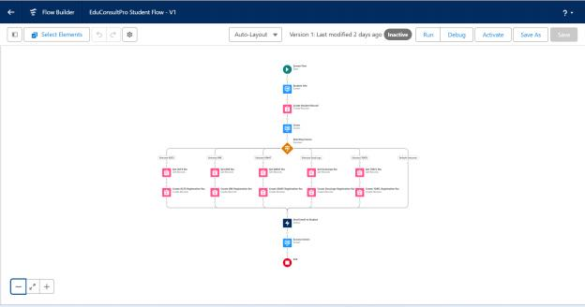

**Task-3: Creating a New User in Salesforce**

**1.1 Create a User with a Standard Platform User Proﬁle**

**1. Access User Setup:**

● Navigate to **Setup** in Salesforce.

● Go to **Administration** → **Users** → **Users**.

● Click on **New User**.

**2. Create User:**

● **Last Name:** Enter "Consultant."

● **License:** Select **Salesforce Platform**.

● **Proﬁle:** Select **Standard Platform User**.

● Fill in all mandatory ﬁe lds, including:

● First Name

● Email

● Username

● Alias

● Click **Save** to create the user.

**1.2 Conﬁgure the User Settings**

**1. Edit User Settings:**

● Return to **Setup** → **Administration** → **Users**.

● Find the newly created user "Consultant" and click **Edit** next to their name.

**2. Conﬁgure Approver Settings:**

● Scroll down to the bottom of the page to **Approver Settings**.

● In the **Manager** ﬁeld, select "Consultant."

● Click **Save** to apply the changes.

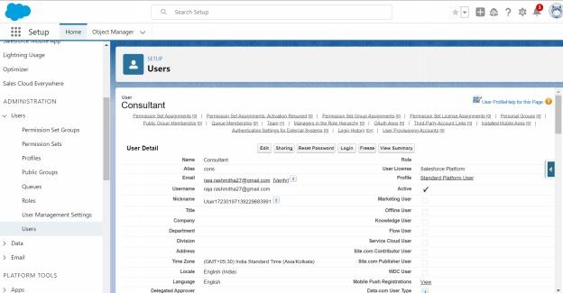

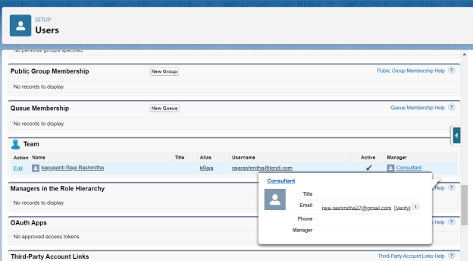

**Task-4: Creating an Approval Process for the Property Object**

**1.1 Create an Email Template**

**1. Access Lightning Email Templates:**

● From **Setup**, enter "Templates" in the Quick Find box.

● Select **Lightning Email Templates** and toggle it on.

**2. Create a New Folder for Email Templates:**

● Go to **App Launcher** and search for **Email Templates**.

● Create a new folder with your desired name.

**3. Create a New Email Template:**

● Within the folder you just created, click to create a new email template.

● Enter the following details:

■ **Folder:** Select the folder you created.

■ **HTML Value:** Use the provided text below and save the template as **"Submission Template"**.

**4. Create Additional Email Templates:**

● Create two more email templates following the same process for **Approval** and **Rejection** of requests.

**1.2 Create an Approval Process for Appointment Object**

**1. Access Approval Processes:**

● From **Setup**, enter "Approval" in the Quick Find box.

● Select **Approval Processes**.

**2. Create a New Approval Process:**

● Under **Manage Approval Processes For**, select **Appointment**.

● Click **Create New Approval Process** → Use **Jump Start Wizard**.

**3. Conﬁgure the Approval Process:**

● **Process Name:** Enter **"Appointment Approval"**.

● **Select Approver:** Choose **Manager** for the option **"Automatically assign an approver using a standard or custom hierarchy ﬁeld "**

● Click **Next**.

● Under **Next Automated Approver Determined By**, select **Manager**.

● **Record Editability Properties:** Choose **"Administrators OR the currently assigned approver can edit records during the approval process "**

● Save the approval process.

**4. Add Initial Submission Actions:**

● Click **View Approval Process Detail Page**.

● Under **Initial Submission Actions**, click **Add New** → **Field Update**.

● Conﬁgure it with the following values:

■ **Name:** Submitted

■ **Field to Update:** Appointment: Status

■ **A Speciﬁc Value:** Pending

**5. Add Email Alert:**

● Click **Add New** → **Email Alert**.

● Conﬁgure it with the following values:

■ **Description:** Submission Email Alert

■ **Unique Name:** Auto Populates

■ **Email Template:** Submission Template

■ **Recipient Type:** Select your Name

**6. Repeat for Final Approval and Rejection Actions:**

● Repeat Steps 4 and 5 for **Final Approval** and **Final Rejection** actions, using the corresponding email templates.

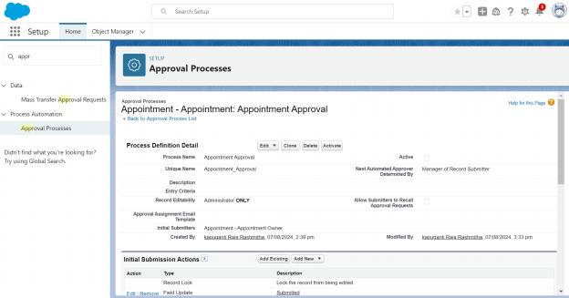

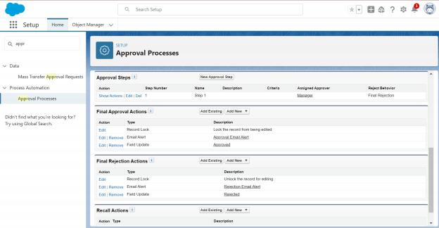

**Task-5: Create a Record-Triggered Flow**

**1.1 Conﬁgure the Start Element**

**1. Access Flows:**

● From **Setup**, enter **Flows** in the Quick Find box.

● Select **Flows**.

**2. Create a New Flow:**

● Click **New Flow**.

● Select **Record-Triggered Flow**.

● Click **Create** to open the Conﬁgure Start window.

**3. Conﬁgure Start:**

● **Object:** Select **Appointment**.

● **Trigger the Flow When:** Select **A record is created**.

**1.2 Add an Action Element**

**1. Add Action Element:**

● After the Start Element, click to add an **Action** element.

● Select the **Submit for approval** action.

● **Label the Action:** Name it **Approval SubFlow**.

**2. Set the Record Id:**

● Set the **Record Id** to **“{!$Record.Id}”** .

**1.3 Save and Activate the Flow**

**1. Save the Flow:**

● **Label:** Name the ﬂow **"EduConsultPro Approval Flow"**.

● Click **Save**.

**2. Activate the Flow:**

● Click on **Activate** to make the ﬂow live.

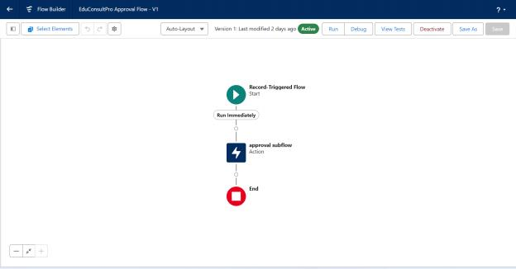

**Task-6: Create a Screen Flow for Existing Students to Book an Appointment**

**1.1 Add Screen Element**

**1. Access Flow Builder:**

● From **Setup**, enter **Flow Builder** in the Quick Find box.

● Select **New Flow** → **Screen Flow**.

**2. Add a Screen Element:**

● Add a **Screen** element.

● In the **Screen Properties** pane, for **Label**, enter **"Get Student Info"**.

● Add two **Text** components from the left panel:

■ **1st Text Component Label:** Enter Student Name

■ **2nd Text Component Label:** Enter Student Email

● Click **Done**.

**1.2 Add GET Record Element**

**1. Add a GET Record Element:**

● Add a **GET Record** element after the **Decision** element, label it as **"Get Rec"**.

● **Select Object:** Student

● **Condition Requirements:** All Conditions are Met (AND)

■ **Field:** Student Name

○ **Operator:** Equals

○ **Value:** {!Enter_Student_Name}

■ **Field:** Email__c

○ **Operator:** Equals

○ **Value:** {!Enter_Student_Email}

**1.3 Add Decision Element**

**1. Add a Decision Element:**

● Add a **Decision** element after the **Select Display Student Details** element, label it as **"Appointment or Case"**.

● **Outcome Label:** Appointment

■ **Condition:**

○ **Resource:** {!How_may I Help_you}

○ **Operator:** Equals

○ **Value:** {!Book_an_Appointment}

● Click the **+** icon and repeat step 2 for the **Case** options.

● Click **Done**.

**1.4 Add Screen Element for Appointment Booking**

**1. Add a Screen Element:**

● Add a **Screen** element after the **Decision** element on the Appointment path, label it as **"Appointment Booking Screen"**.

● Click on **Fields**, select the record variable input, and create a new Resource (AppointmentRecord Res) to display all the ﬁe lds in the **Appointment** object.

● Drag the necessary ﬁe lds to the screen to collect student information.

● Click **Done**.

**1.5 Add GET Record Element for Consultant**

**1. Add a GET Record Element:**

● Add a **GET Record** element after the **Decision** element, under the Appointment path, and label it as **"Get Consultant Rec"**.

● **Select Object:** Consultant

● **Condition Requirements:** All Conditions are Met (AND)

■ **Field:** Name

○ **Operator:** Equals

○ **Value:** {!AppointmentRecord Res.Consultant_Name__c}

**1.6 Create Appointment Record using Create Records Element**

**1. Add a Create Records Element:**

● Add a **Create** element after the **Get Consultant Rec** element, label it as **"Create Appointment"**.

● **How many records to create:** One

● **How to set the record ﬁelds:** Use separate resources and literal values.

● **Select Object:** Appointment

■ **Field:** Appointment_DateTime__c

○ **Value:** {!AppointmentRecord Res.Appointment_DateTime__c}

■ **Field:** Consultant__c

○ **Value:** {!Get_Consultant_Rec.Id}

■ **Field:** Notes__c

○ **Value:** {!AppointmentRecord Res.Notes__c}

■ **Field:** PurposeTopic__c

○ **Value:** {!AppointmentRecord Res.PurposeTopic__c}

■ **Field:** Student_Name__c

○ **Value:** {!Get_Rec.Id}

**1.7 Add Conﬁrmation Screen Element**

**1. Add a Screen Element:**

● Add a **Screen** element after the **Send Email to Student Action** element, label it as **"Conﬁrmation Screen"**.

● From the left panel, drag the **Display Text** component to the main panel, label it as **"Appointment_Conﬁrmation"**.

● Add the data in the Resource picker box

● Click **Done**.

**1.8 Add SubFlow Element**

**1. Add a SubFlow Element:**

● Add a **SubFlow** element after the **Decision** element, on the **Case** path.

● Search and select **Create a Case**.

● Label it as **"Create Student Case"**.

**1.9 Save and Activate the Flow**

**1. Save the Flow:**

● **Label:** Name the ﬂow **"EduConsultantPro Existing Student Flow"**.

● Click **Save**.

**2. Activate the Flow:**

● Click **Activate** to make the ﬂow live.

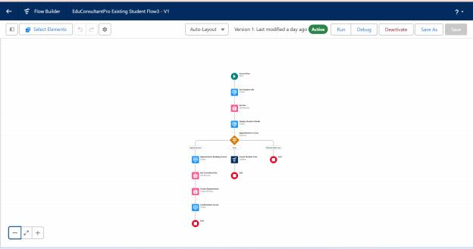

**Task-7: Create a Screen Flow to Combine All Flows**

**1.1 Add Welcome Screen Element**

**1. Add a Screen Element:**

● Add a **Screen** element.

● **Label:** Enter **"Welcome Screen"**.

**2. Conﬁgure Display Text:**

● From the left side panel, search for the **Display Text** component and drag it to the main panel.

● **Label:** Enter **"SuccessMessage"**.

● **Resource Picker Box Content:** Add the content

● Click **Done**.

**1.2 Add Existing or New Student Conﬁrmation Screen**

**1. Add a Screen Element:**

● Add a **Screen** element after the **Welcome Screen** element.

● **Label:** Enter **"Existing or New Student Conﬁrmation Screen"**.

**2. Add Radio Button Component:**

● From the left side panel, add a **Radio Buttons** component.

● **Label:** Enter **"Are you an Existing Student"**.

● Click **Add Choice**:

■ **Type:** Enter **"Yes"** and click **Create Yes Choice**.

■ Repeat for **"No"** choice.

● Click **Done**.

**1.3 Add Decision Element**

**1. Add a Decision Element:**

● Add a **Decision** element after the **Existing or New Student Conﬁrmation Screen** element.

● **Label:** Enter **"Decision 1"**.

**2. Conﬁgure Outcomes:**

● **Outcome Label:** If Existing Student

■ **Condition:**

○ **Resource:** {!Are_you_an_Existing_Student}

○ **Operator:** Equals

○ **Value:** {!Yes}

● Click the **+** icon and repeat for **No** options.

● Click **Done**.

**1.4 Add SubFlow Elements**

**1. Add SubFlow for Existing Students:**

● Add a **SubFlow** element after the **Decision 1** element on the **If Existing Student** path.

● Search and select **"EduConsultantPro Existing Student Flow"**.

● **Label:** Enter **"Existing Student Flow"**.

**2. Add SubFlow for New Students:**

● Add a **SubFlow** element after the **Decision 1** element on the **If Not an Existing Student** path.

● Search and select **"EduConsultantPro Student Flow"**.

● **Label:** Enter **"New Student Flow"**.

**1.5 Save and Activate the Flow**

**1. Save the Flow:**

● **Label:** Enter **"EduConsultPro Flow"**.

● Click **Save**.

**2. Activate the Flow:**

● Click **Activate** to make the ﬂow live.

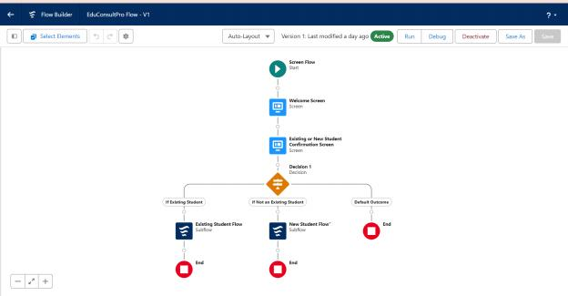

**Task-8: Create and Assign a Lightning App Page**

**1.1 Create a Lightning App Page**

**1. Access Lightning App Builder:**

● From **Setup**, enter **App Builder** in the Quick Find box.

● Click on **Lightning App Builder**.

**2. Start Creating a New Page:**

● Click **New**.

● Select **Home Page**.

● Click **Next**.

**3. Conﬁgure the Page:**

● **Page Name:** Enter **"EduConsultPro Home Page"**.

● **Template:** Select the **Standard Home Page** template.

● Click **Done**.

**4. Add Flow Component:**

● Drag the **Flow** component to the **top-right region** of the page.

**5. Search and Conﬁgure Flow:**

● **Search for:** “ EduConsultantPro Flow” .

● Select it and click **Save**.

**1.2 Activate the Lightning App Page**

**1. Activate the Page:**

● Click **Activate**.

**2. Assign Page to Apps and Proﬁles:**

● Click **App and Proﬁle**.

● Click **Assign to Apps and Proﬁles**.

**3. Conﬁgure App Assignment:**

● **Select App:** Choose the **Sales app**.

● Click **Next**.

**4. Conﬁgure Proﬁle Assignment:**

● Scroll down the list of proﬁles and select **System Administrator**.

● Click **Next**.

**5. Review and Save:**

● Review the assignment details.

● Click **Save**.

