Himanshu Shekhar Murmu
244ca019
05/03/2025

1. List all students who have taken exactly 120 total credits .
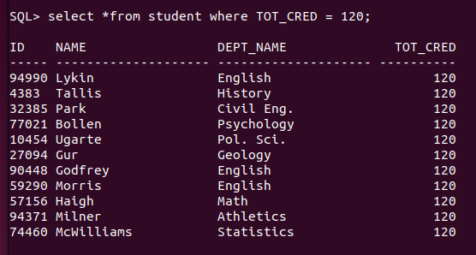
2. Find the names of all course offered by the “Civil Engi” department.
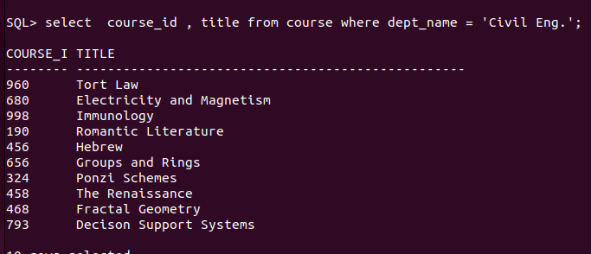
3. Retrieve the name of all instructor who earn exactly 60000.
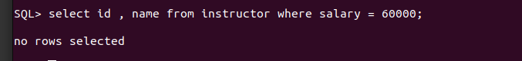
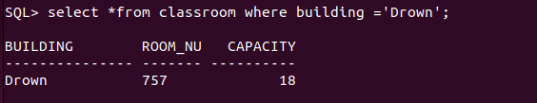
4.List all the classroom located in the “Drown” building.

5. Find the total number of courses offered in the "Summer" semester.
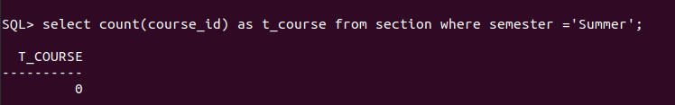

6. List all students who have taken exactly 150 total credits.
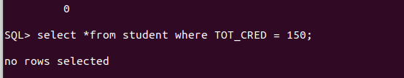
7. Find the names of all courses offered by the "Aerospace Engineering" department.
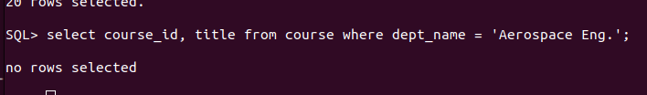
8. Retrieve the names of all instructors who earn exactly ₹80,000.
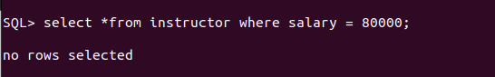

9. List all classrooms located in the "Smith" building.
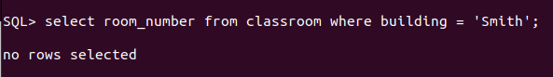
10. Find the total number of courses offered in the "Fall" semester .
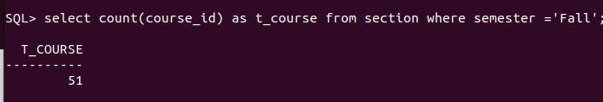

11. List all students who have taken courses with a grade of "A" in the "Spring" semester of
2023.

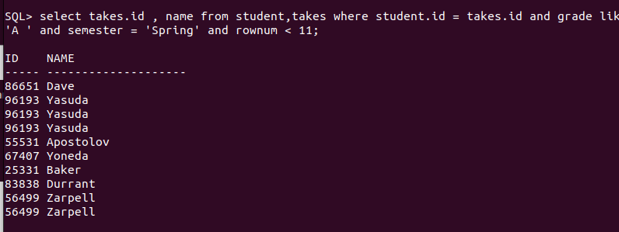
12. Retrieve the names of instructors who have taught in the "Winter" semester of 2022.
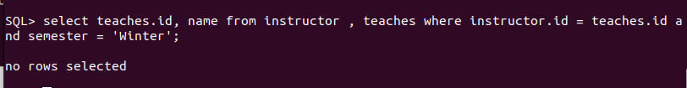

13. Find the average number of students per section in each course.

14. List all courses that have exactly 5 credit.
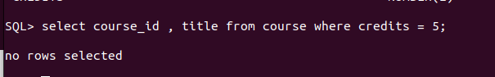
15. Retrieve the names of students who have taken courses in the "Palmer" building.
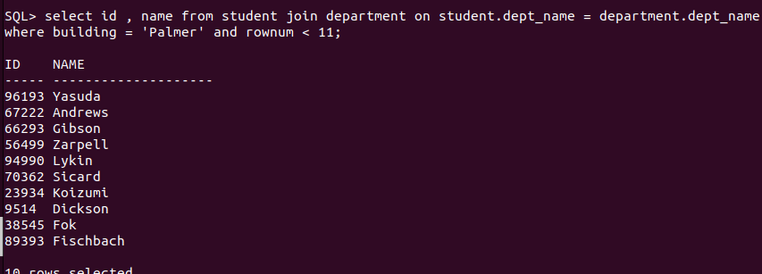

16. Find the total number of sections held in each building.

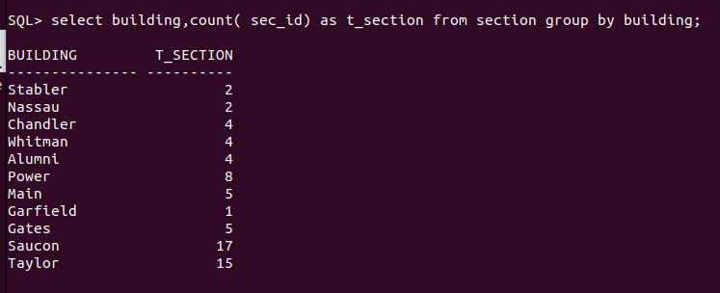
17. List all sections that are held in rooms with a capacity of more than 50.
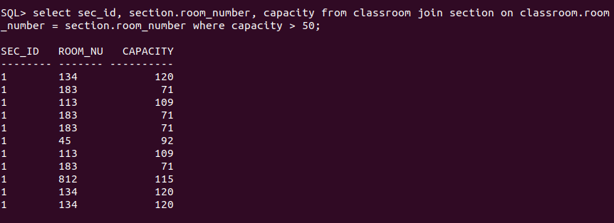
18. Retrieve the names of students who have taken courses with the highest number of
credits in their university.
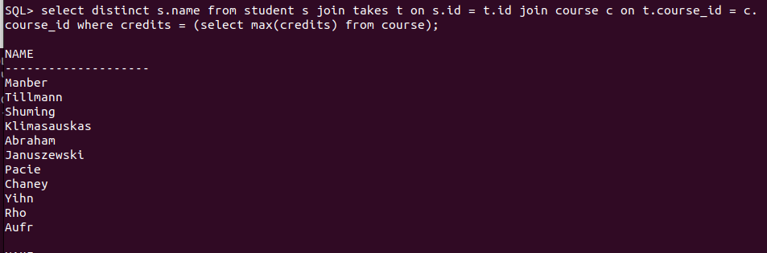

19. Find the departments with the highest number of course.

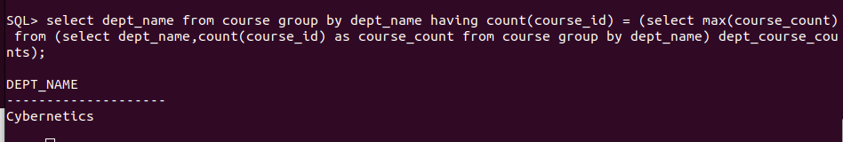

20. List all courses that have been taught by more than 2 instructors.
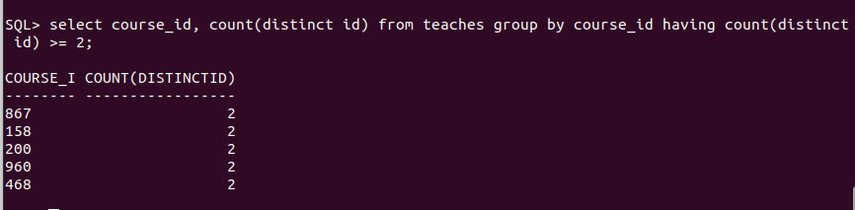

21. List all students who have taken courses with a grade of "B" in the "Summer" semester of
2023.
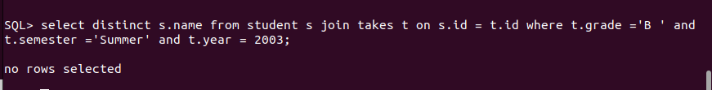
22. Retrieve the names of instructors who have taught in the "Spring" semester of 2021.
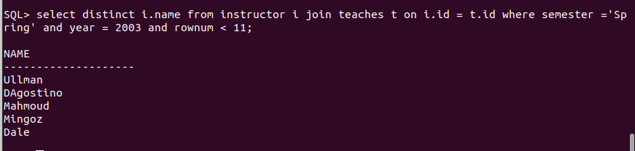
23. Find the average number of credits per student in each department.
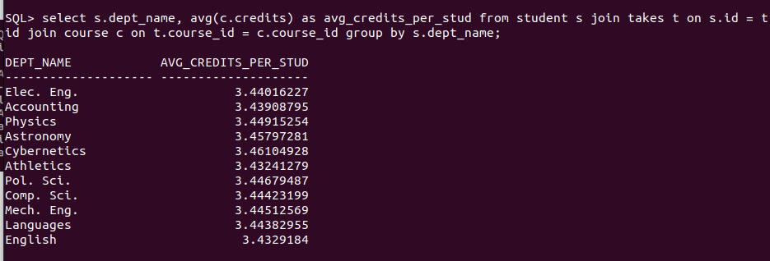

24. List all courses that have exactly 6 credits.

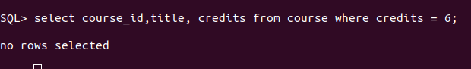

25. Retrieve the names of students who have taken courses in the "Lambert" building.
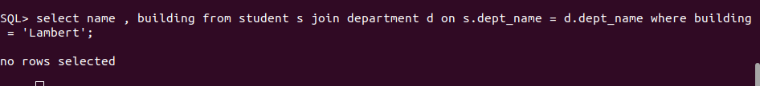

28. Retrieve the names of students who have taken courses with the lowest number of
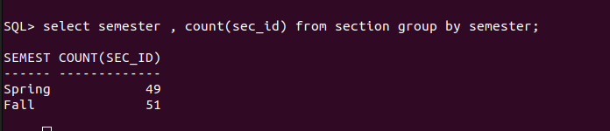
credits in their department.26. Find the total number of sections taught by each semester.

27. List all sections that are held in rooms with a capacity of exactly 200.

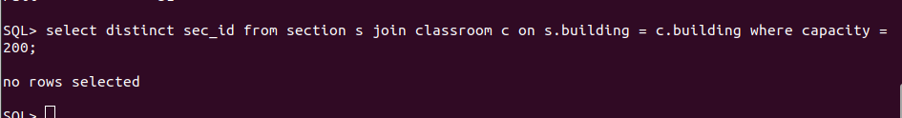
28. Retrieve the names of students who have taken courses with the lowest number of
credits in their department.
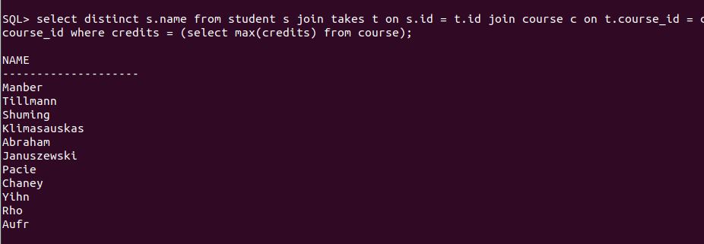

29. Find the departments with the lowest number of course.
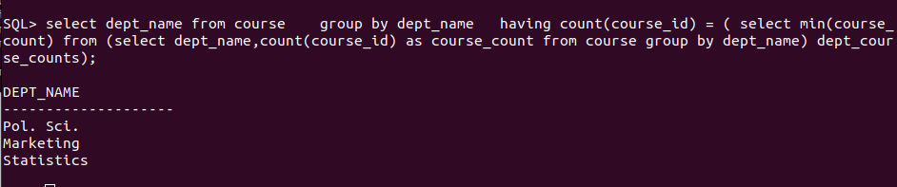
30. List all courses that have been taught by exactly 3 instructors.

