FLOOD SUSCEPTIBILITY MAP MAKING
INPUTS REQUIRED:
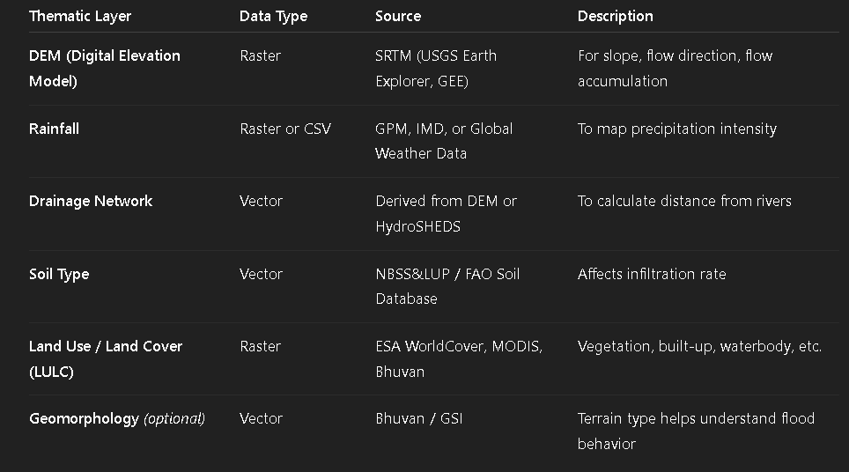

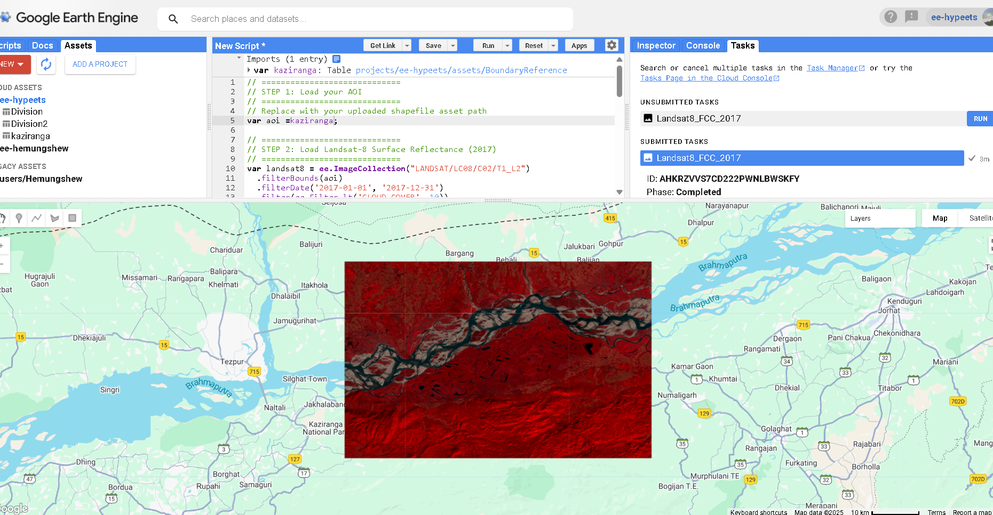

LULC – with & without *builtup*
DIVA GIS for River (Brahmaputra .shp)
Downloaded the River shp for distance from river https://www.hydrosheds.org/products/hydrorivers#downloads
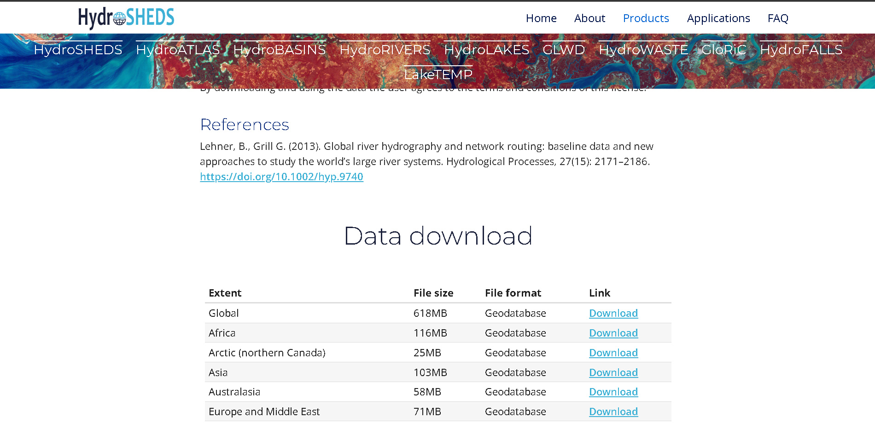
Optional refinement (for more precision)
If your Asia rivers shapefile includes many tiny or irrelevant streams (like drainage lines that don’t exist in your DEM), you can:
- Open Attribute Table → Select by Length (e.g., select streams longer than 1 km).
- Export selection as a new shapefile.
- Use that for Euclidean Distance.
→ This filters out noise while keeping all main and secondary channels.
• Source: https://www.hydrosheds.org/products/hydrorivers
• Coverage: Global, includes the Brahmaputra and all its tributaries.
• Format: Shapefile (.shp)
• Year: Based on SRTM data (~2000), but widely used for hydrological basins and river flow network.
• How to Use:
- Download HydroRIVERS Asia shapefile.
- Clip it using your AOI boundary (Kaziranga / Assam) in ArcMap or QGIS.
- Optionally, filter by MAIN_RIV = "Brahmaputra".

FOR RAINFALL DATA IMD NETCDF FILE DOWNLOADED FOR YEAR 2017

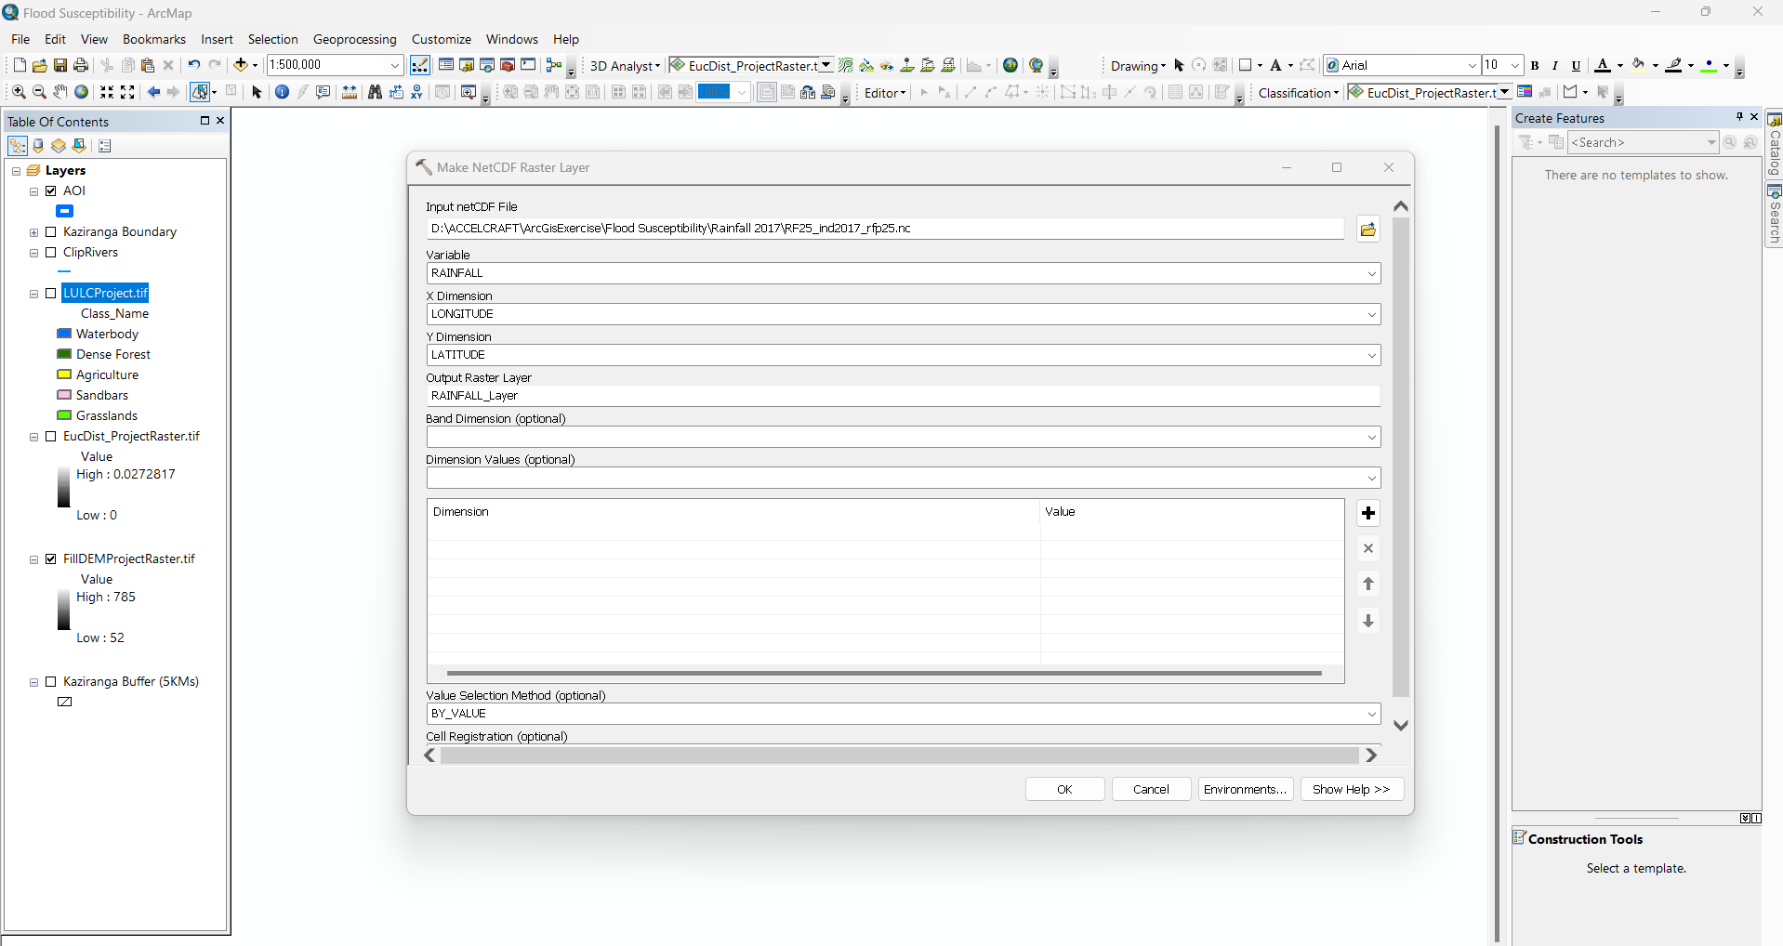

GEE RAINFALL MAP FROM CHIRPS
// --------------------------
// 1. Define your AOI
// Replace with your uploaded AOI asset
var aoi = ee.FeatureCollection('users/yourusername/aoi');

// --------------------------
// 2. Load CHIRPS daily rainfall for 2017
var dailyRain = ee.ImageCollection("UCSB-CHG/CHIRPS/DAILY")
.filterDate('2017-01-01', '2017-12-31');

// --------------------------
// 3. Aggregate daily rainfall to annual rainfall
var annualRain = dailyRain.reduce(ee.Reducer.sum());

// --------------------------
// 4. Clip annual rainfall to AOI
var annualRainClipped = annualRain.clip(aoi);

// --------------------------
// 5. Visualize on map
Map.centerObject(aoi, 9);
Map.addLayer(annualRainClipped, {
min: 0,
max: 4000, // adjust according to expected rainfall
palette: ['lightblue','blue','darkblue']
}, 'Annual Rainfall 2017');

// --------------------------
// 6. Export the annual rainfall map as GeoTIFF
Export.image.toDrive({
image: annualRainClipped,
description: 'AnnualRainfall2017',
scale: 5000, // adjust for resolution (5km ~ CHIRPS)
region: aoi.geometry(),
fileFormat: 'GeoTIFF',
maxPixels: 1e13
});

Weighted Overlay INFLUENCE

