**Roll no: 119**

**Name: Hemangi Dnyaneshwar Shinde.**

**Assignment no:**

**Assignment Name:**

* **For loop using range() function:-**

for x in range(6):  
 print(x)

**Output:**

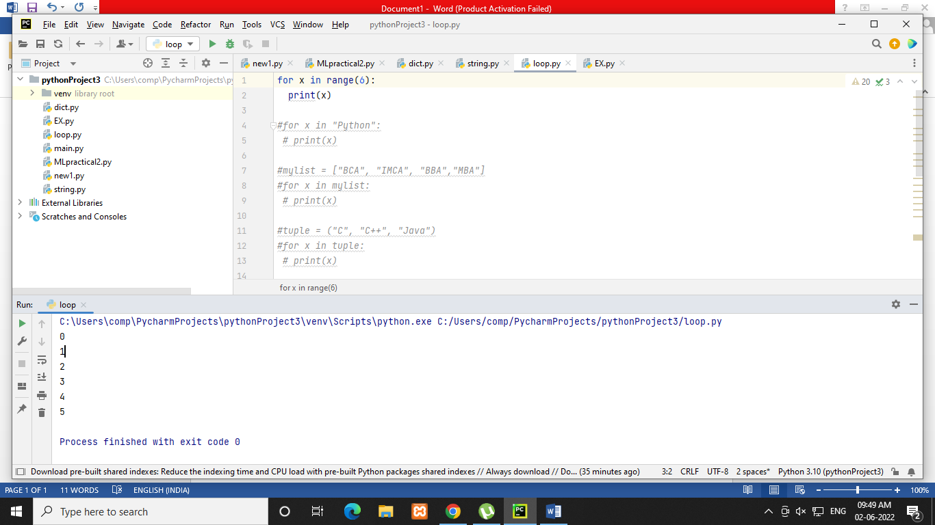

* **For loop using string:**

for x in "Python":  
 print(x)

**Output:**

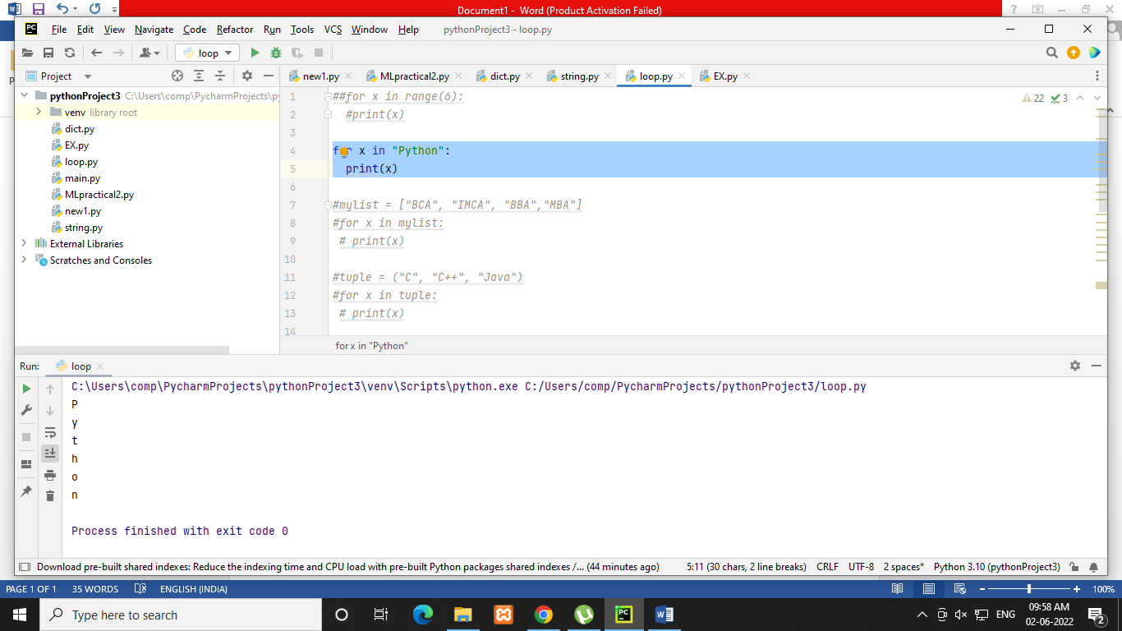

* **For loop using list:**

mylist = ["BCA", "IMCA", "BBA","MBA"]  
 for x in mylist:  
 print(x)

**Output:**

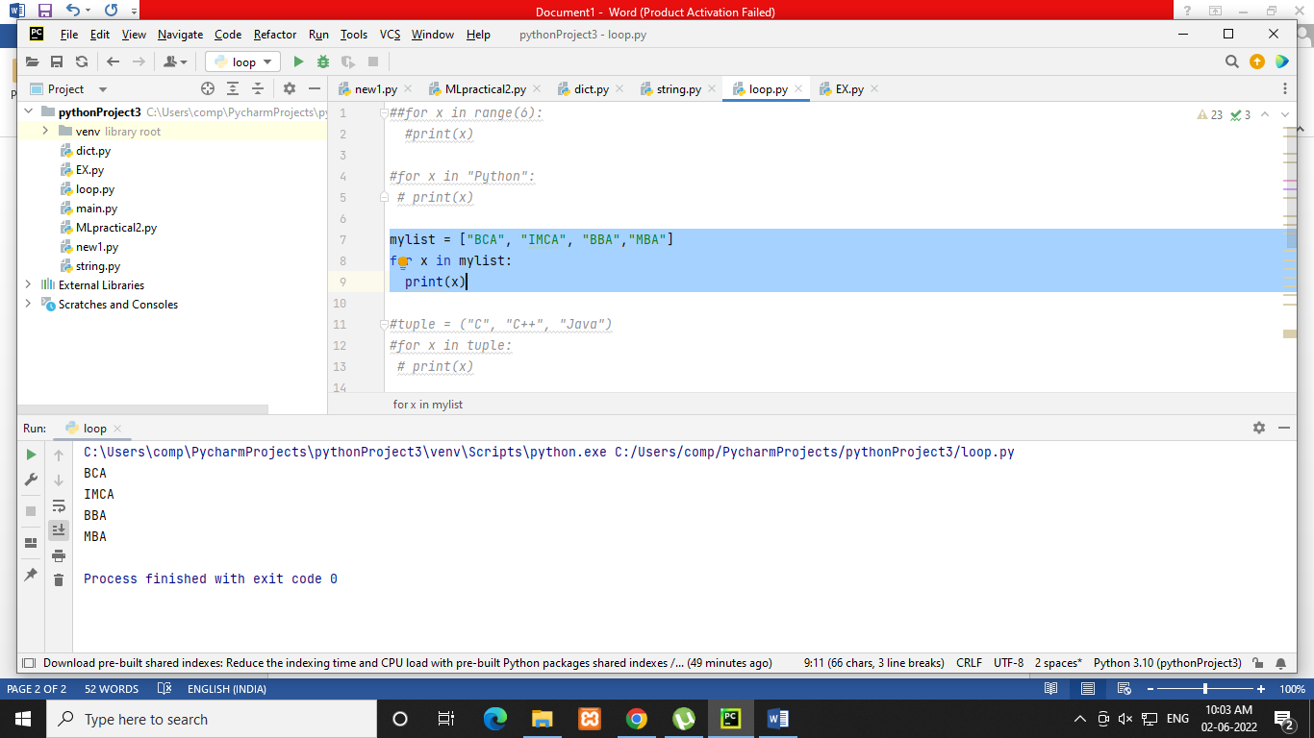

* **For loop using tuple :**

tuple = ("C", "C++", "Java")  
 for x in tuple:  
 print(x)

**Output:**

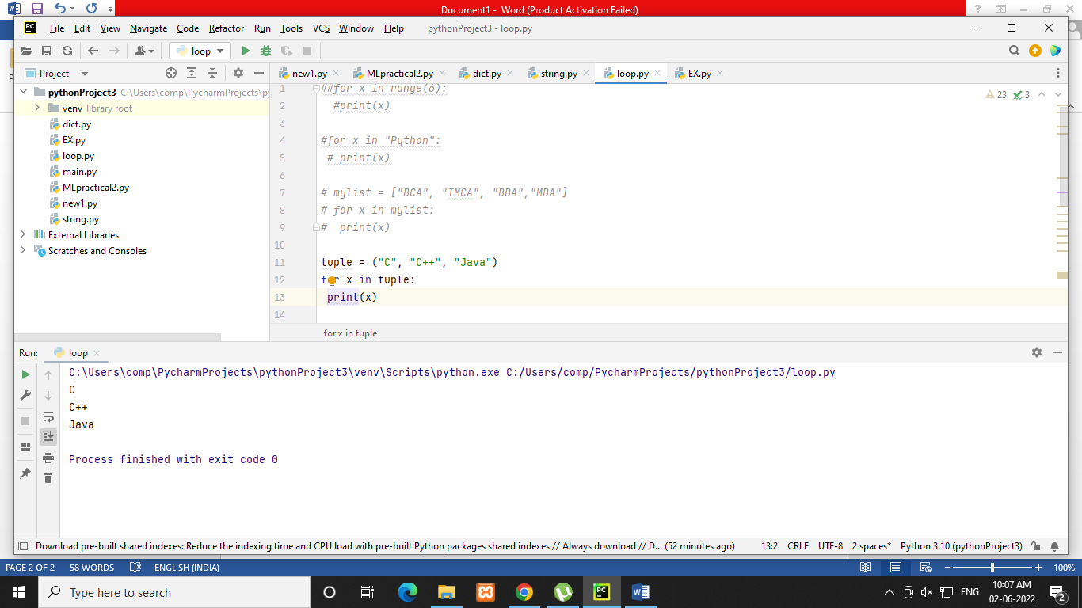

* **For loop using dictionary :**

dict = {  
 "name": "Niyati",  
 "college": "IMR",  
 "course": "IMCA"  
 }  
 for x in dict:  
 print(x)

**Output:**

