**FOURTH** **YEAR** **SEMINAR** **REPORT**

**DRUPAL 8(A CMS BASED ON OOPs)**

Submitted in partial fulfilment of the degree of Bachelor of Technology Rajasthan Technical University



By

**Hemant Vyas**

**(PGI16CE017)**

DEPARTMENT OF COMPUTER ENGINEERING

POORNIMA GROUP OF INSTITUTIONS

(Academic Year 2019-20)

**FOURTH** **YEAR** **SEMINAR** **REPORT**

**DRUPAL 8(A CMS BASED ON OOPs)**

Submitted in partial fulfilment of the degree of Bachelor of Technology Rajasthan Technical University



By

**Hemant Vyas**

**(PGI16CE017)**

DEPARTMENT OF COMPUTER ENGINEERING

POORNIMA GROUP OF INSTITUTIONS

(Academic Year 2019-20)



**CERTIFICATE**

This is to certify that Final Year Practical Training Seminar Report entitled “**DRUPAL 8(A CMS BASED ON OOPs)**” has been submitted by “HEMANT VYAS (PGI16CE017)” for partial fulfilment of the Degree of Bachelor of Technology of Rajasthan Technical University. It is found satisfactory and approved for submission.

Date: 26/03/2020

Mr. Deepak Moud

Head,

Dept. of Comp Engg

PIET, Jaipur

Dr. Dinesh Goyal

Director,

PIET, Jaipur

**DECLARATION**

I hereby declare that the seminar report entitled “**DRUPAL 8(A CMS BASED ON OOPs)**" was carried out and written by me under the guidance of Mr. Vikram Khandelwal (Assistant Professor), Department of Computer Engineering, Poornima Institute of Engineering & Technology, Jaipur. This work has not been previously formed the basis for the award of any degree or diploma or certificate nor has been submitted elsewhere for the award of any degree or diploma.

Place:Jaipur

Date: 26/03/2020

Hemant Vyas

PGI16CE017

**ACKNOWLEDGEMENT**

A project/Seminar topic of such a vast coverage cannot be realized without help from numerous sources and people in the organization. I am thankful to **Dr.** **Dinesh** **Goyal,** **Director,** for providing me a platform to carry out such a training successfully.

I am also very grateful to **Mr.** **Deepak** **Moud** **(HOD,** **CE)** for his kind support.

I would like to take this opportunity to show my gratitude towards **Dr.** **Anil Kumar and Mr. Sumit Mathur** **(Seminar** **Coordinator,** **PTS)** who helped me in successful completion of my Fourth Year Seminar Topic. They have guided, motivated & were source of inspiration for me to carry out the necessary proceedings for the training to be completed successfully.

I am thankful to **Seminar** **Guide** **Mr. Vikram Khandelwal** for his kind support and providing me expertise of the domain to develop the project on ‘Data Security In Cloud Computing’.

I am also privileged to have **Mr. Vikram Khandelwal** who has flourished me with his valuable facilities without which this work cannot be completed.

I would also like to express my hearts felt appreciation to all of my friends whose direct or indirect suggestions help me to develop this project [and to entire team members for their valuable suggestions.

Lastly, thanks to all faculty members of Computer Engineering department for their moral support and guidance.

Submitted by:

**Student** **Name:**

**Hemant Vyas**

**ABSTRACT**

Drupal8 is a open source CMS (content management system) cum CMF (Content management framework) that is gaining in popularity. Due to the reason of flexibility that both developers and it’s user have while using Drupal8 for their websites it’s becoming popular. Since Drupal is open source, it is heavily supported by it’s community of developers who contribute to it and provide additional modules for anyone to use who may require it.

Drupal8 is the latest release of drupal community and also it’s most successful release till today. It sets a standard ease of use, and allow it’s users to manage their content in the most efficient and secured way ever possible. Drupal8 is the choice of every prestigious brand, government, college, universities, NGOs and many more, so that they can engage with it’s visitors on websites and beyond, to deliver the content to them rightfully and efficiently.

Keywords:-

CMS, XSS, CSRF, HIPCAA, OWASP, CDN

Implementation Software and Hardware:

Docker for Drupal 8 Composer Version.

**Table** **of** **Contents**

**Description** Title Certificate Declaration

Acknowledgement Abstract

List of Tables List of Figures

List of Abbreviations

Chapter 1: Introduction to CMS

1.1: Introduction

1.2: Significance of Topic Chapter 2: Technology Specification

2.1: Introduction to Drupal8

2.2: Benefits of Drupal8

2.3: Basic Architecture of Drupal8

2.4: History of Drupal8

Chapter 3: Topic Description

3.1: Why we need drupal8?

3.2: Security in Drupal8

3.3: Scalability of Drupal8

3.4: Easy Content Authoring

3.5: Multilingual

3.6: Content as a Service

Chapter 4: Snapshots

4.1: Front controller of Drupal8 with OOPs, PSR-4

4.2: Overriding Theme layout

4.3: Views of Drupal8

4.4: Request to Response object of Drupal8

Chapter 5: Limitations

Chapter 6: Future Scope

References

**Page** **No.** i ii iii iv v

vii viii ix

1 1 2 4 4 5 6 9

11

11

11

15

16

16 18 212122

23

24

25

26

27

**List** **of** **Figures**

**Figure** **No.** 2.1

**Title**

Front Page of Drupal8 after installation

**Page** **No.**

5

2.2 Basic Architecture of Drupal8 8

3.1 User management in Drupal8 13

**List** **of** **Abbreviations**

CMS Content Management System

XSS Cross Site Scripting

CSRF Cross-site request forgery

PCI Payment Card Industry

HIPAA Healthcare Information Portability and Accountability Act

OWASP Open Web Application Security Project

CDN Content Delivery Network

**Chapter** **1**

**Introduction** **to** **CMS**

**1.1** **Introduction**

A content management system (CMS) is a software application that can be used to manage the creation and modification of digital content. CMSs are typically used for enterprise content management (ECM) and web content management (WCM). ECM typically supports multiple users in a collaborative environment by integrating document management, digital asset management and record retention. Alternatively, WCM is the collaborative authoring for websites and may include text and embed graphics, photos, video, audio, maps and program code that display content and interact with the user. ECM typically includes a WCM function.

A (CMS) typically has two major components: a content management application (CMA), as the front-end user interface that allows a user, even with limited expertise, to add, modify, and remove content from a website without the intervention of a webmaster; and a content delivery application (CDA), that compiles the content and updates the website.

The core CMS features are; indexing; search and retrieval; format management; revision control; and management.

Features may vary depending on the system application but will typically include:

1) Intuitive indexing, search and retrieval features index all data for easy access through search functions and allow users to search by attributes such as publication dates, keywords or author.

2) Format management facilitates turn scanned paper documents and legacy electronic documents into HTML or PDF documents.

3) Revision features allow content to be updated and edited after initial publication. Revision control also tracks any changes made to files by individuals.

4) Publishing functionality allows individuals to use a template or a set of templates approved by the organization, as well as wizards and other tools to create or modify content.

Popular additional features may include:

* SEO-friendly URLs
* Integrated and online help, including discussion boards
* Group-based permission systems
* Full template support and customisable templates
* Easy wizard-based install and versioning procedures
* Admin panel with multiple language support
* Content hierarchy with unlimited depth and size
* Minimal server requirements
* Integrated file managers
* Integrated audit logs

**1.2** **Significance** **of** **CMS**

CMS or Content Management System is basically an application that provides certain capabilities to its users in order to help manage content such as editing, archiving, creating, publishing and distributing of data and information. In other simple words, it enables its users (even those without the understanding of HTML) to effectively manage the contents of their webpage.

1.Increase in Efficiency

Building a website from scratch without CMS, you will easily find yourself lost in your computer screen, working hours and hours choosing the right font or layout, wasting precious time on one individual aspect or another and after all this trouble, still not satisfied in the end.

However, with CMS, you can easily build pages and sites in comparatively much less time along with easily and effectively publishing content (as editing and revisions hardly require any visual design or coding knowledge) which, in turn, will eventually lead to faster and efficient updates than working on one without CMS.

2.Ensure Device/Platform Compatibility

Since we use a variety of mobile devices (of different screen sizes) to access web applications, the importance of responsive web design cannot be underestimated. Mobile Content Management with the help of various features such as navigation, readability, and ease of access plays an important role in making your website responsive for better user experience.

3.Cost-Effectiveness

Opting for an open-source CMS will drastically help reduce the cost of building and maintaining your website as you don’t have to worry about building it from scratch which generally costs 5 to 10 times higher and takes much longer to complete.

You will also save the money, you would pay otherwise to the website developer for every minor change you need to make every time. With CMS, you don’t have to pay and wait for the website developer to finish since you can update all the content on your own.

4.Improve SEO Ranking

CMS not only allows you to develop a content marketing strategy by optimizing your meta-descriptions, keywords, title, etc. all from a single source location based on data collected from leads, sales, and traffic but also offers smart recommendations for best practices also.

Apart from the above, it can also help boost your SEO ranking by making clickable links, adding paragraph tags and suggesting numerous other formatting practices, not to forget the external contribution in the form of comments, likes, forums, etc. to help keep your website relevant.

5.Ease of Access and Control

CMS has not only made content sharing easier by consolidating content into a single repository which further minimizes content redundancy but also incorporated a workflow engine that facilitates content creation, editing, approval, etc. via a collaborative effort of multiple contributors before publishing.

It even reduces security threats by providing unique IDs to allow access to authorized users only thus eliminating the chances of any unauthorized access to the content.

6.Effortless Customization

The biggest reason why you should go for a CMS even if you are a newbie is that of its easy customization solutions (which makes navigation and workflow easy to operate) and its flexibility (which determines the kind of features and functionalities to be added).

Another important thing is your website doesn’t have to undergo a complete website overhaul every time you need to add some new features as the content, functionality and web design can be handled separately without affecting the others.

**Chapter** **2**

**Technology** **Specification**

**2.1** **Introduction** **to** **Drupal8**

Drupal is a free and open-source web content management framework written in PHP and distributed under the GNU General Public License. Drupal provides a back-end framework for at least 2.3% of all websites worldwide – ranging from personal blogs to corporate, political, and government sites. Systems also use Drupal for knowledge management and for business collaboration.

As of December 2019, the Drupal community comprised more than 1.39 million members, including 117,000 users actively contributing, resulting in more than 44,000 free modules that extend and customize Drupal functionality, over 2,800 free themes that change the look and feel of Drupal, and at least 1,300 free distributions that allow users to quickly and easily set up a complex, use-specific Drupal in fewer steps.

The standard release of Drupal, known as Drupal core, contains basic features common to content-management systems. These include user account registration and maintenance, menu management, RSS feeds, taxonomy, page layout customization, and system administration. The Drupal core installation can serve as a simple website, a single- or multi-user blog, an Internet forum, or a community website providing for user-generated content.

Drupal also describes itself as a Web application framework. When compared with notable frameworks Drupal meets most of the generally accepted feature requirements for such web frameworks.

Although Drupal offers a sophisticated API for developers, basic Web-site installation and administration of the framework require no programming skills.

Drupal runs on any computing platform that supports both a web server capable of running PHP and a database to store content and configuration.

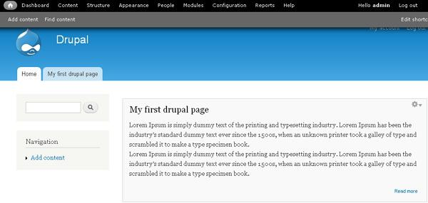

**Fig 2.1 Front page of Drupal 8 after installation**

**2.2** **Benefits of Drupal 8**

Drupal is one of the most popular open source content management systems (CMS) available. It is a robust website content management platform that is used by professional web developers throughout the world. Drupal is used in over 200 countries, it is available in 182 languages and nearly 400,000 websites run on Drupal.

Drupal is such a stable CMS and has such an infinite capacity for development that it is used successfully by many large global organisations

Drupal has all the basic features you need to create both simple and more complex websites – menu management, RSS-feeds, user account registrations, system administration, graphics tools and much more.

It is easy to install and has thousands of themes and templates readily available. All you have to do is upload your chosen template and then write and add your content. All of these templates are ready to go, but for the more advanced users Drupal has a pre-defined configurations feature to enable you to build more complex sites rapidly.

Drupal flawlessly integrates your written text with polls, videos, podcasts and much more. This gives your website the flexibility to mature and expand as you build your brand.

Advanced administrator tools give you the option of setting up multiple user accounts with different levels of access to your website.

There are over 7,000 plugins available that rapidly increase Drupal’s functionality. And because it is open source you can create your own plugins to give your website even greater capacity and functionality.

Drupal has full SEO capabilities and seamlessly integrates with Google analytics.

There is a large worldwide community of developers who are passionate about Drupal and who tirelessly work towards enhancing Drupal’s functionality and security.

**2.3** **Basic** **Architecture** **of** **Drupal8**

Drupal’s founder Dries Buytaert explained some of the reasons why Drupal needed big architectural changes. Forward-looking changes are always necessary for a CMS to stay on top. With Drupal 8 changes, the community wanted to resolve certain limitations of Drupal 7, modernize Drupal as much as possible, and make it universally understandable so that companies of all sizes could easily find developer talent.

To achieve this, Drupal adopted Symfony components, modern PHP concepts, OOP, Twig template engine, and more. It rebuilt its core, APIs, configuration management system, and so on. The results are stunning — Drupal 8 architecture is truly brand-new compared to that of Drupal 7. Let’s take a closer look at some of these changes.

**Drupal 8 and OOP**

Here is something that makes website code better structured, highly reusable, very maintainable and extensible, and also easy to read by non-Drupal developers. This is the adoption of OOP (object-oriented programming) in Drupal 8.

As opposed to traditional, or procedural programming, OOP has most of the code presented as classes and objects of these classes. Objects have certain properties and use certain methods.

The three major principles of OOP include encapsulation, inheritance, and polymorphism. Developers deal with namespaces, indenting and whitespace, naming conventions, and so on.

Sounds complicated? Well, OOP PHP does present a learning curve for developers, which is made up for by numerous benefits.

**Drupal 8: “Symfony inside”**

The new version of Drupal contains the components of Symfony 2 — the modern, object-oriented, PHP-based framework.

It is not necessary for Drupal developers to learn Symfony as a framework — they just need to get acquainted with Symfony components, and the reward is amazing.

With Symfony 2, Drupal development becomes even more flexible and in line with trending technologies.

And, of course, this significantly saves development time. With no need to “reinvent the wheel” and build everything from scratch, Drupal developers can use plenty of ready solutions for various projects.

Among all the inherited Symfony 2 components, the strongest impact on D8 core has probably been made by DependencyInjection, EventDispatcher, and Routing.

**Twig template engine in Drupal 8**

A true “jewel” of Drupal 8 front-end architecture is the Twig template engine that replaces Drupal 7’s PHPTemplate.

Twig gives you clean templates with consistent code. Thanks to its inheritance in Twig files, duplicate code is avoided. The logic and presentation are properly separated. And, overall, Twig is more secure, easier to work with, and richer in options.

“You don’t need extra modules for features like slideshows or widgets on your page. You can do it in the theme,” said Mark Ferree and Matt Cheney in their webinar about best practice architecture in Drupal 8.

**Drupal 8 and Composer**

Composer has been called the best thing that has happened to the world of PHP, and Drupal 8 is now using the best.

This command-line tool manages your website dependencies — all the necessary libraries and packages you need. Composer lists all your website’s dependencies in the special composer.json file.

Saying “dependency manager” cannot fully describe Composer’s powers. The tool is helpful on every step of Drupal 8 development.

A good tone, and a very convenient practice in Drupal 8 allows you to use Composer for installing and updating Drupal core, modules, and themes, applying patches, and more. Commands like “composer create-project” and “composer update drupal/core” are just a couple of examples of numerous commands that can do magic in the terminal.

**Powerful Drupal 8 core**

The heart of Drupal, its core, has become more powerful than it has ever been before. So you no longer need extra modules for many of your needs — a lot of things can be done with D8 core capabilities.

Drupal 8 also introduces lots of new APIs that deal with everything, be it caching, migration, third-party integration or anything else.

The admin dashboard alone is like a flight control console.The Views module is now in the core, and gives you almost unlimited opportunities in structuring and presenting your content in accordance with to all imaginable settings. Intriguing novelties like the Layout Builder module help create layouts for content items and lets anyone feel the architect of their site with no coding as well.

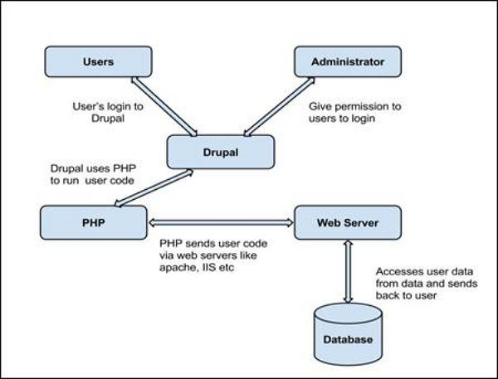 **Fig 2.2 Basic Architecture of Drupal 8**

**2.4 History of Drupal 8**

Originally written by Dries Buytaert as a message board, Drupal became an open source project in 2001. The name Drupal represents an English rendering of the Dutch word druppel, which means "drop" (as in a water droplet). The name came from the now-defunct Drop.org website, whose code slowly evolved into Drupal. Buytaert wanted to call the site "dorp" (Dutch for "village") for its community aspects, but mistyped it when checking the domain name and thought the error sounded better.

Interest in Drupal got a significant boost in 2003 when it helped build "DeanSpace" for Howard Dean, one of the candidates in the U.S. Democratic Party's primary campaign for the 2004 U.S. presidential election. DeanSpace used open-source sharing of Drupal to support a decentralized network of approximately 50 disparate, unofficial pro-Dean websites that allowed users to communicate directly with one another as well as with the campaign. After Dean ended his campaign, members of his Web team continued to pursue their interest in developing a Web platform that could aid political activism by launching CivicSpace Labs in July 2004, "...the first company with full-time employees that was developing and distributing Drupal technology." Other companies began to also specialize in Drupal development. By 2013 the Drupal website listed hundreds of vendors that offered Drupal-related services.

As of 2014 Drupal is developed by a community. From July 2007 to June 2008 the Drupal.org site provided more than 1.4 million downloads of Drupal software, an increase of approximately 125% from the previous year.

As of January 2017 more than 1,180,000 sites use Drupal. These include hundreds of well-known organizations, including corporations, media and publishing companies, governments, non-profits, schools, and individuals. Drupal has won several Packt Open Source CMS Awards and won the Webware 100[clarification needed] three times in a row.

Drupal 6 was released on February 13, 2008, on March 5, 2009 Buytaert announced a code freeze for Drupal 7 for September 1, 2009. Drupal 7 was released on January 5, 2011, with release parties in several countries. After that, maintenance on Drupal 5 stopped, with only Drupal 7 and Drupal 6 maintained. Drupal 7 series maintenance updates are released regularly. Drupal 7 is officially announced to reach end-of-life by 2021, official community support along with support provided by the Drupal Association on Drupal.org will cease by 2021.

On October 7, 2015 Drupal 8 first release candidate (rc1) was announced. Drupal 8 includes new features and improvements for both users and developers, including: a revamped user interface; WYSIWYG and in-place editing; improved mobile support; added and improved key contributed modules including Views, Date, and Entity Reference; introduced a new object-oriented backend leveraging Symfony components; revamped configuration management; and improved multilingual support. Drupal 8 rc1 is the collective work of over 3,200 core contributors.

Drupal 8.0.0 was released on November 19, 2015. Subsequent major and minor releases which bring numerous improvements and bug fixes (including CKEditor WYSIWYG enhancements, added APIs, an improved help page) can be found on the Releases page.

Drupal 9 is currently in development and is scheduled for release on June 3, 2020

**Chapter** **3**

**Topic** **Description**

The topic of this paper work is ‘Drupal 8 a CMS based on OOPs’.

Under this first we discuss why we need Drupal8, Security in Drupal8, Scalability of drupal8, Comparison of drupal8 with other CMS’s.

**3.1 Why we need Drupal8?**

1.) Drupal8 makes content authoring easier:

Content authors and viewers can use the integrated editors that are one of its noticable features which includes WYSIWYG editors or navigate the site with it’s own editor where admin can set the access priviliges for different user roles.

2.) Drupal8 provides Mobile ready sites by default:

Drupal8 uderstands that most of the user surf the internet on their mobile phones or tablets, so it provides sites that are responsive from the very begining of their development and also provides it’s users the ability to override this as per their needs.

3.) Drupal8 provides Multilingual support and Global support:

It provides the developer with the multilingual translation support for its content so that these web sites and be accessed globally without the barrier of language. It support languages of every province .

4.) Drupal 8 provides Digital Ecosystem Integrations:

Drupal8 provides in-built support for it’s organisation’s email, analytics, marketing and many more digital tech solutions by either core modules or contrib module.

**3.2 SECURITY IN DRUPAL8:**

Drupal8 is the proven, secure CMS application framework that stands up against a alot of vulnerabilities in the world to handle the worst from happening to our sites. Drupal8 is designed with stablitiy, scalability and security in mind. Most of the organistaion where security is the first parameter Drupal is choosen including- leading corporation, brands and governments first choice is Drupal. Drupal provides mission-critical sites and applications, testing its security. This can be supported by the fact that 56% of the government sites are on Drupal. A dedicated community of developers and IT professionals are the reason behind it’s security where they address most critical security threats for a site.

1. User access control is granular:

Drupal can give it’s administors the complete control over what it’s anonymous user, authenticated user or any other user role specified by the administrator can view. This access control for administrator allows them to give complete control over who can see, what can be seen and what and where can be modified. Administrators can create new user roles as the requirement of the site or it’s customers and administrator can give them specific and limited permissions. For an instance let’s say we have a blog site which has user role of content creator who can only create the content, and there is another role of reviewer who cann’t draft any content but can only publish the contents which are pending for review. This kind of scenarios where alot of different user and user permissions are required drupal8 can handle it very effeciently. Authenticated users can be assigned any number of roles, and their permissions are cumulative. Administrator can also decide menu links and features that can hidden from users who don’t have appropriate access.

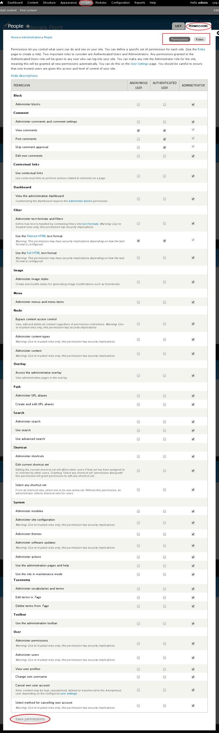

**Fig 3.1 User management in drupal 8**

2. Database Encryption of Drupal8:

In those applications where security is the first priority Drupal can be configured for extremely strong database encryption. Drupal also has the option that whole-database encryption is desired or not, very high granularity i.e. to specify the encryption for database of user accounts, specific forms, and even the values of specific fields can be encrypted in an otherwise plaintext database. The encryption system is designed to pass the best PCI, HIPAA and state privacy laws, including encryption key management.

3. Drupal8 can prevent XSS, CSRF, and various other malicious data entry:

Drupaal8’s Webform API make sure that the data is validated and verified before entry in it’s databases. Its systems test that user-entered data and it’s form fields match the prescribbed formats and also sometime expected set of values. Drupal make use of Tokens which are injected into forms as it is generated, to protect against the CSRF attacks. Drupal8 database abstraction layer makes extra security checks on data as it is entered and retrieved from the database.

4. Drupal8’s Brute Force Detection:

Drupal8 has very strong brute force detection algorithms to tackle the attacks on the sites. It limits the number of try from a single IP addresses over a specific period of times. Another feature of drupal8 is that it saves the failed login attempts and administrator can check via user interface to see the fraudster. It also can ban some individual IP addresses and address ranges.

5. Drupal8 can mitigate Denial of Service (DoS) Attacks:

Drupal8’s extensible cache layer comes pre-configured with basic page, Javascript, and CSS caches.It’s system supports deep integration with performance technologies such as Memcache, Redis, Varnish, and many popular CDN services. Another major reason for handling such huge traffic by Drupal8 is that it’s caching capabilities. It follows two approaches i.e. Internal Page Caching and Dynamic Page Caching whose granular expiry is a common feature.This multi-layered cache architecture is able to handle such large traffics and makes Drupal8 the system of choice for some of the world’s highest-traffic websites.

6.Drupal8 addresses OWASP’s 10 major risks

Drupal8’s security is up to the mark because of the reason that it handles all of the OWASP’s (Open Web Application Security Project) 10 major security risks, a list of most of the common seen risks for the websites.

**3.3 SCALABILITY OF DRUPAL 8**

As a matter of fact if a organization or any website is providing the world’s greatest content can go to vain if the sites take more time to load. It makes its users less intrested in visiting that website again if it gets hit by a lot traffic and the website may go down. But drupal8 can keep up and make sure that site is available even when the site is really popular on web. If it cann’t handle such large traffic then what is the use of such website.

1. Drupal8 can handle Traffic Spikes or Constant Traffic:

One of the case study to support this point can be given by weather.com i.e. a weather company that uses Drupal for managing it’s content, which is among one of the 100 busiest sites in the world. Other such examples of this are grammy.com and publications in the Time Inc. Family, where traffic spikes are handled effeciently all on Drupal.

2. Drupal8 can accommodate Content Growth as time goes:

One of the best features of any CMS is that they can scale to support the most content-rich sites and experience and works smoothly even if the site’s content is frequently updating. Not only Drupal but most of the CMS’s are designed for the sole purpose of managing the content on sites effeciently and Drupal8 is not an exception to this concept. It doesn’t matter what is the nature of the site, it can be any of these –Corporate site, Commerce sites, Media and Publishing or Brand marketing you just name it and drupal8 can handle everything.

3. Scales to handle more traffic, content - and users!

Whether you have 1 or 1,000 content contributors (or more!), Drupal is up to the task. Scalability is Drupal’s middle name -- handling high volumes of visitors, content and Drupal users. It’s all in a day’s work for sites running on Drupal.

**3.4 EASY CONTENT AUTHORING**

Intuitive tools in Drupal for content creation, workflow and publishing make it easy for content creators to do their jobs. Authentication and permissions help manage editorial workflows efficiently, and previews show how content will look on any device before users approve and publish.

1.) Mobile Editing

On-the-go team members can review, edit and approve content from mobile devices, like iPhones, iPads and Android devices, to keep content and campaigns flowing, regardless of where they are and what device they’re on.

2.)In-place Authoring

Drupal allows you to create content with a WYSIWYG editor or to create and edit content in-place: browse to a page, click on the content, and edit right in the context of the content.

3.)Content Revisioning

Drupal enables a quick and easy way to track all changes and revisions - a necessary capability if you have multiple editors and need to maintain a history of content changes. Drupal tells you who did what, when, out of the box.

4.) Content Workflows

Drupal lets you create and manage custom, editorial workflows for all your content processes. Drupal lets you view the stage your content is in -- from creation to review to publication -- and lets you manage user roles and actions, automatically.

5.) Content Tagging and Taxonomy

Beyond creating content, Drupal’s strength is creating structured content – define content elements, tag content based on any attributes, create relevant taxonomy for content so it can be searched, found, used, and reused in ways that satisfy visitors.

**3.5 Multilingual**

An international community of developers has built and maintained Drupal for more than a decade. It has been adopted by multinational organizations around the world, enabling them to quickly launch online experiences tailored to a variety of language needs. Drupal 8, the latest version, was created from square one with multilingual use in mind.

Drupal’s built-in language handling abilities deliver value to those who need localised digital experiences, saving them time and money in the process. Building multilingual sites is now faster and easier than ever. Four core modules in Drupal 8 allow full translation of every part of a site. Quickly build everything from customized sites in any language to complex multilingual web applications with dynamic, language-based displays, using multiple admin languages and translation workflows--all in Drupal.

1.) Translate Everything

Administrators and customers don’t always speak the same language. Drupal not only offers complete content translation workflows to allow businesses to talk directly to their visitors. It also gives individuals who work on the site--administrators, content authors, translators--the choice of their own interface language. Every part of the interface itself can be translated or customised to match your needs, too.

2.)Run Drupal in Your Language

Drupal 8 can be installed in 94 languages, without the need for installing any additional components. You can choose your site default language and English can be turned off or even deleted if you don’t need it. Multilingual sites can dynamically display not only translated content to their visitors, but even entirely locally-tailored information, different page-layouts and -elements, based on customisable factors like browser language. Language information forms part of search results and can be exposed via Drupal’s Search API.

3.) More Languages, Fewer Admin Headaches

Drupal was designed with multilingual use cases in mind. This includes making the life of site administrators easier. Once installed, language packages can be securely, automatically downloaded and implemented without overriding your customised translations. Custom translations can be packaged and deployed across multiple properties. The built-in translation interface provides an overview screen for translators, integrates plural handling, and is responsive--like the rest of Drupal --allowing for on-the-fly access or fixes from any device.

**3.6 Content as a Service**

Drupal lets you think outside the page-based mentality, separating content management from content display, enabling front-end developers to create engaging customer experiences that sing.

Web content used to have one purpose in life: to get pushed to a web page viewed through a desktop browser. But content now must flow freely to sites, native apps, connected devices and show up on third-party sites and social networks too. Digital experiences demand content flexibility. Drupal’s content-as-a-service approach opens the door to ultimate flexibility.

1.) Infinitely Reusable, Future-Proof Content

Most CMSes try to do it all. They manage content in a back-end repository and push it to “front-end” templates that serve up an experience (often static). Drupal lets you decouple the back and front ends where useful. So Drupal content can exist as reusable chunks, free from presentation, ready for creative delivery to sites and apps. Content becomes future-proof.

2.)Unleash Front-End Developers To Build Better Experiences

Drupal’s presentation-neutral content and a RESTful API means front-end developers can come off their leash. They can build interactive sites and apps how they want. Faster. And use tools and frameworks like Node, Angular, Backbone, Ember and others. Free from CMS constraints so their creative vision can be realized and not compromised by the CMS itself..

3.) Fill the Content Bucket More Easily

Your content doesn’t just have to come from your organization. Today, content needs to move in and out freely. Drupal makes it easy to ingest third-party content (e.g. from aggregators and syndicators), bringing content into your Drupal environment, then making it easy to push to any site, app or channel.

4.)Share Content Beyond Your Sites

Today, organizations want to share content across many different channels and apps, and get that content out where the audiences are inside of content aggregators disrupting the news business. Content teams need an easy way to create content, then share it with minimal effort. With Drupal’s content-as-a-service capability, Drupal content is easily consumed by other sites and apps you choose.

5.) Change the Look, Change the Experience in a Snap

Separating back-end content from front-end presentation offers a big bonus: It makes it easy for Drupal front-end developers to redesign or reskin an experience, minus worrying about the content in the CMS. With Drupal, redesigns are a snap - change the look, change the experience.

**Chapter** **4**

**Snapshots**

**4.1 Front Controller of Drupal8 with OOPs and PSR-4 autoloader**

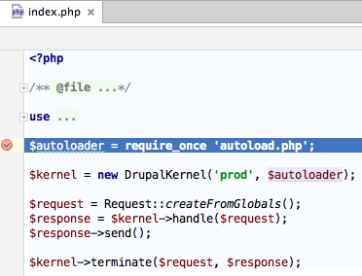

**4.2 Overriding theme layout in Drupal 8**

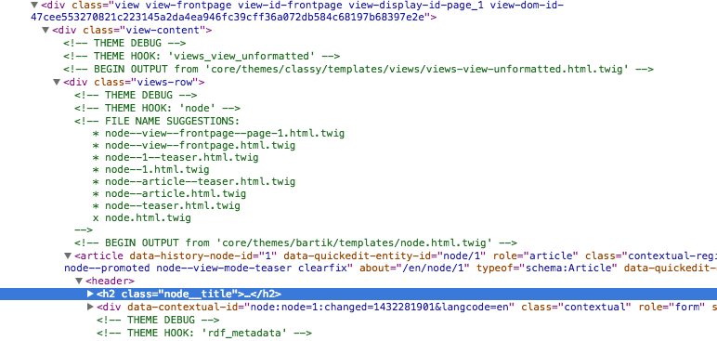

**4.3 Views in Drupal 8**

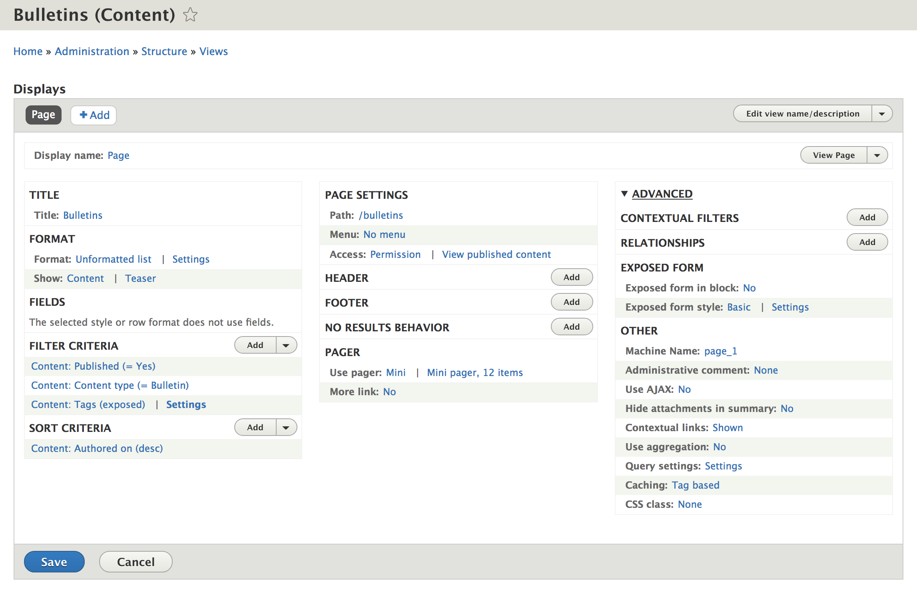

**4.4 Request to Response object for drupal 8**

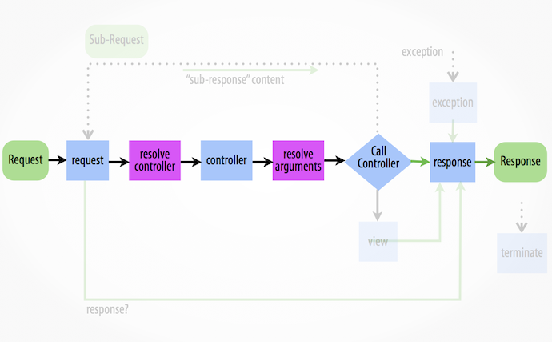

**Chapter** **5**

**LIMITATIONS**

#### Nowadays, the web community has an immense amount of opportunities to create content. People with zero tech background and no developer experience can jump right into building an eCommerce website, hosting a blog or any other web resource.

#### The CMS (content management system) solutions made it a piece of cake for literally anybody. Replace a code console with a graphical user interface – and you will open web content creation to ordinary PC users.

#### Drupal is one of the best known CMS's. This is a free open-source PHP framework for content management. Despite having a developer community of over 1.3m people, extensive features, and decent performance, Drupal receives a lot of criticism and controversial feedback. The World Wide Web is full of articles about the disadvantages of using Drupal.

#### 1. Excessive Memory Consumption

We won’t hide it: Drupal uses a considerable amount of memory, as it loads its large modules on every request. But, as you may have guessed, this issue is easy to avoid.

The first and easiest way to balance memory consumption is to order more RAM power from your hosting provider. This hosting parameter is more than affordable nowadays. Furthermore, remember that memory consumption increase is perfectly normal, as long as the functionality of the CMS is growing correspondingly.

However, if you decide you don’t want to spend another cent, there are ways to cope with this challenge free of charge. Optimization is the key to crossing the RAM consumption problem off the "reasons not to use Drupal" list. The optimizing measures include but are not limited to:

Using Drupal Dynamic Page Cache functionality. This feature allows you to cache the page without your personalized content. Dynamic Page Cache uses the metadata, and, therefore, this module does’t need manual configuration;

Using BigPipe. This is an optimization module that needs zero configuration. In a nutshell, the BigPipe technology divides web pages into smaller parts and pipelines them through a set of execution stages. Opting out of unused modules. You will be surprised to discover how much unnecessary functionality you can deactivate to boost your website performance, compressing files. You will find this feature in your Drupal administration panel for both JS and CSS files.

#### 2. New Versions Bring Drastic Changes

#### More and more people nowadays mistakenly attribute radical Drupal changes to the community’s immaturity and lack of experience. They believe that new Drupal problems are caused by developers' inability to fix them. The true reasons, however, differ from this point of view.

The software scope is continually evolving, and the development approaches are mutating at warp speed. The measures developers need to take to keep their heads above the water are unavoidable in these conditions. That's the reason why Drupal is changing so fast.

How Can I Cope with the Lack of Version Support?

It's absolutely true that sometimes we wish for more compatibility with older versions than we actually receive. Unexpected modules’ unavailability, fresh bugs and other discomforting moments are waiting for you in most open-source projects, so these are not solely Drupal drawbacks. Therefore, moving to newer Drupal versions is important not only to get full modules support, but to get better results in terms of security, speed, and much more.

#### 3. Low Quantity and Quality of Modules on New Versions

Closely linked to the other common Drupal problem, the modules issue arises with every Drupal release. Modules tend to take a considerable amount of time to become "stable". In fact, people complain about a tenfold decrease in module variety during global CMS updates. Sounds horrible, doesn't it?

The real picture is actually not that bad. The majority of beta modules are robust, secure and no less efficient than the so-called stable ones. With that in mind, the supposed issue of lack of functionality starts to look pretty questionable.

What is more essential to remember is that the newer Drupal versions bring cutting-edge technologies to store and manage data, which creates a higher quality system as a whole. This means that waiting for a few module updates pays off anyway.Needless to say, the more websites acquire the Drupal 8 version, the faster the patching and fixing process becomes. There is no ground for alarm in migration, really. We believe that keeping up with the new versions is the one and only progressive development approach.

#### 4. Few Themes

"Why Drupal is bad?", we asked a beginner. "Well, because there are so few themes on the website, for starters!" That was where we ended the conversation.Newer Drupal users are really concerned about the insufficient theme collection the CMS officially provides. First of all, there are tons of external web resources offering both free of charge and paid-for unofficial alternatives. The Drupal community spreads content outside the Drupal.org website as well.

Secondly, we would like to remind you that it's better to consider ready-made themes only as temporary solutions which are good enough for beginners. Creating or fully customizing existing products is necessary if you strive to achieve uniqueness. This implies that the range of ready-made themes is not that important anyway.

This "issue" some people find critical can be compared to a helicopter pilot complaining about road quality. Rational developers will always accept unsubstantial drawbacks in favor of the overwhelming advantages.

**Chapter** **6**

**FUTURE** **SCOPE**

In early September Drupal 8 released version 8.6.0 which included major improvements to the layout system, new media features, and better migration support. This is in addition to many other improvements that have been released since Drupal 8.0 was first unveiled in late 2015.

In terms of adoption, Drupal has picked up steam with 51% growth from April 2017 to April 2018.

Drupal 7 will reach its end of life likely around November 2021 with paid support extending the lifetime with commercial support (as was the case with Drupal 6). Will Drupal 8 reach the level of usage and popularity D7 has? Perhaps not but that is largely due to focus on more robust, “enterprise” level features.

Drupal as a CMS sits largely in between Wordpress and enterprise proprietary CMSs like Adobe CMS and Sitecore in the marketplace. With the release of Drupal 8, the project moved more into the direction of enterprise features (which could explain some of the fall-off in adoption).

Pantheon had two excellent presentations (also at Drupalcon Nashville) that dive deeper into Drupal’s position in relation to other projects, most notably Wordpress. I would recommend watching WordPress vs Drupal: How the website industry is evolving and What's possible with WordPress 5.0 for more information on this topic.

According to builtwith.com, Drupal still has a sizable chunk of Alexa’s Top Million Sites. It should also be noted that Drupal does better the higher you go up the list of those sites which underscores the project’s focus on the enterprise.

**References**

1. Drupal, http://www.drupal.org
2. Comparative analysis of Open Source Management Systems.In Proceedings of the IEEE International Conference on Computational Intelligence and Computing Research, at VIT University, Vellore 2014.
3. Requirements in Web applications development by Alejandro Oliveros, Member, IEEE, Fabián Napolillo and Federico López Infesta.
4. Comparative Analysis Of Web Security In Open Source Content Management System at 2013 International Conference on Intelligent Systems and Signal Processing (ISSP).
5. Research on Web Design Style based on Digital Technology by Yi Zhang, Lifeng Wang, Wei Luo, Chongqing Vocational College of Art and Engineer at 9th International Conference on Measuring Technology and Mechatronics Automation.
6. An Introduction to drupal fast and furious, /www.researchgate.net/publication/234485816_An_Introduction_to_Drupal_Fast_and_Furious
7. The latest stack + latest drupal, https://pantheon.io/drupal-8
8. Why Drupal 8? https://www.drupal.com/why-drupal
9. Drupal7 vs. Drupal8: A technical prespective https://www.ithands.com/blog/drupal-7-vs-drupal-8-technical-perspective/