VALUATION REPORT

Date of Initiate | 3-08-2026 |  | Date of visit |  | 4-08-2025
Contact number |  | 9177753982 |  | Name of the person meet at site
Relationship with the customer

1 | Name of the Applicant | SRI LAKSHMI CONTRUCTION
 | Name of the Owner | Talari Hemanth Ram Kumar S/o Talari Nageswararao
2 | Type of property | RCC
 | Address at site | D.No/Plot No :  Street Name :  Sy.No:  Village Name:  Land mark:  Pincode:
4 | Has the valuator done valuation of this property before this? If yes, when, for whom? |  |  | No
 | Distance from Branch Office |  |  | 20 KM

SANCTION PLAN APPROVAL & OTHER DOCUMENTS DETAILS:
6 | Property Documents verified |  | - Copy of Settlement Deed Doc.No: 298/2023 Dated: 17-01-2023, in favor of Talari Hemanth Ram Kumar S/o Talari Nageswararao  - Copy Of Property Tax With Asst No: 1086303468, in favor Talaari Nageswararao  - Copy of Electricity Bill with Sc No: 1111231287003707, Meter No: 2290100, in favour of T NAGESWARA RAO.
7 | Ownership type |  |  |  |  |  |  |  |  |  |  |  |  | Free Hold
11 | Boundaries as Per Documents & Site:
11 | Boundaries |  |  | EAST |  |  |  |  | WEST |  |  |  |  |  | NORTH |  |  |  |  | SOUTH
11 | As per Doc |  |  | 24 ft Road |  |  |  |  | Plot no 603 |  |  |  |  |  | Plot no 620 |  |  |  |  | Plot no 618
11 | As per Site |  |  | 20 ft CC Raod |  |  |  |  | RCC House of T Babu rao |  |  |  |  |  | RCC House of Ramu |  |  |  |  | RCC House of Acchinaidu
11 | Boundaries Matching |  |  | Yes
 | Set Backs
 | Front in fts |  |  |  | Back in fts |  |  |  |  |  | Right in fts |  |  |  |  |  | Left in fts
 | LAND DIMENSTIONS IN FTS
 | EAST IN FTS |  |  |  | WEST IN FTS |  |  |  |  |  | NORTH IN FTS |  |  |  |  |  | SOUTH IN FTS
 | BUILDING DIMENSIONS
 | EAST IN FTS |  |  |  | WEST IN FTS |  |  |  |  |  | NORTH IN FTS |  |  |  |  |  | SOUTH IN FTS
 | SLAB DIMENSIONS
 | EAST IN FTS |  |  |  | WEST IN FTS |  |  |  |  |  | NORTH IN FTS |  |  |  |  |  | SOUTH IN FTS
12 | Occupant |  |  | Vacant/Occuppies |  |  |  |  |  |  |  | Occupied
12 |  |  |  | Name of Occupant |  |  |  |  |  |  |  | GF -Tenants, FF- Owners
12 |  |  |  | Occupied from
13 | Building details |  |  | Property Demarcation |  |  |  |  |  |  |  | Yes
13 |  |  |  | Property Identified through |  |  |  |  |  |  |  | Property tax and E Bill.
13 |  |  |  | Type of structure |  |  |  |  |  |  |  | RCC |  |  |  | Plot Area |  |  |  |  | 107 Sq .Yds
13 |  |  |  | No. of Floors |  |  |  |  |  |  |  | G+1 |  |  |  | Floor Valued |  |  |  |  | G+1
13 |  |  |  | No of unit per floor |  |  |  |  |  |  |  | 1 Unit |  |  |  | No. of lifts |  |  |  |  | NA
14 | Unit details |  |  | No. of units |  |  |  |  |  |  |  | 3
15 | Quality of construction |  |  | Good |  |  |  |  |  |  |  | Interiors/ Exteriors |  |  |  |  |  |  | Good
16 | Age of the property |  |  | 15 Years |  |  |  |  |  |  |  | Residual life |  |  |  |  |  |  | 45 Years
16 | Location |  |  | Type (Comm., Res, Ind, Mix) |  |  |  |  |  |  |  | Residential
16 |  |  |  | Class of Locality |  |  |  |  |  |  |  | Middle Class
16 |  |  |  | Site is (Dev, Under Dev) |  |  |  |  |  |  |  | Developed
16 |  |  |  | Proximity to civic amenities/public transport |  |  |  |  |  |  |  | Near by
17 | Close Vicinity/Landmark |  |  |  |  |  | Near Post office Pedagantyada
18 | Property within municipal Limits |  |  |  |  |  | Yes |  |  |  |  |  | Name of Panchayat |  |  |  |  | GVMC
19 | Site Access |  |  |  |  |  | Easy |  |  |  |  |  | Availability of basic amenities (Water, Sewer, Electrical, Road) |  |  |  |  | Near By
20 | Marketability |  |  |  |  |  | Good |  |  |  |  |  | Electricity Meter Service No. |  |  |  |  | Sc No: 1111231287003707, Meter No: 2290100,
 | High Tension wires |  |  |  |  |  | Yes/No |  |  |  |  |  | Electricity in the name of
 | Property tax in the name of |  |  |  |  |  |  |  |  |  |  |  | Area left for cross
 | Is property having Joint wall and Joint slab |  |  |  |  |  | Yes/No |  |  |  |  |  | Any graveyard nearby
21 | Floor Wise Area (In Sqft.)
21 | Area’s | Plinth area |  |  |  | Slab area
21 | Ground floor | 0 |  |  |  | 0
21 | First floor | 0 |  |  |  | 0
21 | Second floor
21 | Third Floor
21 | Forth Floor
22 | (A)Description of Constructed Area and Rates
22 | Description |  |  |  |  |  |  | Area |  |  |  |  |  |  |  | Rate (in Rs.) |  |  |  |  |  | Amount  (in Rs.)
 | Land (Sq.Yds.) |  |  |  |  |  |  | 107 Sq. Yds |  |  |  |  |  |  |  | 35000 |  |  |  |  |  | 0
 | Total construction area |  |  |  |  |  |  | 714 |  |  |  |  |  |  |  | 1500 |  |  |  |  |  | 0
 | Total Value |  |  |  |  |  |  |  |  |  |  |  |  |  |  |  |  |  |  |  |  | 0
 | Stage of construction |  |  |  |  |  |  | Completed
 | Stage % |  |  |  |  |  |  | 100% |  |  |  |  |  |  |  | Recommended % |  |  |  |  |  | NA

FLOORWISE DETAILS OF USAGE OF PROPERTY:
Floor | Usage | Units | If Tenanted, Yr of Current Tenancy | Rental Assessment
Ground floor | Residential | 2 | Owners/Tenants | -
- Subject Property is G+1 Rcc Residential Building, GF occupied by tenants and FF Occupied by Owners, Located in GVMC limits.
- Property is identified through property tax and E Bill
- Sanction plan was not provided
- Legal aspects are beyond the scope of valuation.
- Subject property is surrounded with Residential houses.
- Property Tax and E Bill in favour of T.Nageswararao should be Mutate.
- Sy. No of the property Not listed in prohibited properties.
- Distance from Rajahmundry Branch 26.3 Kms.
- Ground floor photos were not taken because of owner objection. FI to note.

GPS Coordinates: 17.671035, 83.195940
- The property is physically inspected by our Engineer/Representati

(Authorized Signatory)

PHOTOGRAPHS
Applicant Name: SRI LAKSHMI CONTRUCTION
Address: Door.No: 18-4-18 ( As Per Doc and Tax), Plot no 619, R.S No: 36/part, Asst no 1086303468, Pedhanaduvuru area, Pedagantyada R H Colony, Pedagantyada village, GVMC limits, Pedagantyada mandal, Visakhapatnam district, Andhra Pradesh – 530044.
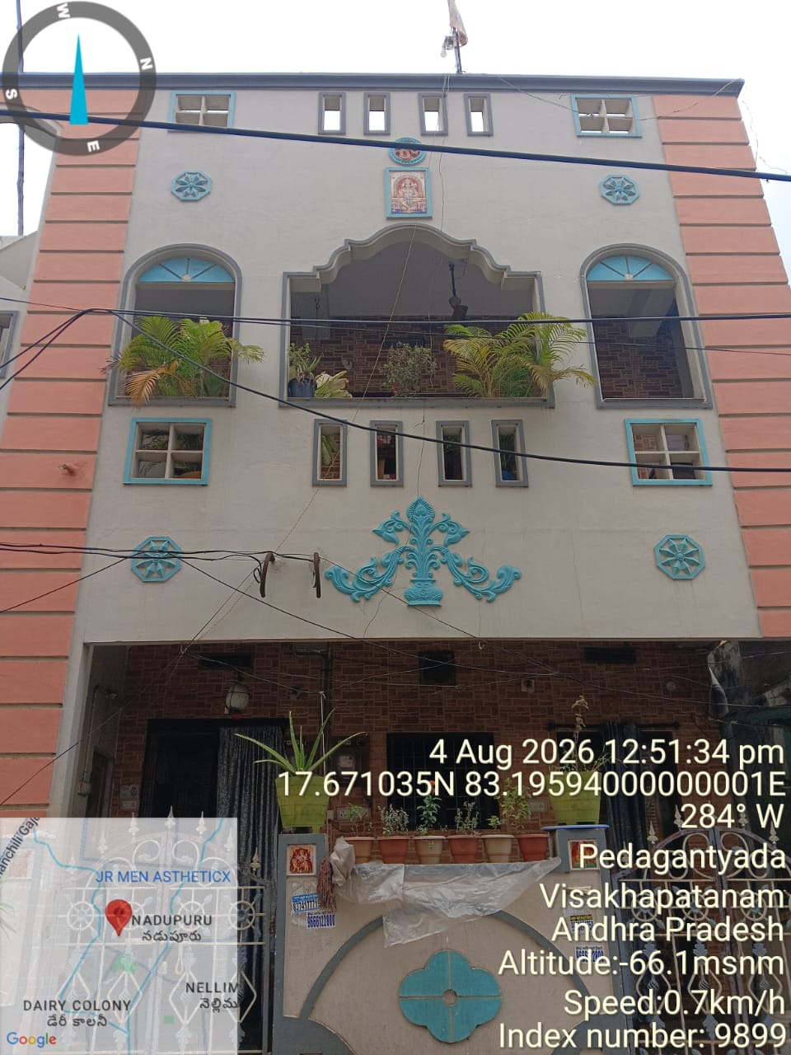 | 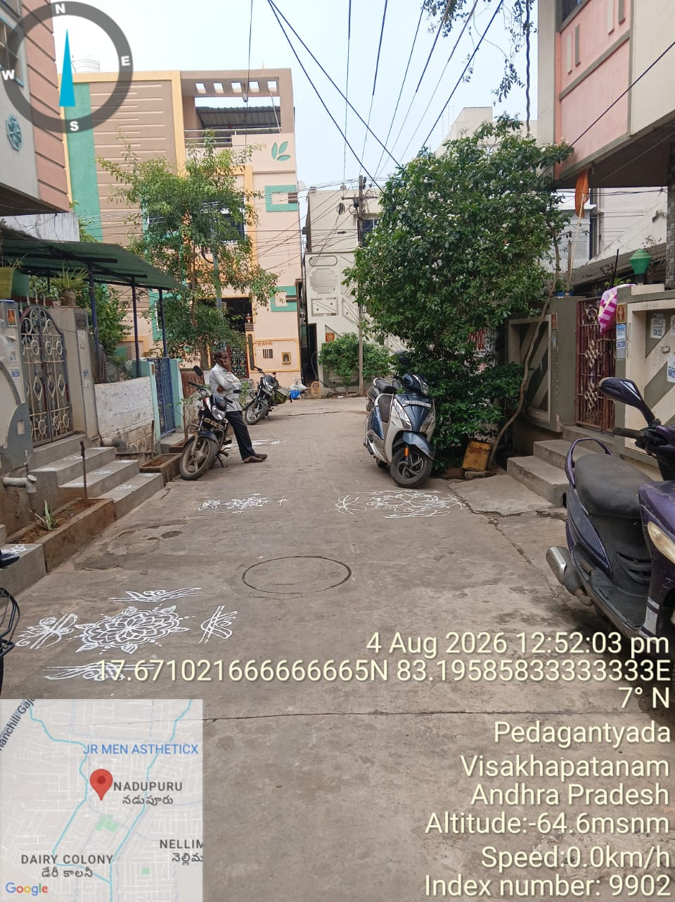
ELEVATION OF THE PROPERTY | ROAD VIEW
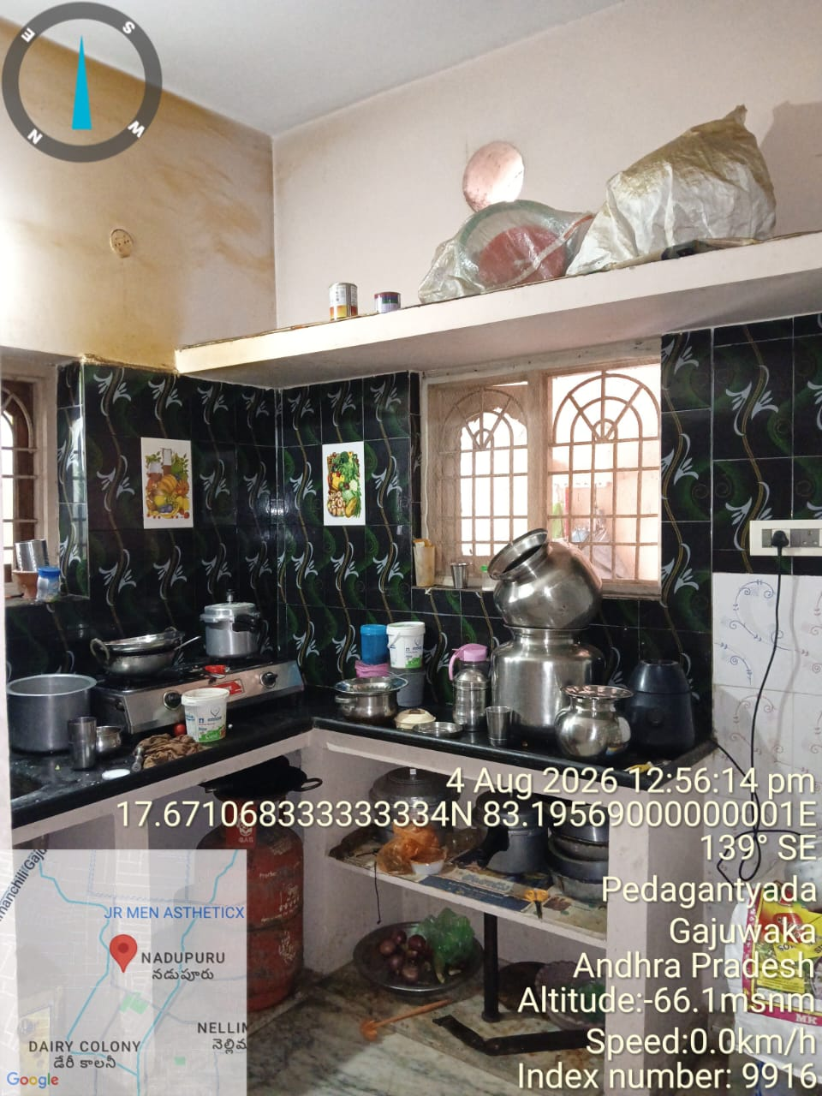 | 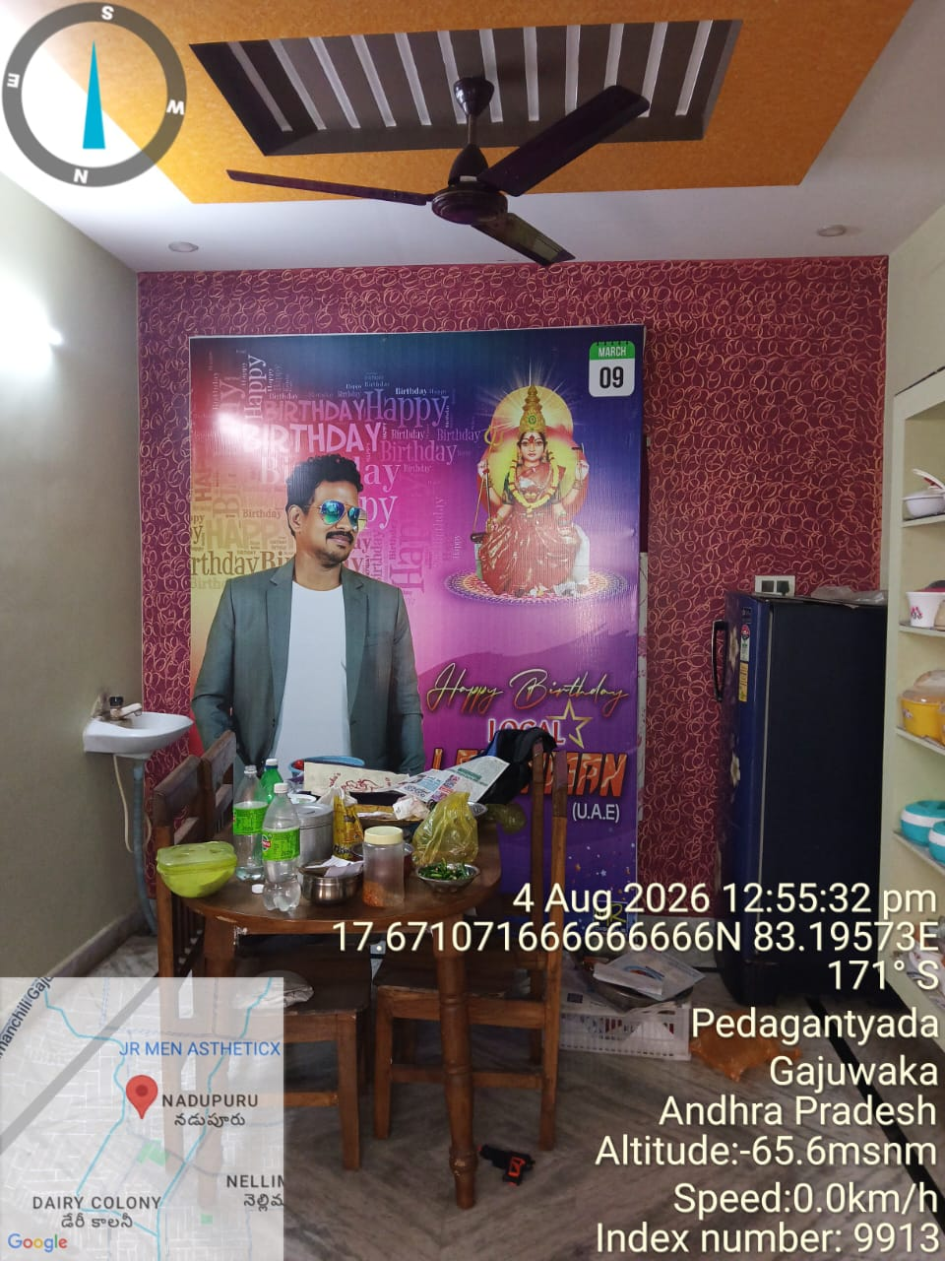
LEFT SIDE VIEW OF THE PROPERTY | RIGHT SIDE VIEW OF THE PROPERTY
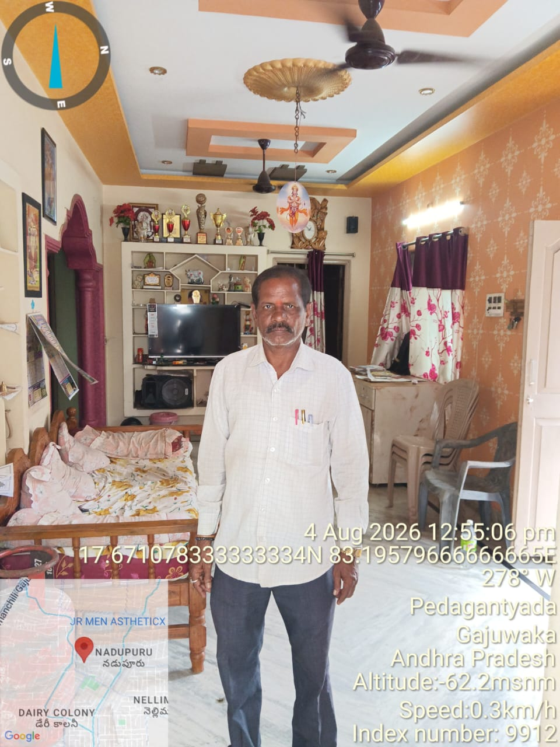 | 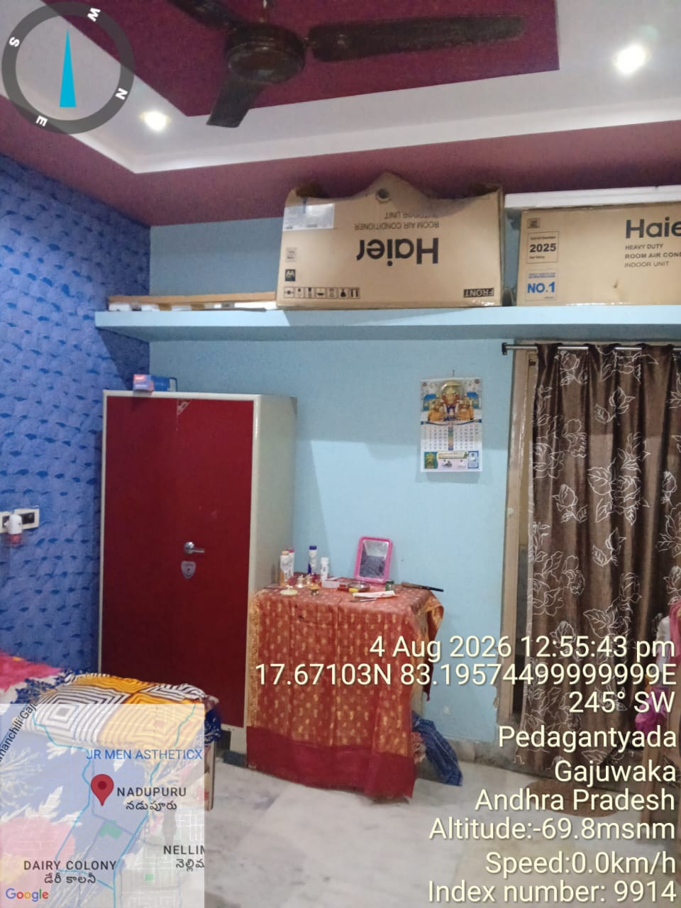
INTERNAL VIEW OF THE PROPERTY | INTERNAL VIEW OF THE PROPERTY
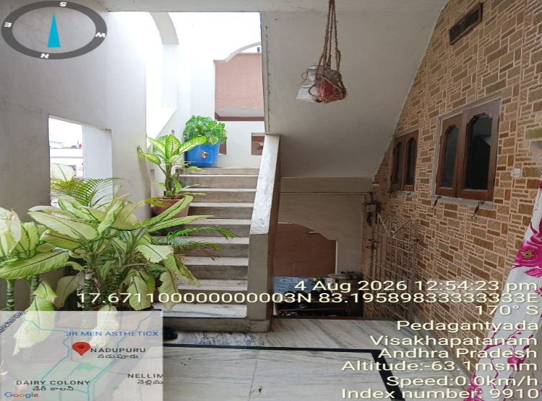 | 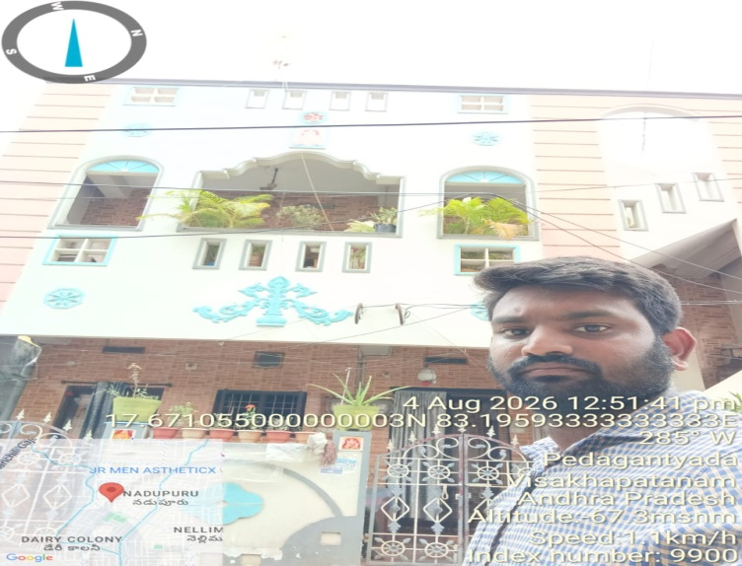
INTERNAL VIEW OF THE PROPERTY | INTERNAL VIEW OF THE PROPERTY
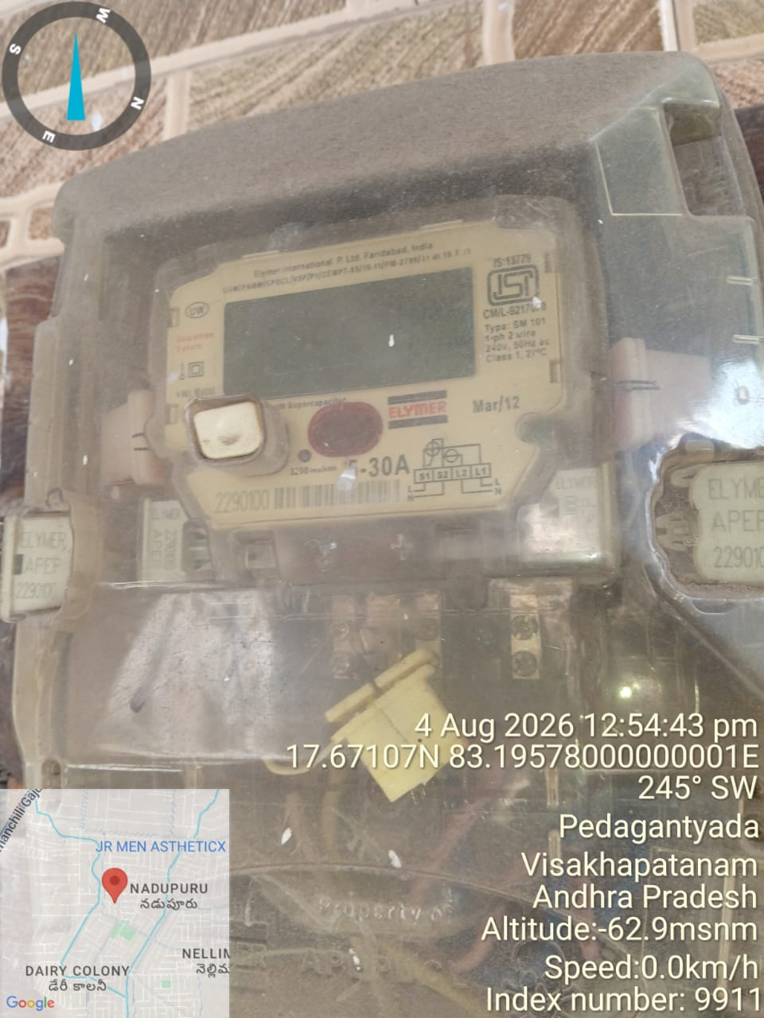 | 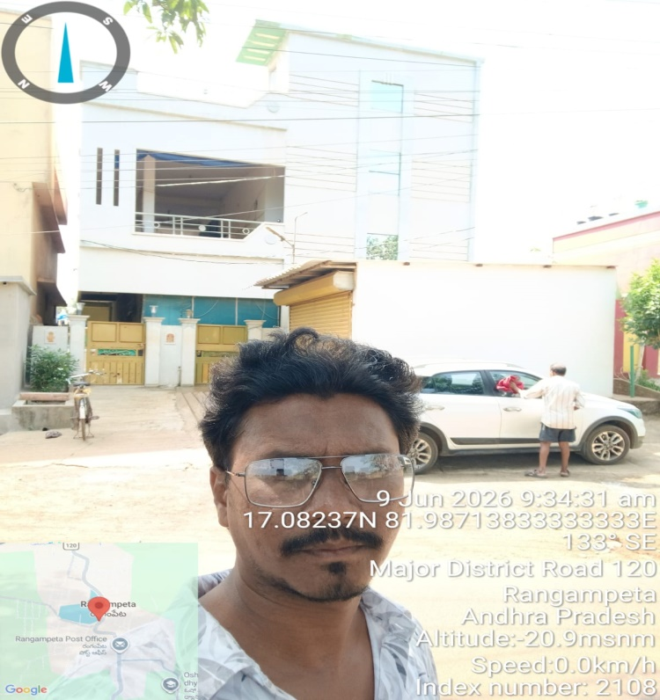
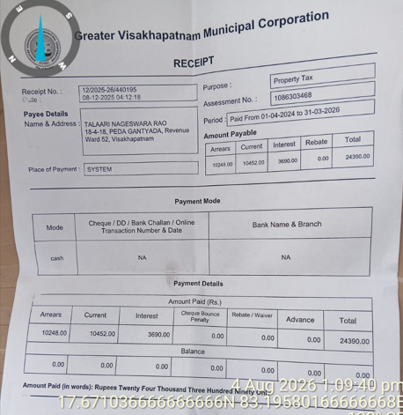 | 