
H.E.M ASSOCIATES
D.No: 36-31-7, Shop No:03,
Karthik Plaza, Innespeta
Rajamahendravaram, - 533101
+91 89191 87569
hem.valuation@gmail.com

TECHNICAL VALUATION REPORT LAND AND BUILDING / LAND
APPLICATION NUMBER | HL660364
BRANCH | Rajamundry
PRODUCT | HL-New purchase
Phone Number | 8639227449
APPLICANT NAME | Balagunda Ramanjali
CO-APPLICANT'S NAME | Mulagada Nagamani
DATE OF INSPECTION | 05-09-2026
INSPECTED BY | Ravi
Authorised Signature | Ganja Srikanth
PROPERTY DETAILS
DOCUMENT HOLDER NAME | Sosapalli Ravikumar S/o. Sosapalli Satyanarayana
PROPERTY TYPE | Residential House
IF OTHERS - SPECIFY PROPERTY TYPE | NA
METHOD OF VALUATION | Building
PROPERTY ADDRESS | Plot No. 145, RS No 777/4C, LP no 83/2013/R, Kolamuru Village, Kolamuru Grampanchayath, Rajamahendravaram Rural mandal, Pidingoyya Sub-D, East Godavari district, Andhrapradesh-533102.
DISTRICT (TO BE FILLED MANDATE) | East Godavari district
STATE (TO BE FILLED MANDATE) | Andhra Pradesh
PINCODE (TO BE FILLED  MANDATE) | 533102
PROPERTY COORDINATES | Latitude | 17.044750
PROPERTY COORDINATES | Longitude | 81.802140
NEAREAST LAND MARK | Seshadri Hills
DISTANCE OF PROPERTY FROM NEAREST VERITAS BRANCH (IN KM) | 6.7 kms
CIVIC STATUS | Kolamuru Grampanchayath
IF OTHERS - SPECIFY THE CIVIC STATUS | NA
NHB - 1991 | Rural
NHB - 2011 | Rural
OWNER'S NAME AS PER THE TITLE DEED WITHDOCUMENT NUMBER (TO BE FILLED  MANDATED) | Copy of Sale Deed with doc no 5923/2025, Dated 14-11-2025, In Favor of Sosapalli Ravikumar S/o. Sosapalli Satyanarayana.
NUMBER OF TITLE DEED INVOLVED WITH DETAILS | Copy of Sale Deed with doc no 5923/2025, Dated 14-11-2025
OWNERSHIP TYPE | Single Owner ship
USAGE OF PROPERTY | Residential
IF OTHERS - SPECIFY THE USAGE | NA
OCCUPANCY STATUS | Owner
APPROVED PLAN | B A no 1984/2025, Dated 19-11-2025, from Kolamuru grampanchayat secretary
DEVIATION OBSERVED | NA
NUMBER OF FLOORS | Ground Floor
NUMBER OF UNITS | Residential | 1
NUMBER OF UNITS | Commercial | 0
TOTAL NUMBER OF UNITS - WITH DETAILS | 1
WHETHER MORE THAN 2 UNITS (CRE) | No
PROPERTY IDENTIFICATION | Good
MARKETABILITY | Fair
AGE OF BUILDING | 1 Years
ESTIMATED FUTURE LIFE OF BUILDING | 59 Years
BOUNDARIES | AS PER TITLE DEED |  | AS PER ACTUAL
EAST | 40FT Wide Road |  | 40 ft Layout Road
WEST | Remaining Land in Plot no 45 |  | RCC Building
NORTH | Remaining Land in Plot no 45 |  | Open Land
SOUTH | Remaining Land in Plot no 45 |  | RCC Building(Satvika Chandhari)
PROPERTY DESCRIPTION
INSPECTED WITH REQUIRED DOCUMENTS LIST OF  DOCUMENTS GIVEN FOR SITE VISIT | - Copy of Sale Deed with doc no 5923/2025, Dated 14-11-2025, In Favor of Sosapalli Ravikumar S/o. Sosapalli Satyanarayana.  - Copy of Power bill with SC no 1432707903024523, meter no 8322423, in Favour of Sosapalli Ravi Kumar.  - Copy of approved plan with B A no 1984/2025, Dated 19-11-2025, from Kolamuru grampanchayat secretary
WHETHER PROPERTY IS A  PURCHASE PROPERTY | NA
IF YES (FILL THE RIGHT SIDE COLUMN) | Agreement entered between | ----
IF YES (FILL THE RIGHT SIDE COLUMN) | Agreement value | ----
IF YES (FILL THE RIGHT SIDE COLUMN) | Agreement date | ----
IF YES (FILL THE RIGHT SIDE COLUMN) | Agreement Validity | ----
ROOF | RCC
FLOORING | Marble
EB SERVICE | Service number | 1432707903024523
EB SERVICE | Meter Number | 8322423
DETAILS OF PROPERTY TAX -  IF APPLICABLE | NA
PLOT DEMARCATED | Yes
APPROXIMATE ROAD WIDTH | 40 FT
IN FEET )
WHETHER PROPERTY LOCATED IN A PASSAGE  LESS THAN 10FT | No
IF YES - MENTION WIDTH OF THE PASSAGE | Width of the passage in feet | NA
IF YES - MENTION WIDTH OF THE PASSAGE | Distance from abutting main road  / street in feet | NA
NATURE OF LOCALITY | Medium Developed
LOCATION & SURROUNDING | Mid End
FACILITY AVAILABLE | Road / Electrical Line / Telephone Line / Street Light
WATER SUPPLY  ARRANGEMENT (MENTION WHATEVER IS AVAILABLE) | Bore well / Open well / Pond, OHT / Sump / Public water connection
DRAINAGE ARRANGEMENT | NA
CONDITIONOFTHEPROPERTY | Good
APPROXIMATE RENTAL VALUE PER MONTH - FOR  THE ENTIRE PROPERTY | /-
LAND DETAILS
LAND ( In Sft ) | 1039 SFT
GLV/SFT WRT SRO RATES | Rs. 1222 Per SFT
GLV OF LAND | Rs. 12,69,658 /-
MARKET VALUE RANGE PER SFT | Rs. 2000/-
RATE PER SQFT ADOPTED | Rs. 2000/-
LAND VALUE | Rs. 20,78,000 /-
RCC ROOF BUA ONLY
EXISTING BUA - IN SFT | 768 SFT
PROPOSED BUA - IN SFT | 0
TOTAL BUA- IN SFT | 768 SFT,
TOTAL CARPET AREA - INSFT | 614 SFT
EXISTING - BUILDING VALUE | Rs. 13,82,400 /-(768*1800)GF
PROPOSED BUILDING VALUE | Rs. 13,82,400 /-(768*1800)GF
ESTIMATED COST OF ENHANCEMENT/ IMPROVEMENTS | NA
ADDITIONAL COST (AMENITIES & SERVICECOST) | Rs. /-
TOTAL BUILDING VALUE / ESTIMATED - INDEPENDENT | Rs. 13,82,400 /-
ANY TYPE OF TEMPORARY ROOF BUA
EXISTING BUA - IN SFT
CARPET AREA - IN SFT
RATE PER SQFT ADOPTED | ---
EXISTING - BUILDING VALUE | ---
ADDITIONAL COST | ---
(AMENITIES & SERVICE COST)
TOTAL BUILDING VALUE /  ESTIMATED - INDEPENDENT | ---
LAND VALUE + RCC BUILDING VALUE | Rs. 34,60,400 /-
LAND VALUE + TEMPORARY BUILDING VALUE | Rs. 34,60,400 /-
TOTAL PROPERTY VALUE  (LAND + RCC+ TEMPORARY STRUCTURE VALUE) | Rs. 34,60,400 /-
ESTIMATED - FORCED SALE  VALUE / DISTRESS SALE VALUE (80%) | Rs. 27,68,320 /-
PERCENTAGE OF WORK PROGRESS | 100%
STAGE OF CONSTRUCTION | 100%
CONSIDERED VALUE FOR  PROPERTY INSURANCE | Rs. 13,82,400 /-
OTHER DETAILS
EXISTING LOAN DETAILS | Proposal number | ----
EXISTING LOAN DETAILS | Existing sanctioned loan amount | ----
REQUEST LOAN AMOUNT | ---
SANCTIONED LOAN AMOUNT | ---
LCR | ---
LTV | ---
COMBINED LTV | ---
TYPE OF STRUCTURE | RCC
HAZARDOUS ZONES APPLICABLE
GEOMETRY / DESIGN / STRUCTURAL
CONFIGURATIONS MET
RECOMMENDED
COMMENTS :
Note:Valuation report is Valid When title deed are genuine.This Valuation report prepared based on the available documents only. Any such missing document may effect the value conditionally. This report is for assessing the fair market value of the subjected property and it is not be interpreted as confirmation of ownership or genunity of documents. Further the bank is advised to satisfy itself before accepting the
security in terms of genuiness of the title documents/approvals/owners/ identity related to the property.
- The Subject property is an Residential, Ground floor RCC Building, Having 2BHK Vacant, Located with in Kolamuru Grampanchayat Limits.
- Property is identified through E Bill and Plan
- Sanction plan has been not provided.
- As per Documents and site is 115.5 Sy.ds, Hence same considered for valuation.
- Sy.no of the property is identified in Bhuvan 2d map, as per Doc is 777/4, As per Bhuvan 2D 777. Attached the same for your reference.
- SR no of the property is not found in the list of IGRS Prohibited list.

PRESENT PROPERTY PHOTOS WITH GEO COORDINATES

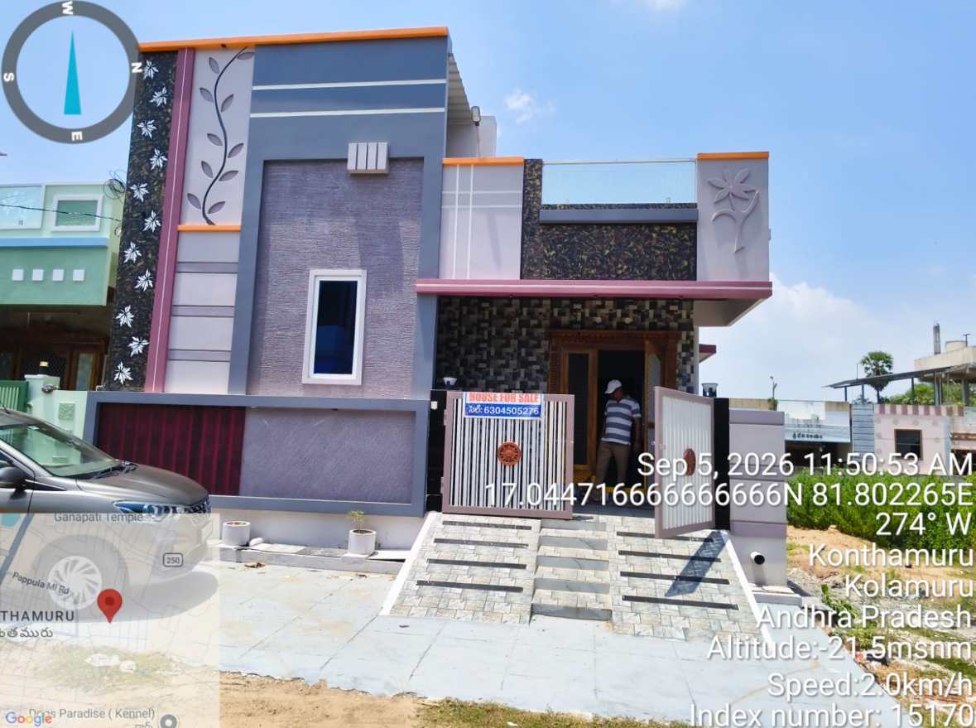 | 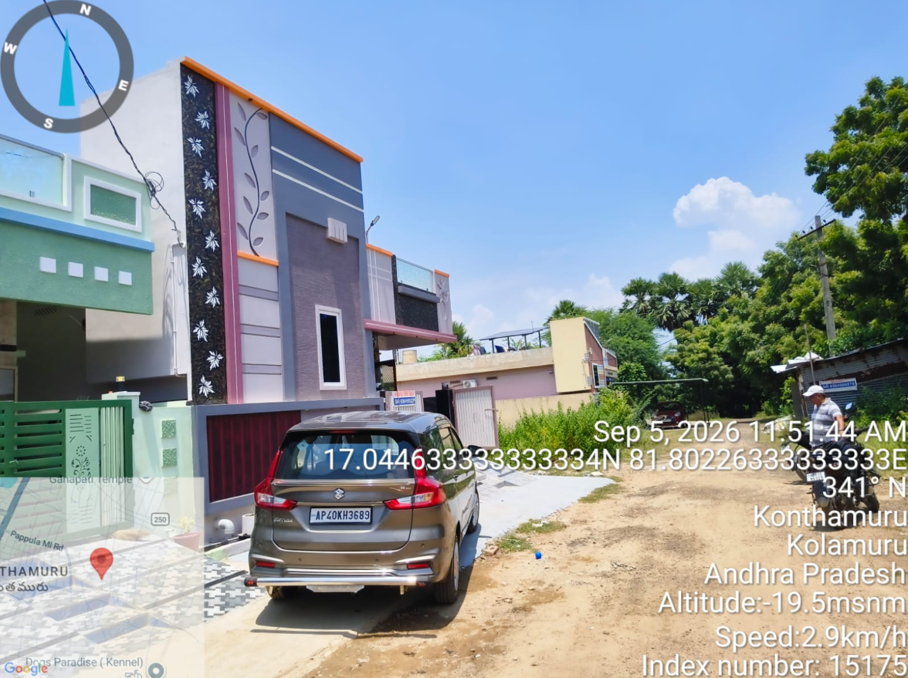 | 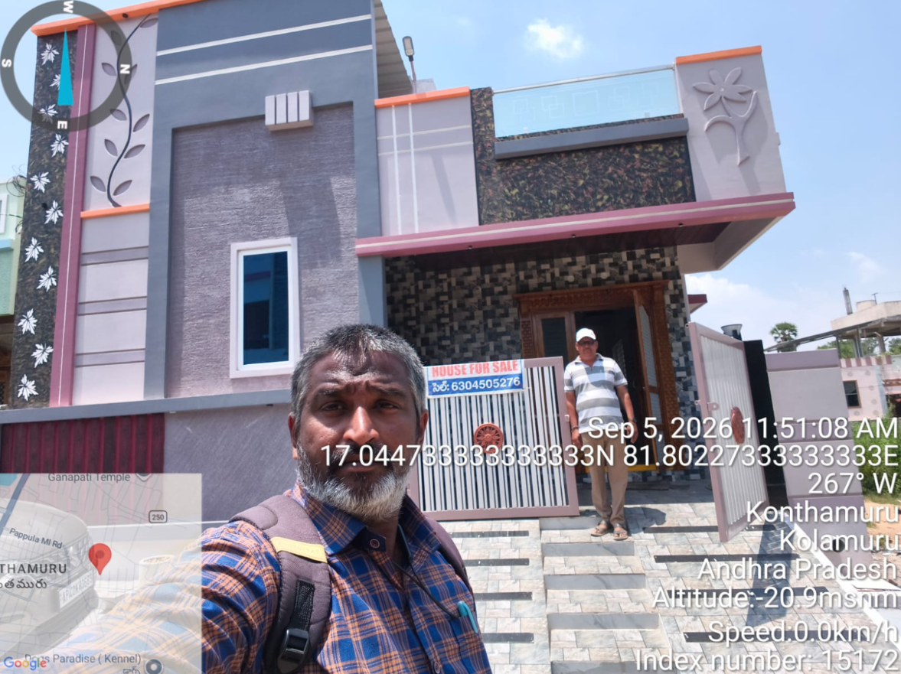
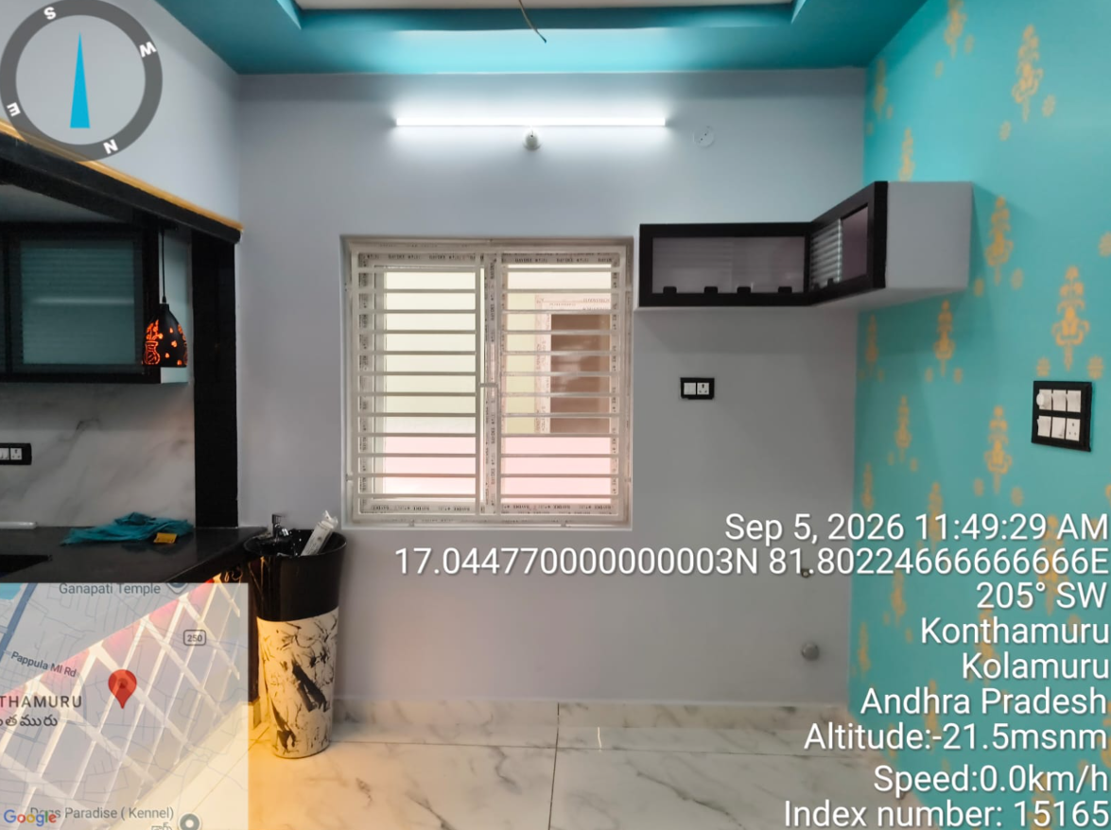 | 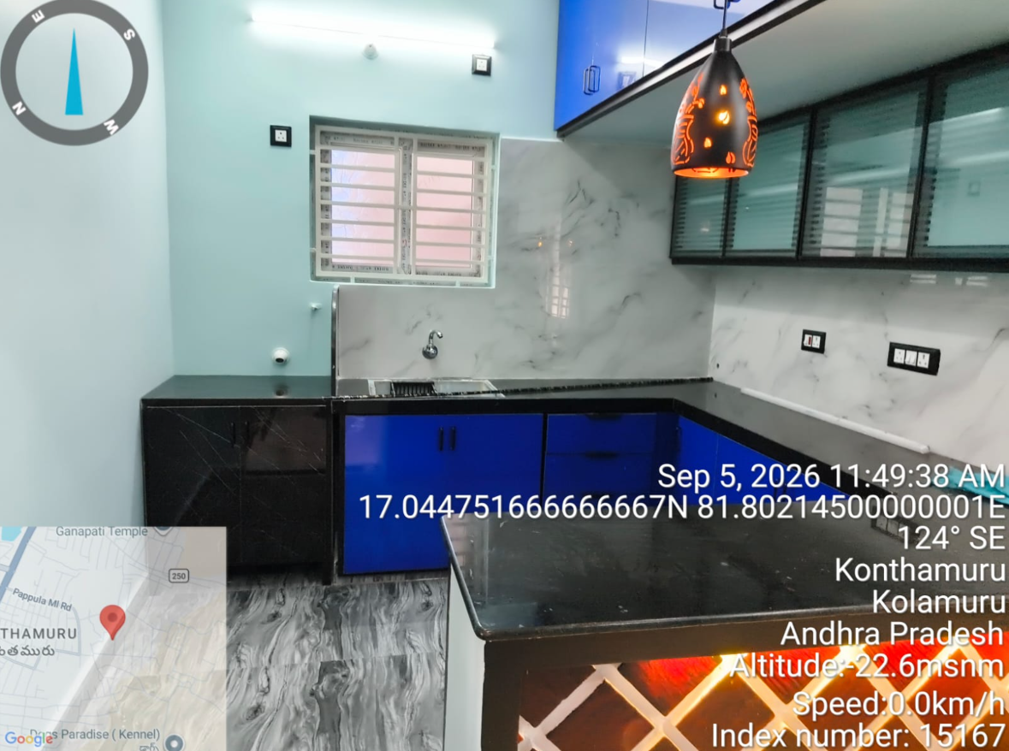 | 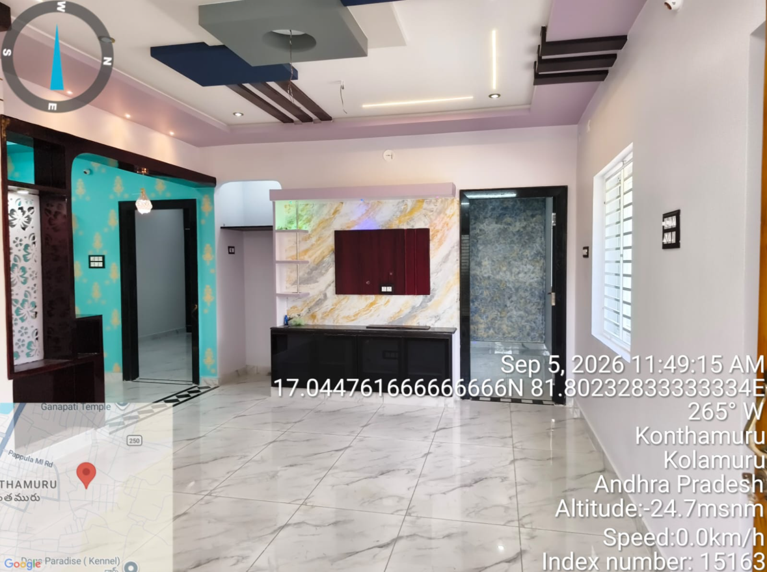
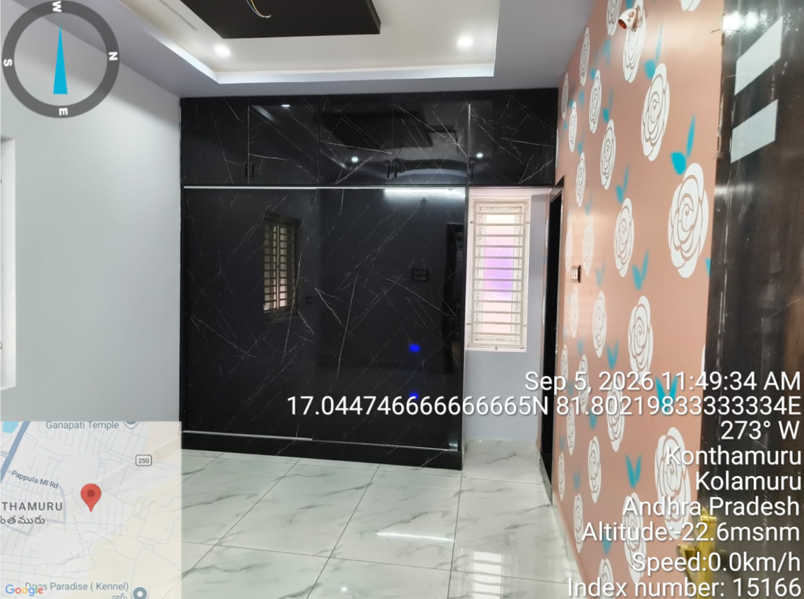 | 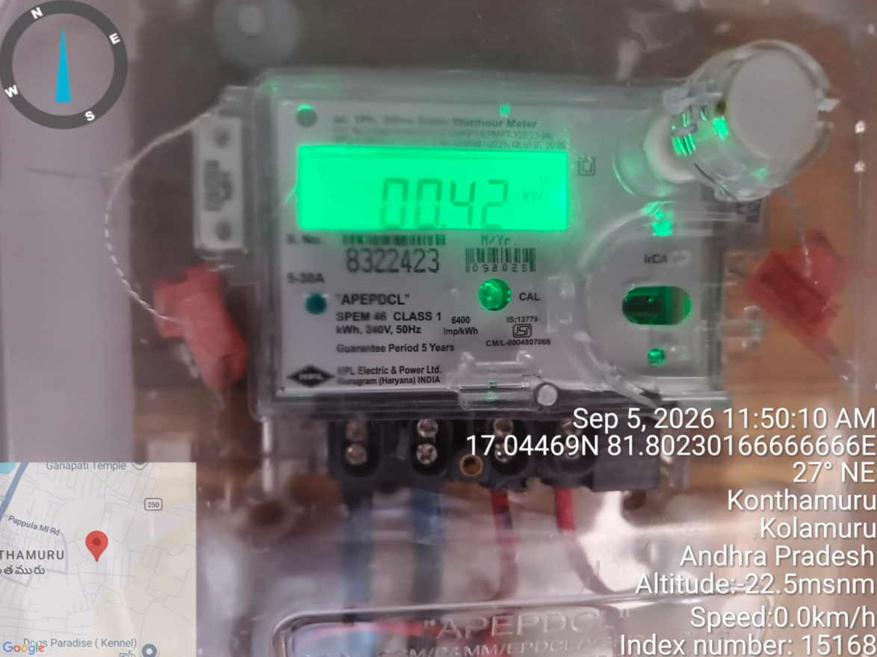 | 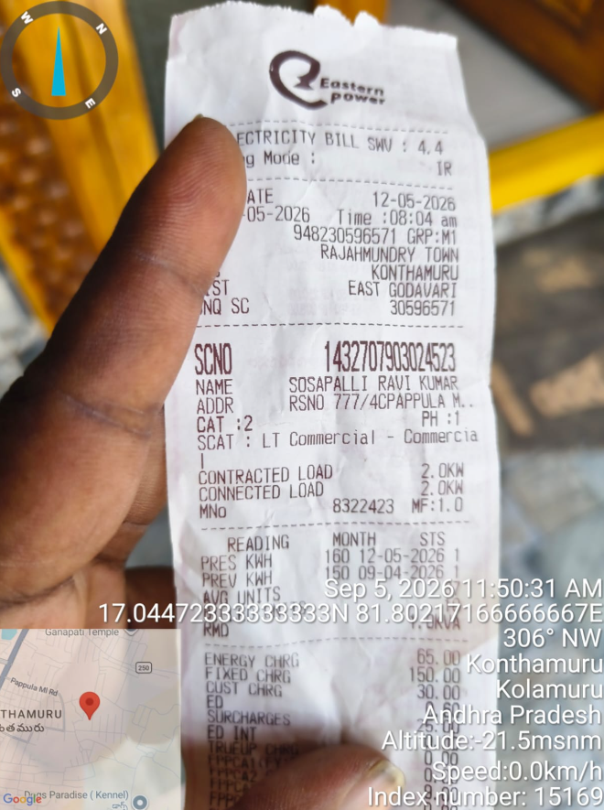
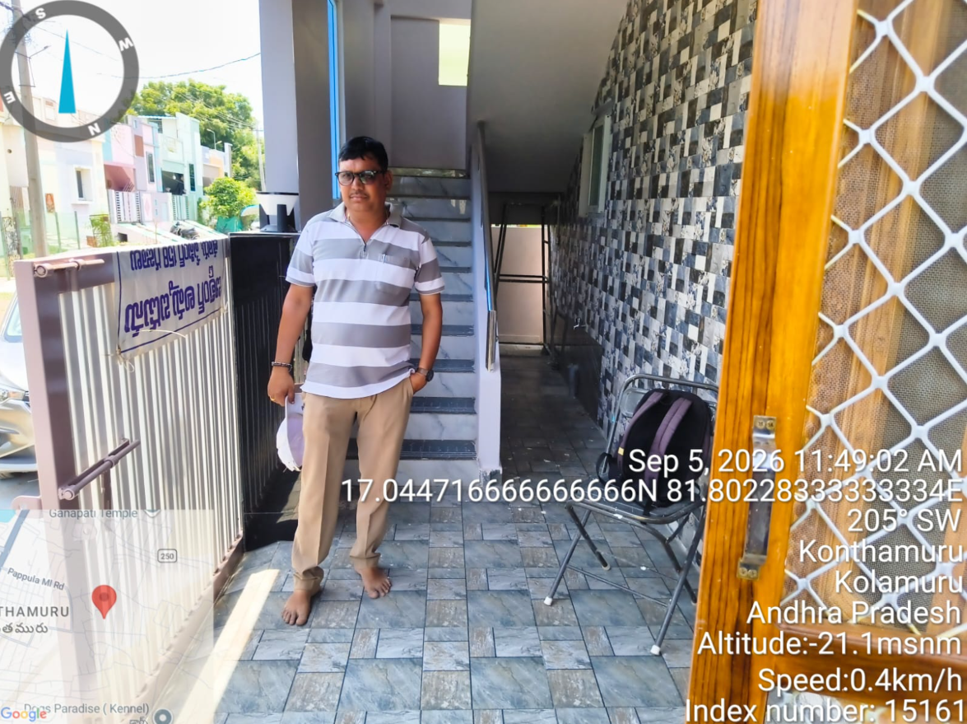 | 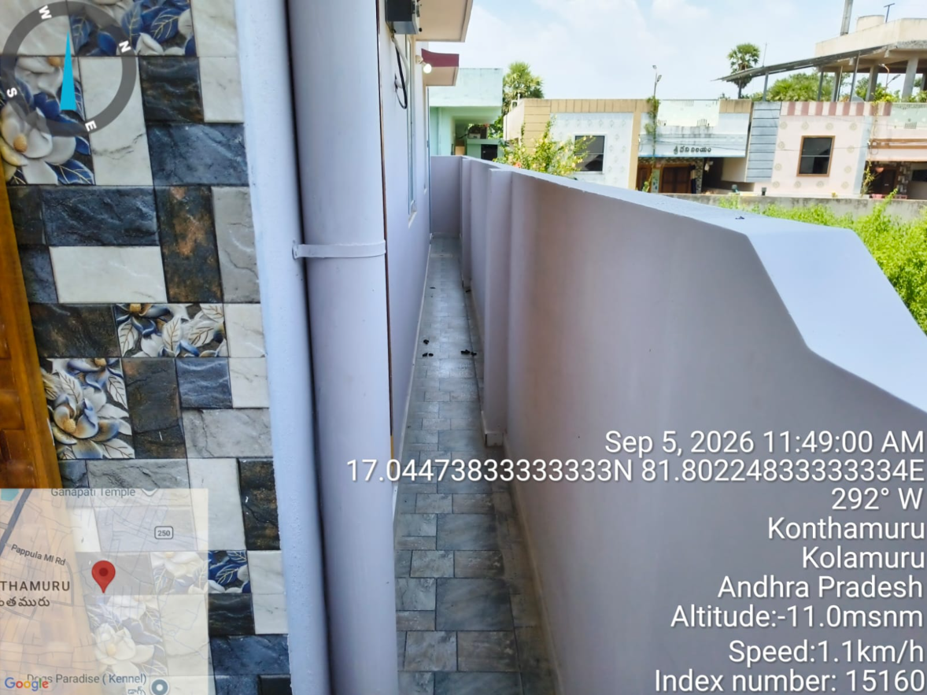 | 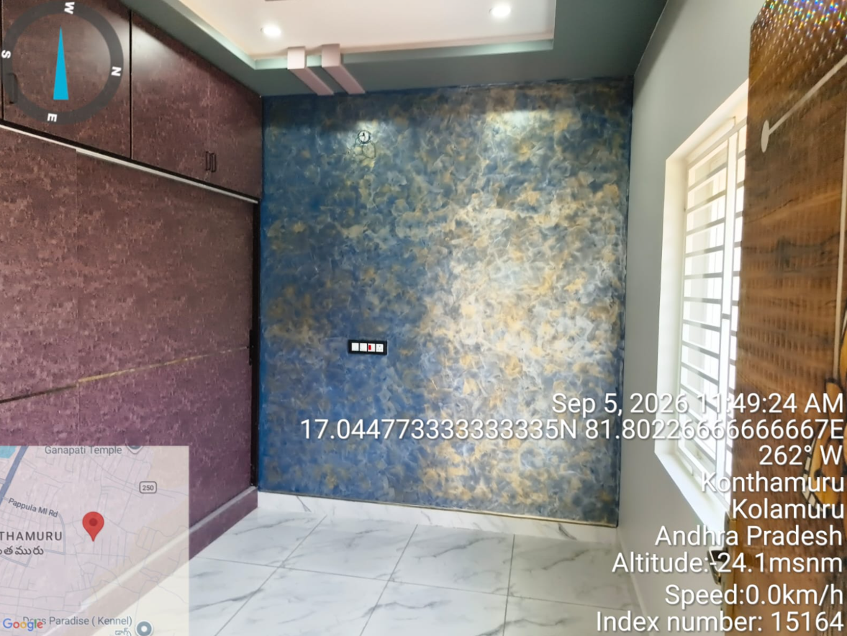

S.R.O. VALUE SHEET
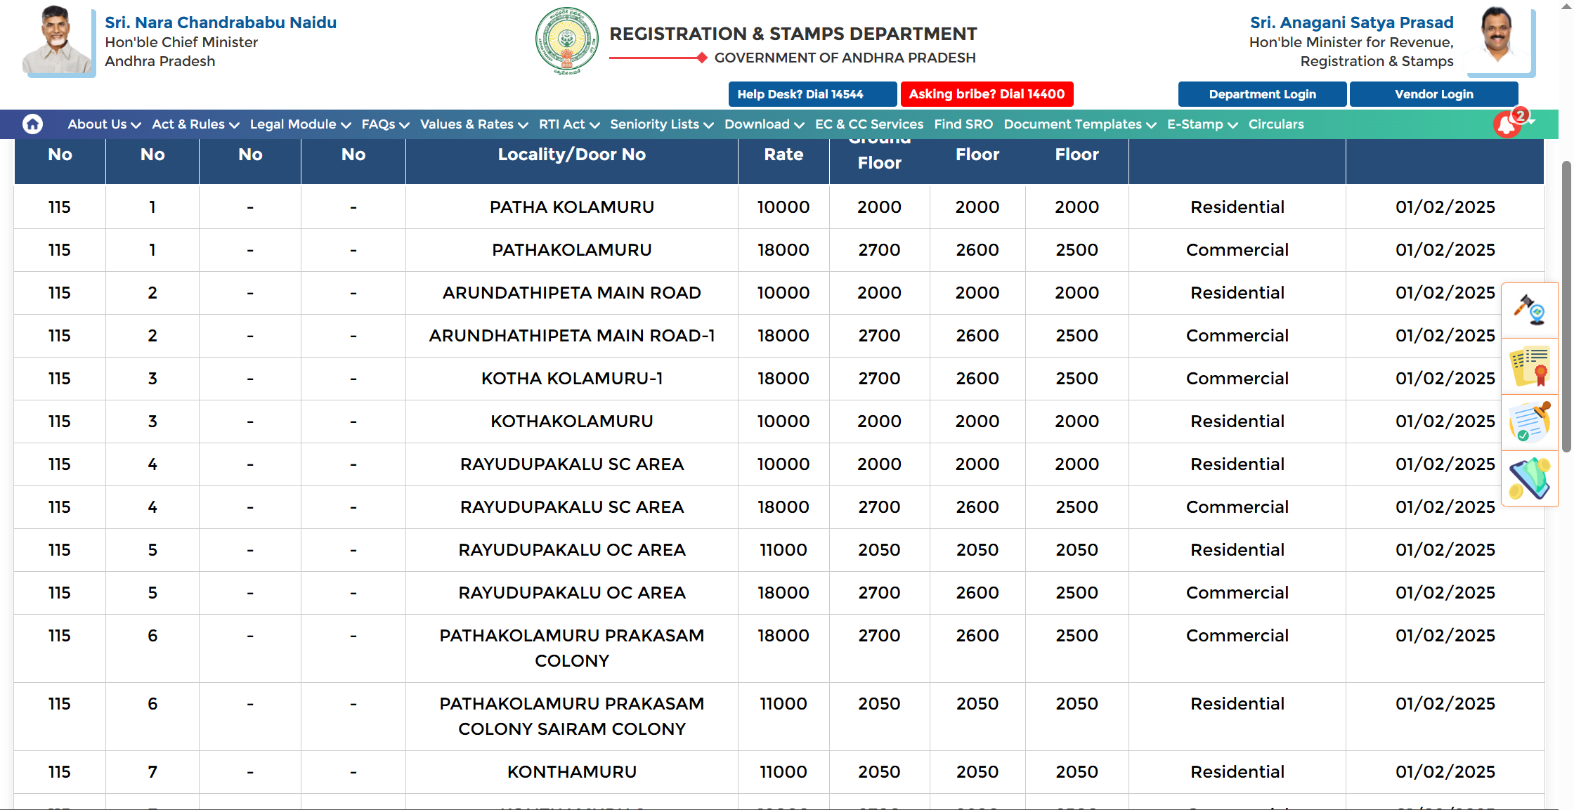
PROHIBITED LIST
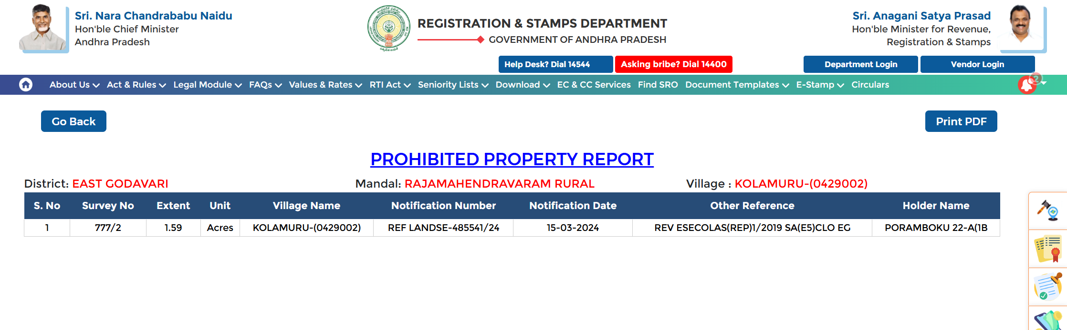
BHUVAN 2D
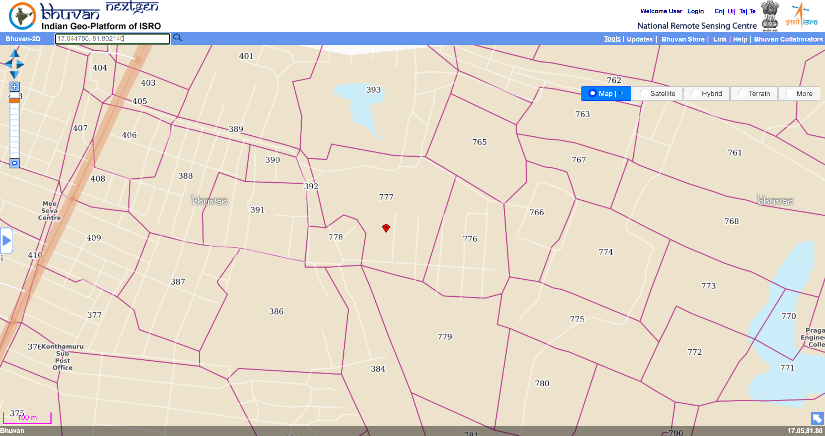
LOCATION MAP
