Behavioural Finance Task Insights

1. **Distribution of Total GBP Assets:**

* Total wealth ranged from £88.9 to £1161.1, with a mean of £455.6 (sd = £216.1)
* Individuals with total assets over £900 appeared to be outliers, as the majority of individuals had total assets below £600.  
    
  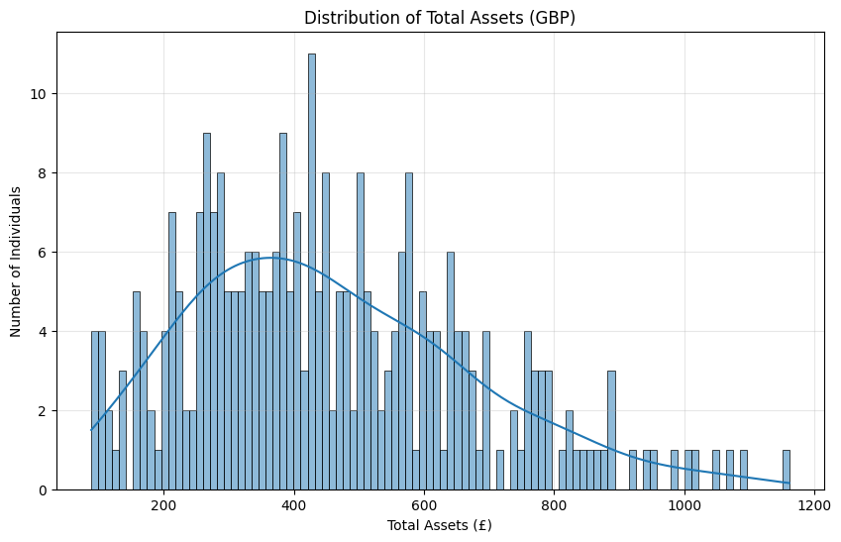

1. **Distribution of Financial Personality Variables:**

* Confidence, risk tolerance, and composure had normal distributions.
* Impulsivity and impact desire were not normally distributed.

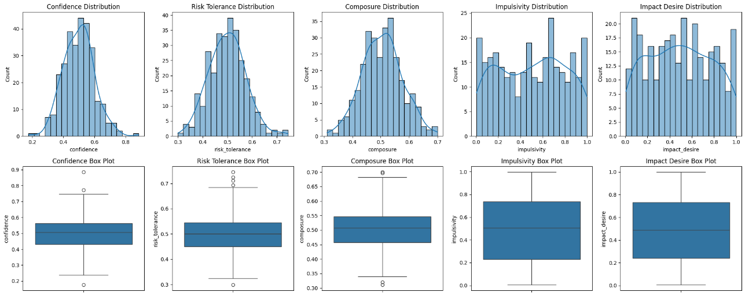

1. **Popularity by asset type:**

* Crypto was the most popular asset type, with 61% of people holding it, followed by equities (38%), and then bonds (34%).
* Cash was the least popular (23%).

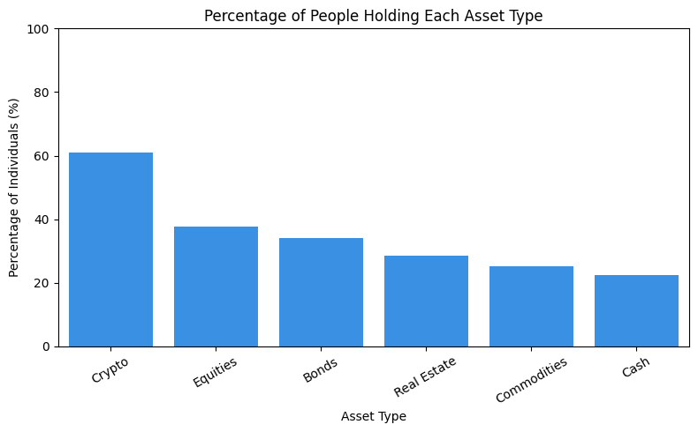

1. **Correlation between financial personality scores and total wealth:**

* Total wealth was not correlated with any financial personality metrics.
* However, risk tolerance showed a strong positive correlation with confidence (r = 0.92) and a moderate positive correlation with composure (r = 0.48), indicating that individuals with higher confidence and composure scores tended to have higher risk tolerance.

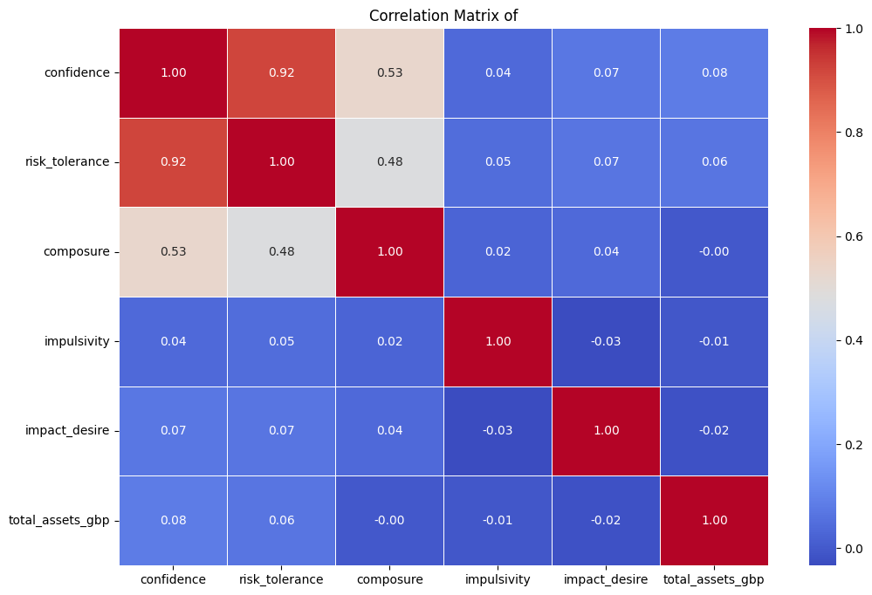

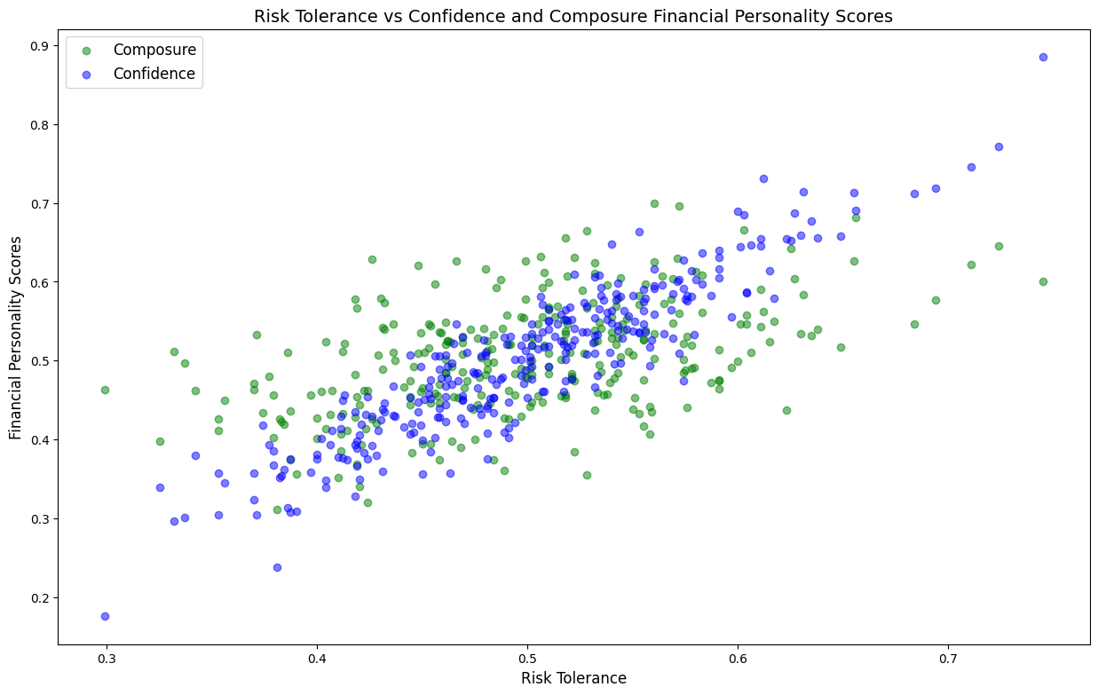

1. **Correlation between financial personality scores and asset type:**

* Impulsivity showed a weak positive correlation with holding crypto (r = 0.24) and a weak negative correlation with holding equities (r = -0.17). This suggests individuals with higher impulsivity scores were slightly more likely to hold crypto (r = 0.24), and slightly less likely to hold equities (r = –0.17).

