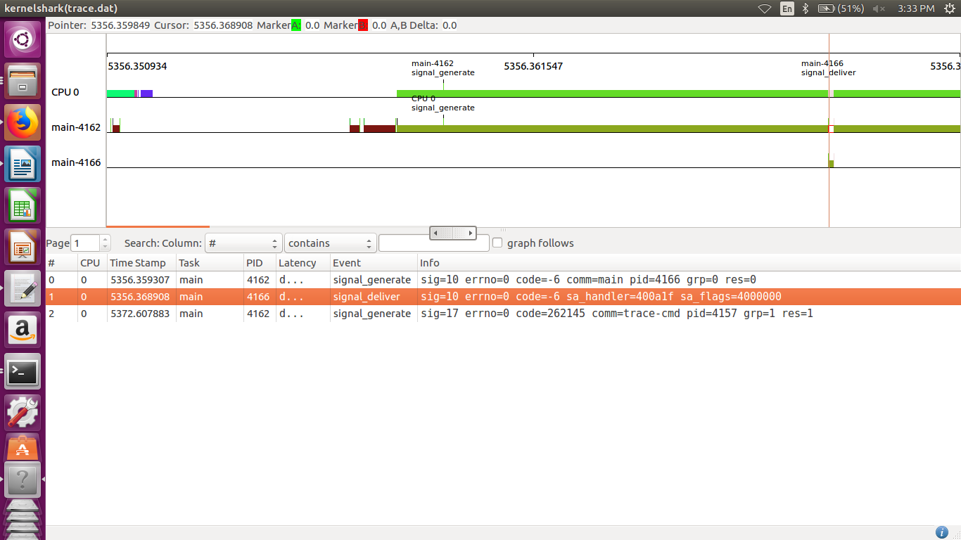

In this task, the thread is in waiting for the semaphore and when the signal is given to the thread it goes to the signal handler and when signal is delivered it again goes back to wait for the semaphore.

