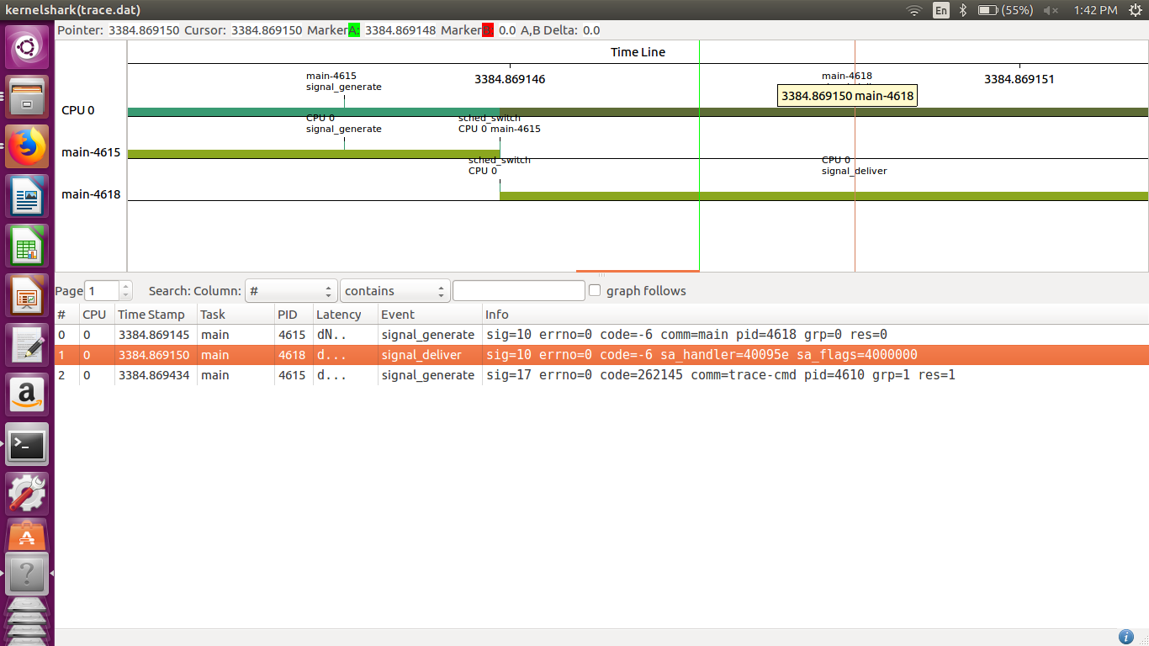

In this task, the thread is in sleep mode and when signal is send it goes to the signal handler and when the signal gets delivered the thread doesn’t go to sleep for the remaining period of time but instead goes ahead in the thread function.

