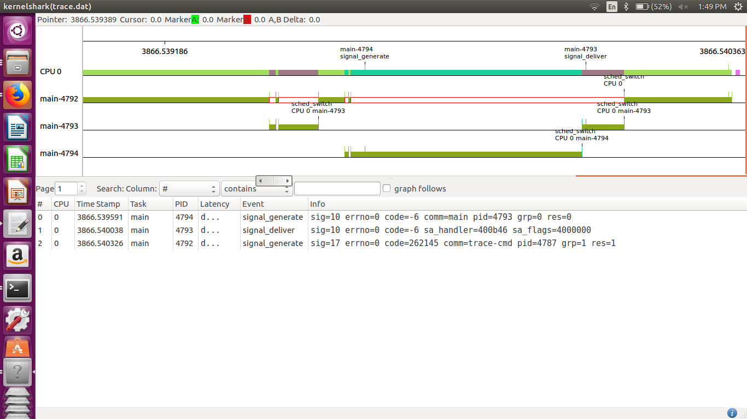

As in the figure, the signal is delivered by high priority thread to the lower priority, but as the higher priority thread is running it would first get completed and then will go to the signal handler for lower priority thread. The reason is the priority of the signal handle is the one given to the calling thread.