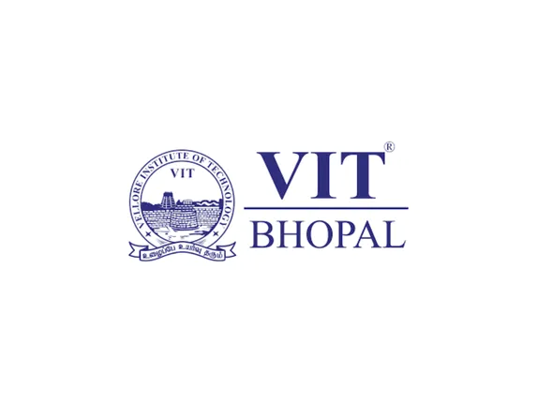

Digital Literacy Project Report

Title Page
Name: Hencee Kevina A.J
Registration Number: 25MIM10164
Branch: Int.Mtech Artificial Intelligence
Year: First Year
Course Code: CSE0001 – Digital Literacy
University: VIT Bhopal University
Submission Date: 30/03/26

Introduction
Digital literacy is an essential skill in today’s technology-driven world. It refers to the ability to effectively use digital tools, platforms, and technologies for communication, learning, and professional development. As part of the Digital Literacy course, this project was designed to help students understand how to navigate the digital environment responsibly and productively. The project involved five tasks covering different aspects of digital literacy, including creating an awareness infographic, building a professional digital portfolio, exploring coding and collaboration platforms, practicing professional email communication, and studying cybercrime awareness. Each task helped develop practical skills useful for academic growth and future career opportunities.

Task 1 – Digital Literacy Infographic
For this task, I created a digital literacy awareness infographic using Canva. The objective was to design a one-page visual resource that helps students understand what digital literacy means and why it is important. The infographic included information about safe internet practices, useful digital tools for students, and the importance of maintaining a professional online presence. The design used simple visuals and icons so that the information could be understood easily. Creating the infographic helped me understand how visual content can be used to spread awareness about digital safety and responsible internet usage.

Task 2 – Student Digital Portfolio
In this task, I created and updated my professional profiles on platforms such as GitHub, LinkedIn, and Kaggle. GitHub was used to host my project repository and manage files related to this assignment. LinkedIn was used to build a professional profile by adding my education details and university information. Kaggle is a platform used for learning data science and participating in competitions. Creating these profiles helped me understand the importance of maintaining a professional online presence. Over the next four years, I plan to upload my projects on GitHub, connect with professionals through LinkedIn, and learn new technical skills through platforms like Kaggle.

Task 3 – Coding & Collaboration Platforms
In this task, I explored coding practice platforms and collaboration tools. I created an account on a coding platform and completed a beginner-level programming challenge to understand how such platforms help improve problem-solving skills. In addition, I created a Digital Literacy Awareness Quiz using Google Forms. The quiz included five questions related to digital literacy topics. Google Forms automatically stores responses in a linked Google Sheet, which makes it easier to collect and analyze responses. This task helped me understand how online tools can support both learning and collaboration.

Task 4 – Email Etiquette & Digital Communication
In this task, I wrote two professional emails: one requesting an assignment deadline extension from a professor and another expressing interest in a summer internship opportunity. Both emails followed professional email etiquette including a clear subject line, polite greeting, structured message body, and proper sign-off. I also created a checklist describing responsible social media behavior for students. This task highlighted the importance of clear and professional communication in digital environments.

Task 5 – Cybercrime Awareness
For this task, I researched cybercrime related to online payment fraud and phishing attacks. These cybercrimes are common and often target students and internet users through fake messages, emails, or websites. During my research, I learned how attackers trick people into sharing sensitive information such as passwords or banking details. One habit I will personally change after researching this topic is being more careful while clicking links or sharing personal information online. I will always verify the authenticity of messages and websites before taking any action.

Conclusion
This project helped me understand the importance of digital literacy in modern academic and professional life. Through the five tasks, I learned how to create awareness content, build a digital portfolio, use online collaboration tools, communicate professionally, and stay safe from cyber threats. These skills are essential for students in today’s digital world.

References
Canva – https://www.canva.com
GitHub – https://github.com
LinkedIn – https://www.linkedin.com
Codechef - https://www.codechef.com/
Google Forms – https://forms.google.com
National Cyber Crime Portal – https://cybercrime.gov.in

