Implementation Proposal

Phase 0

Company 10

Sebastian Rehnby

Version 0.1

# Status

|  |  |  |
| --- | --- | --- |
| Reviewed | Martin Ruzicka, Hans Sanell, Jonas Mattsson, Henrik Nilsson, Vamsi Seshabhattaru | 2010-02-19 |
| Approved | Sebastian Rehnby (PM) | 2010-02-19 |

# Project identity

Company 10, 2010

Chalmers University of Technology, MPSEN

|  |  |  |  |
| --- | --- | --- | --- |
| **Name** | **Responsibility** | **Phone** | **E-mail** |
| Martin Ruzicka | Software Architect | 070 219 20 81 | [ruzicka@student.chalmers.se](mailto:ruzicka@student.chalmers.se) |
| Jonas Mattsson | Database Designer | 070 58 18 095 | [emattsso@student.chalmers.se](mailto:emattsso@student.chalmers.se) |
| Hans Sanell | Software Architect | 073 53 55 210 | [hansn@student.chalmers.se](mailto:hansn@student.chalmers.se) |
| Sebastian Rehnby | Project Manager | 0735 080 850 |  |
| Vamsi Seshabhattaru | Quality Manager | 0739 190 703 | [vamsi@student.chalmers.se](mailto:vamsi@student.chalmers.se) |
| Henrik Schulze Nilsson | Graphical Designer | 0733 643 501 | [henrnil@student.chalmers.se](mailto:henrnil@student.chalmers.se) |

[suit-group-10@googlegroups.com](mailto:suit-group-10@googlegroups.com)

**Client:** Central Operative & Independent Retailers Acquirer, 9 Downing St, Westminster, London SW1A, UK

**Client Contact:** Peter Arch, +44 333 757589, [peter.arch@coira.com](mailto:peter.arch@coira.com)

**Supervisor:** Per Zaring

Content

Status 1

Project identity 2

Document History 4

1. Background 5

1.1. Client 5

1.2. Overall Project Description 5

2. Available Systems 6

2.1. osCommerce 6

2.2. Drupal 6

2.3. Conclusion 6

3. Tools and Practices 7

3.1. Programming Languages 7

3.2. Platforms 7

3.3. Frameworks 7

3.4. Communication Protocols 7

4. System Design 8

4.1. Test Cases 8

4.2. Domain Model 8

4.3. Class Diagram (MUW) 8

4.4. ER Diagram 8

4.5. GUI Mockup 8

5. References 9

# Document History

|  |  |  |  |  |
| --- | --- | --- | --- | --- |
| **Version** | **Date** | **Changes** | **Responsible** | **Approved** |
| 0.1 | 2010-02-18 | First version | SR | SR |

# 

# Background

## Client

Central Operative & Independent Retailers Acquirer (Coira).

## Overall Project Description

Coira wants a web-based portal where customers from all corners of the world can purchase products. This portal should consist of three parts. The portal itself, called MUW (Mall Unlimited Well), that contains the interface towards the customer and the database of available products. A system for handling the suppliers and the purchases, called PUW (Purchase Unlimited Well), that contains the list of approved suppliers and their products. Also, a system for transporters and logistics is needed, called LUW (Logistics Unlimited Well), that contains all approved transporters and there routes. These systems cooperate so that when a customer orders something through MUW, a request is sent to PUW to order the goods from the supplier and a separate request is sent to LUW to book a transport for the purchased goods from the supplier to the customer. All systems should be fault tolerant and provide high availability. All systems must be secure and the integrity of customers, suppliers and transporters must have the highest priority.

MUW handles all interaction with the customer. MUW displays all available products; there details, their price and how long it will take to deliver. MUW also handles the customers orders, displays information and options about orders, such as where they are and if there is any problems, and notifies the customer if there is any hiccups along the way. MUW's graphical interface will provide context-sensitive help at all levels of the interface. At purchase, MUW should find an optimal combination of supplier and transporter. MUW contains the database of available products, their status and suppliers, as well as the customer register. MUW must support several languages and it must be easy to extend the number of languages supported. MUW will also collect statistics about purchases and use these to make predictions about demands and ask PUW to make sure that there is enough supply to satisfy the demand.

PUW is, upon purchase, to contact the chosen supplier and book the products specified. PUW will also keep track of suppliers and update there status in MUW's database. PUW will select suppliers that should undergo a quality review given certain conditions. PUW also has to notify Coira employees if there is not enough suppliers in the system to meet the demand as predicted by MUW, so that new suppliers may be acquired. PUW will also handle delivery notes and send all required data to Coiras financial system.

LUW will be responsible for handling logistics and transportation and keeps track of transporters and their routes. Upon purchase, LUW will book suitable transportation and produce all the needed papers, such as bills of lading and import licenses. LUW is responsible for updating the status of orders and where a particular order is physically. To be able to do this, LUW must accept input from a number of different sources so that the companies that handle the actual transport can update regardless of internal system used. LUW shall utilize a GIS company to compute distances and time consumption. LUW must also make sure that each transport is as profitable as possible with very few, but existing, exceptions. LUW must also allow independent transporters to use the system to plan transports and routes. This includes transports that have nothing to do with Coira. In this case the system is called "Logistics at Transporters" (LaT). In case the system is used this way, the content in the transporters area must be exclusive to that transporter. LUW should notify MUW and Coira personnel in case any hiccups occur.

# Available Systems

Two Open Source systems have been evaluated and considered for use when implementing the web-portal. The following sections provide an overview of considered systems and the implementation decision.

## osCommerce

The first system inspected was osCommerce. The system is built on PHP with a MySQL database as backend. However the implementation of osCommerce is very complicated and bloated, and quite is hard to grasp. Also, the system has received a lot of negative reviews. osCommerce uses old deprecated API functions from the PHP programming language that generate errors and could potentially expose security vulnerabilities.

## Drupal

The second system considered is called Drupal along with the third party module called Ubercart. Drupal is also an open source solution based on PHP and MySQL. The module Ubercart is an implementation of a e-commerce system, directly integrated with Drupals web portal interface. The system is logically implemented using different modules with a clear design. Also, the user interface has a very appealing and stylish modern look.

## Conclusion

The implementation of MUW will heavily rely on the open source project Drupal along with the third party e-commerce module Ubercart.

# Tools and Practices

A number of decisions have been made regarding what tools and common practices to use, to ensure consistency during development.

## Programming Languages

The programming languages used in the implementation will be PHP version 5. The system will rely on MySQL 5 as database backend.

## Platforms

Any platform that can run an Apache or IIS web server along with PHP5 and MySQL will be sufficient for the project. That includes for example Windows, Mac OS X, GNU/Linux.

The project will use Company 10's internal development infrastructure, but the platform requirements should be well documented in the system documentation to ensure compatibility with the client's production environment.

## Frameworks

Due to the implementation relies heavily on the open source project Drupal, it’s API will be used as the framework for the development of new modules.

## Communication Protocols

This section is concerned with the interaction of the subsystems MUW, LUW and PUW. The individual systems are to be implemented as standalone modules, each exposing an external interface for use by other modules. This interface is to be defined using a Service Oriented Architecture (SOA) and implemented using web services. The interface offered by each of the subsystems should be well documented and explained, to ensure correct usage.

The protocols used for the subsystems interfaces will be SOAP over HTTP. SOAP uses the Web Service Definition Language (WSDL), and integrates well with the PHP programming language.

However, the protocol used for the subsystem interfaces can be changed quite easily later on in the project, since the underlying functionality does not change. This should only be done if there are obvious advantages of using a different protocols.

# System Design

The design of the system according to P0 will be shown in diagrams and explanatory texts in the following sections. See Software Requirement Specification document for more information about Phase 0.

## Test Cases

Test cases are described in the Test Plan document.

## Domain Model

Each phase will yield an incremental official delivery to the client, including the corresponding test plan and test report. The system delivered should be thoroughly tested according to the test plan, and transparency of test results and possible issues with a delivery should be clearly communicated to the client. The domain model is shown in figure 1.

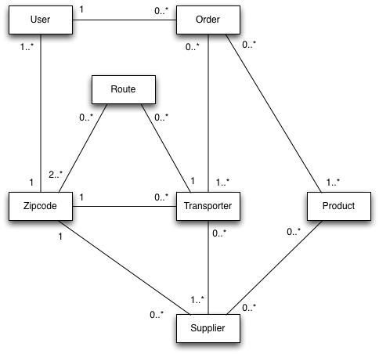

Figure . Domain Model

## Class Diagram (MUW)

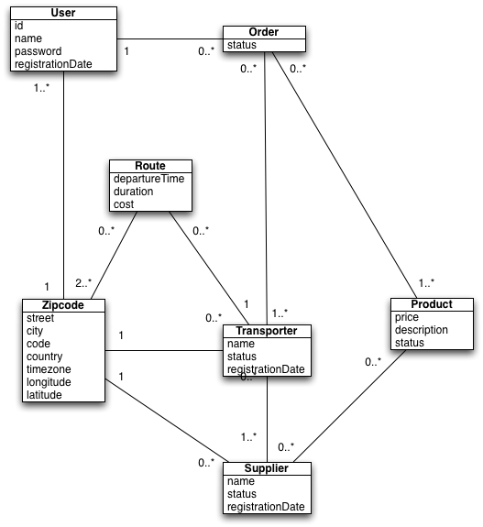

## ER Diagram

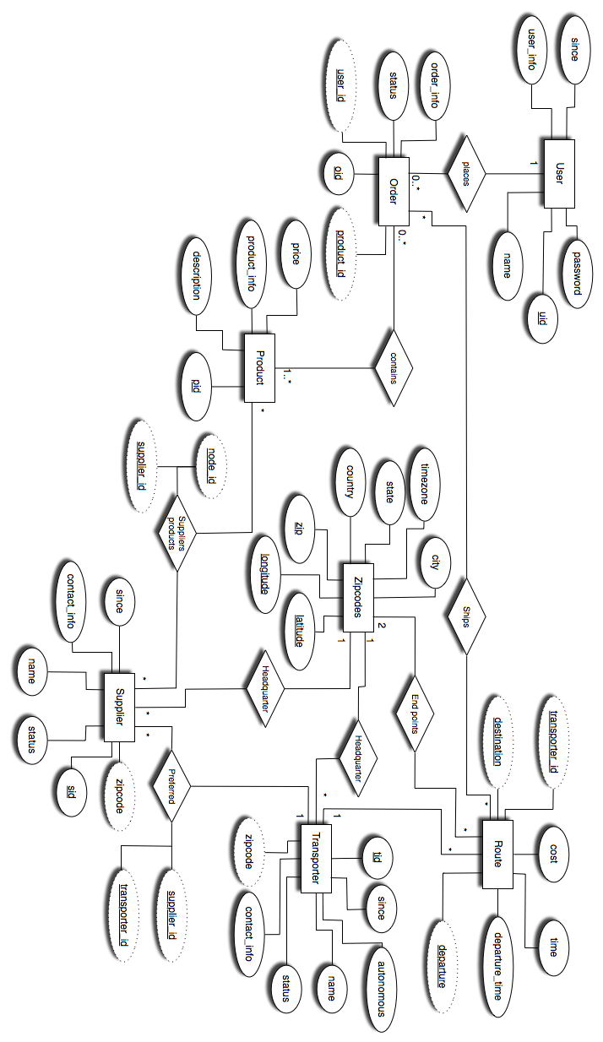

## GUI Mockup

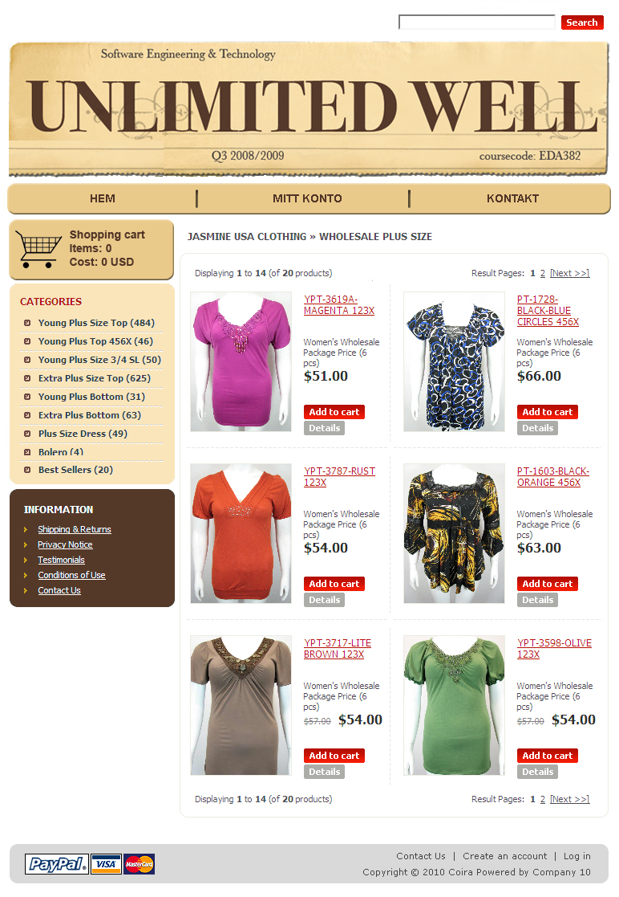

# References

[1] Unlimited Well, Project Specification, 2010

[2] Project Plan, 2010

[2] System Requirements Specification, 2010

[2] Development Plan, 2010