**Low Risk Covid-19 Travel Map – A Generic Solution**

**Abstract:**

**Keywords**: Corona Virus, travel map, safe travel map

**Introduction**

* about Covid-19 pandemic
* travel restrictions and limitations
* summary on new solution
* dataset and generic solution approach

**Literature Survey**

* about travel map literatures - 10 lines
* about existing options in travel map – 10 lines
* few more ?

**Methodology**

In order to discover the safest or low risk travel map between origin and destination, risk zones have been categorised into four, namely, (i) red, (ii) amber, (iii) yellow and (iv) green. The green zone is the very safest zone, yellow is low risk zone, amber is medium risk and red is high risk zone, respectively. Further, to calculate the zone category, two parameters have been used, (i) current zone’s active case count and (ii) maximum active case count from the entire zones.

$$current zone riskscore=\frac{current zone^{'}s active case count}{maximum active case count from the entire zones}$$

The figure [1] shows the coloured categories of four zones with its respective risk score range.



Fig [1] : Zone category with score

The reference range to determine the zone category can be modified based on the condition.

We use risk score matrix to store each routes’ different zones’ count and calculate the overall risk score for all the routes between origin and destination. The risk score matrix is a N X 4 size matrix and the sample risk zone matrix prior to the calculation risk score is shown in the table[1].

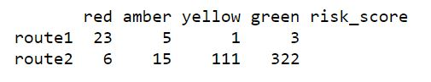

Table[1] : Sample risk zone matrix

In table [1], first four columns are named with risk zone categories and final column is used to store each routes’ calculated risk score. Each row in the table has been used to store each route’s risk score details. For instance, route 1 has 23 red, 5 amber, 1 yellow and 3 green zones. As our intention is to calculate only the risk associated with each route, we skip the green zone count while calculating the risk score. Further, we use zero prefix filling approach to calculate the risk score. The calculated risk score using zero prefix filled approach for the two routes is shown in the Table[2].

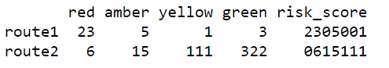

Table[2] : Risk zone matrix with calculated risk score

The zero-filling approach is about finding the big number’s length in each column and just fill prefix zero for the values in the same column if its length is less than maximum number’s length and append the value with risk score column value. The technique will be applied to all the risk zone columns except green. Finally it gives the correct risk score for the decision making.

The steps for discovering low risk travel map is summarised as follows:

Steps to discover low risk travel map

1. ***Load the Covid-19 active cases dataset.***
2. ***Find out the max_active_count_case from the dataset.***
3. ***Read all the routes between origin and destination.***
4. ***Construct the empty risk score matrix with rows count equivalent of number of routes.***
5. ***Read each routes all main locations’ latitude and longitude.***
6. ***Process each route’s main locations latitude and longitude:***
   1. ***find out the place name from latitude and longitude.***
   2. ***Read the active count from the Covid-19 dataset and find out the zone category for the current place.***
   3. ***Update the risk score matrix against current route’s row with zone category count.***
7. ***Calculate risk score for each route using zero prefix fill approach and update the risk score column.***
8. ***Rank each route’s risk based on the score.***

The very first step of the algorithm loads the Covid-19 data set and the active cases for each main places exist in the dataset. The maximum active case count is about finding the place name from the list which has highest active cases comparing with others. The maximum active case value has been used to compute the zone risk score and the risk score will help to find out the zone category. The next step of the algorithm gets the list of all routes between origin and destination. In case there is only one route exist between origin and destination, the proposed algorithm cannot help user as there is no alternative. So, the more possible routes exist between origin and destination, can give more risk score options to the traveller. Once the list of routes obtained, each routes data will be processed to find out the main places, zone category and its risk score.

While processing each route’s main locations, proposed algorithm finds out the place name from latitude and longitude. Once the place name is identified, it finds out the zone category for the place. As and when the new place is identified, its category has been computed and the risk score matrix will be updated for the current route and zone column value will be incremented by one. Once all the routes’ main place details are processed, risk score will be computed and stored in the risk_score column of risk score matrix. Eventually, each routes score can be used to find out the risk involved, and the higher risk score refers the higher risk and lower score refers lower risk.

**Result and Discussion**

In our research, Covid-19 dataset for India has been used and that has been downloaded from the official website[1]. It has confirmed, active, recovered, and deceased cases for each state as well as districts. We use only active cases count to compute the risk score for each route, and load the active cases data and find out the district which has maximum cases for zone categorization. As the dataset has the district wise data, we compute the zone category for each district. However, this algorithm is capable for identifying zone category in small spot/location level if the dataset supports.

The google map data has been used to find out all the routes between origin and destination. Google map API gives all the main locations’ latitude and longitude between origin and destination in JSON format. Further, we do not alter any existing map route but computes the risk involved in each route and advise the traveller with risk score.

Though the proposed solution can be applied in any country/area map, our experiment is mainly focus India as we have used India’s Covid-19 dataset. The figure[2] shows the routes between Kanaykaumari (TamilNadu, India) and Chennai(TamilNadu, Inida), and there are three routes suggested by google map.

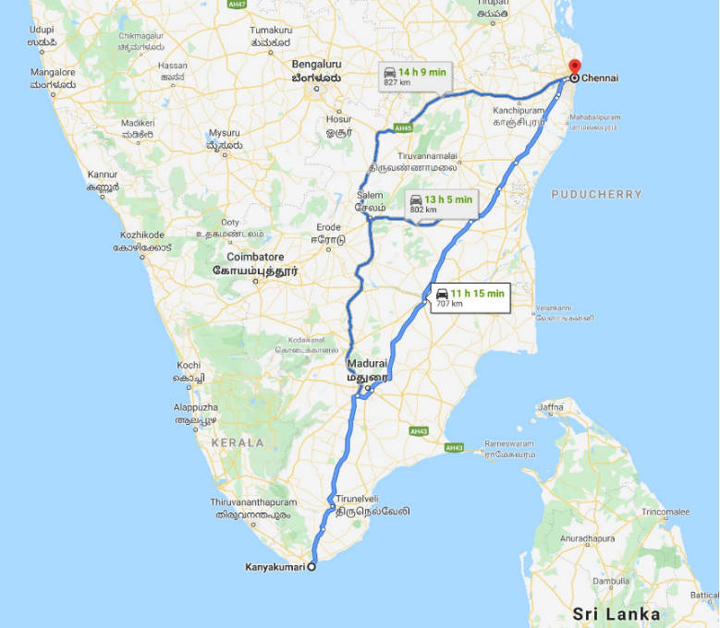

Figure[2]: Three routes between Kanyakumari and Chennai

The algorithm connects with google map and get the latitudes and longitudes for all the three routes in JSON format. The three routes’ places details are processed by the algorithm and eventually it gives the risk score matrix as output. The table[3] shows the risk score matrix for routes between Kanaykaumari (TamilNadu, India) and Chennai(TamilNadu, Inida).

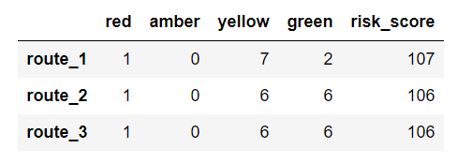

All the three routes have only 1 red zone but route 1 has 7 yellow zones but others have 6 yellow zones each. In this experiment result, route 1 has slightly higher risk comparing with route 2 and route 3.

**Conclusion**

**Further Enhancement**

* Can be used during natural calamities to guide the travellers.
* Generic solution and highly customizable.

References:

1. India Covid-19 cases data

https://api.covid19india.org/documentation/csv/