**J Hencil Peter**

**Swapnil Saurav**

**Jaiprakash**

**Pending Work :**

1. **Abstract (Swapnil)**
2. **Include 2-4 references in introduction section. (Swapnil)**
3. **Methodology – immediate neighbours for risk calculation (Hencil)**
4. **Result and discussion – dive an output using second immediate neighbours approach (Hencil)**
5. **Conclusion and future enhancement – polish the content (JP Sir)**

**Low Risk Covid-19 Travel Map – A Generic Solution**

**Abstract:**

**Keywords**: Corona Virus, travel map, safe travel map

**Introduction**

Coronavirus disease (COVID-19) is an infectious disease which has created a havoc in the world. It is caused by a newly discovered coronavirus. Even though we have seen that most people who gets infected with the COVID-19 virus, experience mild to moderate respiratory illness and recover without requiring special treatment. The recovery rate varies from 92%-97% around the world, which is probably not a cause of concern. More concerning is that older people, and those with underlying medical problems like cardiovascular disease, diabetes, chronic respiratory disease, and cancer are more likely to develop serious illness and even can lead to death.

From the various research, we have seen that the best way to prevent and slow down transmission is be well informed about the COVID-19 virus, the disease it causes and how it spreads. One has to protect themselves and others from infection by washing your hands or using an alcohol based rub frequently and not touching your face. Research also says that the COVID-19 disease spreads primarily through droplets of saliva or discharge from the nose when an infected person coughs or sneezes. It’s very important that we practice respiratory etiquette (for example, by coughing into a flexed elbow) among the other etiquette we mentioned.

At the time of writing this report, there are no specific vaccines or known treatments for COVID-19. However, there are many ongoing clinical trials evaluating potential treatments and organizations are also conducting trial on human for finding an effective vaccine.

In this research, we looked at the Covid-19 scenario in India. Recovery rates are higher but since the disease itself is infectious, both central and state governments have announced lockdowns in various regions. People are not encouraged to travel. This has hit the economy hard.

Covid-19 pandemic is set to impact the India growth story and the country’s gross domestic product (GDP) could in fact shrink in 2020, as per a Dun & Bradstreet global report.

In 2020 fiscal year, India's growth rate could get into negative value of 4.5%. One of the reason is the travel restrictions. The hospitality industry has suffered the most. India’s hotels are reimagining the hospitality industry to survive the coronavirus pandemic because how far can they go with just being creative at the time when people are reluctant to even step out of their homes. The corona virus outbreak in India and the ensuing 70-day lockdown enforced by government has crippled the hospitality industry from small restaurants to big hotel chains and travel industry. Hotels are struggling to pay salaries, and in many cases, even are laying off staff. Companies are re-calibrating and localizing supply chains, which will change the way they operate their business. But these measures are not sustainable.

According to The World Travel and Tourism Council (WTTC), tourism generated $240 bn or 9.2% of India's GDP in 2018 and supported 42.67 mn jobs which is 8.1% of its total employment. This was the biggest motivator to carry out this research. Challenge is to come up with best possible routes during Covid-19 times and this could be extended to any such pandemic we might encounter in future as well. Input that we take is the zone classification by the government into Red, Orange and Green. Red zone indicating complete lockdown of non essential goods and certain type of travel is allowed with special permissions. Orange is where the travel is allowed with certain limitation and Green zone has no travel restrictions. Apart from this, even the people travelling would want to visit few or no red zones and minimal orange zones because the chances of getting infected is very high in these areas. With these info in mind, the paper comes up with an efficient travel route based on any two given points.

The generated travel plan would be the least risky of all the possible routes. The time factor is also taken into account but has very low weight. Many similar papers have been referred but none of the papers have spoken about similar situation. There are many articles which talks about coming up with route planners in emergency situation. The conditions and the attributes analyzed in this paper is different compared to similar research done in the past.

This research can be used in multiple scenarios apart from Covid-19 situations. This study can be extended to include in different situations which requires the planner to re-route the planned route for variety of reasons like, collapse of a bridge, heavy rain in certain part, etc. This research can be used by travel industry for route planner, individual people to plan their travel route to have least chances of surprise and also by supply chain planners.

**Literature Review**

There are many research papers which were referred to understand how the route planning is done in similar situations. A paper titled "Travel Time Forecasting and Dynamic Routes Design for Emergency Vehicles" by Giuseppe Musolino and others were published in 2013. The paper presents a framework to dynamically design routes of emergency vehicles taking into account within-day variations of link travel times on a road network presented. The framework integrates two modelling components: (i) a within-day dynamic assignment model that simulates the interaction between the time-varying network and travel demand, and (ii) a dynamic vehicle routing model that design optimal routes of emergency vehicles. The linking variable of the two modelling components is the short-term forecasted travel time, which allows to design routes of emergency vehicles based on anticipatory knowledge of traffic dynamics on the road network. Some procedures of the proposed framework are calibrated and validated in an experimental evacuation test site.

The safe operation of all highway facilities, including intersections, requires the consideration of three primary elements for safe roadway operations: the driver, the vehicle, and the roadway. Robert Layton presented the detailed analysis in a report to Oregon Department of Transportation (US) in 2012.

There was a study done by a team in Egypt on GIS-Based Network Analysis for the Roads. This study was conducted for Greater Cairo area. Sayed Ahmed, Romani Farid Ibrahim and Hesham A. Hefny, in their paper, says in a crowded city like Grater Cairo Region (GCR), Egypt, finding a desired location becomes a difficult task, especially in emergency situations. The main criteria of any emergency response system (ERS) are its readiness to solve the immediate emergency situation such as fire emergency response, police station emergency response, healthcare emergency response system,etc.

Then there are many papers which talks about the vehicle movement in crowded city. Road accidents are a serious problem in the world especially in developing countries. Travel time of Emergency Vehicle (EV) is an important parameter in emergency rescue during accidents. The situation can be improved provided the emergency information services like Web based emergency information and management systems which identifies incident, alerts emergency vehicle (EV), estimate travel time, enhance pre-emption control and route the EV. The study titled "Travel Time Estimation and Routing for Emergency Vehicles Under Indian Conditions" by R. Anil, M. Satyakumar, Jesh Jayakumar proposes a multilayer fuzzy model to determine the degree-of-priority (DOP) based on emergency vehicle pre-emption demand and impact intensity on each road section.

There are few research papers which focusses on shortest path problem. A research paper published in 2016 titled "Dynamic Path Planning of Emergency Vehicles Based on Travel Time Prediction" by Jiandong Zhao in Journal of Advanced Transportation. The dynamic paths planning problem of emergency vehicles is usually constrained by the factors including time efficiency, resources requirement, and reliability of the road network. Therefore, a two-stage model of dynamic paths planning of emergency vehicles is built with the goal of the shortest travel time and the minimum degree of traffic congestion. Firstly, according to the dynamic characteristics of road network traffic, a polyline-shaped speed function is constructed. And then, based on the real-time and historical data of travel speed, a new kernel clustering algorithm based on shuffled frog leaping algorithm is designed to predict the travel time. Secondly, combined with the expected travel time, the traffic congestion index is defined to measure the reliability of the route. Thirdly, aimed at the problem of solving two-stage target model, a two-stage shortest path algorithm is proposed, which is composed of K-paths algorithm and shuffled frog leaping algorithm.

Travel Time Forecasting and Dynamic Routes Design for Emergency Vehicles by Giuseppe Musolino published in 2013 in Science Direct, proposed a framework to dynamically design routes of emergency vehicles taking into account within-day variations of link travel times on a road network is presented. The framework integrates two modelling components: (i) a within-day dynamic assignment model that simulates the interaction between the time-varying network and travel demand, and (ii) a dynamic vehicle routing model that design optimal routes of emergency vehicles. The linking variable of the two modelling components is the short-term forecasted travel time, which allows to design routes of emergency vehicles based on anticipatory knowledge of traffic dynamics on the road network. Some procedures of the proposed framework are calibrated and validated in an experimental evacuation test site.

**Methodology**

In order to discover the safest or low risk travel map between origin and destination, risk zones have been categorised into four, namely, (i) red, (ii) amber, (iii) yellow and (iv) green. The green zone is the very safest zone, yellow is low risk zone, amber is medium risk and red is high risk zone, respectively. Further, to calculate the zone category, two parameters have been used, (i) current zone’s active case count and (ii) maximum active case count from the entire zones.

$$current zone riskscore=\frac{current zone^{'}s active case count}{maximum active case count from the entire zones}$$

The figure [1] shows the coloured categories of four zones with its respective risk score range.



Fig [1] : Zone category with score

The reference range to determine the zone category can be modified based on the condition.

We use risk score matrix to store each routes’ different zones’ count and calculate the overall risk score for all the routes between origin and destination. The risk score matrix is a N X 4 size matrix and the sample risk zone matrix prior to the calculation risk score is shown in the table[1].

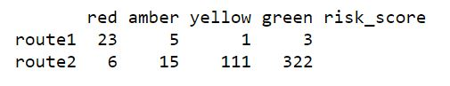

Table[1] : Sample risk zone matrix

In table [1], first four columns are named with risk zone categories and final column is used to store each routes’ calculated risk score. Each row in the table has been used to store each route’s risk score details. For instance, route 1 has 23 red, 5 amber, 1 yellow and 3 green zones. As our intention is to calculate only the risk associated with each route, we skip the green zone count while calculating the risk score. Further, we use zero prefix filling approach to calculate the risk score. The calculated risk score using zero prefix filled approach for the two routes is shown in the Table[2].

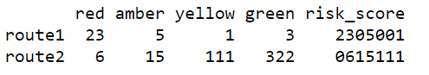

Table[2] : Risk zone matrix with calculated risk score

The zero-filling approach is about finding the big number’s length in each column and just fill prefix zero for the values in the same column if its length is less than maximum number’s length and append the value with risk score column value. The technique will be applied to all the risk zone columns except green. Finally it gives the correct risk score for the decision making.

The steps for discovering low risk travel map is summarised as follows:

Steps to discover low risk travel map

1. ***Load the Covid-19 active cases dataset.***
2. ***Find out the max_active_count_case from the dataset.***
3. ***Read all the routes between origin and destination.***
4. ***Construct the empty risk score matrix with rows count equivalent of number of routes.***
5. ***Read each routes all main locations’ latitude and longitude.***
6. ***Process each route’s main locations latitude and longitude:***
   1. ***find out the place name from latitude and longitude.***
   2. ***Read the active count from the Covid-19 dataset and find out the zone category for the current place.***
   3. ***Update the risk score matrix against current route’s row with zone category count.***
7. ***Calculate risk score for each route using zero prefix fill approach and update the risk score column.***
8. ***Rank each route’s risk based on the score.***

The very first step of the algorithm loads the Covid-19 data set and the active cases for each main places exist in the dataset. The maximum active case count is about finding the place name from the list which has highest active cases comparing with others. The maximum active case value has been used to compute the zone risk score and the risk score will help to find out the zone category. The next step of the algorithm gets the list of all routes between origin and destination. In case there is only one route exist between origin and destination, the proposed algorithm cannot help user as there is no alternative. So, the more possible routes exist between origin and destination, can give more risk score options to the traveller. Once the list of routes obtained, each routes data will be processed to find out the main places, zone category and its risk score.

While processing each route’s main locations, proposed algorithm finds out the place name from latitude and longitude. Once the place name is identified, it finds out the zone category for the place. As and when the new place is identified, its category has been computed and the risk score matrix will be updated for the current route and zone column value will be incremented by one. Once all the routes’ main place details are processed, risk score will be computed and stored in the risk_score column of risk score matrix. Eventually, each routes score can be used to find out the risk involved, and the higher risk score refers the higher risk and lower score refers lower risk.

**Result and Discussion**

In our research, Covid-19 dataset for India has been used and that has been downloaded from the official website[1]. It has confirmed, active, recovered, and deceased cases for each state as well as districts. We use only active cases count to compute the risk score for each route, and load the active cases data and find out the district which has maximum cases for zone categorization. As the dataset has the district wise data, we compute the zone category for each district. However, this algorithm is capable for identifying zone category in small spot/location level if the dataset supports.

The google map data has been used to find out all the routes between origin and destination. Google map API gives all the main locations’ latitude and longitude between origin and destination in JSON format. Further, we do not alter any existing map route but computes the risk involved in each route and advise the traveller with risk score.

Though the proposed solution can be applied in any country/area map, our experiment is mainly focus India as we have used India’s Covid-19 dataset. The figure[2] shows the routes between Kanaykaumari (TamilNadu, India) and Chennai(TamilNadu, Inida), and there are three routes suggested by google map.

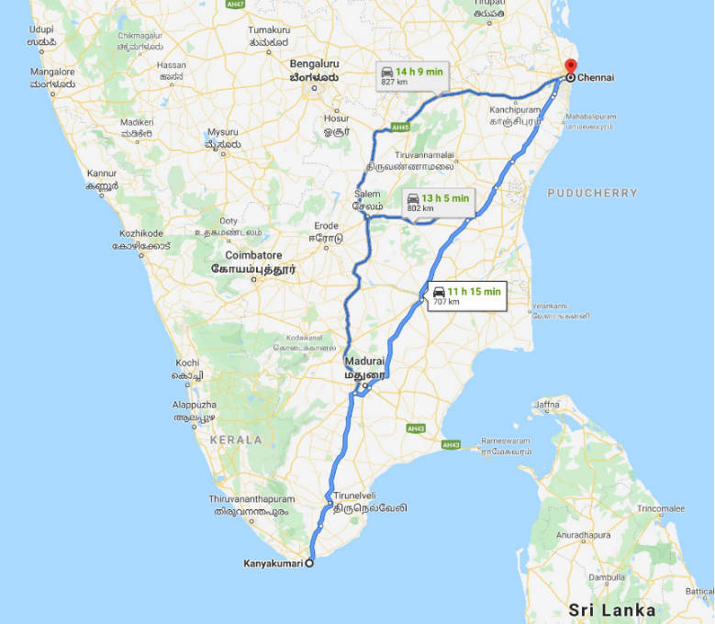

Figure[2]: Three routes between Kanyakumari and Chennai

The algorithm connects with google map and get the latitudes and longitudes for all the three routes in JSON format. The three routes’ places details are processed by the algorithm and eventually it gives the risk score matrix as output. The table[3] shows the risk score matrix for routes between Kanaykaumari (TamilNadu, India) and Chennai(TamilNadu, Inida).

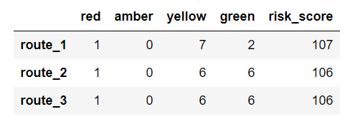

All the three routes have only 1 red zone but route 1 has 7 yellow zones but others have 6 yellow zones each. In this experiment result, route 1 has slightly higher risk comparing with route 2 and route 3.

**Conclusion**

**Further Enhancement**

* Can be used during natural calamities to guide the travellers.
* Generic solution and highly customizable.

**Conclusion and Future Enhancement**

The main focus of this study has been on the lowest possible risk of travelling during COVID-19. In this study Google Map API has been utilized between origin and destination and this approach can be used all over the world during any situation. A future direction of this paper will be to use during natural calamities such as flood, earthquake, and cyclone by rescue team in order to help/guide the affected people. This approach can have generic solution and can be customized according to new requirements.

It is important to note that the approach is suitable to let us know the less possible risk path for travelling from one place to another place by road. This Proposed method has been considered for the COVID-19 data of India. It is not limited to one place or country/area/zone but can be applied to anywhere and in any situation of the world.Therefore, generalization and customization is the next step of the approach.

References:

1. India Covid-19 cases data : https://api.covid19india.org/documentation/csv/
2. https://www.researchgate.net/publication/259037953_Travel_Time_Forecasting_and_Dynamic_Routes_Design_for_Emergency_Vehicles
3. https://cce.oregonstate.edu/sites/cce.oregonstate.edu/files/12-2-stopping-sight-distance.pdf
4. http://ceur-ws.org/Vol-2144/paper2.pdf
5. https://ieeexplore.ieee.org/document/8492696/references#references
6. https://www.hindawi.com/journals/jat/2017/9184891/
7. https://www.sciencedirect.com/science/article/pii/S1877042813040482
8. AmrapaliDabhade, Dr. K. V. Kale, Yogesh Gedam, “Network Analysis for Finding Shortest Path in Hospital Information System”, IJARCSSE, Vol.5, No.7, July 2015, pp. 618-623.
9. Gubara, A. Amasha, Z. Ahmed and S. El Ghazali, “Decision Support System Network Analysis for Emergency Applications”, Informatics and Systems (INFOS), 2014 9th International Conference on, Cairo, 2014, pp. ORDS-40-ORDS44
10. Vineeth Kodire, Sreebha Bhaskaran and H N Vishwas, "GPS and Zig Bee based traffic signal pre-emption", Internatinal conference on Inventive Computation Technologies (ICICT) Aug 2016 published in IEEE Xplore.
11. Satyajith Mondal, Sandip Chakrabathoy and Ankit Gupta, "Estimation of passenger car unit for heterogeneous traffic stream of urban arterials: case study of Kolkata", The International journal of Transportation Research, Feb 2017.
12. Noraimi Azlin Mohd, Zati Aqmar Zaharudin and Nor Amalina Nordin, "Finding shortest path of the ambulance routing: Interface of A* algorithm using C# programming", IEEE kuala Lumpur Malaysia, 2012.
13. https://www.who.int/news-room/articles-detail/key-considerations-for-repatriation-and-quarantine-of-travellers-in-relation-to-the-outbreak-of-novel-coronavirus-2019-ncov