Pharmaceutical Inventory Optimization & Financial Risk Analysis
Comprehensive Technical Project Documentation
Author: Hend Khalid
Track: Data Analytics (DEPI)
Tools Deployed: Power BI, Power Query, Advanced DAX, Microsoft Excel

1. Executive Summary
In the pharmaceutical distribution sector, operational efficiency directly dictates financial survival. This project uncovers a critical Profitability Paradox within warehouse operations: while the business achieves an impressive $185.94M in Total Sales with a strong 25.88% Gross Margin ($48.11M), the final Net Profit remains severely negative at -$27.16M.
This deficit is entirely driven by astronomical storage expenses ($75.52M) and massive inventory waste ($56.41M). By establishing a robust Star Schema data model and an analytical Power BI dashboard infrastructure, this documentation outlines the core technical bottlenecks and delivers data-driven strategic actions to eliminate waste, optimize working capital, and restore business profitability.
2. Business Problem & Project Objectives
2.1 Problem Statement
- Severe Capital Lockup: Over-purchasing and high inventory levels have driven annual storage expenses to an unsustainable $75.52M.
- Critical Waste Leakage: Expiry, cold chain disruptions, and operational damages account for $56.41M in absolute losses.
- The Profit Deficit: Holding and waste expenses completely devour the $48.11M gross profit, resulting in a net loss of $27.16M.
- Supply Chain Bottlenecks: Prolonged supplier lead times force defensive, bulk-ordering behaviors that accelerate product expiration.
2.2 Project Objectives
- Inventory Optimization: Achieve optimal stock levels, improve the inventory turnover ratio, and minimize both stockouts and dead stock.
- Financial Risk Mitigation: Minimize expiry-related losses, reduce holding costs, and establish a framework for calculating Inventory Value at Risk.
- Data-Driven Decision Making: Provide management with interactive visual dashboards to replace intuitive ordering with dynamic, demand-driven procurement.
3. Technical Architecture & Data Modeling
The data architecture utilizes a highly optimized Star Schema to eliminate data redundancy and maximize query performance across transactional layers. As verified by the architectural blueprint , the model enforces a strict separation between descriptive dimensions and event-based transactional tables. All relationships maintain Referential Integrity using a One-to-Many (1:N) cardinality filtering from the Dimensions down to the Fact tables.
3.2 Comprehensive Data Dictionary
A. Dimension Tables (The Descriptive Context)
- Dim_Product: Master data tracking catalog logistics. Columns: Product_ID (PK), Product_Name, Category, Package_Type, Batch_Number, Purchase_Price, Selling_Price, Reorder_Level, Shelf_Life_Days, and Product_Priority.
- Dim_Supplier: Defines procurement channels and operational latency. Columns: Supplier_ID (PK), Supplier_Name, Supplier Short Name, Lead_Time_Days, City, and custom measures: Supplier Risk Loss, Supplier Risk Loss (M).
- Dim_Date: Centralized corporate time intelligence dimension. Columns: Date_ID (PK), Date, Day, Day_Name, Month, Month Num, MonthName, Quarter, Year.
B. Fact Tables (The Transactional & Metric Layers)
- Fact_Sales: Captures product liquidation events. Columns: Sale_ID, Date_ID, Product_ID, Customer_ID, Quantity_Sold, Unit_Selling_Price, Total_Revenue, COGS.
- Fact_Purchases: Tracks capital deployment for raw inventory intake. Columns: Purchase_ID, Date_ID, Product_ID, Supplier_ID, Quantity_Purchased, Unit_Cost, Total_Purchase_Cost.
- Fact_Inventory: Captures daily operational warehouse snapshots. Columns: Batch_Number, Date_ID, Product_ID, Expiry_Date, Quantity_On_Hand, Storage_Cost_per_Unit.
- Fact_Waste: Isolates asset depreciation and physical inventory leakages. Columns: Batch_Number, Product_ID, Expiry_Date, Expirty_Date_new, Quantity_Expired, Loss_Value, Reason (Cold Chain Failure, Damaged, Expired).
4. Advanced DAX Implementation Formulae
All metrics are consolidated within the centralized All_KPIs measure group. Below is the exact logical plain-text formulation of the primary indicators deployed:
4.1 Financial & Core Profitability Measures
total_sales = SUM(Fact_Sales[Total_Revenue])
COGS = SUM(Fact_Sales[COGS])
gross_margin = DIVIDE([total_sales] - [COGS], [total_sales], 0)
Total_Storage_Expense = SUMX(Fact_Inventory, Fact_Inventory[Quantity_On_Hand] * Fact_Inventory[Storage_Cost_per_Unit])
Total_Waste = SUM(Fact_Waste[Loss_Value])
Net_Profit = ([total_sales] - [COGS]) - [Total_Storage_Expense] - [Total_Waste]
4.2 Supply Chain Optimization & Health Metrics
Inventory_Turnover = DIVIDE([COGS], AVERAGE(Fact_Inventory[Quantity_On_Hand]) * AVERAGE(Dim_Product[Purchase_Price]), 0)
Days_of_Inventory = DIVIDE(365, [Inventory_Turnover], 0)
Reorder_Point = [Avg_Daily_Sales] * AVERAGE(Dim_Supplier[Lead_Time_Days])
5. Visual Analytics & Dashboard Evidence
To validate the empirical findings, this section links the data-driven insights directly to the deployed Power BI interactive dashboards.
5.1 Financial Performance & Profitability Analysis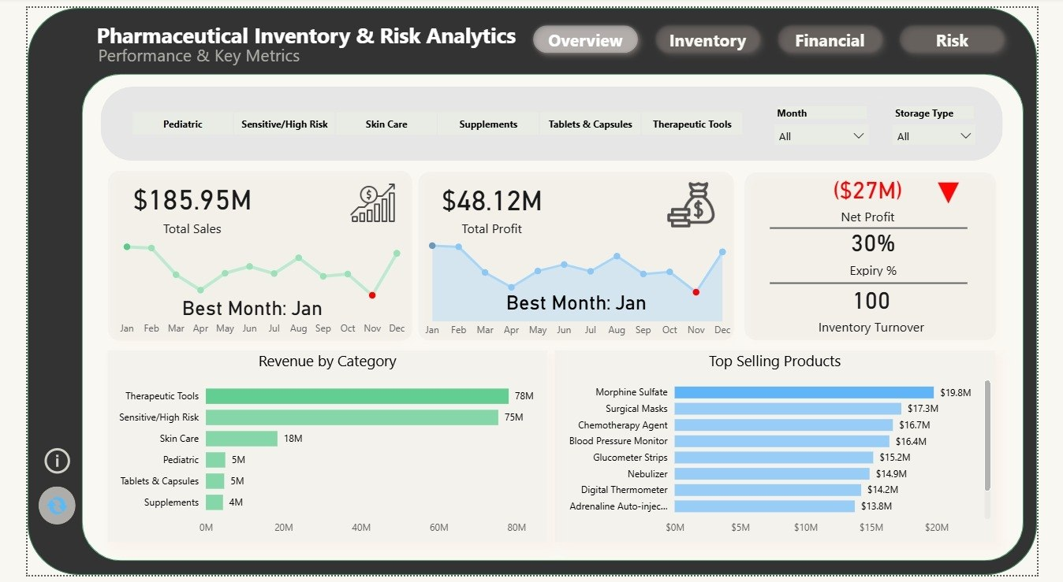Description: This interface isolates macro-level financial indicators, mapping Total Sales ($185.95M) against Gross Profit ($48.12M).
Analytical Proof: The visualization proves the Profitability Paradox. The negative net profit ($-27.17M) is not a demand failure, but rather a catastrophic warehousing expense failure.
5.2 Waste Root-Cause & Risk Exposure
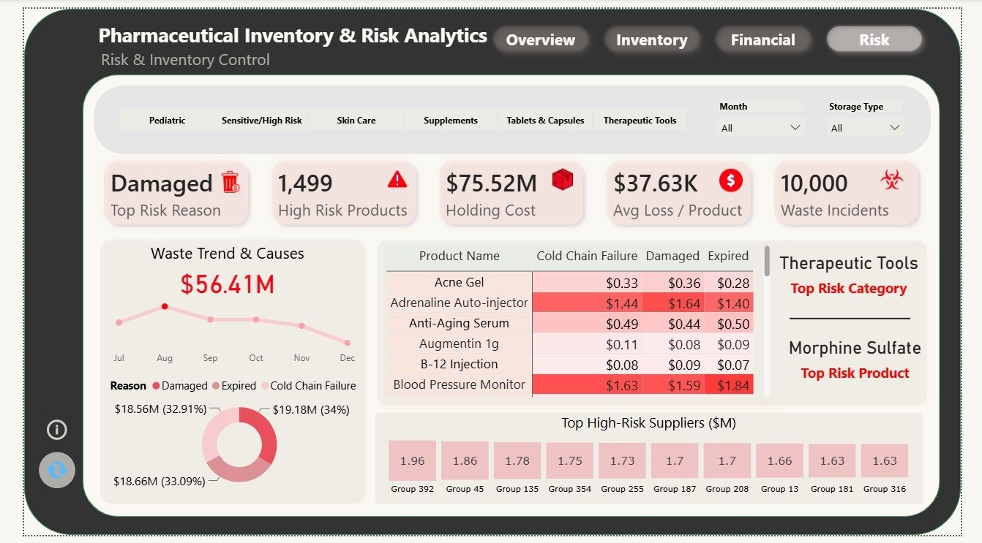Description: This dashboard categorizes the $56.41M in absolute operational losses across 10,000 recorded waste incidents.
Analytical Proof: The Loss Value by Reason Donut Chart provides the ultimate visual proof for management: Cold Chain Failure (34%), Damaged Stock (33.09%), and Expired Stock (32.91%).
This interface evaluates the Quantity on Hand against the Reorder Levels and tracks the total Holding Costs ($75.52M).
Analytical Proof: It reveals that the warehouse is carrying an immense volume of dead stock, which explains why the storage cost exploded to $75.52M.
5.3 Supplier & Logistical Lead Time
This view tracks procurement efficiency by correlating Total Purchase Cost with Supplier Lead Times (Days).
Analytical Proof: The data exposes specific distributors who consistently delay deliveries, justifying our strategic decision to restructure supplier contracts.
6. Strategic Recommendations & Actionable Decisions
- Technical Overhaul of the Cold Chain Infrastructure: Invest capital into refurbishing warehouse refrigeration units. Eliminating Cold Chain Failures saves up to $18.56M in preventable waste.
- Standardization of Warehouse Material Handling: Implement rigid stacking height thresholds and specialized shelving configurations for high-volume Therapeutic Tools to address the root cause of the $19.18M damage loss.
- Transition to Dynamic, Lead-Time-Adjusted Reordering: Replace fixed ordering thresholds with dynamic reorder points that adjust based on real-time supplier Lead_Time_Days to decrease holding costs.
- Implementation of an Automated Expiry Alert System (FEFO Alignment): Configure an automated 90-day predictive push notification layer. Products entering this window must trigger immediate priority distribution to high-volume clinics.
7. Conclusion
Pharmaceutical inventory management is fundamentally a balancing act between operational availability and financial risk. This documentation demonstrates that achieving high sales volumes is futile if the underlying supply chain suffers from unchecked waste and excessive holding costs. Executing the recommended safeguards will immediately stem the $56M+ waste leakage, optimize working capital, and restore the warehouse to strong, positive profitability.

