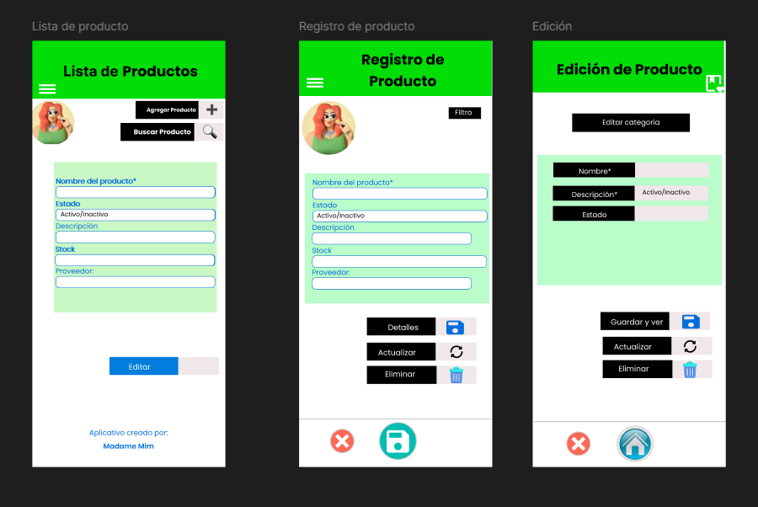

LINK FIGMA
https://www.figma.com/design/cebomc4y5oh716AGEFgyrO/Parcial?node-id=0-1&t=oZLBlAmSQ0KhRwFr-1
LINKG GITHUB
https://github.com/hender23/programacion-movil-2025-a-g1.git

