James Mark Hender
09686207

TABLE OF CONTENTS

Verify Locks work.................................1 - 3
No Lock.................................................4
TestAndSet Lock...................................5
TestAndTestAndSet Lock......................6
MCS Lock..............................................7
Bakery Lock...........................................8

INTRODUCTION:

This tutorial was to show the performance levels between the different types of locks used to increment a non-atomic global variable.

First instead of adding code to prove that each Lock worked, I instead removed the WHILE loop and the condition to break from the WORKER class. This meant that each lock would then have the same number of ops, 1000,2000,4000 and 8000 for threads of 1,2,4,8 respectively. No Lock fails and my Bakery Lock (just could not get it working and would take 25minutes at a time to try and see if I fixed it) show errors while the other locks show correct results. The screenshots below show this.
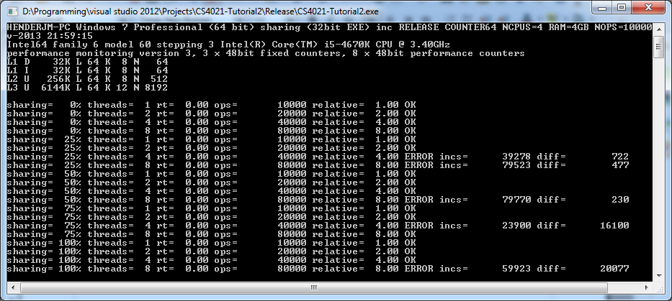
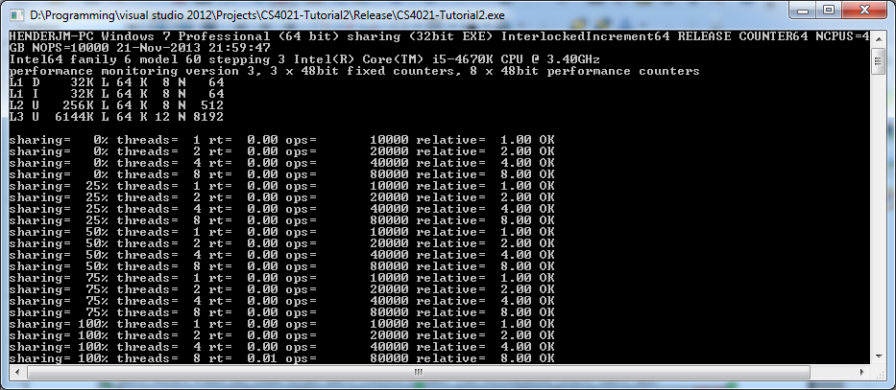

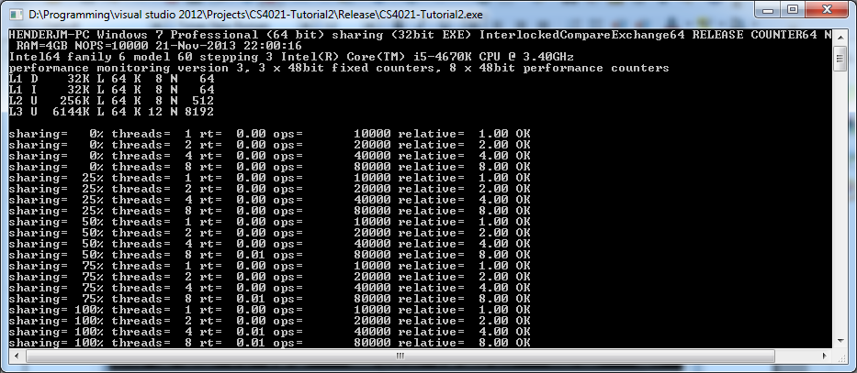
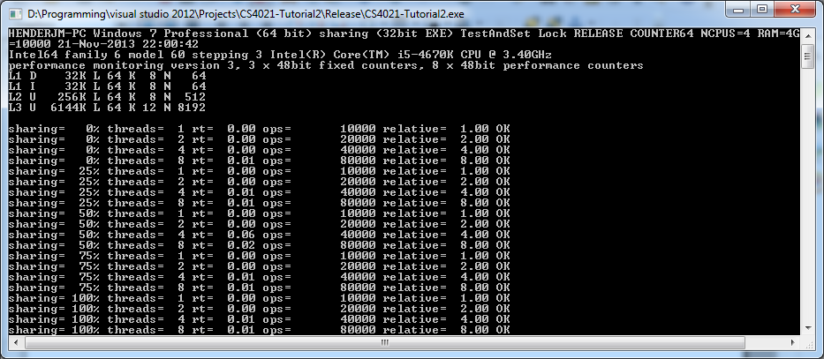
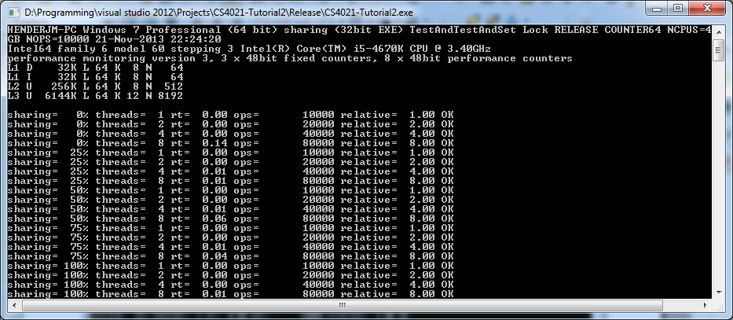

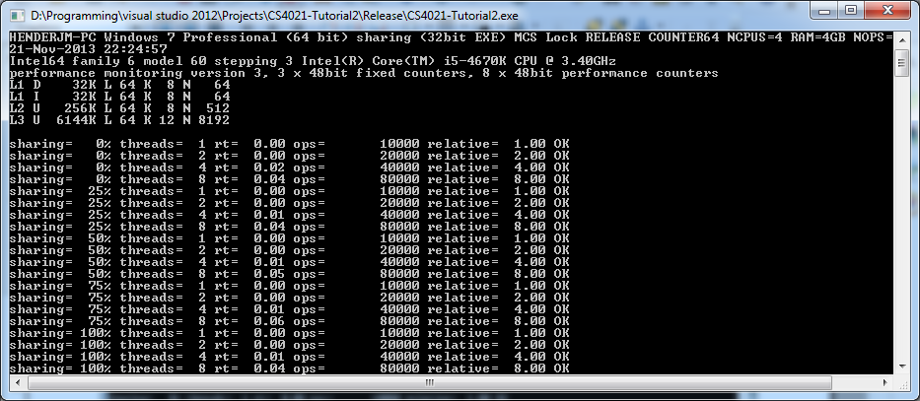

Colour on graph meaning:
0%
25%
50%
75%
100%

No Lock.

No lock exists, thus no mutual exclusion.

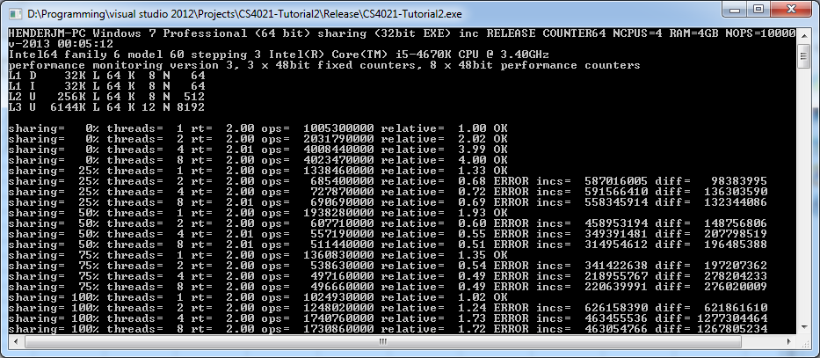

Test and Set
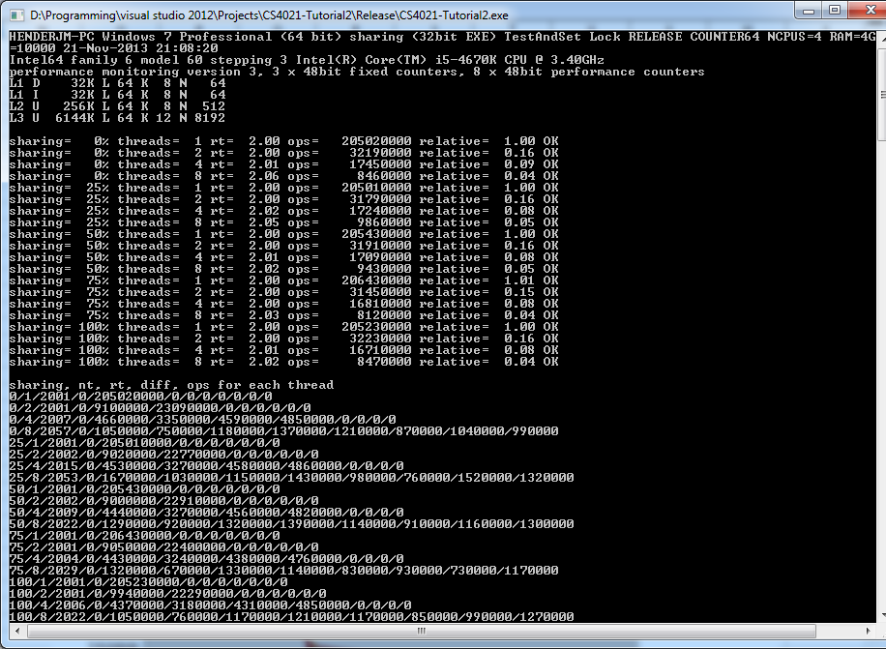
For TestAndSet, it atomically reads the lock which can only be a 1 or 0 and will act on the information accordingly. If it is a 1, it means another thread is already in the critical section, thus has to wait. If it is a 0, it enters the critical section and sets the flag to 1 so no other thread can enter. There is no guarantee of FIFO with this lock. For N threads TAS uses O(1) compared to O(N) for Bakery (slooow) because of RMW operation.

Test and Test and Set

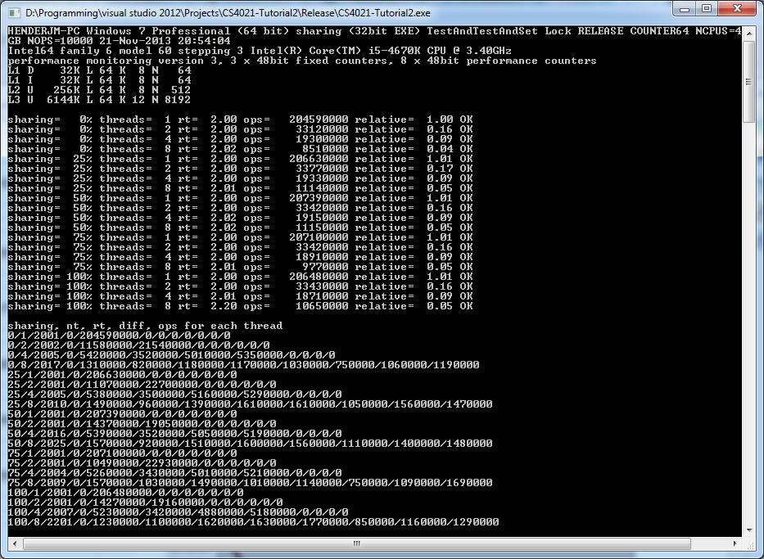

Using TTAS, we see a small improvement but nothing significant.

MCS

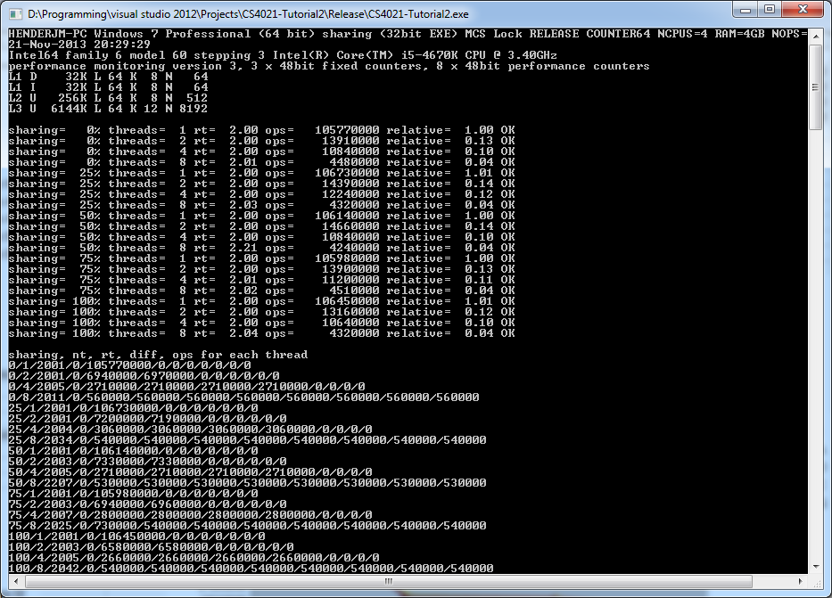

As can be seen from the final graph (again looks terrible through open office) the numbers of ops is significantly lower than other locks used.

