Problem Set B Submission Form

# Overview

|  |  |
| --- | --- |
| Your Name | Hendi Kushta |
| Your SU Email | hkushta@syr.edu |

# Instructions

Put your name and SU email at the top. Answer these questions all from the lab. When asked to include screenshots, please follow the screen shot guidelines from the first homework.

Remember as you complete the homework it is not only about getting it right / correct. We will discuss the answers in class so it’s important to articulate anything you would like to contribute to the discussion in your answer:

* If you feel the question is vague, include any assumptions you've made.
* If you feel the answer requires interpretation or justification provide it.
* If you do not know the answer to the question, articulate what you tried and how you are stuck.
* Highlight any doubts or questions you would like me to review.

This how you receive credit for answering questions which might not be correct. In addition, you must complete the reflection portion of the homework assignment for full credit. Since most answers will be similar this is an important part of your individual submission.

Complete Part II of this document first, then go back and complete the Reflection in Part I.

# Part I - Reflection

Use this section to reflect on your learning. To achieve the highest grade on the assignment you must be as descriptive and personal as possible with your reflection.

1. As you completed this assignment, identify what you learned.

Basic command lines that are needed in this course.

1. What barriers or challenges did you encounter while completing this assignment?
2. How prepared were you to complete this assignment? What can you do to be better prepared?

I was well prepared to complete this assingment.

1. Rate your comfort level with this week’s material. Use the rubric provided.

**4 ==> I understand this material and can explain it to others.**  
3 ==> I understand this material.  
2 ==> I somewhat understand the material but sometimes need guidance from others.  
1 ==> I understand very little of this material and need extra help.

# Part II – Questions

Paste your answers to the Exercises found in the lab document. Make sure to include your netid in any screenshots you provide. If the question asks for commands, only include those commands which are necessary to complete the tasks. Number each answer.

1. Take a screenshot of an open Windows Terminal with the current working directory set to the **advanced-databases** folder. Make sure to follow the screenshot guidelines and include your name/netid in the screenshot.

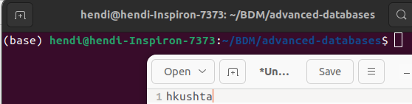

1. Explain the difference between a Docker image and a container. No screen shot necessary.

A Docker image is like a snapshot of a computer setup. It includes all the necessary things for a program to run, such as the code, tools, and settings. Think of it as a template that can be used to create multiple identical environments. These images are created using instructions in a file called a Dockerfile, and they are stored in a central place called a registry, where others can access and use them.

Once we have a Docker image, we can run it to create a Docker container. A container is like a live, running instance of the image. It's isolated from other containers and the computer it's running on, ensuring that what works in one container will work the same way in another. Containers are lightweight and can be easily started, stopped, and removed without affecting the rest of the system. They provide a consistent and portable way to run applications across different environments.

1. What is the purpose of a docker volume? No Screen shot necessary.

A Docker volume is like a special storage area that helps containers share and persist data. Imagine it as a designated folder that exists outside the containers but can be used by them. This is handy because, unlike the temporary storage inside a container, a volume's data stays even if the container is stopped or deleted. Volumes are crucial for tasks like saving database information or sharing files between containers. They make it easy to manage and maintain data separate from the containers, providing a reliable way to store and retrieve information consistently.

1. Start the redis and retwis services with docker-compose. Provide a screenshot of the command you typed, and another screenshot showing the two services are running.

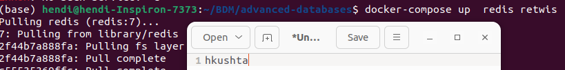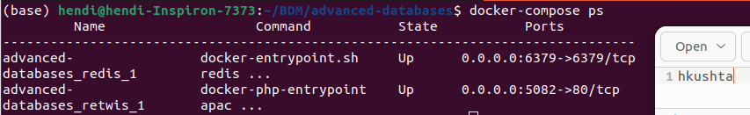

1. What does the last line in the redis logs say? Provide a screenshot of this message. What command did you have to type to see the redis logs?

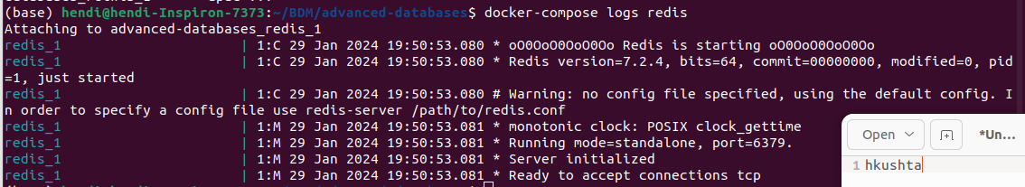  
The last line in redis logs say that the Redis service with the name redis_1 is ready to accept tcp connections.

I used docker-compose logs redis to get all Redis logs.

1. Which ports are being used by the currently running docker services? How do know they are running, and which ports are being used?

To find the ports that are being currently running in docker services, we can just type docke-compose ps. Redis is using port 6379, Retwis is using port 5082.



1. What are the volumes created by all the services in the docker-compose file? What command did you type to get this answer and provide a screenshot of the output.

To get the answer of question 7 I typed docker-compose config

  
The volumes created by all the services in the docker-compose file are found in the config file

